[Chapter 11A *Housing Accessibility*](https://up.codes/viewer/california/ca-building-code-2025/chapter/11A/housing-accessibility#11A)

**CALIFORNIA BUILDING CODE — MATRIX ADOPTION**[**TABLE**](https://up.codes/viewer/california/ca-building-code-2025/chapter/11B/accessibility-to-public-buildings-public-accommodations-commercial-buildings-and#table) **CHAPTER 11A — HOUSING**[**ACCESSIBILITY**](https://up.codes/viewer/california/ca-building-code-2025/chapter/30/elevators-and-conveying-systems#3001.4)

(Matrix Adoption [Tables](https://up.codes/viewer/california/ca-building-code-2025/chapter/11B/accessibility-to-public-buildings-public-accommodations-commercial-buildings-and#table) are nonregulatory, intended only as an aid to the code user.  
See [Chapter 1](https://up.codes/viewer/california/ca-building-code-2025/chapter/1/administration#1) for state agency authority and building [applications](https://up.codes/viewer/california/ca-building-code-2025/chapter/25/gypsum-panel-products-and-plaster#2501.1.1).)

| **Adopting agency** | **BSC** | **BSC-CG** | **SFM** | **HCD** | | | **DSA** | | | **OSHPD** | | | | | | | **BSCC** | **DPH** | **AGR** | **DWR** | **CEC** | **CA** | **SL** | **SLC** |
| --- | --- | --- | --- | --- | --- | --- | --- | --- | --- | --- | --- | --- | --- | --- | --- | --- | --- | --- | --- | --- | --- | --- | --- | --- |
| **1** | **2** | **1/AC** | **AC** | **SS** | **SS/CC** | **1** | **1R** | **2** | **3** | **4** | **5** | **6** |
| Adopt entire chapter |  |  |  |  |  | **X** |  |  |  |  |  |  |  |  |  |  |  |  |  |  |  |  |  |  |
| Adopt entire chapter as amended (amended sections listed below) |  |  |  |  |  |  |  |  |  |  |  |  |  |  |  |  |  |  |  |  |  |  |  |  |
| Adopt only those sections that are listed below |  |  |  |  |  |  |  |  |  |  |  |  |  |  |  |  |  |  |  |  |  |  |  |  |
| Chapter / Section |  |  |  |  |  |  |  |  |  |  |  |  |  |  |  |  |  |  |  |  |  |  |  |  |

***NOTE 1:***[*Covered multifamily dwellings*](https://up.codes/viewer/california/ca-building-code-2025/chapter/2/definitions#covered_multifamily_dwellings_hcd_1_ac_)*may be subject to the requirements of more than one*[*jurisdiction*](https://up.codes/viewer/california/ca-building-code-2025/chapter/2/definitions#jurisdiction_)*or law, which would require*[*compliance*](https://up.codes/viewer/california/ca-building-code-2025/chapter/31/special-construction#3113.1.1)*with each law. Where federal, state or local laws differ, the more stringent requirements apply. For additional information, see the*[*Joint*](https://up.codes/viewer/california/ca-building-code-2025/chapter/2/definitions#joint_)*Statement of the*[*Department*](https://up.codes/viewer/california/ca-building-code-2025/chapter/2/definitions#department_hcd_1_hcd_2_)*of Housing and Urban Development and the*[*Department*](https://up.codes/viewer/california/ca-building-code-2025/chapter/2/definitions#department_hcd_1_hcd_2_)*of Justice issued April*[*30*](https://up.codes/viewer/california/ca-building-code-2025/chapter/30/elevators-and-conveying-systems#30)*, 2013 (www.hud.gov).*

***NOTE 2:***[*Dwelling units*](https://up.codes/viewer/california/ca-building-code-2025/chapter/2/definitions#dwelling_unit_)*constructed as senior citizen housing may also be subject to the Unruh Civil Rights Act. Refer to Division I, Part 2 of the California Civil Code. For additional information regarding*[*application*](https://up.codes/viewer/california/ca-building-code-2025/chapter/25/gypsum-panel-products-and-plaster#2501.1.1)*, interpretation and*[*enforcement*](https://up.codes/viewer/california/ca-building-code-2025/chapter/2/definitions#enforcement_hcd_1_hcd_2_)*, contact the California*[*Department*](https://up.codes/viewer/california/ca-building-code-2025/chapter/2/definitions#department_hcd_1_hcd_2_)*of Fair Employment and Housing.*

[**Division I *— Application, General Provisions and Definitions***](https://up.codes/viewer/california/ca-building-code-2025/chapter/11A/housing-accessibility#divider_11A_I)

[**Section 1101A *Application***](https://up.codes/viewer/california/ca-building-code-2025/chapter/11A/housing-accessibility#1101A)

[**1101A.1 *Scope***](https://up.codes/viewer/california/ca-building-code-2025/chapter/11A/housing-accessibility#1101A.1)

*The*[*application*](https://up.codes/viewer/california/ca-building-code-2025/chapter/25/gypsum-panel-products-and-plaster#2501.1.1)*and authority of this chapter are identified and referenced in Sections*[*1.8.2.1.2*](https://up.codes/viewer/california/ca-building-code-2025/chapter/1/administration#1.8.2.1.2)*and*[*1102A*](https://up.codes/viewer/california/ca-building-code-2025/chapter/11A/housing-accessibility#1102A)*for the*[*Department*](https://up.codes/viewer/california/ca-building-code-2025/chapter/2/definitions#department_hcd_1_hcd_2_)*of Housing and Community Development. Applicable sections are identified in the Matrix Adoption*[*Tables*](https://up.codes/viewer/california/ca-building-code-2025/chapter/11B/accessibility-to-public-buildings-public-accommodations-commercial-buildings-and#table)*of this code under the abbreviation HCD 1-AC.The provisions of this chapter shall apply to the following:*

1. *All*[*newly-constructed*](https://up.codes/viewer/california/ca-building-code-2025/chapter/2/definitions#newly_constructed_hcd_1_ac_)[*covered multifamily dwellings*](https://up.codes/viewer/california/ca-building-code-2025/chapter/2/definitions#covered_multifamily_dwellings_hcd_1_ac_)*.*
2. *New*[*common use areas*](https://up.codes/viewer/california/ca-building-code-2025/chapter/2/definitions#common_use_areas_hcd_1_ac_)*serving existing*[*covered multifamily dwellings*](https://up.codes/viewer/california/ca-building-code-2025/chapter/2/definitions#covered_multifamily_dwellings_hcd_1_ac_)*.*
3. [*Additions*](https://up.codes/viewer/california/ca-building-code-2025/chapter/2/definitions#addition_)*to*[*existing buildings*](https://up.codes/viewer/california/ca-building-code-2025/chapter/2/definitions#building_existing_hcd_1_hcd_2_)*, where the*[*addition*](https://up.codes/viewer/california/ca-building-code-2025/chapter/2/definitions#addition_)*alone meets the definition of a covered multifamily*[*dwelling*](https://up.codes/viewer/california/ca-building-code-2025/chapter/2/definitions#dwelling_)*.*
4. *New*[*common-use*](https://up.codes/viewer/california/ca-building-code-2025/chapter/2/definitions#common_use_)*areas serving new*[*covered multifamily dwellings*](https://up.codes/viewer/california/ca-building-code-2025/chapter/2/definitions#covered_multifamily_dwellings_hcd_1_ac_)*.*
5. *Where any portion of a building's exterior is preserved, but the interior of the building is removed, including all structural portions of floors and ceilings, the building is considered a new building for determining the*[*application*](https://up.codes/viewer/california/ca-building-code-2025/chapter/25/gypsum-panel-products-and-plaster#2501.1.1)*of this chapter.*

[*Chapter 11A*](https://up.codes/viewer/california/ca-building-code-2025/chapter/11A/housing-accessibility#11A)*generally does not apply to public accommodations such as hotels and*[*motels*](https://up.codes/viewer/california/ca-building-code-2025/chapter/2/definitions#motel_hcd_1_hcd_2_)*and*[*public housing*](https://up.codes/viewer/california/ca-building-code-2025/chapter/11B/accessibility-to-public-buildings-public-accommodations-commercial-buildings-and#public_housing)*.*[*Public use areas*](https://up.codes/viewer/california/ca-building-code-2025/chapter/2/definitions#public_use_areas_hcd_1_ac_)*, public accommodations and*[*public housing*](https://up.codes/viewer/california/ca-building-code-2025/chapter/11B/accessibility-to-public-buildings-public-accommodations-commercial-buildings-and#public_housing)*as defined in*[*Chapter 2*](https://up.codes/viewer/california/ca-building-code-2025/chapter/2/definitions#2)*of this code are subject to provisions of the Division of the State Architect (DSA-AC) in*[*Chapter 11B*](https://up.codes/viewer/california/ca-building-code-2025/chapter/11B/accessibility-to-public-buildings-public-accommodations-commercial-buildings-and#11B)*, and are referenced in*[*Section 1.9.1*](https://up.codes/viewer/california/ca-building-code-2025/chapter/1/administration#1.9.1)*.*

[*Newly constructed*](https://up.codes/viewer/california/ca-building-code-2025/chapter/2/definitions#newly_constructed_hcd_1_ac_)[*covered multifamily dwellings*](https://up.codes/viewer/california/ca-building-code-2025/chapter/2/definitions#covered_multifamily_dwellings_hcd_1_ac_)*, which can also be defined as*[*public housing*](https://up.codes/viewer/california/ca-building-code-2025/chapter/11B/accessibility-to-public-buildings-public-accommodations-commercial-buildings-and#public_housing)*, shall be subject to the requirements of*[*Chapter 11B*](https://up.codes/viewer/california/ca-building-code-2025/chapter/11B/accessibility-to-public-buildings-public-accommodations-commercial-buildings-and#11B)*.*

[**Section 1102A *Building Accessibility***](https://up.codes/viewer/california/ca-building-code-2025/chapter/11A/housing-accessibility#1102A)

[**1102A.1 *Where Required***](https://up.codes/viewer/california/ca-building-code-2025/chapter/11A/housing-accessibility#1102A.1)

Diagram

*Buildings or portions of buildings and*[*facilities*](https://up.codes/viewer/california/ca-building-code-2025/chapter/2/definitions#facility_)*within the*[*scope*](https://up.codes/viewer/california/ca-building-code-2025/chapter/31/special-construction#3101.1)*of this chapter shall be accessible to*[*persons with disabilities*](https://up.codes/viewer/california/ca-building-code-2025/chapter/2/definitions#persons_with_disabilities_hcd_1_ac_)*. Each building on a building*[*site*](https://up.codes/viewer/california/ca-building-code-2025/chapter/2/definitions#site_)*shall be considered separately when determining the requirements contained in this chapter, except when calculating the number of units which must comply with*[*Section 1102A.3.1*](https://up.codes/viewer/california/ca-building-code-2025/chapter/11A/housing-accessibility#1102A.3.1)*.*[*Dwelling units*](https://up.codes/viewer/california/ca-building-code-2025/chapter/2/definitions#dwelling_unit_)*within a single structure separated by firewalls do not constitute separate buildings.*

[*Newly-constructed*](https://up.codes/viewer/california/ca-building-code-2025/chapter/2/definitions#newly_constructed_hcd_1_ac_)[*covered multifamily dwellings*](https://up.codes/viewer/california/ca-building-code-2025/chapter/2/definitions#covered_multifamily_dwellings_hcd_1_ac_)*as defined in this chapter, include, but are not limited to, the following:*

1. *Apartment buildings with*[*3*](https://up.codes/viewer/california/ca-building-code-2025/chapter/3/occupancy-classification-and-use#3)*or more*[*dwelling units*](https://up.codes/viewer/california/ca-building-code-2025/chapter/2/definitions#dwelling_unit_)*including timeshare apartments not considered a*[*place of public accommodation*](https://up.codes/viewer/california/ca-building-code-2025/chapter/2/definitions#place_of_public_accommodation_)*or*[*transient lodging*](https://up.codes/viewer/california/ca-building-code-2025/chapter/2/definitions#transient_lodging_)*as defined in Health and Safety Code Section 19955 (a), and*[*Chapter 2*](https://up.codes/viewer/california/ca-building-code-2025/chapter/2/definitions#2)*of the California Building Code.*
2. *Condominiums with 4 or more*[*dwelling units*](https://up.codes/viewer/california/ca-building-code-2025/chapter/2/definitions#dwelling_unit_)*including timeshare condominiums not considered a*[*place of public accommodation*](https://up.codes/viewer/california/ca-building-code-2025/chapter/2/definitions#place_of_public_accommodation_)*or*[*transient lodging*](https://up.codes/viewer/california/ca-building-code-2025/chapter/2/definitions#transient_lodging_)*as defined in Health and Safety Code Section 19955 (a), and*[*Chapter 2*](https://up.codes/viewer/california/ca-building-code-2025/chapter/2/definitions#2)*of the California Building Code.*
3. [*Lodging houses*](https://up.codes/viewer/california/ca-building-code-2025/chapter/2/definitions#lodging_house_hcd_1_hcd_1_ac_)*, as defined in*[*Chapter 2*](https://up.codes/viewer/california/ca-building-code-2025/chapter/2/definitions#2)*of the California Building Code, used as a residence with more than 3 but not more than 5 guest rooms.*
4. [*Congregate residences*](https://up.codes/viewer/california/ca-building-code-2025/chapter/2/definitions#congregate_residence_)*, as defined in*[*Chapter 2*](https://up.codes/viewer/california/ca-building-code-2025/chapter/2/definitions#2)*of the California Building Code, with 3 or more*[*sleeping units*](https://up.codes/viewer/california/ca-building-code-2025/chapter/2/definitions#sleeping_unit_)*.*
5. [*Dwellings*](https://up.codes/viewer/california/ca-building-code-2025/chapter/2/definitions#dwelling_)*with 3 or more efficiency units, as defined in*[*Chapter 2*](https://up.codes/viewer/california/ca-building-code-2025/chapter/2/definitions#2)*of this code, or Section 17958.1 of the California Health and Safety Code.*
6. *Shelters for homeless persons, not otherwise subject to the disabled access provisions of the Division of the State Architect—Access*[*Compliance*](https://up.codes/viewer/california/ca-building-code-2025/chapter/31/special-construction#3113.1.1)*(DSA-AC).*
7. [*Dormitories*](https://up.codes/viewer/california/ca-building-code-2025/chapter/2/definitions#dormitory_)*, as defined in*[*Chapter 2*](https://up.codes/viewer/california/ca-building-code-2025/chapter/2/definitions#2)*of this code, with*[*3*](https://up.codes/viewer/california/ca-building-code-2025/chapter/3/occupancy-classification-and-use#3)*or more guest rooms as defined in*[*Chapter 2*](https://up.codes/viewer/california/ca-building-code-2025/chapter/2/definitions#2)*of the California Building Code.*
8. *Timeshare*[*dwellings*](https://up.codes/viewer/california/ca-building-code-2025/chapter/2/definitions#dwelling_)*with 3 or more units, not considered a place of public accommodations or*[*transient lodging*](https://up.codes/viewer/california/ca-building-code-2025/chapter/2/definitions#transient_lodging_)*as defined in Health and Safety Code Section 19955 (a), and*[*Chapter 2*](https://up.codes/viewer/california/ca-building-code-2025/chapter/2/definitions#2)*of the California Building Code.*
9. *Other*[*Group R*](https://up.codes/viewer/california/ca-building-code-2025/chapter/P/sleeping-lofts#group_r)*occupancies in*[*covered multifamily dwellings*](https://up.codes/viewer/california/ca-building-code-2025/chapter/2/definitions#covered_multifamily_dwellings_hcd_1_ac_)*which are regulated by the Office of the State Fire Marshal. See*[*Section 1.11*](https://up.codes/viewer/california/ca-building-code-2025/chapter/1/administration#1.11)*.*
10. [*Public housing*](https://up.codes/viewer/california/ca-building-code-2025/chapter/11B/accessibility-to-public-buildings-public-accommodations-commercial-buildings-and#public_housing)*as defined in*[*Chapter 2*](https://up.codes/viewer/california/ca-building-code-2025/chapter/2/definitions#2)*of this code is subject to provisions of the Division of the State Architect (DSA-AC) in*[*Chapter 11B*](https://up.codes/viewer/california/ca-building-code-2025/chapter/11B/accessibility-to-public-buildings-public-accommodations-commercial-buildings-and#11B)*.*[*Newly constructed*](https://up.codes/viewer/california/ca-building-code-2025/chapter/2/definitions#newly_constructed_hcd_1_ac_)[*covered multifamily dwellings*](https://up.codes/viewer/california/ca-building-code-2025/chapter/2/definitions#covered_multifamily_dwellings_hcd_1_ac_)*, which can also be defined as*[*public housing*](https://up.codes/viewer/california/ca-building-code-2025/chapter/11B/accessibility-to-public-buildings-public-accommodations-commercial-buildings-and#public_housing)*, shall be subject to the requirements of*[*Chapter 11B*](https://up.codes/viewer/california/ca-building-code-2025/chapter/11B/accessibility-to-public-buildings-public-accommodations-commercial-buildings-and#11B)*.*

**UpCodes Diagram (1)**

**Single Bldg. Classification (FHA)**

[**1102A.2 *Existing Buildings***](https://up.codes/viewer/california/ca-building-code-2025/chapter/11A/housing-accessibility#1102A.2)

*The building standards contained in this chapter do not apply to the*[*alteration*](https://up.codes/viewer/california/ca-building-code-2025/chapter/2/definitions#alteration_)*,*[*repair*](https://up.codes/viewer/california/ca-building-code-2025/chapter/2/definitions#repair_)*, rehabilitation or*[*maintenance*](https://up.codes/viewer/california/ca-building-code-2025/chapter/L/earthquake-recording-instrumentation#L101.3)*of multifamily*[*dwellings*](https://up.codes/viewer/california/ca-building-code-2025/chapter/2/definitions#dwelling_)*constructed for first occupancy on or before March 13, 1991.*

[*Covered multifamily dwellings*](https://up.codes/viewer/california/ca-building-code-2025/chapter/2/definitions#covered_multifamily_dwellings_hcd_1_ac_)*shall be maintained in*[*compliance*](https://up.codes/viewer/california/ca-building-code-2025/chapter/31/special-construction#3113.1.1)*with the*[*accessibility*](https://up.codes/viewer/california/ca-building-code-2025/chapter/30/elevators-and-conveying-systems#3001.4)*standards in effect at the time of*[*construction*](https://up.codes/viewer/california/ca-building-code-2025/chapter/4/special-detailed-requirements-based-on-occupancy-and-use#407.1.1)*. Apartments constructed prior to March*[*13*](https://up.codes/viewer/california/ca-building-code-2025/chapter/13/energy-efficiency#13)*, 1991 shall be maintained in*[*compliance*](https://up.codes/viewer/california/ca-building-code-2025/chapter/31/special-construction#3113.1.1)*with the*[*accessibility*](https://up.codes/viewer/california/ca-building-code-2025/chapter/30/elevators-and-conveying-systems#3001.4)*standards in effect at the time of*[*construction*](https://up.codes/viewer/california/ca-building-code-2025/chapter/4/special-detailed-requirements-based-on-occupancy-and-use#407.1.1)*.*

[*Additions*](https://up.codes/viewer/california/ca-building-code-2025/chapter/2/definitions#addition_)*shall be subject to the requirements of this chapter, provided the*[*addition*](https://up.codes/viewer/california/ca-building-code-2025/chapter/2/definitions#addition_)*, when considered alone, meets the definition of a covered multifamily*[*dwelling*](https://up.codes/viewer/california/ca-building-code-2025/chapter/2/definitions#dwelling_)*, as defined in*[*Chapter 2*](https://up.codes/viewer/california/ca-building-code-2025/chapter/2/definitions#2)*. New*[*common use*](https://up.codes/viewer/california/ca-building-code-2025/chapter/2/definitions#common_use_)[*spaces*](https://up.codes/viewer/california/ca-building-code-2025/chapter/2/definitions#space_)*serving existing*[*covered multifamily dwellings*](https://up.codes/viewer/california/ca-building-code-2025/chapter/2/definitions#covered_multifamily_dwellings_hcd_1_ac_)*shall be subject to the requirements of this chapter.*

***Note:*** For all existing [public use areas](https://up.codes/viewer/california/ca-building-code-2025/chapter/2/definitions#public_use_areas_hcd_1_ac_), public accommodations and [public housing](https://up.codes/viewer/california/ca-building-code-2025/chapter/11B/accessibility-to-public-buildings-public-accommodations-commercial-buildings-and#public_housing), see [Chapter 11B](https://up.codes/viewer/california/ca-building-code-2025/chapter/11B/accessibility-to-public-buildings-public-accommodations-commercial-buildings-and#11B) for provisions of the Division of the State Architect—Access [Compliance](https://up.codes/viewer/california/ca-building-code-2025/chapter/31/special-construction#3113.1.1) (DSA-AC).

[**1102A.3 *Multistory Dwellings***](https://up.codes/viewer/california/ca-building-code-2025/chapter/11A/housing-accessibility#1102A.3)

[**1102A.3.1 *Multistory Apartment or Condominium Dwellings in Buildings With No Elevator***](https://up.codes/viewer/california/ca-building-code-2025/chapter/11A/housing-accessibility#1102A.3.1)

*This section shall apply to*[*multistory dwelling units*](https://up.codes/viewer/california/ca-building-code-2025/chapter/2/definitions#multistory_dwelling_unit_hcd_1_ac_)*on the*[*ground floor*](https://up.codes/viewer/california/ca-building-code-2025/chapter/2/definitions#ground_floor_)*of buildings without elevators for which an*[*application*](https://up.codes/viewer/california/ca-building-code-2025/chapter/25/gypsum-panel-products-and-plaster#2501.1.1)*for a*[*construction*](https://up.codes/viewer/california/ca-building-code-2025/chapter/4/special-detailed-requirements-based-on-occupancy-and-use#407.1.1)[*permit*](https://up.codes/viewer/california/ca-building-code-2025/chapter/2/definitions#permit_)*is submitted on or after July 1, 2005.*

***Exception:***[*Carriage units*](https://up.codes/viewer/california/ca-building-code-2025/chapter/2/definitions#carriage_unit_hcd_1_ac_)*as defined in*[*Chapter 2*](https://up.codes/viewer/california/ca-building-code-2025/chapter/2/definitions#2)*and regulated only by the*[*Department*](https://up.codes/viewer/california/ca-building-code-2025/chapter/2/definitions#department_hcd_1_hcd_2_)*of Housing and Community Development as referenced in*[*Section 1.8.2.1.2*](https://up.codes/viewer/california/ca-building-code-2025/chapter/1/administration#1.8.2.1.2)*.*

*At least 10 percent but not less than one of the multistory*[*dwellings*](https://up.codes/viewer/california/ca-building-code-2025/chapter/2/definitions#dwelling_)*in apartment buildings with*[*3*](https://up.codes/viewer/california/ca-building-code-2025/chapter/3/occupancy-classification-and-use#3)*or more*[*dwelling units*](https://up.codes/viewer/california/ca-building-code-2025/chapter/2/definitions#dwelling_unit_)*and/or condominiums with 4 or more*[*dwelling units*](https://up.codes/viewer/california/ca-building-code-2025/chapter/2/definitions#dwelling_unit_)*shall comply with the following:*

1. *The*[*primary entry*](https://up.codes/viewer/california/ca-building-code-2025/chapter/2/definitions#primary_entry_hcd_1_ac_)*to the*[*dwelling unit*](https://up.codes/viewer/california/ca-building-code-2025/chapter/2/definitions#dwelling_unit_)*shall be on an*[*accessible route*](https://up.codes/viewer/california/ca-building-code-2025/chapter/2/definitions#accessible_route_dsa_ac_hcd_1_ac_)*unless exempted by*[*site*](https://up.codes/viewer/california/ca-building-code-2025/chapter/2/definitions#site_)*impracticality tests in*[*Section 1150A*](https://up.codes/viewer/california/ca-building-code-2025/chapter/11A/housing-accessibility#1150A)*.*
2. *At least one*[*powder room*](https://up.codes/viewer/california/ca-building-code-2025/chapter/2/definitions#powder_room_)*or*[*bathroom*](https://up.codes/viewer/california/ca-building-code-2025/chapter/2/definitions#bathroom_)*shall be located on the*[*primary entry level*](https://up.codes/viewer/california/ca-building-code-2025/chapter/2/definitions#primary_entry_level_hcd_1_ac_)*, served by an*[*accessible route*](https://up.codes/viewer/california/ca-building-code-2025/chapter/2/definitions#accessible_route_dsa_ac_hcd_1_ac_)*and shall comply with the provisions in Division IV.*
3. *All rooms or*[*spaces*](https://up.codes/viewer/california/ca-building-code-2025/chapter/2/definitions#space_)*located on the*[*primary entry level*](https://up.codes/viewer/california/ca-building-code-2025/chapter/2/definitions#primary_entry_level_hcd_1_ac_)*shall be served by an*[*accessible route*](https://up.codes/viewer/california/ca-building-code-2025/chapter/2/definitions#accessible_route_dsa_ac_hcd_1_ac_)*and shall comply with the provisions in Division IV. Rooms and*[*spaces*](https://up.codes/viewer/california/ca-building-code-2025/chapter/2/definitions#space_)*located on the*[*primary entry level*](https://up.codes/viewer/california/ca-building-code-2025/chapter/2/definitions#primary_entry_level_hcd_1_ac_)*and subject to this chapter may include but are not limited to kitchens,*[*powder rooms*](https://up.codes/viewer/california/ca-building-code-2025/chapter/2/definitions#powder_room_)*,*[*bathrooms*](https://up.codes/viewer/california/ca-building-code-2025/chapter/2/definitions#bathroom_)*, living rooms, bedrooms or hallways.*
4. [*Common use areas*](https://up.codes/viewer/california/ca-building-code-2025/chapter/2/definitions#common_use_areas_hcd_1_ac_)*covered by this section shall be accessible as required by this chapter.*[*Public use areas*](https://up.codes/viewer/california/ca-building-code-2025/chapter/2/definitions#public_use_areas_hcd_1_ac_)*as defined in*[*Chapter 2*](https://up.codes/viewer/california/ca-building-code-2025/chapter/2/definitions#2)*of this code are subject to provisions of the Division of the State Architect (DSA-AC) and are referenced in*[*Section 1.9.1.1*](https://up.codes/viewer/california/ca-building-code-2025/chapter/1/administration#1.9.1.1)*.*

*The minimum number of multifamily*[*dwelling units*](https://up.codes/viewer/california/ca-building-code-2025/chapter/2/definitions#dwelling_unit_)*which must comply with this section shall be calculated using the total number of all*[*multistory dwelling units*](https://up.codes/viewer/california/ca-building-code-2025/chapter/2/definitions#multistory_dwelling_unit_hcd_1_ac_)*in buildings on a*[*site*](https://up.codes/viewer/california/ca-building-code-2025/chapter/2/definitions#site_)*which are subject to this section. Any fraction thereof shall be rounded to the next highest whole number.*

[**1102A.3.2 *Multistory Dwelling Units in Buildings With One or More Elevators***](https://up.codes/viewer/california/ca-building-code-2025/chapter/11A/housing-accessibility#1102A.3.2)

Diagram

[*Multistory dwelling units*](https://up.codes/viewer/california/ca-building-code-2025/chapter/2/definitions#multistory_dwelling_unit_hcd_1_ac_)*contained in buildings with elevators shall comply with this section. For*[*multistory dwelling units*](https://up.codes/viewer/california/ca-building-code-2025/chapter/2/definitions#multistory_dwelling_unit_hcd_1_ac_)*in buildings with elevators, the*[*story*](https://up.codes/viewer/california/ca-building-code-2025/chapter/11B/accessibility-to-public-buildings-public-accommodations-commercial-buildings-and#story)*of the unit that is served by the building elevator is considered a*[*ground floor*](https://up.codes/viewer/california/ca-building-code-2025/chapter/2/definitions#ground_floor_)*and the*[*primary entry*](https://up.codes/viewer/california/ca-building-code-2025/chapter/2/definitions#primary_entry_hcd_1_ac_)*floor to the unit and shall comply with the following:*

1. *At least 1*[*powder room*](https://up.codes/viewer/california/ca-building-code-2025/chapter/2/definitions#powder_room_)*or*[*bathroom*](https://up.codes/viewer/california/ca-building-code-2025/chapter/2/definitions#bathroom_)*shall be located on the*[*primary entry level*](https://up.codes/viewer/california/ca-building-code-2025/chapter/2/definitions#primary_entry_level_hcd_1_ac_)*.*
2. *At least 1 kitchen shall be located on the*[*primary entry level*](https://up.codes/viewer/california/ca-building-code-2025/chapter/2/definitions#primary_entry_level_hcd_1_ac_)*.*
3. *All rooms or*[*spaces*](https://up.codes/viewer/california/ca-building-code-2025/chapter/2/definitions#space_)*located on the*[*primary entry level*](https://up.codes/viewer/california/ca-building-code-2025/chapter/2/definitions#primary_entry_level_hcd_1_ac_)*shall be served by an*[*accessible route*](https://up.codes/viewer/california/ca-building-code-2025/chapter/2/definitions#accessible_route_dsa_ac_hcd_1_ac_)*and shall comply with Division IV.*

**UpCodes Diagram (1)**

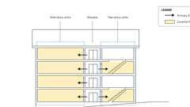

**Covered Multi-Family Dwellings with Elevators**

[**1102A.4 *Temporary Restrictions***](https://up.codes/viewer/california/ca-building-code-2025/chapter/11A/housing-accessibility#1102A.4)

*During periods of partial or restricted use of a building or*[*facility*](https://up.codes/viewer/california/ca-building-code-2025/chapter/2/definitions#facility_)*, the*[*entrances*](https://up.codes/viewer/california/ca-building-code-2025/chapter/2/definitions#entrance_hcd_1_hcd_2_hcd_1_ac_and_dsa_ac_)*used for primary access shall be accessible to and usable by*[*persons with disabilities*](https://up.codes/viewer/california/ca-building-code-2025/chapter/2/definitions#persons_with_disabilities_hcd_1_ac_)*.*

[**Section 1103A *Design and Construction***](https://up.codes/viewer/california/ca-building-code-2025/chapter/11A/housing-accessibility#1103A)

[**1103A.1 *General***](https://up.codes/viewer/california/ca-building-code-2025/chapter/11A/housing-accessibility#1103A.1)

*When buildings are required to be accessible, they shall be designed and constructed as provided in this chapter.*

[**Section 1104A *Covered Multifamily Dwellings***](https://up.codes/viewer/california/ca-building-code-2025/chapter/11A/housing-accessibility#1104A)

Diagram

**UpCodes Diagram (1)**

Primary

**Covered Multifamily Dwellings (CA)**

[**1104A.1 *General***](https://up.codes/viewer/california/ca-building-code-2025/chapter/11A/housing-accessibility#1104A.1)

*All*[*ground-floor*](https://up.codes/viewer/california/ca-building-code-2025/chapter/2/definitions#ground_floor_)[*dwelling units*](https://up.codes/viewer/california/ca-building-code-2025/chapter/2/definitions#dwelling_unit_)*in nonelevator buildings shall be*[*adaptable*](https://up.codes/viewer/california/ca-building-code-2025/chapter/2/definitions#adaptable_dsa_ac_)*and on an*[*accessible route*](https://up.codes/viewer/california/ca-building-code-2025/chapter/2/definitions#accessible_route_dsa_ac_hcd_1_ac_)*, unless an*[*accessible route*](https://up.codes/viewer/california/ca-building-code-2025/chapter/2/definitions#accessible_route_dsa_ac_hcd_1_ac_)*is not required as determined by*[*site*](https://up.codes/viewer/california/ca-building-code-2025/chapter/2/definitions#site_)*impracticality provisions in*[*Section 1150A*](https://up.codes/viewer/california/ca-building-code-2025/chapter/11A/housing-accessibility#1150A)*. For buildings with elevators, see*[*Section 1106A*](https://up.codes/viewer/california/ca-building-code-2025/chapter/11A/housing-accessibility#1106A)*.*

[*Multistory dwelling units*](https://up.codes/viewer/california/ca-building-code-2025/chapter/2/definitions#multistory_dwelling_unit_hcd_1_ac_)*shall comply with*[*Section 1102A.3*](https://up.codes/viewer/california/ca-building-code-2025/chapter/11A/housing-accessibility#1102A.3)*.*

[**1104A.2 *Ground Floors Above Grade***](https://up.codes/viewer/california/ca-building-code-2025/chapter/11A/housing-accessibility#1104A.2)

Diagram

*Where the first floor containing*[*dwelling units*](https://up.codes/viewer/california/ca-building-code-2025/chapter/2/definitions#dwelling_unit_)*in a building is above*[*grade*](https://up.codes/viewer/california/ca-building-code-2025/chapter/J/grading#grade_)*, all units on that floor shall be served by an*[*accessible route*](https://up.codes/viewer/california/ca-building-code-2025/chapter/2/definitions#accessible_route_dsa_ac_hcd_1_ac_)*. This floor will be considered a*[*ground floor*](https://up.codes/viewer/california/ca-building-code-2025/chapter/2/definitions#ground_floor_)*and all*[*dwelling units*](https://up.codes/viewer/california/ca-building-code-2025/chapter/2/definitions#dwelling_unit_)*are considered covered multifamily*[*dwelling units*](https://up.codes/viewer/california/ca-building-code-2025/chapter/2/definitions#dwelling_unit_)*.*

***Exception:***[*Carriage units*](https://up.codes/viewer/california/ca-building-code-2025/chapter/2/definitions#carriage_unit_hcd_1_ac_)*as defined in*[*Chapter 2*](https://up.codes/viewer/california/ca-building-code-2025/chapter/2/definitions#2)*and regulated only by the*[*Department*](https://up.codes/viewer/california/ca-building-code-2025/chapter/2/definitions#department_hcd_1_hcd_2_)*of Housing and Community Development as referenced in*[*Section 1.8.2.1.2*](https://up.codes/viewer/california/ca-building-code-2025/chapter/1/administration#1.8.2.1.2)*.*

[*Multistory dwelling units*](https://up.codes/viewer/california/ca-building-code-2025/chapter/2/definitions#multistory_dwelling_unit_hcd_1_ac_)*shall comply with*[*Section 1102A.3*](https://up.codes/viewer/california/ca-building-code-2025/chapter/11A/housing-accessibility#1102A.3)*.*

**UpCodes Diagrams (2)**

**Covered Dwelling Units over Shops and Garages**

**Covered Multi-Family Dwellings with Elevators**

[**Section 1105A *Garages, Carports and Parking Facilities***](https://up.codes/viewer/california/ca-building-code-2025/chapter/11A/housing-accessibility#1105A)

[**1105A.1 *General***](https://up.codes/viewer/california/ca-building-code-2025/chapter/11A/housing-accessibility#1105A.1)

Diagram

*Garages, carports and other parking*[*facilities*](https://up.codes/viewer/california/ca-building-code-2025/chapter/2/definitions#facility_)*, which are accessory to covered multifamily*[*dwelling units*](https://up.codes/viewer/california/ca-building-code-2025/chapter/2/definitions#dwelling_unit_)*, shall be accessible as required in*[*Section 1109A*](https://up.codes/viewer/california/ca-building-code-2025/chapter/11A/housing-accessibility#1109A)*.*

**UpCodes Diagram (1)**

**Parking Spaces: Van and Single (CA 11A)**

[**Section 1106A *Site and Building Characteristics***](https://up.codes/viewer/california/ca-building-code-2025/chapter/11A/housing-accessibility#1106A)

[**1106A.1 *General***](https://up.codes/viewer/california/ca-building-code-2025/chapter/11A/housing-accessibility#1106A.1)

Diagram

[*Covered multifamily dwellings*](https://up.codes/viewer/california/ca-building-code-2025/chapter/2/definitions#covered_multifamily_dwellings_hcd_1_ac_)*with elevators shall be designed and constructed to provide at least one accessible*[*entrance*](https://up.codes/viewer/california/ca-building-code-2025/chapter/2/definitions#entrance_hcd_1_hcd_2_hcd_1_ac_and_dsa_ac_)*on an*[*accessible route*](https://up.codes/viewer/california/ca-building-code-2025/chapter/2/definitions#accessible_route_dsa_ac_hcd_1_ac_)*, regardless of terrain or unusual characteristics of the*[*site*](https://up.codes/viewer/california/ca-building-code-2025/chapter/2/definitions#site_)*.*[*Covered multifamily dwellings*](https://up.codes/viewer/california/ca-building-code-2025/chapter/2/definitions#covered_multifamily_dwellings_hcd_1_ac_)*without elevators shall be designed and constructed to provide at least one accessible*[*entrance*](https://up.codes/viewer/california/ca-building-code-2025/chapter/2/definitions#entrance_hcd_1_hcd_2_hcd_1_ac_and_dsa_ac_)*on an*[*accessible route*](https://up.codes/viewer/california/ca-building-code-2025/chapter/2/definitions#accessible_route_dsa_ac_hcd_1_ac_)*unless terrain or unusual characteristics of the*[*site*](https://up.codes/viewer/california/ca-building-code-2025/chapter/2/definitions#site_)*prevent an*[*accessible route*](https://up.codes/viewer/california/ca-building-code-2025/chapter/2/definitions#accessible_route_dsa_ac_hcd_1_ac_)*based on the conditions listed below:*

1. ***Accessible***[***Entrance***](https://up.codes/viewer/california/ca-building-code-2025/chapter/2/definitions#entrance_hcd_1_hcd_2_hcd_1_ac_and_dsa_ac_)***.****Regardless of*[*site*](https://up.codes/viewer/california/ca-building-code-2025/chapter/2/definitions#site_)*considerations described in*[*Section 1150A*](https://up.codes/viewer/california/ca-building-code-2025/chapter/11A/housing-accessibility#1150A)*, an accessible*[*entrance*](https://up.codes/viewer/california/ca-building-code-2025/chapter/2/definitions#entrance_hcd_1_hcd_2_hcd_1_ac_and_dsa_ac_)*on an*[*accessible route*](https://up.codes/viewer/california/ca-building-code-2025/chapter/2/definitions#accessible_route_dsa_ac_hcd_1_ac_)*is required when there is an elevator connecting the parking area with the*[*dwelling units*](https://up.codes/viewer/california/ca-building-code-2025/chapter/2/definitions#dwelling_unit_)*on a*[*ground floor*](https://up.codes/viewer/california/ca-building-code-2025/chapter/2/definitions#ground_floor_)*. (In this case, those*[*dwelling units*](https://up.codes/viewer/california/ca-building-code-2025/chapter/2/definitions#dwelling_unit_)*on the*[*ground floor*](https://up.codes/viewer/california/ca-building-code-2025/chapter/2/definitions#ground_floor_)*served by an elevator and at least one of each type of public- and*[*common-use*](https://up.codes/viewer/california/ca-building-code-2025/chapter/2/definitions#common_use_)*areas, would be subject to these requirements.)*
2. ***Elevator building.****When a building elevator or elevators are provided as a means of access to*[*dwelling units*](https://up.codes/viewer/california/ca-building-code-2025/chapter/2/definitions#dwelling_unit_)*other than*[*dwelling units*](https://up.codes/viewer/california/ca-building-code-2025/chapter/2/definitions#dwelling_unit_)*on a*[*ground floor*](https://up.codes/viewer/california/ca-building-code-2025/chapter/2/definitions#ground_floor_)*(see*[*Section 1104A.2*](https://up.codes/viewer/california/ca-building-code-2025/chapter/11A/housing-accessibility#1104A.2)*), the building is an elevator building. All*[*dwelling units*](https://up.codes/viewer/california/ca-building-code-2025/chapter/2/definitions#dwelling_unit_)*become*[*covered multifamily dwellings*](https://up.codes/viewer/california/ca-building-code-2025/chapter/2/definitions#covered_multifamily_dwellings_hcd_1_ac_)*in that building. The elevator in that building must provide*[*accessibility*](https://up.codes/viewer/california/ca-building-code-2025/chapter/30/elevators-and-conveying-systems#3001.4)*to all*[*dwelling units*](https://up.codes/viewer/california/ca-building-code-2025/chapter/2/definitions#dwelling_unit_)*in the building, regardless of the*[*slope*](https://up.codes/viewer/california/ca-building-code-2025/chapter/J/grading#slope_)*of the natural terrain. For*[*multistory dwelling units*](https://up.codes/viewer/california/ca-building-code-2025/chapter/2/definitions#multistory_dwelling_unit_hcd_1_ac_)*in buildings with one or more elevators, see*[*Section 1102A.3.2*](https://up.codes/viewer/california/ca-building-code-2025/chapter/11A/housing-accessibility#1102A.3.2)*.*

***Note:****Where a building elevator is provided only as means of creating an*[*accessible route*](https://up.codes/viewer/california/ca-building-code-2025/chapter/2/definitions#accessible_route_dsa_ac_hcd_1_ac_)*to covered multifamily*[*dwelling units*](https://up.codes/viewer/california/ca-building-code-2025/chapter/2/definitions#dwelling_unit_)*on a*[*ground floor*](https://up.codes/viewer/california/ca-building-code-2025/chapter/2/definitions#ground_floor_)*, the building is not considered to be an elevator building, only*[*dwelling units*](https://up.codes/viewer/california/ca-building-code-2025/chapter/2/definitions#dwelling_unit_)*located on the*[*ground floor*](https://up.codes/viewer/california/ca-building-code-2025/chapter/2/definitions#ground_floor_)*shall be required to comply with this chapter.*

1. ***Elevated walkway.****When an elevated walkway is planned between a building*[*entrance*](https://up.codes/viewer/california/ca-building-code-2025/chapter/2/definitions#entrance_hcd_1_hcd_2_hcd_1_ac_and_dsa_ac_)*and a vehicular or*[*pedestrian*](https://up.codes/viewer/california/ca-building-code-2025/chapter/2/definitions#pedestrian_hcd_1_ac_)*arrival point and the planned walkway has a*[*slope*](https://up.codes/viewer/california/ca-building-code-2025/chapter/J/grading#slope_)*no greater than 10 percent (1 unit vertical in 10 units horizontal), the floor being served by the elevated walkway becomes a*[*ground floor*](https://up.codes/viewer/california/ca-building-code-2025/chapter/2/definitions#ground_floor_)*and*[*accessibility*](https://up.codes/viewer/california/ca-building-code-2025/chapter/30/elevators-and-conveying-systems#3001.4)*to all*[*dwellings*](https://up.codes/viewer/california/ca-building-code-2025/chapter/2/definitions#dwelling_)*on that*[*ground floor*](https://up.codes/viewer/california/ca-building-code-2025/chapter/2/definitions#ground_floor_)*is required.*

***Note:****Since the planned walkway meets the 10 percent*[*slope*](https://up.codes/viewer/california/ca-building-code-2025/chapter/J/grading#slope_)*criterion, it is required to provide an*[*accessible route*](https://up.codes/viewer/california/ca-building-code-2025/chapter/2/definitions#accessible_route_dsa_ac_hcd_1_ac_)*to the*[*entrance*](https://up.codes/viewer/california/ca-building-code-2025/chapter/2/definitions#entrance_hcd_1_hcd_2_hcd_1_ac_and_dsa_ac_)*and the*[*slope*](https://up.codes/viewer/california/ca-building-code-2025/chapter/J/grading#slope_)*of the walkway must be reduced to 1 unit vertical in 12 units horizontal (8.33 percent*[*slope*](https://up.codes/viewer/california/ca-building-code-2025/chapter/J/grading#slope_)*) maximum.*

**UpCodes Diagram (1)**



**Covered Multi-Family Dwellings with Elevators**

[**1106A.2 *Site Impracticality***](https://up.codes/viewer/california/ca-building-code-2025/chapter/11A/housing-accessibility#1106A.2)

*For tests to determine*[*site*](https://up.codes/viewer/california/ca-building-code-2025/chapter/2/definitions#site_)*impracticality due to terrain considerations in nonelevator buildings, see*[*Section 1150A*](https://up.codes/viewer/california/ca-building-code-2025/chapter/11A/housing-accessibility#1150A)*.*

[**Section 1107A *Definitions***](https://up.codes/viewer/california/ca-building-code-2025/chapter/11A/housing-accessibility#1107A)

*All*[*definitions*](https://up.codes/viewer/california/ca-building-code-2025/chapter/J/grading#J102.1)*are located in*[*Chapter 2*](https://up.codes/viewer/california/ca-building-code-2025/chapter/2/definitions#2)*.*

[**Division II *— Exterior Facilities***](https://up.codes/viewer/california/ca-building-code-2025/chapter/11A/housing-accessibility#divider_11A_II)

[**Section 1108A *General Requirements for Accessible Parking and Exterior Routes of Travel***](https://up.codes/viewer/california/ca-building-code-2025/chapter/11A/housing-accessibility#1108A)

Diagram

***Note:****In addition to provisions of this division, exterior routes of travel that provide access to, or egress from, buildings for*[*persons with disabilities*](https://up.codes/viewer/california/ca-building-code-2025/chapter/2/definitions#persons_with_disabilities_hcd_1_ac_)*shall also comply with*[*Chapter 10*](https://up.codes/viewer/california/ca-building-code-2025/chapter/10/means-of-egress#10)*.*

**UpCodes Diagram (1)**

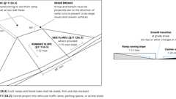

**Curb Ramps (CA 11A)**

[**Section 1109A *Parking Facilities***](https://up.codes/viewer/california/ca-building-code-2025/chapter/11A/housing-accessibility#1109A)

Diagram

**UpCodes Diagrams (4)**

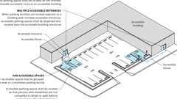

**Location of Accessible Parking Spaces - Condition 1 & 2**

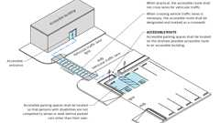

**Location of Accessible Parking Spaces - Condition 3**

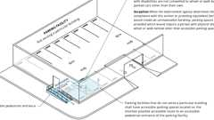

**Location of Accessible Parking Spaces - Condition 4 & 5**

**Assigned and Unassigned Parking (11A)**

[**1109A.1 *Accessible Parking Required***](https://up.codes/viewer/california/ca-building-code-2025/chapter/11A/housing-accessibility#1109A.1)

Diagram

*Each parking*[*facility*](https://up.codes/viewer/california/ca-building-code-2025/chapter/2/definitions#facility_)*provided for*[*covered multifamily dwellings*](https://up.codes/viewer/california/ca-building-code-2025/chapter/2/definitions#covered_multifamily_dwellings_hcd_1_ac_)*and*[*facilities*](https://up.codes/viewer/california/ca-building-code-2025/chapter/2/definitions#facility_)*(e.g.,*[*swimming pools*](https://up.codes/viewer/california/ca-building-code-2025/chapter/2/definitions#swimming_pool_)*, club houses, recreation areas and laundry rooms) that serve*[*covered multifamily dwellings*](https://up.codes/viewer/california/ca-building-code-2025/chapter/2/definitions#covered_multifamily_dwellings_hcd_1_ac_)*shall provide accessible parking as required by this section.*

**UpCodes Diagram (1)**

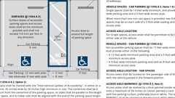

**Parking Spaces: Van and Single (CA 11A)**

[**1109A.2 *Parking Facilities***](https://up.codes/viewer/california/ca-building-code-2025/chapter/11A/housing-accessibility#1109A.2)

*Parking*[*facilities*](https://up.codes/viewer/california/ca-building-code-2025/chapter/2/definitions#facility_)*shall include, but not be limited to, the following:*

1. *Garages*
2. [*Private garages*](https://up.codes/viewer/california/ca-building-code-2025/chapter/2/definitions#private_garage_)
3. *Carports*
4. *Off-street parking (parking lots/*[*spaces*](https://up.codes/viewer/california/ca-building-code-2025/chapter/2/definitions#space_)*)*

[**1109A.2.1 *Private Garages***](https://up.codes/viewer/california/ca-building-code-2025/chapter/11A/housing-accessibility#1109A.2.1)

[*Private garages*](https://up.codes/viewer/california/ca-building-code-2025/chapter/2/definitions#private_garage_)*accessory to covered multifamily*[*dwelling units*](https://up.codes/viewer/california/ca-building-code-2025/chapter/2/definitions#dwelling_unit_)*, shall be accessible as required in*[*Section 1109A*](https://up.codes/viewer/california/ca-building-code-2025/chapter/11A/housing-accessibility#1109A)*.*[*Private garages*](https://up.codes/viewer/california/ca-building-code-2025/chapter/2/definitions#private_garage_)*include individual garages and multiple individual garages grouped together.*

***Exception:****A*[*private garage*](https://up.codes/viewer/california/ca-building-code-2025/chapter/2/definitions#private_garage_)*attached to and directly serving a single covered multifamily*[*dwelling unit*](https://up.codes/viewer/california/ca-building-code-2025/chapter/2/definitions#dwelling_unit_)*providing at least one of the following options:*

1. *A door leading directly from the covered*[*dwelling unit*](https://up.codes/viewer/california/ca-building-code-2025/chapter/2/definitions#dwelling_unit_)*, which immediately enters the garage. The door shall comply on both sides with Sections*[*1132A.3*](https://up.codes/viewer/california/ca-building-code-2025/chapter/11A/housing-accessibility#1132A.3)*through 1132A.9.*
2. *An*[*accessible route*](https://up.codes/viewer/california/ca-building-code-2025/chapter/2/definitions#accessible_route_dsa_ac_hcd_1_ac_)*of travel from the covered*[*dwelling unit*](https://up.codes/viewer/california/ca-building-code-2025/chapter/2/definitions#dwelling_unit_)*to an exterior door entering the garage. See*[*Section 1132A.1*](https://up.codes/viewer/california/ca-building-code-2025/chapter/11A/housing-accessibility#1132A.1)*for requirements at both*[*exit*](https://up.codes/viewer/california/ca-building-code-2025/chapter/2/definitions#exit_)*doors.*
3. *An*[*accessible route*](https://up.codes/viewer/california/ca-building-code-2025/chapter/2/definitions#accessible_route_dsa_ac_hcd_1_ac_)*of travel from the*[*dwelling unit*](https://up.codes/viewer/california/ca-building-code-2025/chapter/2/definitions#dwelling_unit_)*'s*[*primary entry*](https://up.codes/viewer/california/ca-building-code-2025/chapter/2/definitions#primary_entry_hcd_1_ac_)*door to the vehicular*[*entrance*](https://up.codes/viewer/california/ca-building-code-2025/chapter/2/definitions#entrance_hcd_1_hcd_2_hcd_1_ac_and_dsa_ac_)*at the garage. See*[*Section 1132A.1*](https://up.codes/viewer/california/ca-building-code-2025/chapter/11A/housing-accessibility#1132A.1)*for requirements at the*[*primary entry*](https://up.codes/viewer/california/ca-building-code-2025/chapter/2/definitions#primary_entry_hcd_1_ac_)*door.*

[**1109A.3 *Required Accessible Parking Spaces***](https://up.codes/viewer/california/ca-building-code-2025/chapter/11A/housing-accessibility#1109A.3)

*Accessible parking*[*spaces*](https://up.codes/viewer/california/ca-building-code-2025/chapter/2/definitions#space_)*shall be provided at a minimum rate of 2 percent of the covered multifamily*[*dwelling units*](https://up.codes/viewer/california/ca-building-code-2025/chapter/2/definitions#dwelling_unit_)*. At least one*[*space*](https://up.codes/viewer/california/ca-building-code-2025/chapter/2/definitions#space_)*of each type of parking*[*facility*](https://up.codes/viewer/california/ca-building-code-2025/chapter/2/definitions#facility_)*shall be made accessible even if the total number exceeds 2 percent.*

[**1109A.4 *Assigned Accessible Parking Spaces***](https://up.codes/viewer/california/ca-building-code-2025/chapter/11A/housing-accessibility#1109A.4)

Diagram

*When assigned parking*[*spaces*](https://up.codes/viewer/california/ca-building-code-2025/chapter/2/definitions#space_)*are provided for a resident or a group of residents, at least 2 percent of the assigned parking*[*spaces*](https://up.codes/viewer/california/ca-building-code-2025/chapter/2/definitions#space_)*serving covered multifamily*[*dwelling units*](https://up.codes/viewer/california/ca-building-code-2025/chapter/2/definitions#dwelling_unit_)*shall be accessible in each type of parking*[*facility*](https://up.codes/viewer/california/ca-building-code-2025/chapter/2/definitions#facility_)*. At least one*[*space*](https://up.codes/viewer/california/ca-building-code-2025/chapter/2/definitions#space_)*of each type of parking*[*facility*](https://up.codes/viewer/california/ca-building-code-2025/chapter/2/definitions#facility_)*shall be made accessible even if the total number exceeds 2 percent. When assigned parking is provided, signage as required by*[*Section 1109A.8.8*](https://up.codes/viewer/california/ca-building-code-2025/chapter/11A/housing-accessibility#1109A.8.8)*shall not be required.*

**UpCodes Diagram (1)**

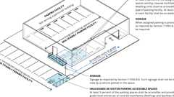Primary

**Assigned and Unassigned Parking (11A)**

[**1109A.5 *Unassigned and Visitor Parking Spaces***](https://up.codes/viewer/california/ca-building-code-2025/chapter/11A/housing-accessibility#1109A.5)

Diagram

*When parking is provided for*[*covered multifamily dwellings*](https://up.codes/viewer/california/ca-building-code-2025/chapter/2/definitions#covered_multifamily_dwellings_hcd_1_ac_)*and is not assigned to a resident or a group of residents at least 5 percent of the parking*[*spaces*](https://up.codes/viewer/california/ca-building-code-2025/chapter/2/definitions#space_)*shall be accessible and provide access to*[*grade*](https://up.codes/viewer/california/ca-building-code-2025/chapter/J/grading#grade_)*-level*[*entrances*](https://up.codes/viewer/california/ca-building-code-2025/chapter/2/definitions#entrance_hcd_1_hcd_2_hcd_1_ac_and_dsa_ac_)*of*[*covered multifamily dwellings*](https://up.codes/viewer/california/ca-building-code-2025/chapter/2/definitions#covered_multifamily_dwellings_hcd_1_ac_)*and*[*facilities*](https://up.codes/viewer/california/ca-building-code-2025/chapter/2/definitions#facility_)*(e.g.,*[*swimming pools*](https://up.codes/viewer/california/ca-building-code-2025/chapter/2/definitions#swimming_pool_)*, club houses, recreation areas and laundry rooms) that serve*[*covered multifamily dwellings*](https://up.codes/viewer/california/ca-building-code-2025/chapter/2/definitions#covered_multifamily_dwellings_hcd_1_ac_)*. Accessible parking*[*spaces*](https://up.codes/viewer/california/ca-building-code-2025/chapter/2/definitions#space_)*shall be provided with signage as required by*[*Section 1109A.8.8*](https://up.codes/viewer/california/ca-building-code-2025/chapter/11A/housing-accessibility#1109A.8.8)*. Such signage shall not be blocked from view by a vehicle parked in the*[*space*](https://up.codes/viewer/california/ca-building-code-2025/chapter/2/definitions#space_)*.*

**UpCodes Diagram (1)**

Primary

**Assigned and Unassigned Parking (11A)**

[**1109A.6 *Requests for Accessible Parking Spaces***](https://up.codes/viewer/california/ca-building-code-2025/chapter/11A/housing-accessibility#1109A.6)

*When assigned parking is provided, designated accessible parking for the*[*dwelling unit*](https://up.codes/viewer/california/ca-building-code-2025/chapter/2/definitions#dwelling_unit_)*shall be provided on request of residents with*[*disabilities*](https://up.codes/viewer/california/ca-building-code-2025/chapter/2/definitions#disability_dsa_ac_)*on the same terms and with the full range of choices (e.g., off-street parking, carport or garage) that are available for other residents.*

[**1109A.7 *Location of Accessible Parking Spaces***](https://up.codes/viewer/california/ca-building-code-2025/chapter/11A/housing-accessibility#1109A.7)

Diagram

*The*[*location*](https://up.codes/viewer/california/ca-building-code-2025/chapter/L/earthquake-recording-instrumentation#L101.2)*of accessible parking*[*spaces*](https://up.codes/viewer/california/ca-building-code-2025/chapter/2/definitions#space_)*shall comply with the following:*

1. *Accessible parking*[*spaces*](https://up.codes/viewer/california/ca-building-code-2025/chapter/2/definitions#space_)*shall be located on the shortest possible*[*accessible route*](https://up.codes/viewer/california/ca-building-code-2025/chapter/2/definitions#accessible_route_dsa_ac_hcd_1_ac_)*to an accessible building, or covered multifamily*[*dwelling unit*](https://up.codes/viewer/california/ca-building-code-2025/chapter/2/definitions#dwelling_unit_)[*entrance*](https://up.codes/viewer/california/ca-building-code-2025/chapter/2/definitions#entrance_hcd_1_hcd_2_hcd_1_ac_and_dsa_ac_)*. All van*[*accessible spaces*](https://up.codes/viewer/california/ca-building-code-2025/chapter/2/definitions#accessible_space_dsa_ac_hcd_1_ac_)*may be grouped on one level of a multilevel parking*[*facility*](https://up.codes/viewer/california/ca-building-code-2025/chapter/2/definitions#facility_)*.*
2. *When parking*[*facilities*](https://up.codes/viewer/california/ca-building-code-2025/chapter/2/definitions#facility_)*are located adjacent to a building with multiple accessible*[*entrances*](https://up.codes/viewer/california/ca-building-code-2025/chapter/2/definitions#entrance_hcd_1_hcd_2_hcd_1_ac_and_dsa_ac_)*, accessible parking*[*spaces*](https://up.codes/viewer/california/ca-building-code-2025/chapter/2/definitions#space_)*shall be dispersed and located near the accessible building*[*entrances*](https://up.codes/viewer/california/ca-building-code-2025/chapter/2/definitions#entrance_hcd_1_hcd_2_hcd_1_ac_and_dsa_ac_)*.*
3. *When practical, the*[*accessible route*](https://up.codes/viewer/california/ca-building-code-2025/chapter/2/definitions#accessible_route_dsa_ac_hcd_1_ac_)*shall not cross lanes for vehicular traffic. When crossing vehicle traffic lanes is necessary, the*[*accessible route*](https://up.codes/viewer/california/ca-building-code-2025/chapter/2/definitions#accessible_route_dsa_ac_hcd_1_ac_)*shall be designated and marked as a crosswalk.*
4. *Parking*[*facilities*](https://up.codes/viewer/california/ca-building-code-2025/chapter/2/definitions#facility_)*that do not serve a particular building shall have accessible parking*[*spaces*](https://up.codes/viewer/california/ca-building-code-2025/chapter/2/definitions#space_)*located on the shortest possible*[*accessible route*](https://up.codes/viewer/california/ca-building-code-2025/chapter/2/definitions#accessible_route_dsa_ac_hcd_1_ac_)*to an accessible*[*pedestrian*](https://up.codes/viewer/california/ca-building-code-2025/chapter/2/definitions#pedestrian_hcd_1_ac_)[*entrance*](https://up.codes/viewer/california/ca-building-code-2025/chapter/2/definitions#entrance_hcd_1_hcd_2_hcd_1_ac_and_dsa_ac_)*of the parking*[*facility*](https://up.codes/viewer/california/ca-building-code-2025/chapter/2/definitions#facility_)*.*
5. *Accessible parking*[*spaces*](https://up.codes/viewer/california/ca-building-code-2025/chapter/2/definitions#space_)*shall be located so that*[*persons with disabilities*](https://up.codes/viewer/california/ca-building-code-2025/chapter/2/definitions#persons_with_disabilities_hcd_1_ac_)*are not compelled to wheel or*[*walk*](https://up.codes/viewer/california/ca-building-code-2025/chapter/2/definitions#walk_dsa_ac_)*behind parked cars other than their own.*

***Exception:****When the*[*enforcement*](https://up.codes/viewer/california/ca-building-code-2025/chapter/2/definitions#enforcement_hcd_1_hcd_2_)*agency determines that*[*compliance*](https://up.codes/viewer/california/ca-building-code-2025/chapter/31/special-construction#3113.1.1)*with this section or providing*[*equivalent facilitation*](https://up.codes/viewer/california/ca-building-code-2025/chapter/11B/accessibility-to-public-buildings-public-accommodations-commercial-buildings-and#equivalent_facilitation)*would create an*[*unreasonable hardship*](https://up.codes/viewer/california/ca-building-code-2025/chapter/2/definitions#unreasonable_hardship_)*, parking*[*spaces*](https://up.codes/viewer/california/ca-building-code-2025/chapter/2/definitions#space_)*may be provided which would require a person with physical*[*disabilities*](https://up.codes/viewer/california/ca-building-code-2025/chapter/2/definitions#disability_dsa_ac_)*to wheel or*[*walk*](https://up.codes/viewer/california/ca-building-code-2025/chapter/2/definitions#walk_dsa_ac_)*behind other than accessible parking*[*spaces*](https://up.codes/viewer/california/ca-building-code-2025/chapter/2/definitions#space_)*.*

**UpCodes Diagrams (3)**

Primary

**Location of Accessible Parking Spaces - Condition 4 & 5**

Primary

**Location of Accessible Parking Spaces - Condition 3**

Primary

**Location of Accessible Parking Spaces - Condition 1 & 2**

[**1109A.8 *Design and Construction***](https://up.codes/viewer/california/ca-building-code-2025/chapter/11A/housing-accessibility#1109A.8)

Diagram

*Accessible parking required by this section shall be designed and constructed in accordance with*[*Section 1109A*](https://up.codes/viewer/california/ca-building-code-2025/chapter/11A/housing-accessibility#1109A)*.*

**UpCodes Diagrams (2)**

Primary

**Parking Spaces: Van and Single (CA 11A)**

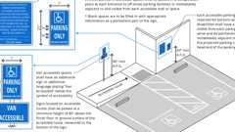

**Parking Signage (11A)**

[**1109A.8.1 *Vertical Clearances***](https://up.codes/viewer/california/ca-building-code-2025/chapter/11A/housing-accessibility#1109A.8.1)

*All*[*entrances*](https://up.codes/viewer/california/ca-building-code-2025/chapter/2/definitions#entrance_hcd_1_hcd_2_hcd_1_ac_and_dsa_ac_)*,*[*exits*](https://up.codes/viewer/california/ca-building-code-2025/chapter/2/definitions#exit_)*and vehicular passageways to and from required accessible parking*[*spaces*](https://up.codes/viewer/california/ca-building-code-2025/chapter/2/definitions#space_)*within parking*[*facilities*](https://up.codes/viewer/california/ca-building-code-2025/chapter/2/definitions#facility_)*, shall have a minimum vertical clearance of 8 feet 2 inches (2489 mm) from the floor to the lowest projection of the ceiling. Reflective warning*[*signs*](https://up.codes/viewer/california/ca-building-code-2025/chapter/2/definitions#sign_hcd_1_ac_dsa_ac_)*complying with*[*Section 1143A*](https://up.codes/viewer/california/ca-building-code-2025/chapter/11A/housing-accessibility#1143A)*for character height shall be installed at transitions from the 8 feet 2 inch ceiling to lower ceiling heights in vehicular passageways in the same parking level.*

[**1109A.8.2 *Arrangement of Parking Spaces***](https://up.codes/viewer/california/ca-building-code-2025/chapter/11A/housing-accessibility#1109A.8.2)

*Parking*[*spaces*](https://up.codes/viewer/california/ca-building-code-2025/chapter/2/definitions#space_)*shall be arranged to comply with the following:*

1. *In each parking area, a bumper or curb shall be provided and located to prevent encroachment of cars over the required width of walkways.*
2. [*Ramps*](https://up.codes/viewer/california/ca-building-code-2025/chapter/2/definitions#ramp_)*, including*[*curb ramps*](https://up.codes/viewer/california/ca-building-code-2025/chapter/2/definitions#curb_ramp_)*, shall not encroach into any accessible parking*[*space*](https://up.codes/viewer/california/ca-building-code-2025/chapter/2/definitions#space_)*or the adjacent loading and unloading*[*access aisle*](https://up.codes/viewer/california/ca-building-code-2025/chapter/2/definitions#access_aisle_dsa_ac_)*.*

[**1109A.8.3 *Slope of Accessible Parking Spaces and Access Aisles***](https://up.codes/viewer/california/ca-building-code-2025/chapter/11A/housing-accessibility#1109A.8.3)

Diagram

*Surface*[*slopes*](https://up.codes/viewer/california/ca-building-code-2025/chapter/J/grading#slope_)*of accessible parking*[*spaces*](https://up.codes/viewer/california/ca-building-code-2025/chapter/2/definitions#space_)*and*[*access aisles*](https://up.codes/viewer/california/ca-building-code-2025/chapter/2/definitions#access_aisle_dsa_ac_)*shall be the minimum possible and shall not exceed 1/4inch (6.35 mm) per foot (2.083-percent gradient) in any direction.*

**UpCodes Diagram (1)**



**Parking Spaces: Van and Single (CA 11A)**

[**1109A.8.4 *Accessible Parking Space Size***](https://up.codes/viewer/california/ca-building-code-2025/chapter/11A/housing-accessibility#1109A.8.4)

*Accessible parking*[*spaces*](https://up.codes/viewer/california/ca-building-code-2025/chapter/2/definitions#space_)*shall comply with Sections*[*1109A.8.5*](https://up.codes/viewer/california/ca-building-code-2025/chapter/11A/housing-accessibility#1109A.8.5)*and*[*1109A.8.6*](https://up.codes/viewer/california/ca-building-code-2025/chapter/11A/housing-accessibility#1109A.8.6)*.*

[**1109A.8.5 *Accessible Single Parking Space***](https://up.codes/viewer/california/ca-building-code-2025/chapter/11A/housing-accessibility#1109A.8.5)

Diagram

*Where accessible single*[*spaces*](https://up.codes/viewer/california/ca-building-code-2025/chapter/2/definitions#space_)*are provided, they shall be constructed in accordance with the following:*

1. *Single*[*spaces*](https://up.codes/viewer/california/ca-building-code-2025/chapter/2/definitions#space_)*shall be 14 feet (4267 mm) wide minimum, and shall provide a 9-foot (2743 mm) wide parking area and a 5-foot (1524 mm) wide loading and unloading*[*access aisle*](https://up.codes/viewer/california/ca-building-code-2025/chapter/2/definitions#access_aisle_dsa_ac_)*.*[*Access aisles*](https://up.codes/viewer/california/ca-building-code-2025/chapter/2/definitions#access_aisle_dsa_ac_)*shall be permitted to be located on either side of the vehicle, and shall extend the full required length of the parking*[*spaces*](https://up.codes/viewer/california/ca-building-code-2025/chapter/2/definitions#space_)*they serve.*
2. *When more than one*[*space*](https://up.codes/viewer/california/ca-building-code-2025/chapter/2/definitions#space_)*is provided, two 9-foot (2743 mm) wide parking*[*spaces*](https://up.codes/viewer/california/ca-building-code-2025/chapter/2/definitions#space_)*may be lined on each side of a 5-foot (1524 mm) wide loading and unloading*[*access aisle*](https://up.codes/viewer/california/ca-building-code-2025/chapter/2/definitions#access_aisle_dsa_ac_)*.*
3. *The minimum length of each parking*[*space*](https://up.codes/viewer/california/ca-building-code-2025/chapter/2/definitions#space_)*shall be 18 feet (5486 mm).*
4. *The loading and unloading*[*access aisle*](https://up.codes/viewer/california/ca-building-code-2025/chapter/2/definitions#access_aisle_dsa_ac_)*shall be marked by a border painted blue. Within the blue border, hatched lines a maximum of 36 inches (914 mm) on center shall be painted a color contrasting with the parking surface, preferably blue or white. The words "NO PARKING" shall be painted on the ground within each 5-foot (1524 mm) wide loading and unloading*[*access aisle*](https://up.codes/viewer/california/ca-building-code-2025/chapter/2/definitions#access_aisle_dsa_ac_)*. This notice shall be painted in white letters no less than 12 inches (305 mm) high and located so that it is visible from the adjacent*[*vehicular way*](https://up.codes/viewer/california/ca-building-code-2025/chapter/2/definitions#vehicular_way_hcd_1_ac_dsa_ac_)*.*
   * ***Note:****See*[*Figures*](https://up.codes/viewer/california/ca-building-code-2025/chapter/11B/accessibility-to-public-buildings-public-accommodations-commercial-buildings-and#figure)[*11A-2A*](https://up.codes/viewer/california/ca-building-code-2025/chapter/11A/housing-accessibility#11A-2A)*,*[*11A-2B*](https://up.codes/viewer/california/ca-building-code-2025/chapter/11A/housing-accessibility#11A-2B)*and 11A-2C.*

**UpCodes Diagram (1)**



**Parking Spaces: Van and Single (CA 11A)**

[**1109A.8.6 *Van Accessible Parking Space***](https://up.codes/viewer/california/ca-building-code-2025/chapter/11A/housing-accessibility#1109A.8.6)

Diagram

*One in every eight*[*accessible spaces*](https://up.codes/viewer/california/ca-building-code-2025/chapter/2/definitions#accessible_space_dsa_ac_hcd_1_ac_)*, but not less than one, shall be van accessible and shall be constructed in accordance with the following:*

1. *Each van-accessible parking*[*space*](https://up.codes/viewer/california/ca-building-code-2025/chapter/2/definitions#space_)*shall be 17 feet (5181 mm) wide minimum, and shall provide either of the following:*
   1. *1.1.   A 12-foot (3658 mm) wide minimum parking area and a 5-foot (1524 mm) wide minimum loading and unloading*[*access aisle*](https://up.codes/viewer/california/ca-building-code-2025/chapter/2/definitions#access_aisle_dsa_ac_)*.*
   2. *1.2.   A 9-foot (2743 mm) wide minimum parking area and an 8-foot (2438 mm) wide minimum loading and unloading*[*access aisle*](https://up.codes/viewer/california/ca-building-code-2025/chapter/2/definitions#access_aisle_dsa_ac_)*.*

[*Access aisles*](https://up.codes/viewer/california/ca-building-code-2025/chapter/2/definitions#access_aisle_dsa_ac_)*shall be located on the passenger side of the vehicle with the vehicle parked in the forward position, and shall extend the full required length of the parking*[*spaces*](https://up.codes/viewer/california/ca-building-code-2025/chapter/2/definitions#space_)*they serve.*

1. *The minimum length of each*[*space*](https://up.codes/viewer/california/ca-building-code-2025/chapter/2/definitions#space_)*shall be 18 feet (5486 mm).*
2. *Each*[*space*](https://up.codes/viewer/california/ca-building-code-2025/chapter/2/definitions#space_)*shall be designated "van accessible" as required by*[*Section 1109A.8.8*](https://up.codes/viewer/california/ca-building-code-2025/chapter/11A/housing-accessibility#1109A.8.8)*.*
3. *All van*[*accessible spaces*](https://up.codes/viewer/california/ca-building-code-2025/chapter/2/definitions#accessible_space_dsa_ac_hcd_1_ac_)*may be grouped on one level of a multilevel parking*[*facility*](https://up.codes/viewer/california/ca-building-code-2025/chapter/2/definitions#facility_)*.*
4. *The loading and unloading*[*access aisle*](https://up.codes/viewer/california/ca-building-code-2025/chapter/2/definitions#access_aisle_dsa_ac_)*shall be marked by a border painted blue. Within the blue border, hatched lines a maximum of 36 inches (914 mm) on center shall be painted a color contrasting with the parking surface, preferably blue or white. The words "NO PARKING" shall be painted on the ground within each loading and unloading*[*access aisle*](https://up.codes/viewer/california/ca-building-code-2025/chapter/2/definitions#access_aisle_dsa_ac_)*. This notice shall be painted in white letters no less than 12 inches (305 mm) high and located so that it is visible from the adjacent*[*vehicular way*](https://up.codes/viewer/california/ca-building-code-2025/chapter/2/definitions#vehicular_way_hcd_1_ac_dsa_ac_)*.*
   1. ***Note:****See*[*Figures*](https://up.codes/viewer/california/ca-building-code-2025/chapter/11B/accessibility-to-public-buildings-public-accommodations-commercial-buildings-and#figure)[*11A-2A*](https://up.codes/viewer/california/ca-building-code-2025/chapter/11A/housing-accessibility#11A-2A)*,*[*11A-2B*](https://up.codes/viewer/california/ca-building-code-2025/chapter/11A/housing-accessibility#11A-2B)*and 11A-2C.*

**UpCodes Diagram (1)**



**Parking Spaces: Van and Single (CA 11A)**

[**1109A.8.7 *Adjacent Parking***](https://up.codes/viewer/california/ca-building-code-2025/chapter/11A/housing-accessibility#1109A.8.7)

*Parking*[*spaces*](https://up.codes/viewer/california/ca-building-code-2025/chapter/2/definitions#space_)*adjacent to accessible parking*[*spaces*](https://up.codes/viewer/california/ca-building-code-2025/chapter/2/definitions#space_)*shall not be considered as loading and unloading*[*access aisles*](https://up.codes/viewer/california/ca-building-code-2025/chapter/2/definitions#access_aisle_dsa_ac_)*.*

[**1109A.8.8 *Identification***](https://up.codes/viewer/california/ca-building-code-2025/chapter/11A/housing-accessibility#1109A.8.8)

*Each accessible parking*[*space*](https://up.codes/viewer/california/ca-building-code-2025/chapter/2/definitions#space_)*shall be identified with signage and surface marking in accordance with Sections*[*1109A.8.8.1*](https://up.codes/viewer/california/ca-building-code-2025/chapter/11A/housing-accessibility#1109A.8.8.1)*and*[*1109A.8.8.2*](https://up.codes/viewer/california/ca-building-code-2025/chapter/11A/housing-accessibility#1109A.8.8.2)*.*

[**1109A.8.8.1 *Parking Signage***](https://up.codes/viewer/california/ca-building-code-2025/chapter/11A/housing-accessibility#1109A.8.8.1)

Diagram

*Each accessible parking*[*space*](https://up.codes/viewer/california/ca-building-code-2025/chapter/2/definitions#space_)[*reserved*](https://up.codes/viewer/california/ca-building-code-2025/chapter/11B/accessibility-to-public-buildings-public-accommodations-commercial-buildings-and#reserved)*for*[*persons with disabilities*](https://up.codes/viewer/california/ca-building-code-2025/chapter/2/definitions#persons_with_disabilities_hcd_1_ac_)*shall be identified by a reflective*[*sign*](https://up.codes/viewer/california/ca-building-code-2025/chapter/2/definitions#sign_hcd_1_ac_dsa_ac_)*consisting of the "*[*International Symbol of Accessibility*](https://up.codes/viewer/california/ca-building-code-2025/chapter/2/definitions#international_symbol_of_accessibility_)*" complying with*[*Section 1143A.8*](https://up.codes/viewer/california/ca-building-code-2025/chapter/11A/housing-accessibility#1143A.8)*. The*[*sign*](https://up.codes/viewer/california/ca-building-code-2025/chapter/2/definitions#sign_hcd_1_ac_dsa_ac_)*shall not be smaller than 70 square inches (4516 mm2) in area, and shall be posted 60 inches minimum above the finish floor or ground surface, measured to the bottom of the*[*sign*](https://up.codes/viewer/california/ca-building-code-2025/chapter/2/definitions#sign_hcd_1_ac_dsa_ac_)*.*[*Signs*](https://up.codes/viewer/california/ca-building-code-2025/chapter/2/definitions#sign_hcd_1_ac_dsa_ac_)*located on*[*accessible routes*](https://up.codes/viewer/california/ca-building-code-2025/chapter/2/definitions#accessible_route_dsa_ac_hcd_1_ac_)*shall be posted at a minimum height of 80 inches (2032 mm) above the finish floor or ground surface of the*[*accessible route*](https://up.codes/viewer/california/ca-building-code-2025/chapter/2/definitions#accessible_route_dsa_ac_hcd_1_ac_)*, measured to the bottom of the*[*sign*](https://up.codes/viewer/california/ca-building-code-2025/chapter/2/definitions#sign_hcd_1_ac_dsa_ac_)*.*

[*Signs*](https://up.codes/viewer/california/ca-building-code-2025/chapter/2/definitions#sign_hcd_1_ac_dsa_ac_)*identifying accessible parking*[*spaces*](https://up.codes/viewer/california/ca-building-code-2025/chapter/2/definitions#space_)*shall be visible from each parking*[*space*](https://up.codes/viewer/california/ca-building-code-2025/chapter/2/definitions#space_)*they serve, and shall be permanently posted immediately adjacent to the parking*[*space*](https://up.codes/viewer/california/ca-building-code-2025/chapter/2/definitions#space_)*or within the projected parking*[*space*](https://up.codes/viewer/california/ca-building-code-2025/chapter/2/definitions#space_)*width at the head end of the parking*[*space*](https://up.codes/viewer/california/ca-building-code-2025/chapter/2/definitions#space_)*.*[*Signs*](https://up.codes/viewer/california/ca-building-code-2025/chapter/2/definitions#sign_hcd_1_ac_dsa_ac_)*may also be permanently posted on a*[*wall*](https://up.codes/viewer/california/ca-building-code-2025/chapter/2/definitions#wall_)*at the interior end of the parking*[*space*](https://up.codes/viewer/california/ca-building-code-2025/chapter/2/definitions#space_)*.*

*Van*[*accessible spaces*](https://up.codes/viewer/california/ca-building-code-2025/chapter/2/definitions#accessible_space_dsa_ac_hcd_1_ac_)*shall comply with*[*Section 1109A.8.6*](https://up.codes/viewer/california/ca-building-code-2025/chapter/11A/housing-accessibility#1109A.8.6)*and shall have an additional*[*sign*](https://up.codes/viewer/california/ca-building-code-2025/chapter/2/definitions#sign_hcd_1_ac_dsa_ac_)*or additional language stating "Van Accessible" below the symbol of*[*accessibility*](https://up.codes/viewer/california/ca-building-code-2025/chapter/30/elevators-and-conveying-systems#3001.4)*.*

*An additional*[*sign*](https://up.codes/viewer/california/ca-building-code-2025/chapter/2/definitions#sign_hcd_1_ac_dsa_ac_)*shall also be posted in a conspicuous place at each*[*entrance*](https://up.codes/viewer/california/ca-building-code-2025/chapter/2/definitions#entrance_hcd_1_hcd_2_hcd_1_ac_and_dsa_ac_)*to off-street parking*[*facilities*](https://up.codes/viewer/california/ca-building-code-2025/chapter/2/definitions#facility_)*or immediately adjacent to and visible from each accessible stall or*[*space*](https://up.codes/viewer/california/ca-building-code-2025/chapter/2/definitions#space_)*. The*[*sign*](https://up.codes/viewer/california/ca-building-code-2025/chapter/2/definitions#sign_hcd_1_ac_dsa_ac_)*shall not be less than 17 inches (432 mm) by 22 inches (559 mm) in*[*size*](https://up.codes/viewer/california/ca-building-code-2025/chapter/9/fire-protection-and-life-safety-systems#911.1.3)*with lettering not less than 1 inch (25.4 mm) in height, and shall clearly and conspicuously state the following:*

*"Unauthorized vehicles parked in designated*[*accessible spaces*](https://up.codes/viewer/california/ca-building-code-2025/chapter/2/definitions#accessible_space_dsa_ac_hcd_1_ac_)*not displaying distinguishing placards or special license plates issued for*[*persons with disabilities*](https://up.codes/viewer/california/ca-building-code-2025/chapter/2/definitions#persons_with_disabilities_hcd_1_ac_)*will be towed away at the*[*owner*](https://up.codes/viewer/california/ca-building-code-2025/chapter/2/definitions#owner_)*'s expense. Towed vehicles may be reclaimed at ____________________ or by telephoning__________."*

*Blank*[*spaces*](https://up.codes/viewer/california/ca-building-code-2025/chapter/2/definitions#space_)*are to be filled in with appropriate information as a*[*permanent*](https://up.codes/viewer/california/ca-building-code-2025/chapter/2/definitions#permanent_dsa_ac_)*part of the*[*sign*](https://up.codes/viewer/california/ca-building-code-2025/chapter/2/definitions#sign_hcd_1_ac_dsa_ac_)*.*

**UpCodes Diagram (1)**

Primary

**Parking Signage (11A)**

[**1109A.8.8.2 *Parking Space Marking***](https://up.codes/viewer/california/ca-building-code-2025/chapter/11A/housing-accessibility#1109A.8.8.2)

Diagram

In addition to the signage requirements, each accessible parking [space](https://up.codes/viewer/california/ca-building-code-2025/chapter/2/definitions#space_) shall have a surface [identification](https://up.codes/viewer/california/ca-building-code-2025/chapter/22A/steel#2201A.2)*complying with*either of the following:

1. *The parking*[*space*](https://up.codes/viewer/california/ca-building-code-2025/chapter/2/definitions#space_)*shall be outlined or painted blue, and shall be marked with the "*[*International Symbol of Accessibility*](https://up.codes/viewer/california/ca-building-code-2025/chapter/2/definitions#international_symbol_of_accessibility_)*" in white or a suitable contrasting color. The "*[*International Symbol of Accessibility*](https://up.codes/viewer/california/ca-building-code-2025/chapter/2/definitions#international_symbol_of_accessibility_)*" shall be 36 inches (914 mm) wide by 36 inches (914 mm) high minimum, with the centerline 6 inches (152 mm) maximum from the centerline of the parking*[*space*](https://up.codes/viewer/california/ca-building-code-2025/chapter/2/definitions#space_)*, its sides parallel to the length of the parking*[*space*](https://up.codes/viewer/california/ca-building-code-2025/chapter/2/definitions#space_)*, and its lower side aligned with the end of the parking*[*space*](https://up.codes/viewer/california/ca-building-code-2025/chapter/2/definitions#space_)*.*
2. *The parking*[*space*](https://up.codes/viewer/california/ca-building-code-2025/chapter/2/definitions#space_)*shall be marked with the "*[*International Symbol of Accessibility*](https://up.codes/viewer/california/ca-building-code-2025/chapter/2/definitions#international_symbol_of_accessibility_)*", in white on a blue background, 36 inches (914 mm) wide by 36 inches (914 mm) high minimum in*[*size*](https://up.codes/viewer/california/ca-building-code-2025/chapter/9/fire-protection-and-life-safety-systems#911.1.3)*. The centerline of the "*[*International Symbol of Accessibility*](https://up.codes/viewer/california/ca-building-code-2025/chapter/2/definitions#international_symbol_of_accessibility_)*" shall be 6 inches (152 mm) maximum from the centerline of the parking*[*space*](https://up.codes/viewer/california/ca-building-code-2025/chapter/2/definitions#space_)*, its sides shall be parallel to the length of the parking*[*space*](https://up.codes/viewer/california/ca-building-code-2025/chapter/2/definitions#space_)*, and its lower side shall be aligned with the end of the parking*[*space*](https://up.codes/viewer/california/ca-building-code-2025/chapter/2/definitions#space_)*length.*

***Note:****See*[*Figures*](https://up.codes/viewer/california/ca-building-code-2025/chapter/11B/accessibility-to-public-buildings-public-accommodations-commercial-buildings-and#figure)[*11A-2A*](https://up.codes/viewer/california/ca-building-code-2025/chapter/11A/housing-accessibility#11A-2A)*,*[*11A-2B*](https://up.codes/viewer/california/ca-building-code-2025/chapter/11A/housing-accessibility#11A-2B)*and 11A-2C.*

**UpCodes Diagrams (4)**

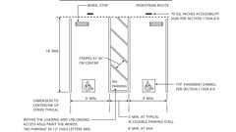Primary

**CA 11A: Figure 11A-2A Double Parking Stalls**

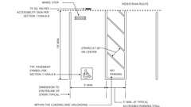Primary

**CA 11A: Figure 11A-2B Single and Van Accessible Parking Stalls**

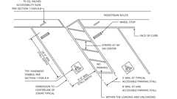Primary

**CA 11A: Figure 11A-2C Diagonal Parking Stalls**



**Parking Spaces: Van and Single (CA 11A)**

[**Section 1110A *Exterior Accessible Routes***](https://up.codes/viewer/california/ca-building-code-2025/chapter/11A/housing-accessibility#1110A)

Diagram

**UpCodes Diagrams (4)**

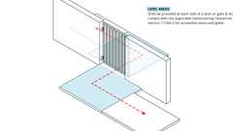

**Walks & Sidewalks on Accessible Routes - Level Areas**

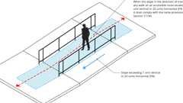

**Walks & Sidewalks on Accessible Routes - Slope**

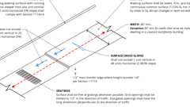

**Walks & Sidewalks on Accessible Routes**

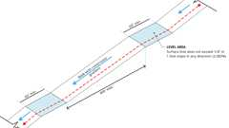

**Walks & Sidewalks on Accessible Routes - Continuous Gradients**

[**1110A.1 *General***](https://up.codes/viewer/california/ca-building-code-2025/chapter/11A/housing-accessibility#1110A.1)

Diagram

*When a building or portion of a building is required to be accessible or*[*adaptable*](https://up.codes/viewer/california/ca-building-code-2025/chapter/2/definitions#adaptable_dsa_ac_)*, an*[*accessible route*](https://up.codes/viewer/california/ca-building-code-2025/chapter/2/definitions#accessible_route_dsa_ac_hcd_1_ac_)*shall be provided to all portions of the building, accessible building*[*entrances*](https://up.codes/viewer/california/ca-building-code-2025/chapter/2/definitions#entrance_hcd_1_hcd_2_hcd_1_ac_and_dsa_ac_)*and between the building and the*[*public way*](https://up.codes/viewer/california/ca-building-code-2025/chapter/2/definitions#public_way_)*. The*[*accessible route*](https://up.codes/viewer/california/ca-building-code-2025/chapter/2/definitions#accessible_route_dsa_ac_hcd_1_ac_)*shall be the most practical direct route and to the maximum extent feasible, coincide with the route for the*[*general*](https://up.codes/viewer/california/ca-building-code-2025/chapter/L/earthquake-recording-instrumentation#L101.1)*public and building residents.*

*Exterior*[*accessible routes*](https://up.codes/viewer/california/ca-building-code-2025/chapter/2/definitions#accessible_route_dsa_ac_hcd_1_ac_)*shall be provided as follows:*

1. *At least one*[*accessible route*](https://up.codes/viewer/california/ca-building-code-2025/chapter/2/definitions#accessible_route_dsa_ac_hcd_1_ac_)*within the boundary of the*[*site*](https://up.codes/viewer/california/ca-building-code-2025/chapter/2/definitions#site_)*shall be provided from public transportation stops, accessible parking and accessible passenger loading and unloading*[*zones*](https://up.codes/viewer/california/ca-building-code-2025/chapter/2/definitions#zone_)*, and public streets or*[*sidewalks*](https://up.codes/viewer/california/ca-building-code-2025/chapter/2/definitions#sidewalk_)*to the accessible building*[*entrance*](https://up.codes/viewer/california/ca-building-code-2025/chapter/2/definitions#entrance_hcd_1_hcd_2_hcd_1_ac_and_dsa_ac_)*they serve. Where more than one route of travel is provided, all routes shall be accessible.*
2. *At least one*[*accessible route*](https://up.codes/viewer/california/ca-building-code-2025/chapter/2/definitions#accessible_route_dsa_ac_hcd_1_ac_)*shall connect accessible buildings,*[*facilities*](https://up.codes/viewer/california/ca-building-code-2025/chapter/2/definitions#facility_)*,*[*elements*](https://up.codes/viewer/california/ca-building-code-2025/chapter/2/definitions#element_dsa_ac_)*and*[*spaces*](https://up.codes/viewer/california/ca-building-code-2025/chapter/2/definitions#space_)*that are on the same*[*site*](https://up.codes/viewer/california/ca-building-code-2025/chapter/2/definitions#site_)*.*[*Accessible routes*](https://up.codes/viewer/california/ca-building-code-2025/chapter/2/definitions#accessible_route_dsa_ac_hcd_1_ac_)*shall be provided between accessible buildings and accessible*[*site*](https://up.codes/viewer/california/ca-building-code-2025/chapter/2/definitions#site_)[*facilities*](https://up.codes/viewer/california/ca-building-code-2025/chapter/2/definitions#facility_)*when more than one building or*[*facility*](https://up.codes/viewer/california/ca-building-code-2025/chapter/2/definitions#facility_)*is located on a*[*site*](https://up.codes/viewer/california/ca-building-code-2025/chapter/2/definitions#site_)*.*
3. *At least one*[*accessible route*](https://up.codes/viewer/california/ca-building-code-2025/chapter/2/definitions#accessible_route_dsa_ac_hcd_1_ac_)*shall connect accessible building or*[*facility*](https://up.codes/viewer/california/ca-building-code-2025/chapter/2/definitions#facility_)[*entrances*](https://up.codes/viewer/california/ca-building-code-2025/chapter/2/definitions#entrance_hcd_1_hcd_2_hcd_1_ac_and_dsa_ac_)*with all*[*accessible spaces*](https://up.codes/viewer/california/ca-building-code-2025/chapter/2/definitions#accessible_space_dsa_ac_hcd_1_ac_)*,*[*elements*](https://up.codes/viewer/california/ca-building-code-2025/chapter/2/definitions#element_dsa_ac_)*and covered multifamily*[*dwelling units*](https://up.codes/viewer/california/ca-building-code-2025/chapter/2/definitions#dwelling_unit_)*.*
4. *An*[*accessible route*](https://up.codes/viewer/california/ca-building-code-2025/chapter/2/definitions#accessible_route_dsa_ac_hcd_1_ac_)*shall connect at least one accessible*[*entrance*](https://up.codes/viewer/california/ca-building-code-2025/chapter/2/definitions#entrance_hcd_1_hcd_2_hcd_1_ac_and_dsa_ac_)*of each covered multifamily*[*dwelling unit*](https://up.codes/viewer/california/ca-building-code-2025/chapter/2/definitions#dwelling_unit_)*with exterior*[*spaces*](https://up.codes/viewer/california/ca-building-code-2025/chapter/2/definitions#space_)*and*[*facilities*](https://up.codes/viewer/california/ca-building-code-2025/chapter/2/definitions#facility_)*that serve the*[*dwelling unit*](https://up.codes/viewer/california/ca-building-code-2025/chapter/2/definitions#dwelling_unit_)*.*
5. *Where elevators are provided for vertical access, all elevators shall be accessible. See*[*Section 1124A*](https://up.codes/viewer/california/ca-building-code-2025/chapter/11A/housing-accessibility#1124A)*.*

***Note:****If the*[*slope*](https://up.codes/viewer/california/ca-building-code-2025/chapter/J/grading#slope_)*of the*[*finished grade*](https://up.codes/viewer/california/ca-building-code-2025/chapter/J/grading#grade_finished_)*between*[*covered multifamily dwellings*](https://up.codes/viewer/california/ca-building-code-2025/chapter/2/definitions#covered_multifamily_dwellings_hcd_1_ac_)*and*[*site*](https://up.codes/viewer/california/ca-building-code-2025/chapter/2/definitions#site_)*arrival points,*[*public use*](https://up.codes/viewer/california/ca-building-code-2025/chapter/2/definitions#public_use_dsa_ac_)*or*[*common use*](https://up.codes/viewer/california/ca-building-code-2025/chapter/2/definitions#common_use_)[*facilities*](https://up.codes/viewer/california/ca-building-code-2025/chapter/2/definitions#facility_)*(including parking) exceeds 1 unit vertical in 12 units horizontal (8.33-percent*[*slope*](https://up.codes/viewer/california/ca-building-code-2025/chapter/J/grading#slope_)*), or where other physical barriers (natural or artificial) or legal restrictions, all of which are outside the control of the*[*owner*](https://up.codes/viewer/california/ca-building-code-2025/chapter/2/definitions#owner_)*, prevent the*[*installation*](https://up.codes/viewer/california/ca-building-code-2025/chapter/27/electrical#2702.1.3)*of an*[*accessible route*](https://up.codes/viewer/california/ca-building-code-2025/chapter/2/definitions#accessible_route_dsa_ac_hcd_1_ac_)*, an acceptable alternative is to provide access by a vehicular route, provided:*

* 1. *There is accessible parking on an*[*accessible route*](https://up.codes/viewer/california/ca-building-code-2025/chapter/2/definitions#accessible_route_dsa_ac_hcd_1_ac_)*for at least 2 percent of the covered multifamily*[*dwelling units*](https://up.codes/viewer/california/ca-building-code-2025/chapter/2/definitions#dwelling_unit_)*, and*
  2. *Necessary*[*site*](https://up.codes/viewer/california/ca-building-code-2025/chapter/2/definitions#site_)*provisions such as parking*[*spaces*](https://up.codes/viewer/california/ca-building-code-2025/chapter/2/definitions#space_)*and*[*curb ramps*](https://up.codes/viewer/california/ca-building-code-2025/chapter/2/definitions#curb_ramp_)*are provided at the*[*public use*](https://up.codes/viewer/california/ca-building-code-2025/chapter/2/definitions#public_use_dsa_ac_)*or*[*common use*](https://up.codes/viewer/california/ca-building-code-2025/chapter/2/definitions#common_use_)[*facility*](https://up.codes/viewer/california/ca-building-code-2025/chapter/2/definitions#facility_)*.*

**UpCodes Diagrams (5)**

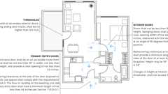

**Accessible Unit Doors (CA 11A)**

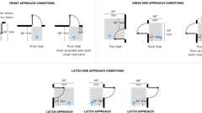

**Maneuvering Clearances: Doors (CA 11A)**



**Location of Accessible Parking Spaces - Condition 1 & 2**



**Location of Accessible Parking Spaces - Condition 3**



**Location of Accessible Parking Spaces - Condition 4 & 5**

[**1110A.2 *Signs***](https://up.codes/viewer/california/ca-building-code-2025/chapter/11A/housing-accessibility#1110A.2)

*At every primary*[*public entrance*](https://up.codes/viewer/california/ca-building-code-2025/chapter/2/definitions#public_entrance_)*and at every major junction where the*[*accessible route*](https://up.codes/viewer/california/ca-building-code-2025/chapter/2/definitions#accessible_route_dsa_ac_hcd_1_ac_)*diverges from the*[*circulation path*](https://up.codes/viewer/california/ca-building-code-2025/chapter/2/definitions#circulation_path_)*along or leading to an*[*accessible route*](https://up.codes/viewer/california/ca-building-code-2025/chapter/2/definitions#accessible_route_dsa_ac_hcd_1_ac_)*,*[*entrance*](https://up.codes/viewer/california/ca-building-code-2025/chapter/2/definitions#entrance_hcd_1_hcd_2_hcd_1_ac_and_dsa_ac_)*or*[*facility*](https://up.codes/viewer/california/ca-building-code-2025/chapter/2/definitions#facility_)*, there shall be a*[*sign*](https://up.codes/viewer/california/ca-building-code-2025/chapter/2/definitions#sign_hcd_1_ac_dsa_ac_)*displaying the "*[*International Symbol of Accessibility*](https://up.codes/viewer/california/ca-building-code-2025/chapter/2/definitions#international_symbol_of_accessibility_)*."*[*Signs*](https://up.codes/viewer/california/ca-building-code-2025/chapter/2/definitions#sign_hcd_1_ac_dsa_ac_)*shall indicate the direction to accessible building*[*entrances*](https://up.codes/viewer/california/ca-building-code-2025/chapter/2/definitions#entrance_hcd_1_hcd_2_hcd_1_ac_and_dsa_ac_)*and*[*facilities*](https://up.codes/viewer/california/ca-building-code-2025/chapter/2/definitions#facility_)*and shall comply with the requirements found in*[*Section 1143A*](https://up.codes/viewer/california/ca-building-code-2025/chapter/11A/housing-accessibility#1143A)*.*

[**1110A.3 *Floor and Ground Surfaces***](https://up.codes/viewer/california/ca-building-code-2025/chapter/11A/housing-accessibility#1110A.3)

Diagram

*Floor and ground surfaces shall be stable, firm and*[*slip resistant*](https://up.codes/viewer/california/ca-building-code-2025/chapter/2/definitions#slip_resistant_)*. If carpet or carpet tile is used in a*[*common-use*](https://up.codes/viewer/california/ca-building-code-2025/chapter/2/definitions#common_use_)*area or*[*public-use*](https://up.codes/viewer/california/ca-building-code-2025/chapter/2/definitions#public_use_dsa_ac_)*area on a ground or floor surface, it shall have firm*[*backing*](https://up.codes/viewer/california/ca-building-code-2025/chapter/2/definitions#backing_)*or no*[*backing*](https://up.codes/viewer/california/ca-building-code-2025/chapter/2/definitions#backing_)*. Carpet or carpet tile shall have a level loop, textured loop, level cut pile or level cut/uncut pile texture. The maximum pile height shall be 1/2inch (12.7 mm). Exposed edges of carpet shall be fastened to floor surfaces and have*[*trim*](https://up.codes/viewer/california/ca-building-code-2025/chapter/2/definitions#trim_)*along the entire length of the exposed edge. Carpet edge*[*trim*](https://up.codes/viewer/california/ca-building-code-2025/chapter/2/definitions#trim_)*shall comply with*[*Section 1111A*](https://up.codes/viewer/california/ca-building-code-2025/chapter/11A/housing-accessibility#1111A)*requirements for changes in level.*

**UpCodes Diagrams (2)**

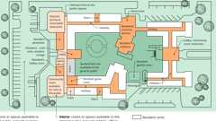

**Common vs. Public Use Area (11A)**



**Walks & Sidewalks on Accessible Routes**

**Building products (4)**

[[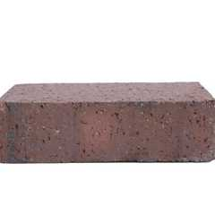](https://up.codes/product/back-up-pavers-4-x-2-x-7?viewer_juris_key=california)](https://up.codes/product/back-up-pavers-4-x-2-x-7?viewer_juris_key=california)

**[Back Up Pavers 4 x 2¼ x 7⅝](https://up.codes/product/back-up-pavers-4-x-2-x-7?viewer_juris_key=california)**

**[Interstate Brick](https://up.codes/product/back-up-pavers-4-x-2-x-7?viewer_juris_key=california)**

[[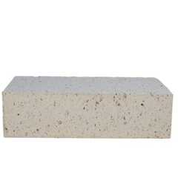](https://up.codes/product/modular-paver-4-x-2-x-7?viewer_juris_key=california)](https://up.codes/product/modular-paver-4-x-2-x-7?viewer_juris_key=california)

**[Modular Paver 4 x 2¼ x 7⅝](https://up.codes/product/modular-paver-4-x-2-x-7?viewer_juris_key=california)**

**[Interstate Brick](https://up.codes/product/modular-paver-4-x-2-x-7?viewer_juris_key=california)**

[[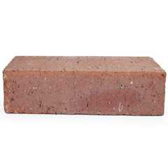](https://up.codes/product/modular-solid-4-x-2-x-8?viewer_juris_key=california)](https://up.codes/product/modular-solid-4-x-2-x-8?viewer_juris_key=california)

**[Modular Solid 4 x 2¼ x 8](https://up.codes/product/modular-solid-4-x-2-x-8?viewer_juris_key=california)**

**[Interstate Brick](https://up.codes/product/modular-solid-4-x-2-x-8?viewer_juris_key=california)**

[[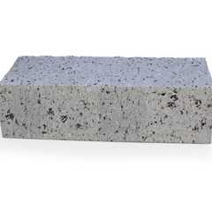](https://up.codes/product/true-paver-4-x-2-x-8?viewer_juris_key=california)](https://up.codes/product/true-paver-4-x-2-x-8?viewer_juris_key=california)

**[True Paver 4 x 2¼ x 8](https://up.codes/product/true-paver-4-x-2-x-8?viewer_juris_key=california)**

**[Interstate Brick](https://up.codes/product/true-paver-4-x-2-x-8?viewer_juris_key=california)**

[**1110A.3.1 *Recessed Doormats***](https://up.codes/viewer/california/ca-building-code-2025/chapter/11A/housing-accessibility#1110A.3.1)

*Recessed doormats shall be adequately anchored to prevent interference with*[*wheelchair*](https://up.codes/viewer/california/ca-building-code-2025/chapter/2/definitions#wheelchair_hcd_1_ac_dsa_ac_)*traffic.*

[**1110A.4 *Exterior Accessible Routes Over 200 Feet***](https://up.codes/viewer/california/ca-building-code-2025/chapter/11A/housing-accessibility#1110A.4)

Diagram

*Exterior*[*accessible routes*](https://up.codes/viewer/california/ca-building-code-2025/chapter/2/definitions#accessible_route_dsa_ac_hcd_1_ac_)*that exceed 200 feet (60 960 mm) in length shall comply with*[*Section 1138A.1.2*](https://up.codes/viewer/california/ca-building-code-2025/chapter/11A/housing-accessibility#1138A.1.2)*. (See*[*Figure*](https://up.codes/viewer/california/ca-building-code-2025/chapter/11B/accessibility-to-public-buildings-public-accommodations-commercial-buildings-and#figure)*11A-1L)*

**UpCodes Diagram (1)**

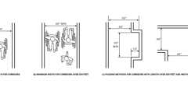Primary

**CA 11A: Figure 11A-1L Int. Accessible Route Over 200 Feet; Occ. Load 10+**

[**Section 1111A *Changes in Level on Accessible Routes***](https://up.codes/viewer/california/ca-building-code-2025/chapter/11A/housing-accessibility#1111A)

Diagram

**UpCodes Diagram (1)**



**Walks & Sidewalks on Accessible Routes**

[**1111A.1 *Changes in Level Not Exceeding 1/2Inch***](https://up.codes/viewer/california/ca-building-code-2025/chapter/11A/housing-accessibility#1111A.1)

Diagram

*Abrupt changes in level along any*[*accessible route*](https://up.codes/viewer/california/ca-building-code-2025/chapter/2/definitions#accessible_route_dsa_ac_hcd_1_ac_)*shall not exceed 1/2inch (12.7 mm). When changes in level do occur, they shall be beveled with a*[*slope*](https://up.codes/viewer/california/ca-building-code-2025/chapter/J/grading#slope_)*no greater than 1 unit vertical in 2 units horizontal (50-percent*[*slope*](https://up.codes/viewer/california/ca-building-code-2025/chapter/J/grading#slope_)*). Changes in level not exceeding 1/4inch (6.35 mm) may be vertical.*

**UpCodes Diagram (1)**

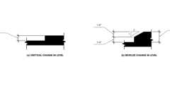

**CA 11A: Figure 11A-1F Change in Level**

[**1111A.2 *Changes Greater Than 1/2 Inch***](https://up.codes/viewer/california/ca-building-code-2025/chapter/11A/housing-accessibility#1111A.2)

*Changes in level greater than 1/2inch (12.7 mm) shall be made by means of a sloped surface not greater than 1 unit vertical in 20 units horizontal (5-percent*[*slope*](https://up.codes/viewer/california/ca-building-code-2025/chapter/J/grading#slope_)*), or a*[*curb ramp*](https://up.codes/viewer/california/ca-building-code-2025/chapter/2/definitions#curb_ramp_)*,*[*ramp*](https://up.codes/viewer/california/ca-building-code-2025/chapter/2/definitions#ramp_)*, elevator or*[*platform (wheelchair) lift*](https://up.codes/viewer/california/ca-building-code-2025/chapter/2/definitions#platform_%28wheelchair%29_lift_)*.*[*Stairs*](https://up.codes/viewer/california/ca-building-code-2025/chapter/2/definitions#stair_)*shall not be part of an*[*accessible route*](https://up.codes/viewer/california/ca-building-code-2025/chapter/2/definitions#accessible_route_dsa_ac_hcd_1_ac_)*. When*[*stairs*](https://up.codes/viewer/california/ca-building-code-2025/chapter/2/definitions#stair_)*are located along or adjacent to an*[*accessible route*](https://up.codes/viewer/california/ca-building-code-2025/chapter/2/definitions#accessible_route_dsa_ac_hcd_1_ac_)*they shall comply with*[*Section 1115A*](https://up.codes/viewer/california/ca-building-code-2025/chapter/11A/housing-accessibility#1115A)*for exterior*[*stairways*](https://up.codes/viewer/california/ca-building-code-2025/chapter/2/definitions#stairway_)*.*

[**Section 1112A *Curb Ramps on Accessible Routes***](https://up.codes/viewer/california/ca-building-code-2025/chapter/11A/housing-accessibility#1112A)

Diagram

**UpCodes Diagrams (2)**

Primary

**Curb Ramps (CA 11A)**

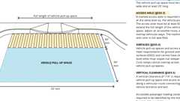

**Passenger Loading Zones**

[**1112A.1 *General***](https://up.codes/viewer/california/ca-building-code-2025/chapter/11A/housing-accessibility#1112A.1)

[*Curb ramps*](https://up.codes/viewer/california/ca-building-code-2025/chapter/2/definitions#curb_ramp_)*within the boundary of the*[*site*](https://up.codes/viewer/california/ca-building-code-2025/chapter/2/definitions#site_)*shall be constructed at each corner of street intersections and where a*[*pedestrian way*](https://up.codes/viewer/california/ca-building-code-2025/chapter/2/definitions#pedestrian_way_)*crosses a curb. The preferred and recommended*[*location*](https://up.codes/viewer/california/ca-building-code-2025/chapter/L/earthquake-recording-instrumentation#L101.2)*for*[*curb ramps*](https://up.codes/viewer/california/ca-building-code-2025/chapter/2/definitions#curb_ramp_)*is in the center of the crosswalk of each street corner. Where it is necessary to locate a*[*curb ramp*](https://up.codes/viewer/california/ca-building-code-2025/chapter/2/definitions#curb_ramp_)*in the center of the curb return, the street surfaces shall be marked to identify*[*pedestrian*](https://up.codes/viewer/california/ca-building-code-2025/chapter/2/definitions#pedestrian_hcd_1_ac_)*crosswalks, and the lower end of the*[*curb ramp*](https://up.codes/viewer/california/ca-building-code-2025/chapter/2/definitions#curb_ramp_)*shall terminate within such crosswalk areas.*[*Curb ramps*](https://up.codes/viewer/california/ca-building-code-2025/chapter/2/definitions#curb_ramp_)*do not require*[*handrails*](https://up.codes/viewer/california/ca-building-code-2025/chapter/2/definitions#handrail_)*.*

[**1112A.2 *Obstructions***](https://up.codes/viewer/california/ca-building-code-2025/chapter/11A/housing-accessibility#1112A.2)

[*Curb ramps*](https://up.codes/viewer/california/ca-building-code-2025/chapter/2/definitions#curb_ramp_)*shall be located or protected to prevent obstruction by parked cars. Built-up*[*curb ramps*](https://up.codes/viewer/california/ca-building-code-2025/chapter/2/definitions#curb_ramp_)*shall be located so that they do not project into vehicular traffic lanes, parking*[*spaces*](https://up.codes/viewer/california/ca-building-code-2025/chapter/2/definitions#space_)*or the adjacent loading and unloading*[*access aisle*](https://up.codes/viewer/california/ca-building-code-2025/chapter/2/definitions#access_aisle_dsa_ac_)*.*

[**1112A.3 *Width of Curb Ramps***](https://up.codes/viewer/california/ca-building-code-2025/chapter/11A/housing-accessibility#1112A.3)

[*Curb ramps*](https://up.codes/viewer/california/ca-building-code-2025/chapter/2/definitions#curb_ramp_)*shall be a minimum of 48 inches (1219 mm) in width.*

[**1112A.4 *Diagonal Curb Ramps***](https://up.codes/viewer/california/ca-building-code-2025/chapter/11A/housing-accessibility#1112A.4)

Diagram

*If diagonal (or corner-type)*[*curb ramps*](https://up.codes/viewer/california/ca-building-code-2025/chapter/2/definitions#curb_ramp_)*have returned curbs or other well-defined edges, such edges shall be parallel to the direction of*[*pedestrian*](https://up.codes/viewer/california/ca-building-code-2025/chapter/2/definitions#pedestrian_hcd_1_ac_)*flow. The bottom of diagonal*[*curb ramps*](https://up.codes/viewer/california/ca-building-code-2025/chapter/2/definitions#curb_ramp_)*shall have a 48-inch (1219 mm) minimum*[*clear*](https://up.codes/viewer/california/ca-building-code-2025/chapter/2/definitions#clear_dsa_ac_)[*space*](https://up.codes/viewer/california/ca-building-code-2025/chapter/2/definitions#space_)*as shown in*[*Figures*](https://up.codes/viewer/california/ca-building-code-2025/chapter/11B/accessibility-to-public-buildings-public-accommodations-commercial-buildings-and#figure)[*11A-3A*](https://up.codes/viewer/california/ca-building-code-2025/chapter/11A/housing-accessibility#11A-3A)*through 11A-3L. If diagonal*[*curb ramps*](https://up.codes/viewer/california/ca-building-code-2025/chapter/2/definitions#curb_ramp_)*are provided at*[*marked crossings*](https://up.codes/viewer/california/ca-building-code-2025/chapter/2/definitions#marked_crossing_)*, the 48-inch (1219 mm)*[*clear*](https://up.codes/viewer/california/ca-building-code-2025/chapter/2/definitions#clear_dsa_ac_)[*space*](https://up.codes/viewer/california/ca-building-code-2025/chapter/2/definitions#space_)*shall be within the markings (see*[*Figures*](https://up.codes/viewer/california/ca-building-code-2025/chapter/11B/accessibility-to-public-buildings-public-accommodations-commercial-buildings-and#figure)[*11A-3A*](https://up.codes/viewer/california/ca-building-code-2025/chapter/11A/housing-accessibility#11A-3A)*through 11A-3L). If diagonal*[*curb ramps*](https://up.codes/viewer/california/ca-building-code-2025/chapter/2/definitions#curb_ramp_)*have flared sides, they shall also have at least a 24-inch-long (610 mm) segment of straight curb located on each side of the*[*curb ramp*](https://up.codes/viewer/california/ca-building-code-2025/chapter/2/definitions#curb_ramp_)*and within the*[*marked crossing*](https://up.codes/viewer/california/ca-building-code-2025/chapter/2/definitions#marked_crossing_)*. See*[*Figures*](https://up.codes/viewer/california/ca-building-code-2025/chapter/11B/accessibility-to-public-buildings-public-accommodations-commercial-buildings-and#figure)[*11A-3A*](https://up.codes/viewer/california/ca-building-code-2025/chapter/11A/housing-accessibility#11A-3A)*through 11A-3L.*

**UpCodes Diagrams (12)**

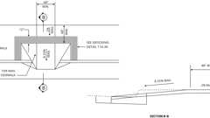Primary

**CA 11A: Figure 11A-3C Curb Detail**

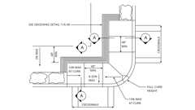Primary

**CA 11A: Figure 11A-3D Curb Detail**

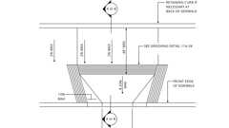Primary

**CA 11A: Figure 11A-3E Curb Detail**

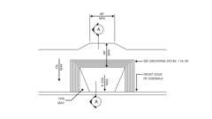Primary

**CA 11A: Figure 11A-3G Curb Detail**

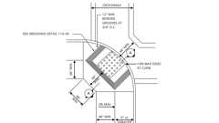Primary

**CA 11A: Figure 11A-3H Curb Detail**

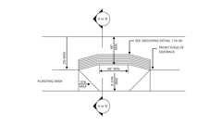Primary

**CA 11A: Figure 11A-3I Curb Detail**

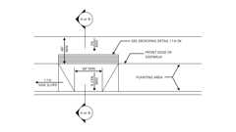Primary

**CA 11A: Figure 11A-3J Curb Detail**

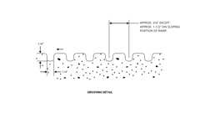Primary

**CA 11A: Figure 11A-3K Curb Detail**

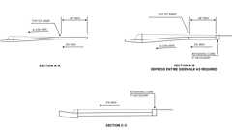Primary

**CA 11A: Figure 11A-3L Curb Sections**

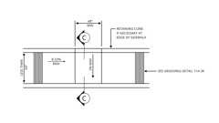Primary

**CA 11A: Figure 11A-3F Curb Detail - Sidewalk Less Than 60" Wide**

Show 2 more

[**1112A.5 *Slope of Curb Ramps***](https://up.codes/viewer/california/ca-building-code-2025/chapter/11A/housing-accessibility#1112A.5)

*The*[*slope*](https://up.codes/viewer/california/ca-building-code-2025/chapter/J/grading#slope_)*of*[*curb ramps*](https://up.codes/viewer/california/ca-building-code-2025/chapter/2/definitions#curb_ramp_)*shall not exceed 1 unit vertical to 12 units horizontal (8.33-percent*[*slope*](https://up.codes/viewer/california/ca-building-code-2025/chapter/J/grading#slope_)*) and shall lie, generally, in a single sloped plane. Transitions from*[*ramps*](https://up.codes/viewer/california/ca-building-code-2025/chapter/2/definitions#ramp_)*to*[*walks*](https://up.codes/viewer/california/ca-building-code-2025/chapter/2/definitions#walk_dsa_ac_)*, gutters or streets shall be flush and free of abrupt changes. Maximum*[*slopes*](https://up.codes/viewer/california/ca-building-code-2025/chapter/J/grading#slope_)*of adjoining gutters, road surface immediately adjacent to the*[*curb ramp*](https://up.codes/viewer/california/ca-building-code-2025/chapter/2/definitions#curb_ramp_)*, or*[*accessible route*](https://up.codes/viewer/california/ca-building-code-2025/chapter/2/definitions#accessible_route_dsa_ac_hcd_1_ac_)*shall not exceed 1 unit vertical to 20 units horizontal (5-percent*[*slope*](https://up.codes/viewer/california/ca-building-code-2025/chapter/J/grading#slope_)*) within 4 feet (1219 mm) of the top and bottom of the*[*curb ramp*](https://up.codes/viewer/california/ca-building-code-2025/chapter/2/definitions#curb_ramp_)*.*

*If a*[*curb ramp*](https://up.codes/viewer/california/ca-building-code-2025/chapter/2/definitions#curb_ramp_)*is located where*[*pedestrians*](https://up.codes/viewer/california/ca-building-code-2025/chapter/2/definitions#pedestrian_hcd_1_ac_)*must*[*walk*](https://up.codes/viewer/california/ca-building-code-2025/chapter/2/definitions#walk_dsa_ac_)*across the*[*ramp*](https://up.codes/viewer/california/ca-building-code-2025/chapter/2/definitions#ramp_)*, then it shall have flared sides; the maximum*[*slope*](https://up.codes/viewer/california/ca-building-code-2025/chapter/J/grading#slope_)*of the flare shall be 1 unit vertical in 10 units horizontal (10-percent*[*slope*](https://up.codes/viewer/california/ca-building-code-2025/chapter/J/grading#slope_)*).*[*Curb ramps*](https://up.codes/viewer/california/ca-building-code-2025/chapter/2/definitions#curb_ramp_)*with returned curbs may be used where*[*pedestrians*](https://up.codes/viewer/california/ca-building-code-2025/chapter/2/definitions#pedestrian_hcd_1_ac_)*would not normally*[*walk*](https://up.codes/viewer/california/ca-building-code-2025/chapter/2/definitions#walk_dsa_ac_)*across the*[*ramp*](https://up.codes/viewer/california/ca-building-code-2025/chapter/2/definitions#ramp_)*. See*[*Figures*](https://up.codes/viewer/california/ca-building-code-2025/chapter/11B/accessibility-to-public-buildings-public-accommodations-commercial-buildings-and#figure)[*11A-3A*](https://up.codes/viewer/california/ca-building-code-2025/chapter/11A/housing-accessibility#11A-3A)*through 11A-3L.*

[**1112A.6 *Level Landing***](https://up.codes/viewer/california/ca-building-code-2025/chapter/11A/housing-accessibility#1112A.6)

*A level landing 48 inches (1219 mm) deep shall be provided at the upper end of each*[*curb ramp*](https://up.codes/viewer/california/ca-building-code-2025/chapter/2/definitions#curb_ramp_)*over its full width to*[*permit*](https://up.codes/viewer/california/ca-building-code-2025/chapter/2/definitions#permit_)*safe egress from the*[*ramp*](https://up.codes/viewer/california/ca-building-code-2025/chapter/2/definitions#ramp_)*surface, or the*[*slope*](https://up.codes/viewer/california/ca-building-code-2025/chapter/J/grading#slope_)*of the fanned or flared sides of the*[*curb ramp*](https://up.codes/viewer/california/ca-building-code-2025/chapter/2/definitions#curb_ramp_)*, shall not exceed 1 unit vertical to 12 units horizontal (8.33-percent*[*slope*](https://up.codes/viewer/california/ca-building-code-2025/chapter/J/grading#slope_)*).*

[**1112A.7 *Finish***](https://up.codes/viewer/california/ca-building-code-2025/chapter/11A/housing-accessibility#1112A.7)

*The surface of each*[*curb ramp*](https://up.codes/viewer/california/ca-building-code-2025/chapter/2/definitions#curb_ramp_)*and its flared sides shall be stable, firm and*[*slip-resistant*](https://up.codes/viewer/california/ca-building-code-2025/chapter/2/definitions#slip_resistant_)*and shall be of contrasting finish from that of the adjacent*[*sidewalk*](https://up.codes/viewer/california/ca-building-code-2025/chapter/2/definitions#sidewalk_)*.*

[**1112A.8 *Border***](https://up.codes/viewer/california/ca-building-code-2025/chapter/11A/housing-accessibility#1112A.8)

*All*[*curb ramps*](https://up.codes/viewer/california/ca-building-code-2025/chapter/2/definitions#curb_ramp_)*shall have a grooved border 12 inches (305 mm) wide at the level surface of the*[*sidewalk*](https://up.codes/viewer/california/ca-building-code-2025/chapter/2/definitions#sidewalk_)*along the top and each side approximately 3/4inch (19 mm) on center. All*[*curb ramps*](https://up.codes/viewer/california/ca-building-code-2025/chapter/2/definitions#curb_ramp_)*constructed between the face of the curb and the street shall have a grooved border at the level surface of the*[*sidewalk*](https://up.codes/viewer/california/ca-building-code-2025/chapter/2/definitions#sidewalk_)*. See*[*Figures*](https://up.codes/viewer/california/ca-building-code-2025/chapter/11B/accessibility-to-public-buildings-public-accommodations-commercial-buildings-and#figure)[*11A-3A*](https://up.codes/viewer/california/ca-building-code-2025/chapter/11A/housing-accessibility#11A-3A)*through 11A-3K.*

[**1112A.9 *Detectable Warnings***](https://up.codes/viewer/california/ca-building-code-2025/chapter/11A/housing-accessibility#1112A.9)

*See*[*Chapter 11B*](https://up.codes/viewer/california/ca-building-code-2025/chapter/11B/accessibility-to-public-buildings-public-accommodations-commercial-buildings-and#11B)*.*

[**Section 1113A *Walks and Sidewalks on Accessible Routes***](https://up.codes/viewer/california/ca-building-code-2025/chapter/11A/housing-accessibility#1113A)

Diagram

**UpCodes Diagrams (4)**



**Walks & Sidewalks on Accessible Routes - Level Areas**



**Walks & Sidewalks on Accessible Routes - Slope**



**Walks & Sidewalks on Accessible Routes**



**Walks & Sidewalks on Accessible Routes - Continuous Gradients**

[**1113A.1 *Width and Continuous Surface***](https://up.codes/viewer/california/ca-building-code-2025/chapter/11A/housing-accessibility#1113A.1)

Diagram

[*Walks*](https://up.codes/viewer/california/ca-building-code-2025/chapter/2/definitions#walk_dsa_ac_)*and*[*sidewalks*](https://up.codes/viewer/california/ca-building-code-2025/chapter/2/definitions#sidewalk_)*subject to this chapter shall have a continuous common surface, not interrupted by*[*steps*](https://up.codes/viewer/california/ca-building-code-2025/chapter/2/definitions#step_)*or by abrupt changes in level exceeding 1/2inch (12.7 mm). (See*[*Section 1111A*](https://up.codes/viewer/california/ca-building-code-2025/chapter/11A/housing-accessibility#1111A)*).*

*Walking surfaces shall be stable, firm and*[*slip resistant*](https://up.codes/viewer/california/ca-building-code-2025/chapter/2/definitions#slip_resistant_)*, and shall comply with*[*Section 1110A.3*](https://up.codes/viewer/california/ca-building-code-2025/chapter/11A/housing-accessibility#1110A.3)*.*

**UpCodes Diagram (1)**

Primary

**Walks & Sidewalks on Accessible Routes**

[**1113A.1.1 *Width***](https://up.codes/viewer/california/ca-building-code-2025/chapter/11A/housing-accessibility#1113A.1.1)

[*Walks*](https://up.codes/viewer/california/ca-building-code-2025/chapter/2/definitions#walk_dsa_ac_)*and*[*sidewalks*](https://up.codes/viewer/california/ca-building-code-2025/chapter/2/definitions#sidewalk_)*shall be a minimum of 48 inches (1219 mm) in width, except that*[*walks*](https://up.codes/viewer/california/ca-building-code-2025/chapter/2/definitions#walk_dsa_ac_)*serving an*[*individual dwelling unit*](https://up.codes/viewer/california/ca-building-code-2025/chapter/7/fire-and-smoke-protection-features#712.1.2)*in covered multifamily buildings may be reduced to 36 inches (914 mm) in*[*clear*](https://up.codes/viewer/california/ca-building-code-2025/chapter/2/definitions#clear_dsa_ac_)*width except at doors.*

[**1113A.1.2 *Surface Cross Slopes***](https://up.codes/viewer/california/ca-building-code-2025/chapter/11A/housing-accessibility#1113A.1.2)

*Surface*[*cross slopes*](https://up.codes/viewer/california/ca-building-code-2025/chapter/2/definitions#cross_slope_)*shall not exceed 1 unit vertical in 48 units horizontal (2.083-percent*[*slope*](https://up.codes/viewer/california/ca-building-code-2025/chapter/J/grading#slope_)*).*

[**1113A.2 *Walks With Continuous Gradients***](https://up.codes/viewer/california/ca-building-code-2025/chapter/11A/housing-accessibility#1113A.2)

Diagram

*All*[*walks*](https://up.codes/viewer/california/ca-building-code-2025/chapter/2/definitions#walk_dsa_ac_)*on an*[*accessible route*](https://up.codes/viewer/california/ca-building-code-2025/chapter/2/definitions#accessible_route_dsa_ac_hcd_1_ac_)*with continuous gradients shall have*[*level areas*](https://up.codes/viewer/california/ca-building-code-2025/chapter/2/definitions#level_area_hcd_1_ac_)*at least 60 inches (1524 mm) in length at intervals of at least every 400 feet (122 m).*

**UpCodes Diagram (1)**

Primary

**Walks & Sidewalks on Accessible Routes - Continuous Gradients**

[**1113A.3 *Five Percent Gradient***](https://up.codes/viewer/california/ca-building-code-2025/chapter/11A/housing-accessibility#1113A.3)

Diagram

*When the*[*slope*](https://up.codes/viewer/california/ca-building-code-2025/chapter/J/grading#slope_)*in the direction of travel of any*[*walk*](https://up.codes/viewer/california/ca-building-code-2025/chapter/2/definitions#walk_dsa_ac_)*on an*[*accessible route*](https://up.codes/viewer/california/ca-building-code-2025/chapter/2/definitions#accessible_route_dsa_ac_hcd_1_ac_)*exceeds 1 unit vertical in 20 units horizontal (5-percent*[*slope*](https://up.codes/viewer/california/ca-building-code-2025/chapter/J/grading#slope_)*), it shall comply with the*[*ramp*](https://up.codes/viewer/california/ca-building-code-2025/chapter/2/definitions#ramp_)*provisions of*[*Section 1114A*](https://up.codes/viewer/california/ca-building-code-2025/chapter/11A/housing-accessibility#1114A)*.*

**UpCodes Diagram (1)**

Primary

**Walks & Sidewalks on Accessible Routes - Slope**

[**1113A.4 *Level Areas***](https://up.codes/viewer/california/ca-building-code-2025/chapter/11A/housing-accessibility#1113A.4)

Diagram

[*Walks*](https://up.codes/viewer/california/ca-building-code-2025/chapter/2/definitions#walk_dsa_ac_)*on an*[*accessible route*](https://up.codes/viewer/california/ca-building-code-2025/chapter/2/definitions#accessible_route_dsa_ac_hcd_1_ac_)*shall be provided with a*[*level area*](https://up.codes/viewer/california/ca-building-code-2025/chapter/2/definitions#level_area_hcd_1_ac_)*at each side of a door or gate.*[*Level areas*](https://up.codes/viewer/california/ca-building-code-2025/chapter/2/definitions#level_area_hcd_1_ac_)*shall comply with the applicable requirements for maneuvering clearances in*[*Section 1126A.3*](https://up.codes/viewer/california/ca-building-code-2025/chapter/11A/housing-accessibility#1126A.3)*.*

**UpCodes Diagrams (2)**

Primary

**Walks & Sidewalks on Accessible Routes - Level Areas**



**Walks & Sidewalks on Accessible Routes - Continuous Gradients**

[**1113A.5 *Gratings***](https://up.codes/viewer/california/ca-building-code-2025/chapter/11A/housing-accessibility#1113A.5)

Diagram

[*Walks*](https://up.codes/viewer/california/ca-building-code-2025/chapter/2/definitions#walk_dsa_ac_)*,*[*sidewalks*](https://up.codes/viewer/california/ca-building-code-2025/chapter/2/definitions#sidewalk_)*and*[*pedestrian ways*](https://up.codes/viewer/california/ca-building-code-2025/chapter/2/definitions#pedestrian_way_)*on an*[*accessible route*](https://up.codes/viewer/california/ca-building-code-2025/chapter/2/definitions#accessible_route_dsa_ac_hcd_1_ac_)*shall be free of gratings whenever possible. Gratings located in the surface of any of these areas, grid*[*openings*](https://up.codes/viewer/california/ca-building-code-2025/chapter/7/fire-and-smoke-protection-features#712.1.13)*in gratings shall be limited to 1/2inch (12.7 mm) in the direction of traffic. Elongated*[*openings*](https://up.codes/viewer/california/ca-building-code-2025/chapter/7/fire-and-smoke-protection-features#712.1.13)*in gratings shall be placed so that the long dimension is perpendicular to the dominant direction of traffic.*

***Exceptions:***

1. *Where the*[*enforcement*](https://up.codes/viewer/california/ca-building-code-2025/chapter/2/definitions#enforcement_hcd_1_hcd_2_)*agency determines that*[*compliance*](https://up.codes/viewer/california/ca-building-code-2025/chapter/31/special-construction#3113.1.1)*with this section would create an*[*unreasonable hardship*](https://up.codes/viewer/california/ca-building-code-2025/chapter/2/definitions#unreasonable_hardship_)*, an exception may be granted when*[*equivalent facilitation*](https://up.codes/viewer/california/ca-building-code-2025/chapter/11B/accessibility-to-public-buildings-public-accommodations-commercial-buildings-and#equivalent_facilitation)*is provided.*
2. *This section shall not apply in those conditions where, due to legal or physical constraints, all or portions of the*[*site*](https://up.codes/viewer/california/ca-building-code-2025/chapter/2/definitions#site_)*of the project will not allow*[*compliance*](https://up.codes/viewer/california/ca-building-code-2025/chapter/31/special-construction#3113.1.1)*with these building standards or*[*equivalent facilitation*](https://up.codes/viewer/california/ca-building-code-2025/chapter/11B/accessibility-to-public-buildings-public-accommodations-commercial-buildings-and#equivalent_facilitation)*on all or portions of one*[*site*](https://up.codes/viewer/california/ca-building-code-2025/chapter/2/definitions#site_)*without creating an*[*unreasonable hardship*](https://up.codes/viewer/california/ca-building-code-2025/chapter/2/definitions#unreasonable_hardship_)*.*

**UpCodes Diagram (1)**

Primary

**Walks & Sidewalks on Accessible Routes**

[**1113A.6 *Handrails***](https://up.codes/viewer/california/ca-building-code-2025/chapter/11A/housing-accessibility#1113A.6)

Diagram

[*Handrails*](https://up.codes/viewer/california/ca-building-code-2025/chapter/2/definitions#handrail_)*provided along walking surfaces with*[*running slopes*](https://up.codes/viewer/california/ca-building-code-2025/chapter/2/definitions#running_slope_)*not steeper than one unit vertical in 20 units horizontal (5-percent*[*slope*](https://up.codes/viewer/california/ca-building-code-2025/chapter/J/grading#slope_)*) shall comply with*[*Section 1114A.6*](https://up.codes/viewer/california/ca-building-code-2025/chapter/11A/housing-accessibility#1114A.6)*.*

**UpCodes Diagram (1)**

Primary

**Walks & Sidewalks on Accessible Routes**

[**Section 1114A *Exterior Ramps and Landings on Accessible Routes***](https://up.codes/viewer/california/ca-building-code-2025/chapter/11A/housing-accessibility#1114A)

Diagram

**UpCodes Diagram (1)**



**Walks & Sidewalks on Accessible Routes - Slope**

[**1114A.1 *Width***](https://up.codes/viewer/california/ca-building-code-2025/chapter/11A/housing-accessibility#1114A.1)

Diagram

*The*[*clear*](https://up.codes/viewer/california/ca-building-code-2025/chapter/2/definitions#clear_dsa_ac_)*width of*[*ramps*](https://up.codes/viewer/california/ca-building-code-2025/chapter/2/definitions#ramp_)*shall be consistent with the requirements in*[*Chapter 10*](https://up.codes/viewer/california/ca-building-code-2025/chapter/10/means-of-egress#10)*of this code, but in no case shall be less than 48 inches (1219 mm)*

[*Handrails*](https://up.codes/viewer/california/ca-building-code-2025/chapter/2/definitions#handrail_)*may project into the required*[*clear*](https://up.codes/viewer/california/ca-building-code-2025/chapter/2/definitions#clear_dsa_ac_)*width of the*[*ramp*](https://up.codes/viewer/california/ca-building-code-2025/chapter/2/definitions#ramp_)*at each side 3 1/2inches (89 mm) maximum at the*[*handrail*](https://up.codes/viewer/california/ca-building-code-2025/chapter/2/definitions#handrail_)*height. Curbs, wheel guides and/or appurtenances shall not project into the required*[*clear*](https://up.codes/viewer/california/ca-building-code-2025/chapter/2/definitions#clear_dsa_ac_)*width of*[*ramps*](https://up.codes/viewer/california/ca-building-code-2025/chapter/2/definitions#ramp_)*.*

***Exception:****The*[*clear*](https://up.codes/viewer/california/ca-building-code-2025/chapter/2/definitions#clear_dsa_ac_)*width of*[*ramps*](https://up.codes/viewer/california/ca-building-code-2025/chapter/2/definitions#ramp_)*serving accessible*[*entrances*](https://up.codes/viewer/california/ca-building-code-2025/chapter/2/definitions#entrance_hcd_1_hcd_2_hcd_1_ac_and_dsa_ac_)*to*[*covered multifamily dwellings*](https://up.codes/viewer/california/ca-building-code-2025/chapter/2/definitions#covered_multifamily_dwellings_hcd_1_ac_)*with an*[*occupant load*](https://up.codes/viewer/california/ca-building-code-2025/chapter/2/definitions#occupant_load_)*of 10 or less may be 36 inches (914 mm) minimum between*[*handrails*](https://up.codes/viewer/california/ca-building-code-2025/chapter/2/definitions#handrail_)*.*

***Note:****See*[*Section 1114A.6.2.4*](https://up.codes/viewer/california/ca-building-code-2025/chapter/11A/housing-accessibility#1114A.6.2.4)*for*[*handrail*](https://up.codes/viewer/california/ca-building-code-2025/chapter/2/definitions#handrail_)*projections.*

**UpCodes Diagram (1)**

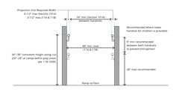Primary

**Ramp Handrail Height and Clearance (CA)**

[**1114A.2 *Slope***](https://up.codes/viewer/california/ca-building-code-2025/chapter/11A/housing-accessibility#1114A.2)

Diagram

*The maximum*[*slope*](https://up.codes/viewer/california/ca-building-code-2025/chapter/J/grading#slope_)*of*[*ramps*](https://up.codes/viewer/california/ca-building-code-2025/chapter/2/definitions#ramp_)*on an*[*accessible route*](https://up.codes/viewer/california/ca-building-code-2025/chapter/2/definitions#accessible_route_dsa_ac_hcd_1_ac_)*shall be no greater than 1 unit vertical in 12 units horizontal (8.33-percent*[*slope*](https://up.codes/viewer/california/ca-building-code-2025/chapter/J/grading#slope_)*). Transitions from*[*ramps*](https://up.codes/viewer/california/ca-building-code-2025/chapter/2/definitions#ramp_)*to*[*walks*](https://up.codes/viewer/california/ca-building-code-2025/chapter/2/definitions#walk_dsa_ac_)*, gutters or streets shall be flush and free of abrupt changes.*

***Exception:***[*Ramps*](https://up.codes/viewer/california/ca-building-code-2025/chapter/2/definitions#ramp_)*serving*[*decks*](https://up.codes/viewer/california/ca-building-code-2025/chapter/2/definitions#deck_)*, patios or balconies as specified in*[*Section 1132A.4*](https://up.codes/viewer/california/ca-building-code-2025/chapter/11A/housing-accessibility#1132A.4)*.*

**UpCodes Diagram (1)**



**Walks & Sidewalks on Accessible Routes - Slope**

[**1114A.2.1 *Cross Slope***](https://up.codes/viewer/california/ca-building-code-2025/chapter/11A/housing-accessibility#1114A.2.1)

*The*[*cross slope*](https://up.codes/viewer/california/ca-building-code-2025/chapter/2/definitions#cross_slope_)*of*[*ramp*](https://up.codes/viewer/california/ca-building-code-2025/chapter/2/definitions#ramp_)*surfaces shall be no greater than 1 unit vertical in 48 units horizontal (2.083-percent*[*slope*](https://up.codes/viewer/california/ca-building-code-2025/chapter/J/grading#slope_)*).*

[**1114A.3 *Outdoor Ramps***](https://up.codes/viewer/california/ca-building-code-2025/chapter/11A/housing-accessibility#1114A.3)

*Outdoor*[*ramps*](https://up.codes/viewer/california/ca-building-code-2025/chapter/2/definitions#ramp_)*,*[*ramp*](https://up.codes/viewer/california/ca-building-code-2025/chapter/2/definitions#ramp_)*landings and their approaches shall be designed so that water will not accumulate on the walking surface.*

[**1114A.4 *Landings***](https://up.codes/viewer/california/ca-building-code-2025/chapter/11A/housing-accessibility#1114A.4)

[*Ramp*](https://up.codes/viewer/california/ca-building-code-2025/chapter/2/definitions#ramp_)*landings shall be level and comply with this section.*

[**1114A.4.1 *Location of Landings***](https://up.codes/viewer/california/ca-building-code-2025/chapter/11A/housing-accessibility#1114A.4.1)

*Landings shall be provided at the top and bottom of each*[*ramp*](https://up.codes/viewer/california/ca-building-code-2025/chapter/2/definitions#ramp_)*. Intermediate landings shall be provided at intervals not exceeding 30 inches (762 mm) of vertical rise and at each change of direction. Landings are not considered in determining the maximum horizontal distance of each*[*ramp*](https://up.codes/viewer/california/ca-building-code-2025/chapter/2/definitions#ramp_)*.*

***Note:****Examples of*[*ramp*](https://up.codes/viewer/california/ca-building-code-2025/chapter/2/definitions#ramp_)[*dimensions*](https://up.codes/viewer/california/ca-building-code-2025/chapter/23/wood#2301.2)*are:*

|  |  |  |
| --- | --- | --- |
| [***SLOPE***](https://up.codes/viewer/california/ca-building-code-2025/chapter/J/grading#slope_)  ***(***[***Grading***](https://up.codes/viewer/california/ca-building-code-2025/chapter/J/grading#grading_)***%)*** | ***MAXIMUM RISE***  ***(Inches)*** | ***MAXIMUM HORIZONTAL PROJECTION***  ***(Feet)*** |
| ***(x 25.4 for mm)*** | ***(x 304.8) for mm)*** |
| *1:12 (8.33%)* | *30* | *30* |
| *1:15 (6.67%)* | *30* | *37.5* |
| *1:16 (6.25%)* | *30* | *40* |
| *1:20 (5.00%)* | *30* | *50* |

[**1114A.4.2 *Size of Top Landings***](https://up.codes/viewer/california/ca-building-code-2025/chapter/11A/housing-accessibility#1114A.4.2)

*Top landings shall not be less than 60 inches (1524 mm) wide. Top landings shall have a minimum length of not less than 60 inches (1524 mm) in the direction of the*[*ramp*](https://up.codes/viewer/california/ca-building-code-2025/chapter/2/definitions#ramp_)*run. See*[*Section 1126A.3*](https://up.codes/viewer/california/ca-building-code-2025/chapter/11A/housing-accessibility#1126A.3)*for maneuvering clearances at doors.*

[**1114A.4.3 *Size of Bottom and Intermediate Landings***](https://up.codes/viewer/california/ca-building-code-2025/chapter/11A/housing-accessibility#1114A.4.3)

*The minimum width of bottom and intermediate landings shall not be less than the width of the*[*ramp*](https://up.codes/viewer/california/ca-building-code-2025/chapter/2/definitions#ramp_)*.*

*Intermediate landings shall have a length in the direction of*[*ramp*](https://up.codes/viewer/california/ca-building-code-2025/chapter/2/definitions#ramp_)*run of not less than 60 inches (1524 mm). Bottom landings shall have a length in the direction of*[*ramp*](https://up.codes/viewer/california/ca-building-code-2025/chapter/2/definitions#ramp_)*run of not less than 72 inches (1829 mm).*

[**1114A.4.4 *Encroachment of Doors***](https://up.codes/viewer/california/ca-building-code-2025/chapter/11A/housing-accessibility#1114A.4.4)

Diagram

*Doors in any position shall not reduce the minimum dimension of the landing to less than 42 inches (1067 mm) and shall not reduce the required width by more than 3 inches (76.2 mm) when fully open. (See*[*Figure*](https://up.codes/viewer/california/ca-building-code-2025/chapter/11B/accessibility-to-public-buildings-public-accommodations-commercial-buildings-and#figure)*11A-6D).*

**UpCodes Diagram (1)**

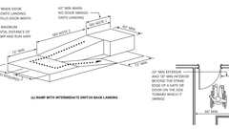Primary

**CA 11A: Figure 11A-6D Ramp Landing and Doorway**

[**1114A.4.5 *Strike Edge Extension***](https://up.codes/viewer/california/ca-building-code-2025/chapter/11A/housing-accessibility#1114A.4.5)

*The width of the landing shall comply with*[*Section 1126A.3*](https://up.codes/viewer/california/ca-building-code-2025/chapter/11A/housing-accessibility#1126A.3)*for strike edge extension and maneuvering clearance at doors.*

*Where doorways are located adjacent to a*[*ramp*](https://up.codes/viewer/california/ca-building-code-2025/chapter/2/definitions#ramp_)*landing, maneuvering clearance required by*[*Section 1126A.3*](https://up.codes/viewer/california/ca-building-code-2025/chapter/11A/housing-accessibility#1126A.3)*shall be permitted to overlap the required landing area.*

[**1114A.4.6 *Change of Direction***](https://up.codes/viewer/california/ca-building-code-2025/chapter/11A/housing-accessibility#1114A.4.6)

*Intermediate landings at a change of direction shall be sized to provide 60 inches turning*[*space*](https://up.codes/viewer/california/ca-building-code-2025/chapter/2/definitions#space_)*complying with*[*Section 1138A.1.3*](https://up.codes/viewer/california/ca-building-code-2025/chapter/11A/housing-accessibility#1138A.1.3)*. Intermediate landings at a change of direction in excess of 30 degrees shall have a length in the direction of*[*ramp*](https://up.codes/viewer/california/ca-building-code-2025/chapter/2/definitions#ramp_)*run of not less than 72 inches (1829 mm). (See*[*Figures*](https://up.codes/viewer/california/ca-building-code-2025/chapter/11B/accessibility-to-public-buildings-public-accommodations-commercial-buildings-and#figure)*11A-6C and 11A-6D.)*

[**1114A.5 *Ramp Height***](https://up.codes/viewer/california/ca-building-code-2025/chapter/11A/housing-accessibility#1114A.5)

[*Ramps*](https://up.codes/viewer/california/ca-building-code-2025/chapter/2/definitions#ramp_)*more than 30 inches (762 mm) above the adjacent floor or ground and open on one or both sides shall be provided with guardrails as required by*[*Section 1013*](https://up.codes/viewer/california/ca-building-code-2025/chapter/10/means-of-egress#1013)*. Guardrails shall be continuous from the top of the*[*ramp*](https://up.codes/viewer/california/ca-building-code-2025/chapter/2/definitions#ramp_)*to the bottom of the*[*ramp*](https://up.codes/viewer/california/ca-building-code-2025/chapter/2/definitions#ramp_)*.*

[**1114A.6 *Ramp Handrails***](https://up.codes/viewer/california/ca-building-code-2025/chapter/11A/housing-accessibility#1114A.6)

Diagram

**UpCodes Diagram (1)**



**Walks & Sidewalks on Accessible Routes**

[**1114A.6.1 *Where Required***](https://up.codes/viewer/california/ca-building-code-2025/chapter/11A/housing-accessibility#1114A.6.1)

[*Handrails*](https://up.codes/viewer/california/ca-building-code-2025/chapter/2/definitions#handrail_)*shall be provided at each side of*[*ramps*](https://up.codes/viewer/california/ca-building-code-2025/chapter/2/definitions#ramp_)*when the*[*slope*](https://up.codes/viewer/california/ca-building-code-2025/chapter/J/grading#slope_)*exceeds 1 unit vertical in 20 units horizontal (5-percent*[*slope*](https://up.codes/viewer/california/ca-building-code-2025/chapter/J/grading#slope_)*).*

***Exceptions:***

1. [*Curb ramps*](https://up.codes/viewer/california/ca-building-code-2025/chapter/2/definitions#curb_ramp_)*.*
2. [*Ramps*](https://up.codes/viewer/california/ca-building-code-2025/chapter/2/definitions#ramp_)*that serve an*[*individual dwelling unit*](https://up.codes/viewer/california/ca-building-code-2025/chapter/7/fire-and-smoke-protection-features#712.1.2)*may have one*[*handrail*](https://up.codes/viewer/california/ca-building-code-2025/chapter/2/definitions#handrail_)*, except that*[*ramps*](https://up.codes/viewer/california/ca-building-code-2025/chapter/2/definitions#ramp_)*open on one or both sides shall have*[*handrails*](https://up.codes/viewer/california/ca-building-code-2025/chapter/2/definitions#handrail_)*provided on the open side or sides.*
3. [*Ramps*](https://up.codes/viewer/california/ca-building-code-2025/chapter/2/definitions#ramp_)*at exterior door landings with less than 6 inches (152 mm) rise or less than 72 inches (1829 mm) in length.*

[**1114A.6.2 *Handrail Configuration***](https://up.codes/viewer/california/ca-building-code-2025/chapter/11A/housing-accessibility#1114A.6.2)

Diagram

**UpCodes Diagrams (3)**



**Ramp Handrail Height and Clearance (CA)**

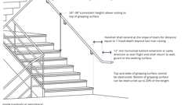

**Handrails at Stairs (CA)**

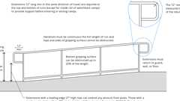

**Ramp Handrail Heights and Clearances**

[**1114A.6.2.1 *Handrail Heights***](https://up.codes/viewer/california/ca-building-code-2025/chapter/11A/housing-accessibility#1114A.6.2.1)

*The top of*[*handrails*](https://up.codes/viewer/california/ca-building-code-2025/chapter/2/definitions#handrail_)*shall be 34 to 38 inches (864 to 965 mm) above the*[*ramp*](https://up.codes/viewer/california/ca-building-code-2025/chapter/2/definitions#ramp_)*surface.*

[**1114A.6.2.2 *Handrail Continuity***](https://up.codes/viewer/california/ca-building-code-2025/chapter/11A/housing-accessibility#1114A.6.2.2)

[*Handrails*](https://up.codes/viewer/california/ca-building-code-2025/chapter/2/definitions#handrail_)*on all*[*ramps*](https://up.codes/viewer/california/ca-building-code-2025/chapter/2/definitions#ramp_)*shall be continuous within the full length of each*[*ramp*](https://up.codes/viewer/california/ca-building-code-2025/chapter/2/definitions#ramp_)*run. Inside*[*handrails*](https://up.codes/viewer/california/ca-building-code-2025/chapter/2/definitions#handrail_)*on switchback or dogleg*[*ramps*](https://up.codes/viewer/california/ca-building-code-2025/chapter/2/definitions#ramp_)*shall be continuous between*[*ramp*](https://up.codes/viewer/california/ca-building-code-2025/chapter/2/definitions#ramp_)*runs.*

[**1114A.6.2.3 *Handrail Extensions***](https://up.codes/viewer/california/ca-building-code-2025/chapter/11A/housing-accessibility#1114A.6.2.3)

[*Handrails*](https://up.codes/viewer/california/ca-building-code-2025/chapter/2/definitions#handrail_)*shall extend a minimum of 12 inches (305 mm) horizontally above landings, beyond the top and bottom of the*[*ramp*](https://up.codes/viewer/california/ca-building-code-2025/chapter/2/definitions#ramp_)*runs. Extensions shall return to a*[*wall*](https://up.codes/viewer/california/ca-building-code-2025/chapter/2/definitions#wall_)*,*[*guard*](https://up.codes/viewer/california/ca-building-code-2025/chapter/11B/accessibility-to-public-buildings-public-accommodations-commercial-buildings-and#guard)*or the walking surface, or shall be continuous to the*[*handrail*](https://up.codes/viewer/california/ca-building-code-2025/chapter/2/definitions#handrail_)*of an adjacent*[*ramp*](https://up.codes/viewer/california/ca-building-code-2025/chapter/2/definitions#ramp_)*run.*[*Handrail*](https://up.codes/viewer/california/ca-building-code-2025/chapter/2/definitions#handrail_)*extensions shall be in the same direction as the*[*ramp*](https://up.codes/viewer/california/ca-building-code-2025/chapter/2/definitions#ramp_)*runs. (See*[*Figure*](https://up.codes/viewer/california/ca-building-code-2025/chapter/11B/accessibility-to-public-buildings-public-accommodations-commercial-buildings-and#figure)*11A-5A.)*

[**1114A.6.2.4 *Handrail Projections***](https://up.codes/viewer/california/ca-building-code-2025/chapter/11A/housing-accessibility#1114A.6.2.4)

Diagram

[*Handrails*](https://up.codes/viewer/california/ca-building-code-2025/chapter/2/definitions#handrail_)*projecting from a*[*wall*](https://up.codes/viewer/california/ca-building-code-2025/chapter/2/definitions#wall_)*shall have a*[*space*](https://up.codes/viewer/california/ca-building-code-2025/chapter/2/definitions#space_)*of 11/2inches (38.1 mm) minimum between the*[*wall*](https://up.codes/viewer/california/ca-building-code-2025/chapter/2/definitions#wall_)*and the*[*handrail*](https://up.codes/viewer/california/ca-building-code-2025/chapter/2/definitions#handrail_)*.*

[*Handrails*](https://up.codes/viewer/california/ca-building-code-2025/chapter/2/definitions#handrail_)*may be located in a recess if the recess is a maximum of 3 inches (76.2 mm) deep and extends at least 18 inches (457 mm) above the top of the rail. Any*[*wall*](https://up.codes/viewer/california/ca-building-code-2025/chapter/2/definitions#wall_)*or other surface adjacent to the*[*handrail*](https://up.codes/viewer/california/ca-building-code-2025/chapter/2/definitions#handrail_)*shall be free of sharp or abrasive*[*elements*](https://up.codes/viewer/california/ca-building-code-2025/chapter/2/definitions#element_dsa_ac_)*. (See*[*Figure*](https://up.codes/viewer/california/ca-building-code-2025/chapter/11B/accessibility-to-public-buildings-public-accommodations-commercial-buildings-and#figure)*11A-6B.)*

**UpCodes Diagram (1)**

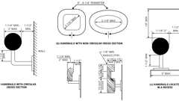Primary

**CA 11A: Figure 11A-6B Handrails**

[**1114A.6.2.5 *Handrail Gripping Surfaces***](https://up.codes/viewer/california/ca-building-code-2025/chapter/11A/housing-accessibility#1114A.6.2.5)

[*Handrail*](https://up.codes/viewer/california/ca-building-code-2025/chapter/2/definitions#handrail_)*gripping surfaces shall be continuous along their length, and shall not be obstructed along their tops or sides. The bottoms of*[*handrail*](https://up.codes/viewer/california/ca-building-code-2025/chapter/2/definitions#handrail_)*gripping surfaces shall not be obstructed for more than 20 percent of their length. When provided, horizontal projections shall occur 11/2inches (38 mm) minimum below the bottom of the*[*handrail*](https://up.codes/viewer/california/ca-building-code-2025/chapter/2/definitions#handrail_)*gripping surface. The distance between horizontal projections and the bottom of the gripping surface shall be permitted to be reduced by 1/8inch (3.2 mm) for each 1/2inch (12.7 mm) of additional*[*handrail*](https://up.codes/viewer/california/ca-building-code-2025/chapter/2/definitions#handrail_)*perimeter dimension that exceeds 4 inches (102 mm).*

[*Handrail*](https://up.codes/viewer/california/ca-building-code-2025/chapter/2/definitions#handrail_)*gripping surfaces and any surfaces adjacent to them shall be free of sharp or abrasive*[*elements*](https://up.codes/viewer/california/ca-building-code-2025/chapter/2/definitions#element_dsa_ac_)*, and shall have rounded edges.*

***Exception:****Where*[*handrails*](https://up.codes/viewer/california/ca-building-code-2025/chapter/2/definitions#handrail_)*are provided along walking surfaces with*[*slopes*](https://up.codes/viewer/california/ca-building-code-2025/chapter/J/grading#slope_)*not steeper than 1 unit vertical in 20 units horizontal, the bottoms of*[*handrail*](https://up.codes/viewer/california/ca-building-code-2025/chapter/2/definitions#handrail_)*gripping surfaces shall be permitted to be obstructed along their entire length where they are integral to crash rails or bumper*[*guards*](https://up.codes/viewer/california/ca-building-code-2025/chapter/11B/accessibility-to-public-buildings-public-accommodations-commercial-buildings-and#guard)*.*

[**1114A.6.2.6 *Cross Section***](https://up.codes/viewer/california/ca-building-code-2025/chapter/11A/housing-accessibility#1114A.6.2.6)

Diagram

[*Handrail*](https://up.codes/viewer/california/ca-building-code-2025/chapter/2/definitions#handrail_)*gripping surfaces shall comply with this section, or the shape shall provide equivalent gripping surface.*

1. ***Circular cross section.****The*[*handrail*](https://up.codes/viewer/california/ca-building-code-2025/chapter/2/definitions#handrail_)*gripping surfaces with a circular cross section shall not be less than 1*[*1*](https://up.codes/viewer/california/ca-building-code-2025/chapter/1/administration#1)*/4inches (31.75 mm) nor more than 2 inches (50.8 mm) in cross-sectional dimension.*
2. ***Noncircular cross section.***[*Handrail*](https://up.codes/viewer/california/ca-building-code-2025/chapter/2/definitions#handrail_)*gripping surfaces with a noncircular cross section shall have a perimeter dimension of 4 inches (102 mm) minimum and 61/4inches (159 mm) maximum, and a cross-section dimension of 2*[*1*](https://up.codes/viewer/california/ca-building-code-2025/chapter/1/administration#1)*/*[*4*](https://up.codes/viewer/california/ca-building-code-2025/chapter/4/special-detailed-requirements-based-on-occupancy-and-use#4)*inches (57 mm) maximum.*

**UpCodes Diagram (1)**

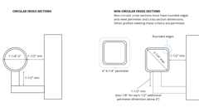

**Handrails: Cross Section (Type I)**

[**1114A.6.2.7 *Fittings***](https://up.codes/viewer/california/ca-building-code-2025/chapter/11A/housing-accessibility#1114A.6.2.7)

[*Handrails*](https://up.codes/viewer/california/ca-building-code-2025/chapter/2/definitions#handrail_)*shall not rotate within their fittings.*

[**1114A.7 *Edge Protection***](https://up.codes/viewer/california/ca-building-code-2025/chapter/11A/housing-accessibility#1114A.7)

Diagram

[*Ramps*](https://up.codes/viewer/california/ca-building-code-2025/chapter/2/definitions#ramp_)*and*[*ramp*](https://up.codes/viewer/california/ca-building-code-2025/chapter/2/definitions#ramp_)*landings shall be provided with a continuous and uninterrupted barrier on each side along the entire length in*[*compliance*](https://up.codes/viewer/california/ca-building-code-2025/chapter/31/special-construction#3113.1.1)*with*[*ramp*](https://up.codes/viewer/california/ca-building-code-2025/chapter/2/definitions#ramp_)*provisions located in*[*Chapter 10*](https://up.codes/viewer/california/ca-building-code-2025/chapter/10/means-of-egress#10)*. (See*[*Figure*](https://up.codes/viewer/california/ca-building-code-2025/chapter/11B/accessibility-to-public-buildings-public-accommodations-commercial-buildings-and#figure)*11A-5A.)*

***Note:*** Extended floors or ground surfaces, as permitted in [Chapter 10](https://up.codes/viewer/california/ca-building-code-2025/chapter/10/means-of-egress#10), are not allowed for [ramps](https://up.codes/viewer/california/ca-building-code-2025/chapter/2/definitions#ramp_) and [ramp](https://up.codes/viewer/california/ca-building-code-2025/chapter/2/definitions#ramp_) landings part of an [accessible route](https://up.codes/viewer/california/ca-building-code-2025/chapter/2/definitions#accessible_route_dsa_ac_hcd_1_ac_).

**UpCodes Diagram (1)**

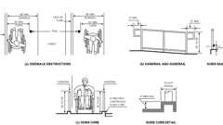Primary

**CA 11A: Figure 11A-5A Ramps and Sidewalks**

[**Section 1115A *Exterior Stairways***](https://up.codes/viewer/california/ca-building-code-2025/chapter/11A/housing-accessibility#1115A)

[**1115A.1 *General***](https://up.codes/viewer/california/ca-building-code-2025/chapter/11A/housing-accessibility#1115A.1)

*Exterior*[*stairways*](https://up.codes/viewer/california/ca-building-code-2025/chapter/2/definitions#stairway_)*serving buildings on a*[*site*](https://up.codes/viewer/california/ca-building-code-2025/chapter/2/definitions#site_)*containing covered multifamily*[*dwelling units*](https://up.codes/viewer/california/ca-building-code-2025/chapter/2/definitions#dwelling_unit_)*shall comply with this section.*

[**1115A.2 *Open Risers***](https://up.codes/viewer/california/ca-building-code-2025/chapter/11A/housing-accessibility#1115A.2)

Diagram

[*Open risers*](https://up.codes/viewer/california/ca-building-code-2025/chapter/2/definitions#open_riser_)*are not permitted on exterior*[*stairways*](https://up.codes/viewer/california/ca-building-code-2025/chapter/2/definitions#stairway_)*.*

***Exceptions:***

1. *An opening of not more than 1/2inch (12.7 mm) may be permitted between the*[*base*](https://up.codes/viewer/california/ca-building-code-2025/chapter/2/definitions#base_dsa_ss_dsa_ss_cc_oshpd_1_1r_2_4_5_)*of the*[*riser*](https://up.codes/viewer/california/ca-building-code-2025/chapter/2/definitions#riser_)*and the*[*tread*](https://up.codes/viewer/california/ca-building-code-2025/chapter/2/definitions#tread_)*.*
2. [*Risers*](https://up.codes/viewer/california/ca-building-code-2025/chapter/2/definitions#riser_)*constructed of grating containing*[*openings*](https://up.codes/viewer/california/ca-building-code-2025/chapter/7/fire-and-smoke-protection-features#712.1.13)*of not more than 1/2inch (12.7 mm) may be permitted.*

**UpCodes Diagram (1)**

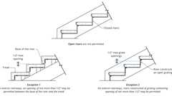

**Open Stair Risers (CA)**

[**1115A.3 *Treads***](https://up.codes/viewer/california/ca-building-code-2025/chapter/11A/housing-accessibility#1115A.3)

*All*[*tread*](https://up.codes/viewer/california/ca-building-code-2025/chapter/2/definitions#tread_)*surfaces shall be stable, firm and*[*slip resistant*](https://up.codes/viewer/california/ca-building-code-2025/chapter/2/definitions#slip_resistant_)*, and shall comply with*[*Section 1110A.3*](https://up.codes/viewer/california/ca-building-code-2025/chapter/11A/housing-accessibility#1110A.3)*.*[*Treads*](https://up.codes/viewer/california/ca-building-code-2025/chapter/2/definitions#tread_)*shall have smooth, rounded or chamfered exposed edges, and no abrupt edges at the*[*nosing*](https://up.codes/viewer/california/ca-building-code-2025/chapter/2/definitions#nosing_)*(lower front edge).*

[**1115A.4 *Nosing***](https://up.codes/viewer/california/ca-building-code-2025/chapter/11A/housing-accessibility#1115A.4)

Diagram

[*Nosing*](https://up.codes/viewer/california/ca-building-code-2025/chapter/2/definitions#nosing_)*shall not project more than 11/4inches (31.8 mm) past the face of the*[*riser*](https://up.codes/viewer/california/ca-building-code-2025/chapter/2/definitions#riser_)*below.*[*Risers*](https://up.codes/viewer/california/ca-building-code-2025/chapter/2/definitions#riser_)*shall be sloped or the underside of the*[*nosing*](https://up.codes/viewer/california/ca-building-code-2025/chapter/2/definitions#nosing_)*shall have an angle not more than 30 degrees (0.52 rad) from the vertical. (See*[*Figure*](https://up.codes/viewer/california/ca-building-code-2025/chapter/11B/accessibility-to-public-buildings-public-accommodations-commercial-buildings-and#figure)*11A-6A).*

**UpCodes Diagram (1)**

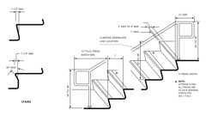Primary

**CA 11A: Figure 11A-6A Warning Striping and Handrail Extensions**

[**1115A.5 *Striping for the Visually Impaired***](https://up.codes/viewer/california/ca-building-code-2025/chapter/11A/housing-accessibility#1115A.5)

*Exterior*[*stairs*](https://up.codes/viewer/california/ca-building-code-2025/chapter/2/definitions#stair_)*serving buildings on a*[*site*](https://up.codes/viewer/california/ca-building-code-2025/chapter/2/definitions#site_)*containing multifamily*[*dwelling units*](https://up.codes/viewer/california/ca-building-code-2025/chapter/2/definitions#dwelling_unit_)*shall have the upper approach and all*[*treads*](https://up.codes/viewer/california/ca-building-code-2025/chapter/2/definitions#tread_)*marked by a stripe providing*[*clear*](https://up.codes/viewer/california/ca-building-code-2025/chapter/2/definitions#clear_dsa_ac_)*visual contrast.*

*The stripe shall be a minimum of 2 inches (50.8 mm) wide to a maximum of 4 inches (101.6 mm) wide placed parallel to, and not more than 1 inch (25.4 mm) from, the nose of the*[*step*](https://up.codes/viewer/california/ca-building-code-2025/chapter/2/definitions#step_)*or upper approach. The stripe shall extend the full width of the*[*step*](https://up.codes/viewer/california/ca-building-code-2025/chapter/2/definitions#step_)*or upper approach and shall be of material that is at least as*[*slip resistant*](https://up.codes/viewer/california/ca-building-code-2025/chapter/2/definitions#slip_resistant_)*as the other*[*treads*](https://up.codes/viewer/california/ca-building-code-2025/chapter/2/definitions#tread_)*of the*[*stair*](https://up.codes/viewer/california/ca-building-code-2025/chapter/2/definitions#stair_)*. A painted stripe shall be acceptable. Grooves shall not be used to satisfy this requirement.*

[**1115A.6 *Exterior Stairway Handrails***](https://up.codes/viewer/california/ca-building-code-2025/chapter/11A/housing-accessibility#1115A.6)

[**1115A.6.1 *Where Required***](https://up.codes/viewer/california/ca-building-code-2025/chapter/11A/housing-accessibility#1115A.6.1)

[*Stairways*](https://up.codes/viewer/california/ca-building-code-2025/chapter/2/definitions#stairway_)*shall have*[*handrails*](https://up.codes/viewer/california/ca-building-code-2025/chapter/2/definitions#handrail_)*on each side. Intermediate*[*handrails*](https://up.codes/viewer/california/ca-building-code-2025/chapter/2/definitions#handrail_)*shall be located equidistant from the sides of the*[*stairway*](https://up.codes/viewer/california/ca-building-code-2025/chapter/2/definitions#stairway_)*and comply with*[*Section 1014.9*](https://up.codes/viewer/california/ca-building-code-2025/chapter/10/means-of-egress#1014.9)*.*

***Exception:***[*Stairways*](https://up.codes/viewer/california/ca-building-code-2025/chapter/2/definitions#stairway_)*serving an*[*individual dwelling unit*](https://up.codes/viewer/california/ca-building-code-2025/chapter/7/fire-and-smoke-protection-features#712.1.2)*may have one*[*handrail*](https://up.codes/viewer/california/ca-building-code-2025/chapter/2/definitions#handrail_)*, except that*[*stairways*](https://up.codes/viewer/california/ca-building-code-2025/chapter/2/definitions#stairway_)*open on one or both sides shall have*[*handrails*](https://up.codes/viewer/california/ca-building-code-2025/chapter/2/definitions#handrail_)*on the open side or sides.*

[**1115A.6.2 *Handrail Configuration***](https://up.codes/viewer/california/ca-building-code-2025/chapter/11A/housing-accessibility#1115A.6.2)

Diagram

**UpCodes Diagram (1)**



**Handrails at Stairs (CA)**

[**1115A.6.2.1 *Handrail Heights***](https://up.codes/viewer/california/ca-building-code-2025/chapter/11A/housing-accessibility#1115A.6.2.1)

*The top of*[*handrails*](https://up.codes/viewer/california/ca-building-code-2025/chapter/2/definitions#handrail_)*shall be 34 to 38 inches (864 to 965 mm) above the*[*nosing*](https://up.codes/viewer/california/ca-building-code-2025/chapter/2/definitions#nosing_)*of the*[*treads*](https://up.codes/viewer/california/ca-building-code-2025/chapter/2/definitions#tread_)*.*

[**1115A.6.2.2 *Handrail Continuity***](https://up.codes/viewer/california/ca-building-code-2025/chapter/11A/housing-accessibility#1115A.6.2.2)

[*Handrails*](https://up.codes/viewer/california/ca-building-code-2025/chapter/2/definitions#handrail_)*on all*[*stairways*](https://up.codes/viewer/california/ca-building-code-2025/chapter/2/definitions#stairway_)*shall be continuous within the full length of each*[*stair*](https://up.codes/viewer/california/ca-building-code-2025/chapter/2/definitions#stair_)[*flight*](https://up.codes/viewer/california/ca-building-code-2025/chapter/2/definitions#flight_)*. Inside*[*handrails*](https://up.codes/viewer/california/ca-building-code-2025/chapter/2/definitions#handrail_)*on switchback or dogleg*[*stairs*](https://up.codes/viewer/california/ca-building-code-2025/chapter/2/definitions#stair_)*shall be continuous between*[*stair*](https://up.codes/viewer/california/ca-building-code-2025/chapter/2/definitions#stair_)[*flights*](https://up.codes/viewer/california/ca-building-code-2025/chapter/2/definitions#flight_)*.*

[**1115A.6.2.3 *Handrail Extensions***](https://up.codes/viewer/california/ca-building-code-2025/chapter/11A/housing-accessibility#1115A.6.2.3)

Diagram

*At the top of*[*stair*](https://up.codes/viewer/california/ca-building-code-2025/chapter/2/definitions#stair_)[*flights*](https://up.codes/viewer/california/ca-building-code-2025/chapter/2/definitions#flight_)*,*[*handrails*](https://up.codes/viewer/california/ca-building-code-2025/chapter/2/definitions#handrail_)*shall extend a minimum of 12 inches (305 mm) horizontally above landings, beginning directly above the first*[*riser*](https://up.codes/viewer/california/ca-building-code-2025/chapter/2/definitions#riser_)[*nosing*](https://up.codes/viewer/california/ca-building-code-2025/chapter/2/definitions#nosing_)*. Extensions shall return to a*[*wall*](https://up.codes/viewer/california/ca-building-code-2025/chapter/2/definitions#wall_)*,*[*guard*](https://up.codes/viewer/california/ca-building-code-2025/chapter/11B/accessibility-to-public-buildings-public-accommodations-commercial-buildings-and#guard)*or the walking surface, or shall be continuous to the*[*handrail*](https://up.codes/viewer/california/ca-building-code-2025/chapter/2/definitions#handrail_)*of an adjacent*[*stair*](https://up.codes/viewer/california/ca-building-code-2025/chapter/2/definitions#stair_)[*flight*](https://up.codes/viewer/california/ca-building-code-2025/chapter/2/definitions#flight_)*.*

*At the bottom of*[*stair*](https://up.codes/viewer/california/ca-building-code-2025/chapter/2/definitions#stair_)[*flights*](https://up.codes/viewer/california/ca-building-code-2025/chapter/2/definitions#flight_)*,*[*handrails*](https://up.codes/viewer/california/ca-building-code-2025/chapter/2/definitions#handrail_)*shall extend at the*[*slope*](https://up.codes/viewer/california/ca-building-code-2025/chapter/J/grading#slope_)*of the*[*stair*](https://up.codes/viewer/california/ca-building-code-2025/chapter/2/definitions#stair_)[*flight*](https://up.codes/viewer/california/ca-building-code-2025/chapter/2/definitions#flight_)*for a distance equal to one*[*tread*](https://up.codes/viewer/california/ca-building-code-2025/chapter/2/definitions#tread_)*depth beyond the last*[*riser*](https://up.codes/viewer/california/ca-building-code-2025/chapter/2/definitions#riser_)[*nosing*](https://up.codes/viewer/california/ca-building-code-2025/chapter/2/definitions#nosing_)*. Such extension shall continue with 12 inches (305 mm) minimum horizontal extension, shall be continuous to the*[*handrail*](https://up.codes/viewer/california/ca-building-code-2025/chapter/2/definitions#handrail_)*of an adjacent*[*stair*](https://up.codes/viewer/california/ca-building-code-2025/chapter/2/definitions#stair_)[*flight*](https://up.codes/viewer/california/ca-building-code-2025/chapter/2/definitions#flight_)*, or shall return to a*[*wall*](https://up.codes/viewer/california/ca-building-code-2025/chapter/2/definitions#wall_)*,*[*guard*](https://up.codes/viewer/california/ca-building-code-2025/chapter/11B/accessibility-to-public-buildings-public-accommodations-commercial-buildings-and#guard)*or the walking surface.*[*Handrail*](https://up.codes/viewer/california/ca-building-code-2025/chapter/2/definitions#handrail_)*horizontal extensions shall be in the same direction as the*[*stair*](https://up.codes/viewer/california/ca-building-code-2025/chapter/2/definitions#stair_)[*flights*](https://up.codes/viewer/california/ca-building-code-2025/chapter/2/definitions#flight_)*. (See*[*Figures*](https://up.codes/viewer/california/ca-building-code-2025/chapter/11B/accessibility-to-public-buildings-public-accommodations-commercial-buildings-and#figure)[*11A-6A*](https://up.codes/viewer/california/ca-building-code-2025/chapter/11A/housing-accessibility#11A-6A)*and 11A-6E.)*

**UpCodes Diagram (1)**

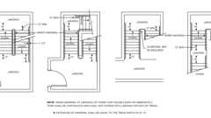Primary

**CA 11A: Figure 11A-6E Stair Handrails**

[**1115A.6.2.4 *Handrail Projections***](https://up.codes/viewer/california/ca-building-code-2025/chapter/11A/housing-accessibility#1115A.6.2.4)

Diagram

[*Handrails*](https://up.codes/viewer/california/ca-building-code-2025/chapter/2/definitions#handrail_)*projecting from a*[*wall*](https://up.codes/viewer/california/ca-building-code-2025/chapter/2/definitions#wall_)*shall have a*[*space*](https://up.codes/viewer/california/ca-building-code-2025/chapter/2/definitions#space_)*of 11/2inches (38.1 mm) minimum between the*[*wall*](https://up.codes/viewer/california/ca-building-code-2025/chapter/2/definitions#wall_)*and the*[*handrail*](https://up.codes/viewer/california/ca-building-code-2025/chapter/2/definitions#handrail_)*.*

[*Handrails*](https://up.codes/viewer/california/ca-building-code-2025/chapter/2/definitions#handrail_)*may be located in a recess if the recess is a maximum of 3 inches (76.2 mm) deep and extends at least 18 inches (457 mm) above the top of the rail. Any*[*wall*](https://up.codes/viewer/california/ca-building-code-2025/chapter/2/definitions#wall_)*or other surface adjacent to the*[*handrail*](https://up.codes/viewer/california/ca-building-code-2025/chapter/2/definitions#handrail_)*shall be free of sharp or abrasive*[*elements*](https://up.codes/viewer/california/ca-building-code-2025/chapter/2/definitions#element_dsa_ac_)*. (See*[*Figure*](https://up.codes/viewer/california/ca-building-code-2025/chapter/11B/accessibility-to-public-buildings-public-accommodations-commercial-buildings-and#figure)*11A-6B.)*

**UpCodes Diagram (1)**

Primary

**CA 11A: Figure 11A-6B Handrails**

[**1115A.6.2.5 *Handrail Gripping Surfaces***](https://up.codes/viewer/california/ca-building-code-2025/chapter/11A/housing-accessibility#1115A.6.2.5)

[*Handrail*](https://up.codes/viewer/california/ca-building-code-2025/chapter/2/definitions#handrail_)*gripping surfaces shall be continuous along their length, and shall not be obstructed along their tops or sides. The bottoms of*[*handrail*](https://up.codes/viewer/california/ca-building-code-2025/chapter/2/definitions#handrail_)*gripping surfaces shall not be obstructed for more than 20 percent of their length. When provided, horizontal projections shall occur 11/2inches (38.1 mm) minimum below the bottom of the*[*handrail*](https://up.codes/viewer/california/ca-building-code-2025/chapter/2/definitions#handrail_)*gripping surface. The distance between horizontal projections and the bottom of the gripping surface shall be permitted to be reduced by 1/8inch (3.2 mm) for each 1/2inch (12.7 mm) of additional*[*handrail*](https://up.codes/viewer/california/ca-building-code-2025/chapter/2/definitions#handrail_)*perimeter dimension that exceeds 4 inches (102 mm).*

[*Handrail*](https://up.codes/viewer/california/ca-building-code-2025/chapter/2/definitions#handrail_)*gripping surfaces and any surfaces adjacent to them shall be free of sharp or abrasive*[*elements*](https://up.codes/viewer/california/ca-building-code-2025/chapter/2/definitions#element_dsa_ac_)*, and shall have rounded edges.*

[**1115A.6.2.6 *Cross Section***](https://up.codes/viewer/california/ca-building-code-2025/chapter/11A/housing-accessibility#1115A.6.2.6)

Diagram

[*Handrail*](https://up.codes/viewer/california/ca-building-code-2025/chapter/2/definitions#handrail_)*gripping surfaces shall comply with this section, or the shape shall provide equivalent gripping surface.*

1. ***Circular cross section.***[*Handrail*](https://up.codes/viewer/california/ca-building-code-2025/chapter/2/definitions#handrail_)*gripping surfaces with a circular cross section shall not be less than 1*[*1*](https://up.codes/viewer/california/ca-building-code-2025/chapter/1/administration#1)*/4inches (31.75 mm) nor more than 2 inches (50.8 mm) in cross-sectional dimension.*
2. ***Noncircular cross section.***[*Handrail*](https://up.codes/viewer/california/ca-building-code-2025/chapter/2/definitions#handrail_)*gripping surfaces with a noncircular cross section shall have a perimeter dimension of 4 inches (102 mm) minimum and 61/4inches (159 mm) maximum, and a cross-section dimension of 2*[*1*](https://up.codes/viewer/california/ca-building-code-2025/chapter/1/administration#1)*/*[*4*](https://up.codes/viewer/california/ca-building-code-2025/chapter/4/special-detailed-requirements-based-on-occupancy-and-use#4)*inches (57 mm) maximum.*

**UpCodes Diagram (1)**



**Handrails: Cross Section (Type I)**

[**1115A.6.2.7 *Fittings***](https://up.codes/viewer/california/ca-building-code-2025/chapter/11A/housing-accessibility#1115A.6.2.7)

[*Handrails*](https://up.codes/viewer/california/ca-building-code-2025/chapter/2/definitions#handrail_)*shall not rotate within their fittings.*

[**Section 1116A *Hazards on Accessible Routes***](https://up.codes/viewer/california/ca-building-code-2025/chapter/11A/housing-accessibility#1116A)

[**1116A.1 *Warning Curbs***](https://up.codes/viewer/california/ca-building-code-2025/chapter/11A/housing-accessibility#1116A.1)

*Abrupt changes in level exceeding 4 inches (101.6 mm) in vertical dimension, such as changes in level at planters or fountains located in or adjacent to*[*walks*](https://up.codes/viewer/california/ca-building-code-2025/chapter/2/definitions#walk_dsa_ac_)*,*[*sidewalks*](https://up.codes/viewer/california/ca-building-code-2025/chapter/2/definitions#sidewalk_)*or other*[*pedestrian ways*](https://up.codes/viewer/california/ca-building-code-2025/chapter/2/definitions#pedestrian_way_)*shall be identified by curbs or other*[*approved*](https://up.codes/viewer/california/ca-building-code-2025/chapter/11B/accessibility-to-public-buildings-public-accommodations-commercial-buildings-and#approved)*barriers projecting at least 6 inches (152.4 mm) in height above the*[*walk*](https://up.codes/viewer/california/ca-building-code-2025/chapter/2/definitions#walk_dsa_ac_)*or*[*sidewalk*](https://up.codes/viewer/california/ca-building-code-2025/chapter/2/definitions#sidewalk_)*surface to warn the blind of a potential drop-off.*

***Exceptions:***

1. *Between a*[*walk*](https://up.codes/viewer/california/ca-building-code-2025/chapter/2/definitions#walk_dsa_ac_)*or*[*sidewalk*](https://up.codes/viewer/california/ca-building-code-2025/chapter/2/definitions#sidewalk_)*and an adjacent street or*[*driveway*](https://up.codes/viewer/california/ca-building-code-2025/chapter/2/definitions#driveway_dsa_ac_)*.*
2. *When a guardrail or*[*handrail*](https://up.codes/viewer/california/ca-building-code-2025/chapter/2/definitions#handrail_)*is provided with edge*[*protection*](https://up.codes/viewer/california/ca-building-code-2025/chapter/22/steel#2201.3)*in accordance with*[*Section 1012.10.1*](https://up.codes/viewer/california/ca-building-code-2025/chapter/10/means-of-egress#1012.10.1)*.*

[**1116A.2 *Headroom Clearance***](https://up.codes/viewer/california/ca-building-code-2025/chapter/11A/housing-accessibility#1116A.2)

[*Walks*](https://up.codes/viewer/california/ca-building-code-2025/chapter/2/definitions#walk_dsa_ac_)*,*[*pedestrian ways*](https://up.codes/viewer/california/ca-building-code-2025/chapter/2/definitions#pedestrian_way_)*, and other circulation*[*spaces*](https://up.codes/viewer/california/ca-building-code-2025/chapter/2/definitions#space_)*, which are part of the required egress system, shall have a minimum*[*clear*](https://up.codes/viewer/california/ca-building-code-2025/chapter/2/definitions#clear_dsa_ac_)*headroom as required in*[*Section 1003.2*](https://up.codes/viewer/california/ca-building-code-2025/chapter/10/means-of-egress#1003.2)*. Other*[*walks*](https://up.codes/viewer/california/ca-building-code-2025/chapter/2/definitions#walk_dsa_ac_)*,*[*pedestrian ways*](https://up.codes/viewer/california/ca-building-code-2025/chapter/2/definitions#pedestrian_way_)*and circulation*[*spaces*](https://up.codes/viewer/california/ca-building-code-2025/chapter/2/definitions#space_)*shall have a minimum*[*clear*](https://up.codes/viewer/california/ca-building-code-2025/chapter/2/definitions#clear_dsa_ac_)*headroom of 80 inches (2032 mm). If the vertical clearance of an area adjoining an*[*accessible route*](https://up.codes/viewer/california/ca-building-code-2025/chapter/2/definitions#accessible_route_dsa_ac_hcd_1_ac_)*is reduced to less than 80 inches (2032 mm), a guardrail or other barrier having its leading edge at or below 27 inches (686 mm) above the finished floor shall be provided.*

***Exception:****Doorways and archways less than 24 inches (610 mm) in depth may have a minimum*[*clear*](https://up.codes/viewer/california/ca-building-code-2025/chapter/2/definitions#clear_dsa_ac_)*headroom of 80 inches (2032 mm). (See*[*Section 1126A*](https://up.codes/viewer/california/ca-building-code-2025/chapter/11A/housing-accessibility#1126A)*for door requirements.)*

[**1116A.3 *Overhanging Obstructions***](https://up.codes/viewer/california/ca-building-code-2025/chapter/11A/housing-accessibility#1116A.3)

Diagram

*Any obstruction that overhangs a*[*pedestrian way*](https://up.codes/viewer/california/ca-building-code-2025/chapter/2/definitions#pedestrian_way_)*shall be a minimum of 80 inches (2032 mm) above the walking surface as measured from the bottom of the obstruction. (See*[*Figure*](https://up.codes/viewer/california/ca-building-code-2025/chapter/11B/accessibility-to-public-buildings-public-accommodations-commercial-buildings-and#figure)*11A-1B.) Where a guy support is used parallel to a*[*path of travel*](https://up.codes/viewer/california/ca-building-code-2025/chapter/2/definitions#path_of_travel_dsa_ac_)*, including, but not limited to,*[*sidewalks*](https://up.codes/viewer/california/ca-building-code-2025/chapter/2/definitions#sidewalk_)*, a guy brace,*[*sidewalk*](https://up.codes/viewer/california/ca-building-code-2025/chapter/2/definitions#sidewalk_)*guy or similar device shall be used to prevent an overhanging obstruction. (See*[*Section 1116A.2*](https://up.codes/viewer/california/ca-building-code-2025/chapter/11A/housing-accessibility#1116A.2)*for required headroom clearance.)*

***Exception:****Door closers and door stops shall be permitted to be 78 inches (1981 mm) minimum above the finish floor or ground.*

**UpCodes Diagram (1)**

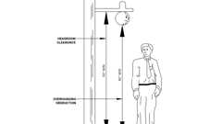Primary

**CA 11A: Figure 11A-1B Headroom Clearance and Overhanging Obstruction**

[**1116A.4 *Free-Standing Signs***](https://up.codes/viewer/california/ca-building-code-2025/chapter/11A/housing-accessibility#1116A.4)

*Wherever*[*signs*](https://up.codes/viewer/california/ca-building-code-2025/chapter/2/definitions#sign_hcd_1_ac_dsa_ac_)*mounted on posts or pylons protrude from the post or pylons and the bottom edge of the*[*sign*](https://up.codes/viewer/california/ca-building-code-2025/chapter/2/definitions#sign_hcd_1_ac_dsa_ac_)*is less than 80 inches (2032 mm) above the finished floor or ground level, the edges of such*[*signs*](https://up.codes/viewer/california/ca-building-code-2025/chapter/2/definitions#sign_hcd_1_ac_dsa_ac_)*shall be rounded or eased and the corners shall have a minimum radius of 0.125 inches (see*[*Section 1116A.2*](https://up.codes/viewer/california/ca-building-code-2025/chapter/11A/housing-accessibility#1116A.2)*for required headroom clearance).*

[**1116A.5 *Detectable Warnings at Vehicular Areas***](https://up.codes/viewer/california/ca-building-code-2025/chapter/11A/housing-accessibility#1116A.5)

*When a*[*walk*](https://up.codes/viewer/california/ca-building-code-2025/chapter/2/definitions#walk_dsa_ac_)*crosses or adjoins a*[*vehicular way*](https://up.codes/viewer/california/ca-building-code-2025/chapter/2/definitions#vehicular_way_hcd_1_ac_dsa_ac_)*, the walking surface shall be separated from the vehicular area by curbs, railings or other*[*elements*](https://up.codes/viewer/california/ca-building-code-2025/chapter/2/definitions#element_dsa_ac_)*, or the boundary between the*[*pedestrian*](https://up.codes/viewer/california/ca-building-code-2025/chapter/2/definitions#pedestrian_hcd_1_ac_)*areas and the vehicular areas shall be defined by a continuous*[*detectable warning*](https://up.codes/viewer/california/ca-building-code-2025/chapter/2/definitions#detectable_warning_)*36 inches (914 mm) wide minimum, complying with*[*Chapter 11B*](https://up.codes/viewer/california/ca-building-code-2025/chapter/11B/accessibility-to-public-buildings-public-accommodations-commercial-buildings-and#11B)*, Section 11B-*[*705*](https://up.codes/viewer/california/ca-building-code-2025/chapter/7/fire-and-smoke-protection-features#705)*.*

[**Division III *— Building Features***](https://up.codes/viewer/california/ca-building-code-2025/chapter/11A/housing-accessibility#divider_11A_III)

[**Section 1117A *General Requirements for Accessible Entrances, Exits, Interior Routes of Travel and Facility Accessibility***](https://up.codes/viewer/california/ca-building-code-2025/chapter/11A/housing-accessibility#1117A)

Diagram

***Note:****In addition to provisions of this division, interior routes of travel that provide access to, or egress from, buildings for*[*persons with disabilities*](https://up.codes/viewer/california/ca-building-code-2025/chapter/2/definitions#persons_with_disabilities_hcd_1_ac_)*shall also comply with*[*Chapter 10*](https://up.codes/viewer/california/ca-building-code-2025/chapter/10/means-of-egress#10)*.*

**UpCodes Diagram (1)**

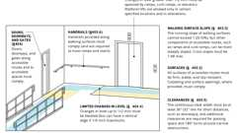

**Accessible Route Components**

[**1117A.1 *General***](https://up.codes/viewer/california/ca-building-code-2025/chapter/11A/housing-accessibility#1117A.1)

*When buildings are required to be accessible, building*[*facilities*](https://up.codes/viewer/california/ca-building-code-2025/chapter/2/definitions#facility_)*shall be accessible as provided in this division. Where specific floors of a building are required to be accessible, the requirements of this division shall apply only to the*[*facilities*](https://up.codes/viewer/california/ca-building-code-2025/chapter/2/definitions#facility_)*located on accessible floors.*

[**1117A.2 *Primary Entrances and Exterior Exit Doors***](https://up.codes/viewer/california/ca-building-code-2025/chapter/11A/housing-accessibility#1117A.2)

Diagram

*All primary*[*entrances*](https://up.codes/viewer/california/ca-building-code-2025/chapter/2/definitions#entrance_hcd_1_hcd_2_hcd_1_ac_and_dsa_ac_)*and exterior*[*ground floor*](https://up.codes/viewer/california/ca-building-code-2025/chapter/2/definitions#ground_floor_)[*exit*](https://up.codes/viewer/california/ca-building-code-2025/chapter/2/definitions#exit_)*doors to buildings and*[*facilities*](https://up.codes/viewer/california/ca-building-code-2025/chapter/2/definitions#facility_)*on*[*accessible routes*](https://up.codes/viewer/california/ca-building-code-2025/chapter/2/definitions#accessible_route_dsa_ac_hcd_1_ac_)*shall be accessible to*[*persons with disabilities*](https://up.codes/viewer/california/ca-building-code-2025/chapter/2/definitions#persons_with_disabilities_hcd_1_ac_)*.*

**UpCodes Diagram (1)**



**Accessible Unit Doors (CA 11A)**

[**1117A.3 *Separate Dwelling Unit Entrances***](https://up.codes/viewer/california/ca-building-code-2025/chapter/11A/housing-accessibility#1117A.3)

*When a*[*ground-floor*](https://up.codes/viewer/california/ca-building-code-2025/chapter/2/definitions#ground_floor_)[*dwelling unit*](https://up.codes/viewer/california/ca-building-code-2025/chapter/2/definitions#dwelling_unit_)*of a building has a separate*[*entrance*](https://up.codes/viewer/california/ca-building-code-2025/chapter/2/definitions#entrance_hcd_1_hcd_2_hcd_1_ac_and_dsa_ac_)*, each such*[*ground-floor*](https://up.codes/viewer/california/ca-building-code-2025/chapter/2/definitions#ground_floor_)[*dwelling unit*](https://up.codes/viewer/california/ca-building-code-2025/chapter/2/definitions#dwelling_unit_)*shall be served by an*[*accessible route*](https://up.codes/viewer/california/ca-building-code-2025/chapter/2/definitions#accessible_route_dsa_ac_hcd_1_ac_)*, except where the terrain or unusual characteristics of the*[*site*](https://up.codes/viewer/california/ca-building-code-2025/chapter/2/definitions#site_)*prohibit an*[*accessible route*](https://up.codes/viewer/california/ca-building-code-2025/chapter/2/definitions#accessible_route_dsa_ac_hcd_1_ac_)*(see*[*Section 1150A*](https://up.codes/viewer/california/ca-building-code-2025/chapter/11A/housing-accessibility#1150A)*for*[*site*](https://up.codes/viewer/california/ca-building-code-2025/chapter/2/definitions#site_)*impracticality tests).*

[**1117A.4 *Multiple Entrances***](https://up.codes/viewer/california/ca-building-code-2025/chapter/11A/housing-accessibility#1117A.4)

*Only one*[*entrance*](https://up.codes/viewer/california/ca-building-code-2025/chapter/2/definitions#entrance_hcd_1_hcd_2_hcd_1_ac_and_dsa_ac_)*to covered multifamily buildings is required to be accessible to any one*[*ground floor*](https://up.codes/viewer/california/ca-building-code-2025/chapter/2/definitions#ground_floor_)*of a building, except in cases where an*[*individual dwelling unit*](https://up.codes/viewer/california/ca-building-code-2025/chapter/7/fire-and-smoke-protection-features#712.1.2)*has a separate exterior*[*entrance*](https://up.codes/viewer/california/ca-building-code-2025/chapter/2/definitions#entrance_hcd_1_hcd_2_hcd_1_ac_and_dsa_ac_)*. Where the building contains clusters of*[*dwelling units*](https://up.codes/viewer/california/ca-building-code-2025/chapter/2/definitions#dwelling_unit_)*with each cluster sharing a different exterior*[*entrance*](https://up.codes/viewer/california/ca-building-code-2025/chapter/2/definitions#entrance_hcd_1_hcd_2_hcd_1_ac_and_dsa_ac_)*, more than one*[*entrance*](https://up.codes/viewer/california/ca-building-code-2025/chapter/2/definitions#entrance_hcd_1_hcd_2_hcd_1_ac_and_dsa_ac_)*may be required to be accessible, as determined by analysis of the*[*site*](https://up.codes/viewer/california/ca-building-code-2025/chapter/2/definitions#site_)*. In every case, the accessible*[*entrance*](https://up.codes/viewer/california/ca-building-code-2025/chapter/2/definitions#entrance_hcd_1_hcd_2_hcd_1_ac_and_dsa_ac_)*shall be on an*[*accessible route*](https://up.codes/viewer/california/ca-building-code-2025/chapter/2/definitions#accessible_route_dsa_ac_hcd_1_ac_)*to the covered*[*dwelling units*](https://up.codes/viewer/california/ca-building-code-2025/chapter/2/definitions#dwelling_unit_)*it serves.*

[**1117A.5 *Entrances From Parking Structures, Tunnels or Elevated Walkways***](https://up.codes/viewer/california/ca-building-code-2025/chapter/11A/housing-accessibility#1117A.5)

*Where*[*direct access*](https://up.codes/viewer/california/ca-building-code-2025/chapter/2/definitions#direct_access_)*for*[*pedestrians*](https://up.codes/viewer/california/ca-building-code-2025/chapter/2/definitions#pedestrian_hcd_1_ac_)*is provided from a parking structure to a building or*[*facility*](https://up.codes/viewer/california/ca-building-code-2025/chapter/2/definitions#facility_)*, each*[*direct access*](https://up.codes/viewer/california/ca-building-code-2025/chapter/2/definitions#direct_access_)*to the building or*[*facility*](https://up.codes/viewer/california/ca-building-code-2025/chapter/2/definitions#facility_)[*entrance*](https://up.codes/viewer/california/ca-building-code-2025/chapter/2/definitions#entrance_hcd_1_hcd_2_hcd_1_ac_and_dsa_ac_)*shall be accessible.*

*Where*[*direct access*](https://up.codes/viewer/california/ca-building-code-2025/chapter/2/definitions#direct_access_)*for*[*pedestrians*](https://up.codes/viewer/california/ca-building-code-2025/chapter/2/definitions#pedestrian_hcd_1_ac_)*is provided from a*[*pedestrian*](https://up.codes/viewer/california/ca-building-code-2025/chapter/2/definitions#pedestrian_hcd_1_ac_)*tunnel or elevated walkway to a building or*[*facility*](https://up.codes/viewer/california/ca-building-code-2025/chapter/2/definitions#facility_)*, all*[*entrances*](https://up.codes/viewer/california/ca-building-code-2025/chapter/2/definitions#entrance_hcd_1_hcd_2_hcd_1_ac_and_dsa_ac_)*to the building or*[*facility*](https://up.codes/viewer/california/ca-building-code-2025/chapter/2/definitions#facility_)*from each tunnel or walkway shall be accessible.*

[**Section 1118A *Egress and Areas of Refuge***](https://up.codes/viewer/california/ca-building-code-2025/chapter/11A/housing-accessibility#1118A)

Diagram

**UpCodes Diagram (1)**

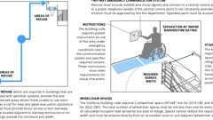

**Areas of Refuge (CA)**

[**1118A.1 *General***](https://up.codes/viewer/california/ca-building-code-2025/chapter/11A/housing-accessibility#1118A.1)

*Including but not limited to the requirements contained in this chapter for*[*accessible routes*](https://up.codes/viewer/california/ca-building-code-2025/chapter/2/definitions#accessible_route_dsa_ac_hcd_1_ac_)*, signage and emergency warning systems in buildings or portions of buildings required to be accessible shall be provided with*[*accessible means of egress*](https://up.codes/viewer/california/ca-building-code-2025/chapter/2/definitions#accessible_means_of_egress_)*as required by*[*Chapter 10*](https://up.codes/viewer/california/ca-building-code-2025/chapter/10/means-of-egress#10)*.*

[**Section 1119A *Interior Accessible Routes***](https://up.codes/viewer/california/ca-building-code-2025/chapter/11A/housing-accessibility#1119A)

Diagram

**UpCodes Diagram (1)**

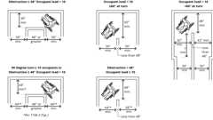

**Interior Accessible Routes (CA 11A)**

[**1119A.1 *General***](https://up.codes/viewer/california/ca-building-code-2025/chapter/11A/housing-accessibility#1119A.1)

Diagram

*When a building or portion of a building is required to be accessible or*[*adaptable*](https://up.codes/viewer/california/ca-building-code-2025/chapter/2/definitions#adaptable_dsa_ac_)*, an*[*accessible route*](https://up.codes/viewer/california/ca-building-code-2025/chapter/2/definitions#accessible_route_dsa_ac_hcd_1_ac_)*shall be provided to all portions of the building, accessible building*[*entrances*](https://up.codes/viewer/california/ca-building-code-2025/chapter/2/definitions#entrance_hcd_1_hcd_2_hcd_1_ac_and_dsa_ac_)*and to covered multifamily*[*dwelling units*](https://up.codes/viewer/california/ca-building-code-2025/chapter/2/definitions#dwelling_unit_)*. The*[*accessible route*](https://up.codes/viewer/california/ca-building-code-2025/chapter/2/definitions#accessible_route_dsa_ac_hcd_1_ac_)*shall, to the maximum extent feasible, coincide with the route for the*[*general*](https://up.codes/viewer/california/ca-building-code-2025/chapter/L/earthquake-recording-instrumentation#L101.1)*public and other building residents.*[*Accessible routes*](https://up.codes/viewer/california/ca-building-code-2025/chapter/2/definitions#accessible_route_dsa_ac_hcd_1_ac_)*shall not pass through kitchens,*[*storage*](https://up.codes/viewer/california/ca-building-code-2025/chapter/9/fire-protection-and-life-safety-systems#911.1.5)*rooms, restrooms, closets or other*[*spaces*](https://up.codes/viewer/california/ca-building-code-2025/chapter/2/definitions#space_)*used for similar purposes except within an*[*individual dwelling unit*](https://up.codes/viewer/california/ca-building-code-2025/chapter/7/fire-and-smoke-protection-features#712.1.2)*.*

*Interior*[*accessible routes*](https://up.codes/viewer/california/ca-building-code-2025/chapter/2/definitions#accessible_route_dsa_ac_hcd_1_ac_)*shall be provided as follows:*

1. *Where more than one route of travel is provided, all routes shall be accessible.*
2. *At least one*[*accessible route*](https://up.codes/viewer/california/ca-building-code-2025/chapter/2/definitions#accessible_route_dsa_ac_hcd_1_ac_)*shall connect accessible building or*[*facility*](https://up.codes/viewer/california/ca-building-code-2025/chapter/2/definitions#facility_)[*entrances*](https://up.codes/viewer/california/ca-building-code-2025/chapter/2/definitions#entrance_hcd_1_hcd_2_hcd_1_ac_and_dsa_ac_)*with all*[*accessible spaces*](https://up.codes/viewer/california/ca-building-code-2025/chapter/2/definitions#accessible_space_dsa_ac_hcd_1_ac_)*,*[*elements*](https://up.codes/viewer/california/ca-building-code-2025/chapter/2/definitions#element_dsa_ac_)*and covered multifamily*[*dwelling units*](https://up.codes/viewer/california/ca-building-code-2025/chapter/2/definitions#dwelling_unit_)*.*
3. *An*[*accessible route*](https://up.codes/viewer/california/ca-building-code-2025/chapter/2/definitions#accessible_route_dsa_ac_hcd_1_ac_)*shall connect at least one accessible primary*[*entrance*](https://up.codes/viewer/california/ca-building-code-2025/chapter/2/definitions#entrance_hcd_1_hcd_2_hcd_1_ac_and_dsa_ac_)*of each covered multifamily*[*dwelling unit*](https://up.codes/viewer/california/ca-building-code-2025/chapter/2/definitions#dwelling_unit_)*with interior and exterior*[*spaces*](https://up.codes/viewer/california/ca-building-code-2025/chapter/2/definitions#space_)*and*[*facilities*](https://up.codes/viewer/california/ca-building-code-2025/chapter/2/definitions#facility_)*that serve the unit.*
4. *Where elevators are provided for vertical access, all elevators shall be accessible.*

**UpCodes Diagrams (2)**



**Accessible Unit Doors (CA 11A)**



**Maneuvering Clearances: Doors (CA 11A)**

[**1119A.2 *Floor and Ground Surfaces***](https://up.codes/viewer/california/ca-building-code-2025/chapter/11A/housing-accessibility#1119A.2)

*Floor and ground surfaces shall be stable, firm and*[*slip resistant*](https://up.codes/viewer/california/ca-building-code-2025/chapter/2/definitions#slip_resistant_)*. If carpet or carpet tile is used in a*[*common use*](https://up.codes/viewer/california/ca-building-code-2025/chapter/2/definitions#common_use_)*area or*[*public use*](https://up.codes/viewer/california/ca-building-code-2025/chapter/2/definitions#public_use_dsa_ac_)*area on a ground or floor surface, it shall have firm*[*backing*](https://up.codes/viewer/california/ca-building-code-2025/chapter/2/definitions#backing_)*or no*[*backing*](https://up.codes/viewer/california/ca-building-code-2025/chapter/2/definitions#backing_)*. Carpet or carpet tile shall have a level loop, textured loop, level cut pile or level cut/uncut pile texture. The maximum pile height shall be 1/2inch (12.7 mm). Exposed edges of carpet shall be fastened to floor surfaces and have*[*trim*](https://up.codes/viewer/california/ca-building-code-2025/chapter/2/definitions#trim_)*along the entire length of the exposed edge. Carpet edge*[*trim*](https://up.codes/viewer/california/ca-building-code-2025/chapter/2/definitions#trim_)*shall comply with*[*Section 1121A*](https://up.codes/viewer/california/ca-building-code-2025/chapter/11A/housing-accessibility#1121A)*requirements for changes in level.*

[**1119A.2.1 *Recessed Doormats***](https://up.codes/viewer/california/ca-building-code-2025/chapter/11A/housing-accessibility#1119A.2.1)

*Recessed doormats shall be adequately anchored to prevent interference with*[*wheelchair*](https://up.codes/viewer/california/ca-building-code-2025/chapter/2/definitions#wheelchair_hcd_1_ac_dsa_ac_)*traffic.*

[**1119A.3 *Widths***](https://up.codes/viewer/california/ca-building-code-2025/chapter/11A/housing-accessibility#1119A.3)

Diagram

*Interior*[*accessible routes*](https://up.codes/viewer/california/ca-building-code-2025/chapter/2/definitions#accessible_route_dsa_ac_hcd_1_ac_)*serving an*[*occupant load*](https://up.codes/viewer/california/ca-building-code-2025/chapter/2/definitions#occupant_load_)*of 10 or more shall not be less than 44 inches (1118 mm) in width. Interior*[*accessible routes*](https://up.codes/viewer/california/ca-building-code-2025/chapter/2/definitions#accessible_route_dsa_ac_hcd_1_ac_)*serving an*[*occupant load*](https://up.codes/viewer/california/ca-building-code-2025/chapter/2/definitions#occupant_load_)*of less than 10 shall not be less than 36 inches (914 mm) in width.*

*If a person in a*[*wheelchair*](https://up.codes/viewer/california/ca-building-code-2025/chapter/2/definitions#wheelchair_hcd_1_ac_dsa_ac_)*must make a turn around a corner or an obstruction, the minimum*[*clear*](https://up.codes/viewer/california/ca-building-code-2025/chapter/2/definitions#clear_dsa_ac_)*width of the*[*accessible route*](https://up.codes/viewer/california/ca-building-code-2025/chapter/2/definitions#accessible_route_dsa_ac_hcd_1_ac_)*shall be as specified in*[*Section 1138A.1.5*](https://up.codes/viewer/california/ca-building-code-2025/chapter/11A/housing-accessibility#1138A.1.5)*.*

**UpCodes Diagram (1)**

Primary

**Interior Accessible Routes (CA 11A)**

[**1119A.4 *Interior Accessible Routes Over 200 Feet***](https://up.codes/viewer/california/ca-building-code-2025/chapter/11A/housing-accessibility#1119A.4)

Diagram

*Interior*[*accessible routes*](https://up.codes/viewer/california/ca-building-code-2025/chapter/2/definitions#accessible_route_dsa_ac_hcd_1_ac_)*that exceed 200 feet (60 960 mm) in length shall comply with*[*Section 1138A.1.2*](https://up.codes/viewer/california/ca-building-code-2025/chapter/11A/housing-accessibility#1138A.1.2)*. (See*[*Figure*](https://up.codes/viewer/california/ca-building-code-2025/chapter/11B/accessibility-to-public-buildings-public-accommodations-commercial-buildings-and#figure)*11A-1L.)*

**UpCodes Diagram (1)**

Primary

**CA 11A: Figure 11A-1L Int. Accessible Route Over 200 Feet; Occ. Load 10+**

[**1119A.5 *Changes in Elevation***](https://up.codes/viewer/california/ca-building-code-2025/chapter/11A/housing-accessibility#1119A.5)

*Interior*[*accessible routes*](https://up.codes/viewer/california/ca-building-code-2025/chapter/2/definitions#accessible_route_dsa_ac_hcd_1_ac_)*which have changes in elevation shall be transitioned and comply with Sections*[*1121A*](https://up.codes/viewer/california/ca-building-code-2025/chapter/11A/housing-accessibility#1121A)*or*[*1122A*](https://up.codes/viewer/california/ca-building-code-2025/chapter/11A/housing-accessibility#1122A)*.*

***Exception:****Doors and*[*thresholds*](https://up.codes/viewer/california/ca-building-code-2025/chapter/10/means-of-egress#1010.1.6)*as provided in*[*Section 1126A*](https://up.codes/viewer/california/ca-building-code-2025/chapter/11A/housing-accessibility#1126A)*.*

[**Section 1120A *Reserved***](https://up.codes/viewer/california/ca-building-code-2025/chapter/11A/housing-accessibility#1120A)

[**Section 1121A *Changes in Level on Accessible Routes***](https://up.codes/viewer/california/ca-building-code-2025/chapter/11A/housing-accessibility#1121A)

[**1121A.1 *Changes in Level Not Exceeding 1/2 Inch***](https://up.codes/viewer/california/ca-building-code-2025/chapter/11A/housing-accessibility#1121A.1)

*Abrupt changes in level along any*[*accessible route*](https://up.codes/viewer/california/ca-building-code-2025/chapter/2/definitions#accessible_route_dsa_ac_hcd_1_ac_)*shall not exceed inch (12.7 mm). When changes in level do occur, they shall be beveled with a*[*slope*](https://up.codes/viewer/california/ca-building-code-2025/chapter/J/grading#slope_)*no greater than 1 unit vertical in 2 units horizontal (50-percent*[*slope*](https://up.codes/viewer/california/ca-building-code-2025/chapter/J/grading#slope_)*). Changes in level not exceeding 1/4 inch (6.35 mm) may be vertical.*

[**1121A.2 *Changes Greater Than 1/2 Inch***](https://up.codes/viewer/california/ca-building-code-2025/chapter/11A/housing-accessibility#1121A.2)

*Changes in level greater than 1/2inch (12.7 mm) shall be made by means of a sloped surface not greater than 1 unit vertical in 20 units horizontal (5-percent*[*slope*](https://up.codes/viewer/california/ca-building-code-2025/chapter/J/grading#slope_)*), or a*[*curb ramp*](https://up.codes/viewer/california/ca-building-code-2025/chapter/2/definitions#curb_ramp_)*,*[*ramp*](https://up.codes/viewer/california/ca-building-code-2025/chapter/2/definitions#ramp_)*, elevator or*[*platform (wheelchair) lift*](https://up.codes/viewer/california/ca-building-code-2025/chapter/2/definitions#platform_%28wheelchair%29_lift_)*.*[*Stairs*](https://up.codes/viewer/california/ca-building-code-2025/chapter/2/definitions#stair_)*shall not be part of an*[*accessible route*](https://up.codes/viewer/california/ca-building-code-2025/chapter/2/definitions#accessible_route_dsa_ac_hcd_1_ac_)*. When*[*stairs*](https://up.codes/viewer/california/ca-building-code-2025/chapter/2/definitions#stair_)*are located along or adjacent to an*[*accessible route*](https://up.codes/viewer/california/ca-building-code-2025/chapter/2/definitions#accessible_route_dsa_ac_hcd_1_ac_)*they shall comply with*[*Section 1123A*](https://up.codes/viewer/california/ca-building-code-2025/chapter/11A/housing-accessibility#1123A)*for interior*[*stairways*](https://up.codes/viewer/california/ca-building-code-2025/chapter/2/definitions#stairway_)*.*

[**Section 1122A *Interior Ramps and Landings on Accessible Routes***](https://up.codes/viewer/california/ca-building-code-2025/chapter/11A/housing-accessibility#1122A)

Diagram

**UpCodes Diagram (1)**

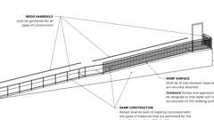

**Ramp Construction**

[**1122A.1 *Width***](https://up.codes/viewer/california/ca-building-code-2025/chapter/11A/housing-accessibility#1122A.1)

Diagram

*The*[*clear*](https://up.codes/viewer/california/ca-building-code-2025/chapter/2/definitions#clear_dsa_ac_)*width of*[*ramps*](https://up.codes/viewer/california/ca-building-code-2025/chapter/2/definitions#ramp_)*shall be consistent with the requirements in*[*Chapter 10*](https://up.codes/viewer/california/ca-building-code-2025/chapter/10/means-of-egress#10)*of this code, but in no case shall be less than 48 inches (1219 mm).*

[*Handrails*](https://up.codes/viewer/california/ca-building-code-2025/chapter/2/definitions#handrail_)*may project into the required*[*clear*](https://up.codes/viewer/california/ca-building-code-2025/chapter/2/definitions#clear_dsa_ac_)*width of the*[*ramp*](https://up.codes/viewer/california/ca-building-code-2025/chapter/2/definitions#ramp_)*at each side 31/2inches (89 mm) maximum at the*[*handrail*](https://up.codes/viewer/california/ca-building-code-2025/chapter/2/definitions#handrail_)*height. Curbs, wheel guides and/or appurtenances shall not project into the required*[*clear*](https://up.codes/viewer/california/ca-building-code-2025/chapter/2/definitions#clear_dsa_ac_)*width of*[*ramps*](https://up.codes/viewer/california/ca-building-code-2025/chapter/2/definitions#ramp_)*.*

***Exception:****The*[*clear*](https://up.codes/viewer/california/ca-building-code-2025/chapter/2/definitions#clear_dsa_ac_)*width of*[*ramps*](https://up.codes/viewer/california/ca-building-code-2025/chapter/2/definitions#ramp_)*serving accessible*[*entrances*](https://up.codes/viewer/california/ca-building-code-2025/chapter/2/definitions#entrance_hcd_1_hcd_2_hcd_1_ac_and_dsa_ac_)*to*[*covered multifamily dwellings*](https://up.codes/viewer/california/ca-building-code-2025/chapter/2/definitions#covered_multifamily_dwellings_hcd_1_ac_)*with an*[*occupant load*](https://up.codes/viewer/california/ca-building-code-2025/chapter/2/definitions#occupant_load_)*of 10 or less may be 36 inches (914 mm) minimum between*[*handrails*](https://up.codes/viewer/california/ca-building-code-2025/chapter/2/definitions#handrail_)*.*

***Note:*** See [Section 1122A.5.2.4](https://up.codes/viewer/california/ca-building-code-2025/chapter/11A/housing-accessibility#1122A.5.2.4) for [handrail](https://up.codes/viewer/california/ca-building-code-2025/chapter/2/definitions#handrail_) projections.

**UpCodes Diagram (1)**

Primary

**Ramp Handrail Height and Clearance (CA)**

[**1122A.2 *Slope***](https://up.codes/viewer/california/ca-building-code-2025/chapter/11A/housing-accessibility#1122A.2)

*The maximum*[*slope*](https://up.codes/viewer/california/ca-building-code-2025/chapter/J/grading#slope_)*of*[*ramps*](https://up.codes/viewer/california/ca-building-code-2025/chapter/2/definitions#ramp_)*on an*[*accessible route*](https://up.codes/viewer/california/ca-building-code-2025/chapter/2/definitions#accessible_route_dsa_ac_hcd_1_ac_)*shall be no greater than 1 unit vertical in 12 units horizontal (8.33-percent*[*slope*](https://up.codes/viewer/california/ca-building-code-2025/chapter/J/grading#slope_)*).*

[**1122A.2.1 *Cross Slope***](https://up.codes/viewer/california/ca-building-code-2025/chapter/11A/housing-accessibility#1122A.2.1)

*The*[*cross slope*](https://up.codes/viewer/california/ca-building-code-2025/chapter/2/definitions#cross_slope_)*of*[*ramp*](https://up.codes/viewer/california/ca-building-code-2025/chapter/2/definitions#ramp_)*surfaces shall be no greater than 1 unit vertical in 48 units horizontal (2.083-percent*[*slope*](https://up.codes/viewer/california/ca-building-code-2025/chapter/J/grading#slope_)*).*

[**1122A.3 *Landings***](https://up.codes/viewer/california/ca-building-code-2025/chapter/11A/housing-accessibility#1122A.3)

Diagram

[*Ramp*](https://up.codes/viewer/california/ca-building-code-2025/chapter/2/definitions#ramp_)*landings shall be level and comply with this section. (See*[*Figure*](https://up.codes/viewer/california/ca-building-code-2025/chapter/11B/accessibility-to-public-buildings-public-accommodations-commercial-buildings-and#figure)*11A-6C.)*

**UpCodes Diagram (1)**

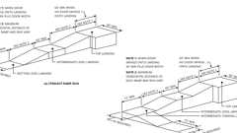Primary

**CA 11A: Figure 11A-6C Ramp Dimensions**

[**1122A.3.1 *Location of Landings***](https://up.codes/viewer/california/ca-building-code-2025/chapter/11A/housing-accessibility#1122A.3.1)

*Landings shall be provided at the top and bottom of each*[*ramp*](https://up.codes/viewer/california/ca-building-code-2025/chapter/2/definitions#ramp_)*. Intermediate landings shall be provided at intervals not exceeding 30 inches (762 mm) of vertical rise and at each change of direction. Landings are not considered in determining the maximum horizontal distance of each*[*ramp*](https://up.codes/viewer/california/ca-building-code-2025/chapter/2/definitions#ramp_)*.*

***Note:****Examples of*[*ramp*](https://up.codes/viewer/california/ca-building-code-2025/chapter/2/definitions#ramp_)[*dimensions*](https://up.codes/viewer/california/ca-building-code-2025/chapter/23/wood#2301.2)*are:*

|  |  |  |
| --- | --- | --- |
| [***SLOPE***](https://up.codes/viewer/california/ca-building-code-2025/chapter/J/grading#slope_)  ***(***[***Grading***](https://up.codes/viewer/california/ca-building-code-2025/chapter/J/grading#grading_)***%)*** | ***MAXIMUM RISE***  ***(Inches)*** | ***MAXIMUM HORIZONTAL PROJECTION***  ***(Feet)*** |
| ***(x 25.4 for mm)*** | ***(x 304.8) for mm)*** |
| *1:12 (8.33%)* | *30* | *30* |
| *1:15 (6.67%)* | *30* | *37.5* |
| *1:16 (6.25%)* | *30* | *40* |
| *1:20 (5.00%)* | *30* | *50* |

[**1122A.3.2 *Size of Top Landings***](https://up.codes/viewer/california/ca-building-code-2025/chapter/11A/housing-accessibility#1122A.3.2)

Diagram

*Top landings shall not be less than 60 inches (1524 mm) wide. Top landings shall have a minimum length of not less than 60 inches (1524 mm) in the direction of the*[*ramp*](https://up.codes/viewer/california/ca-building-code-2025/chapter/2/definitions#ramp_)*run. See*[*Section 1126A.3*](https://up.codes/viewer/california/ca-building-code-2025/chapter/11A/housing-accessibility#1126A.3)*for maneuvering clearances at doors. (See*[*Figure*](https://up.codes/viewer/california/ca-building-code-2025/chapter/11B/accessibility-to-public-buildings-public-accommodations-commercial-buildings-and#figure)*11A-6C.)*

**UpCodes Diagram (1)**

Primary

**CA 11A: Figure 11A-6C Ramp Dimensions**

[**1122A.3.3 *Size of Bottom and Intermediate Landings***](https://up.codes/viewer/california/ca-building-code-2025/chapter/11A/housing-accessibility#1122A.3.3)

*The minimum width of bottom and intermediate landings shall not be less than the width of the*[*ramp*](https://up.codes/viewer/california/ca-building-code-2025/chapter/2/definitions#ramp_)*.*

*Intermediate landings shall have a length in the direction of*[*ramp*](https://up.codes/viewer/california/ca-building-code-2025/chapter/2/definitions#ramp_)*run of not less than 60 inches (1524 mm).*

*Bottom landings shall have a length in the direction of*[*ramp*](https://up.codes/viewer/california/ca-building-code-2025/chapter/2/definitions#ramp_)*run of not less than 72 inches (1829 mm).*

[**1122A.3.4 *Encroachment of Doors***](https://up.codes/viewer/california/ca-building-code-2025/chapter/11A/housing-accessibility#1122A.3.4)

Diagram

*Doors in any position shall not reduce the minimum dimension of the landing to less than 42 inches (1067 mm) and shall not reduce the required width by more than 3 inches (76.2 mm) when fully open. (See*[*Figure*](https://up.codes/viewer/california/ca-building-code-2025/chapter/11B/accessibility-to-public-buildings-public-accommodations-commercial-buildings-and#figure)*11A-6D.)*

**UpCodes Diagram (1)**

Primary

**CA 11A: Figure 11A-6D Ramp Landing and Doorway**

[**1122A.3.5 *Strike Edge Extension***](https://up.codes/viewer/california/ca-building-code-2025/chapter/11A/housing-accessibility#1122A.3.5)

*The width of the landing shall comply with*[*Section 1126A.3*](https://up.codes/viewer/california/ca-building-code-2025/chapter/11A/housing-accessibility#1126A.3)*for maneuvering clearance at doors.*

*Where doorways are located adjacent to a*[*ramp*](https://up.codes/viewer/california/ca-building-code-2025/chapter/2/definitions#ramp_)*landing, maneuvering clearance required by*[*Section 1126A.3*](https://up.codes/viewer/california/ca-building-code-2025/chapter/11A/housing-accessibility#1126A.3)*shall be permitted to overlap the required landing area.*

[**1122A.3.6 *Change of Direction***](https://up.codes/viewer/california/ca-building-code-2025/chapter/11A/housing-accessibility#1122A.3.6)

Diagram

*Intermediate landings at a change of direction shall be sized to provide 60 inches turning*[*space*](https://up.codes/viewer/california/ca-building-code-2025/chapter/2/definitions#space_)*complying with*[*Section 1138A.1.3*](https://up.codes/viewer/california/ca-building-code-2025/chapter/11A/housing-accessibility#1138A.1.3)*. Intermediate landings at a change of direction in excess of 30 degrees shall have a length in the direction of*[*ramp*](https://up.codes/viewer/california/ca-building-code-2025/chapter/2/definitions#ramp_)*run of not less than 72 inches (1829 mm). (See*[*Figures*](https://up.codes/viewer/california/ca-building-code-2025/chapter/11B/accessibility-to-public-buildings-public-accommodations-commercial-buildings-and#figure)*11A-6C and 11A-6D.)*

**UpCodes Diagram (1)**

Primary

**CA 11A: Figure 11A-6C Ramp Dimensions**

[**1122A.4 *Ramp Height***](https://up.codes/viewer/california/ca-building-code-2025/chapter/11A/housing-accessibility#1122A.4)

[*Ramps*](https://up.codes/viewer/california/ca-building-code-2025/chapter/2/definitions#ramp_)*more than 30 inches (762 mm) above the adjacent floor or ground and open on one or both sides shall be provided with a*[*guard*](https://up.codes/viewer/california/ca-building-code-2025/chapter/11B/accessibility-to-public-buildings-public-accommodations-commercial-buildings-and#guard)*as required by*[*Section 1013*](https://up.codes/viewer/california/ca-building-code-2025/chapter/10/means-of-egress#1013)*. Guardrails shall be continuous from the top of the*[*ramp*](https://up.codes/viewer/california/ca-building-code-2025/chapter/2/definitions#ramp_)*to the bottom of the*[*ramp*](https://up.codes/viewer/california/ca-building-code-2025/chapter/2/definitions#ramp_)*.*

[**1122A.5 *Ramp Handrails***](https://up.codes/viewer/california/ca-building-code-2025/chapter/11A/housing-accessibility#1122A.5)

[**1122A.5.1 *Where Required***](https://up.codes/viewer/california/ca-building-code-2025/chapter/11A/housing-accessibility#1122A.5.1)

[*Handrails*](https://up.codes/viewer/california/ca-building-code-2025/chapter/2/definitions#handrail_)*shall be provided at each side of*[*ramps*](https://up.codes/viewer/california/ca-building-code-2025/chapter/2/definitions#ramp_)*when the*[*slope*](https://up.codes/viewer/california/ca-building-code-2025/chapter/J/grading#slope_)*exceeds 1 unit vertical in 20 units horizontal (5-percent*[*slope*](https://up.codes/viewer/california/ca-building-code-2025/chapter/J/grading#slope_)*).*

***Exceptions:***

1. [*Curb ramps*](https://up.codes/viewer/california/ca-building-code-2025/chapter/2/definitions#curb_ramp_)*.*
2. [*Ramps*](https://up.codes/viewer/california/ca-building-code-2025/chapter/2/definitions#ramp_)*that serve an*[*individual dwelling unit*](https://up.codes/viewer/california/ca-building-code-2025/chapter/7/fire-and-smoke-protection-features#712.1.2)*may have one*[*handrail*](https://up.codes/viewer/california/ca-building-code-2025/chapter/2/definitions#handrail_)*, except that*[*ramps*](https://up.codes/viewer/california/ca-building-code-2025/chapter/2/definitions#ramp_)*open on one or both sides shall have*[*handrails*](https://up.codes/viewer/california/ca-building-code-2025/chapter/2/definitions#handrail_)*provided on the open side or sides.*

[**1122A.5.2 *Handrail Configuration***](https://up.codes/viewer/california/ca-building-code-2025/chapter/11A/housing-accessibility#1122A.5.2)

[**1122A.5.2.1 *Handrail Heights***](https://up.codes/viewer/california/ca-building-code-2025/chapter/11A/housing-accessibility#1122A.5.2.1)

Diagram

*The top of*[*handrails*](https://up.codes/viewer/california/ca-building-code-2025/chapter/2/definitions#handrail_)*shall be 34 to 38 inches (864 to 965 mm) above the*[*ramp*](https://up.codes/viewer/california/ca-building-code-2025/chapter/2/definitions#ramp_)*surface.*

**UpCodes Diagram (1)**



**Ramp Handrail Height and Clearance (CA)**

[**1122A.5.2.2 *Handrail Continuity***](https://up.codes/viewer/california/ca-building-code-2025/chapter/11A/housing-accessibility#1122A.5.2.2)

[*Handrails*](https://up.codes/viewer/california/ca-building-code-2025/chapter/2/definitions#handrail_)*on all*[*ramps*](https://up.codes/viewer/california/ca-building-code-2025/chapter/2/definitions#ramp_)*shall be continuous within the full length of each*[*ramp*](https://up.codes/viewer/california/ca-building-code-2025/chapter/2/definitions#ramp_)*run. Inside*[*handrails*](https://up.codes/viewer/california/ca-building-code-2025/chapter/2/definitions#handrail_)*on switchback or dogleg*[*ramps*](https://up.codes/viewer/california/ca-building-code-2025/chapter/2/definitions#ramp_)*shall be continuous between*[*ramp*](https://up.codes/viewer/california/ca-building-code-2025/chapter/2/definitions#ramp_)*runs.*

[**1122A.5.2.3 *Handrail Extensions***](https://up.codes/viewer/california/ca-building-code-2025/chapter/11A/housing-accessibility#1122A.5.2.3)

Diagram

[*Handrails*](https://up.codes/viewer/california/ca-building-code-2025/chapter/2/definitions#handrail_)*shall extend a minimum of 12 inches (305 mm) horizontally above landings, beyond the top and bottom of the*[*ramp*](https://up.codes/viewer/california/ca-building-code-2025/chapter/2/definitions#ramp_)*runs. Extensions shall return to a*[*wall*](https://up.codes/viewer/california/ca-building-code-2025/chapter/2/definitions#wall_)*,*[*guard*](https://up.codes/viewer/california/ca-building-code-2025/chapter/11B/accessibility-to-public-buildings-public-accommodations-commercial-buildings-and#guard)*or the walking surface, or shall be continuous to the*[*handrail*](https://up.codes/viewer/california/ca-building-code-2025/chapter/2/definitions#handrail_)*of an adjacent*[*ramp*](https://up.codes/viewer/california/ca-building-code-2025/chapter/2/definitions#ramp_)*run.*[*Handrail*](https://up.codes/viewer/california/ca-building-code-2025/chapter/2/definitions#handrail_)*extensions shall be in the same direction as the*[*ramp*](https://up.codes/viewer/california/ca-building-code-2025/chapter/2/definitions#ramp_)*runs. (See*[*Figure*](https://up.codes/viewer/california/ca-building-code-2025/chapter/11B/accessibility-to-public-buildings-public-accommodations-commercial-buildings-and#figure)*11A-5A.)*

**UpCodes Diagram (1)**

Primary

**CA 11A: Figure 11A-5A Ramps and Sidewalks**

[**1122A.5.2.4 *Handrail Projections***](https://up.codes/viewer/california/ca-building-code-2025/chapter/11A/housing-accessibility#1122A.5.2.4)

Diagram

[*Handrails*](https://up.codes/viewer/california/ca-building-code-2025/chapter/2/definitions#handrail_)*projecting from a*[*wall*](https://up.codes/viewer/california/ca-building-code-2025/chapter/2/definitions#wall_)*shall have a*[*space*](https://up.codes/viewer/california/ca-building-code-2025/chapter/2/definitions#space_)*of 1 1/2inches (38.1 mm) minimum between the*[*wall*](https://up.codes/viewer/california/ca-building-code-2025/chapter/2/definitions#wall_)*and the*[*handrail*](https://up.codes/viewer/california/ca-building-code-2025/chapter/2/definitions#handrail_)*.*

[*Handrails*](https://up.codes/viewer/california/ca-building-code-2025/chapter/2/definitions#handrail_)*may be located in a recess if the recess is a maximum of 3 inches (76.2 mm) deep and extends at least 18 inches (457 mm) above the top of the rail. Any*[*wall*](https://up.codes/viewer/california/ca-building-code-2025/chapter/2/definitions#wall_)*or other surface adjacent to the*[*handrail*](https://up.codes/viewer/california/ca-building-code-2025/chapter/2/definitions#handrail_)*shall be free of sharp or abrasive*[*elements*](https://up.codes/viewer/california/ca-building-code-2025/chapter/2/definitions#element_dsa_ac_)*. (See*[*Figure*](https://up.codes/viewer/california/ca-building-code-2025/chapter/11B/accessibility-to-public-buildings-public-accommodations-commercial-buildings-and#figure)*11A-6B.)*

**UpCodes Diagram (1)**

Primary

**CA 11A: Figure 11A-6B Handrails**

[**1122A.5.2.5 *Handrail Gripping Surfaces***](https://up.codes/viewer/california/ca-building-code-2025/chapter/11A/housing-accessibility#1122A.5.2.5)

[*Handrail*](https://up.codes/viewer/california/ca-building-code-2025/chapter/2/definitions#handrail_)*gripping surfaces shall be continuous along their length, and shall not be obstructed along their tops or sides. The bottoms of*[*handrail*](https://up.codes/viewer/california/ca-building-code-2025/chapter/2/definitions#handrail_)*gripping surfaces shall not be obstructed for more than 20 percent of their length. When provided, horizontal projections shall occur 1 1/2inches (38 mm) minimum below the bottom of the*[*handrail*](https://up.codes/viewer/california/ca-building-code-2025/chapter/2/definitions#handrail_)*gripping surface. The distance between horizontal projections and the bottom of the gripping surface shall be permitted to be reduced by 1/8inch (3.2 mm) for each 1/2inch (12.7 mm) of additional*[*handrail*](https://up.codes/viewer/california/ca-building-code-2025/chapter/2/definitions#handrail_)*perimeter dimension that exceeds 4 inches (102 mm).*

[*Handrail*](https://up.codes/viewer/california/ca-building-code-2025/chapter/2/definitions#handrail_)*gripping surfaces and any surfaces adjacent to them shall be free of sharp or abrasive*[*elements*](https://up.codes/viewer/california/ca-building-code-2025/chapter/2/definitions#element_dsa_ac_)*, and shall have rounded edges.*

***Exception:****Where*[*handrails*](https://up.codes/viewer/california/ca-building-code-2025/chapter/2/definitions#handrail_)*are provided along walking surfaces with*[*slopes*](https://up.codes/viewer/california/ca-building-code-2025/chapter/J/grading#slope_)*not steeper than 1 unit vertical in 20 units horizontal, the bottoms of*[*handrail*](https://up.codes/viewer/california/ca-building-code-2025/chapter/2/definitions#handrail_)*gripping surfaces shall be permitted to be obstructed along their entire length where they are integral to crash rails or bumper*[*guards*](https://up.codes/viewer/california/ca-building-code-2025/chapter/11B/accessibility-to-public-buildings-public-accommodations-commercial-buildings-and#guard)*.*

[**1122A.5.2.6 *Cross Section***](https://up.codes/viewer/california/ca-building-code-2025/chapter/11A/housing-accessibility#1122A.5.2.6)

Diagram

[*Handrail*](https://up.codes/viewer/california/ca-building-code-2025/chapter/2/definitions#handrail_)*gripping surfaces shall comply with this section, or the shape shall provide equivalent gripping surface.*

1. ***Circular cross section.****The*[*handrail*](https://up.codes/viewer/california/ca-building-code-2025/chapter/2/definitions#handrail_)*gripping surfaces with a circular cross section shall not be less than*[*1*](https://up.codes/viewer/california/ca-building-code-2025/chapter/1/administration#1)[*1*](https://up.codes/viewer/california/ca-building-code-2025/chapter/1/administration#1)*/4inches (31.75 mm) nor more than 2 inches (50.8 mm) in cross-sectional dimension.*
2. ***Noncircular cross section.***[*Handrail*](https://up.codes/viewer/california/ca-building-code-2025/chapter/2/definitions#handrail_)*gripping surfaces with a noncircular cross section shall have a perimeter dimension of 4 inches (102 mm) minimum and 6 1/4inches (159 mm) maximum, and a cross-section dimension of*[*2*](https://up.codes/viewer/california/ca-building-code-2025/chapter/2/definitions#2)[*1*](https://up.codes/viewer/california/ca-building-code-2025/chapter/1/administration#1)*/4inches (57 mm) maximum.*

**UpCodes Diagram (1)**



**Handrails: Cross Section (Type I)**

[**1122A.5.2.7 *Fittings***](https://up.codes/viewer/california/ca-building-code-2025/chapter/11A/housing-accessibility#1122A.5.2.7)

[*Handrails*](https://up.codes/viewer/california/ca-building-code-2025/chapter/2/definitions#handrail_)*shall not rotate within their fittings.*

[**1122A.6 *Edge Protection***](https://up.codes/viewer/california/ca-building-code-2025/chapter/11A/housing-accessibility#1122A.6)

[*Ramps*](https://up.codes/viewer/california/ca-building-code-2025/chapter/2/definitions#ramp_)*and*[*ramp*](https://up.codes/viewer/california/ca-building-code-2025/chapter/2/definitions#ramp_)*landings shall be provided with a continuous and uninterrupted barrier on each side along the entire length in*[*compliance*](https://up.codes/viewer/california/ca-building-code-2025/chapter/31/special-construction#3113.1.1)*with Sections*[*1012.10*](https://up.codes/viewer/california/ca-building-code-2025/chapter/10/means-of-egress#1012.10)*and*[*1012.10.1*](https://up.codes/viewer/california/ca-building-code-2025/chapter/10/means-of-egress#1012.10.1)*. (See*[*Figure*](https://up.codes/viewer/california/ca-building-code-2025/chapter/11B/accessibility-to-public-buildings-public-accommodations-commercial-buildings-and#figure)*11A-5A.)*

***Note:****Extended floors or ground surfaces, as permitted in*[*Section 1012.10.2*](https://up.codes/viewer/california/ca-building-code-2025/chapter/10/means-of-egress#1012.10.2)*, are not allowed for*[*ramps*](https://up.codes/viewer/california/ca-building-code-2025/chapter/2/definitions#ramp_)*and*[*ramp*](https://up.codes/viewer/california/ca-building-code-2025/chapter/2/definitions#ramp_)*landings providing access to, or egress from, buildings or*[*facilities*](https://up.codes/viewer/california/ca-building-code-2025/chapter/2/definitions#facility_)*where*[*accessibility*](https://up.codes/viewer/california/ca-building-code-2025/chapter/30/elevators-and-conveying-systems#3001.4)*is required.*

[**Section 1123A *Interior Stairways***](https://up.codes/viewer/california/ca-building-code-2025/chapter/11A/housing-accessibility#1123A)

[**1123A.1 *General***](https://up.codes/viewer/california/ca-building-code-2025/chapter/11A/housing-accessibility#1123A.1)

*Interior*[*stairways*](https://up.codes/viewer/california/ca-building-code-2025/chapter/2/definitions#stairway_)*serving buildings containing covered multifamily*[*dwelling units*](https://up.codes/viewer/california/ca-building-code-2025/chapter/2/definitions#dwelling_unit_)*shall comply with this section.*

[**1123A.2 *Open Risers***](https://up.codes/viewer/california/ca-building-code-2025/chapter/11A/housing-accessibility#1123A.2)

[*Open risers*](https://up.codes/viewer/california/ca-building-code-2025/chapter/2/definitions#open_riser_)*shall not be permitted on interior*[*stairways*](https://up.codes/viewer/california/ca-building-code-2025/chapter/2/definitions#stairway_)*.*

***Exception:***[*Stairways*](https://up.codes/viewer/california/ca-building-code-2025/chapter/2/definitions#stairway_)*within an*[*individual dwelling unit*](https://up.codes/viewer/california/ca-building-code-2025/chapter/7/fire-and-smoke-protection-features#712.1.2)*.*

[**1123A.3 *Treads***](https://up.codes/viewer/california/ca-building-code-2025/chapter/11A/housing-accessibility#1123A.3)

*All*[*tread*](https://up.codes/viewer/california/ca-building-code-2025/chapter/2/definitions#tread_)*surfaces shall be stable, firm and*[*slip resistant*](https://up.codes/viewer/california/ca-building-code-2025/chapter/2/definitions#slip_resistant_)*, and shall comply with*[*Section 1119A.2*](https://up.codes/viewer/california/ca-building-code-2025/chapter/11A/housing-accessibility#1119A.2)*.*[*Treads*](https://up.codes/viewer/california/ca-building-code-2025/chapter/2/definitions#tread_)*shall have smooth, rounded or chamfered exposed edges and no abrupt edges at the*[*nosing*](https://up.codes/viewer/california/ca-building-code-2025/chapter/2/definitions#nosing_)*(lower front edge).*

[**1123A.4 *Nosing***](https://up.codes/viewer/california/ca-building-code-2025/chapter/11A/housing-accessibility#1123A.4)

Diagram

[*Nosing*](https://up.codes/viewer/california/ca-building-code-2025/chapter/2/definitions#nosing_)*shall not project more than 11/4inches (31.8 mm) past the face of the*[*riser*](https://up.codes/viewer/california/ca-building-code-2025/chapter/2/definitions#riser_)*below.*[*Risers*](https://up.codes/viewer/california/ca-building-code-2025/chapter/2/definitions#riser_)*shall be sloped or the underside of the*[*nosing*](https://up.codes/viewer/california/ca-building-code-2025/chapter/2/definitions#nosing_)*shall have an angle not more than 30 degrees (0.52 rad) from the vertical. (See*[*Figure*](https://up.codes/viewer/california/ca-building-code-2025/chapter/11B/accessibility-to-public-buildings-public-accommodations-commercial-buildings-and#figure)*11A-6A.)*

**UpCodes Diagram (1)**

Primary

**CA 11A: Figure 11A-6A Warning Striping and Handrail Extensions**

[**1123A.5 *Striping for the Visually Impaired***](https://up.codes/viewer/california/ca-building-code-2025/chapter/11A/housing-accessibility#1123A.5)

*Interior*[*stairs*](https://up.codes/viewer/california/ca-building-code-2025/chapter/2/definitions#stair_)*shall have the upper approach and lower*[*tread*](https://up.codes/viewer/california/ca-building-code-2025/chapter/2/definitions#tread_)*marked by a stripe providing*[*clear*](https://up.codes/viewer/california/ca-building-code-2025/chapter/2/definitions#clear_dsa_ac_)*visual contrast.*

*The stripe shall be a minimum of 2 inches (50.8 mm) wide to a maximum of 4 inches (101.6 mm) wide placed parallel to, and not more than 1 inch (25.4 mm) from, the nose of the*[*step*](https://up.codes/viewer/california/ca-building-code-2025/chapter/2/definitions#step_)*or upper approach. The stripe shall extend the full width of the*[*step*](https://up.codes/viewer/california/ca-building-code-2025/chapter/2/definitions#step_)*or upper approach and shall be of material that is at least as*[*slip resistant*](https://up.codes/viewer/california/ca-building-code-2025/chapter/2/definitions#slip_resistant_)*as the other*[*treads*](https://up.codes/viewer/california/ca-building-code-2025/chapter/2/definitions#tread_)*of the*[*stair*](https://up.codes/viewer/california/ca-building-code-2025/chapter/2/definitions#stair_)*. A painted stripe shall be acceptable. Grooves shall not be used to satisfy this requirement.*

***Exception:****Striping is not required for*[*stairways*](https://up.codes/viewer/california/ca-building-code-2025/chapter/2/definitions#stairway_)*within*[*individual dwelling units*](https://up.codes/viewer/california/ca-building-code-2025/chapter/7/fire-and-smoke-protection-features#712.1.2)*.*

[**1123A.6 *Interior Stairway Handrails***](https://up.codes/viewer/california/ca-building-code-2025/chapter/11A/housing-accessibility#1123A.6)

[**1123A.6.1 *Where Required***](https://up.codes/viewer/california/ca-building-code-2025/chapter/11A/housing-accessibility#1123A.6.1)

[*Stairways*](https://up.codes/viewer/california/ca-building-code-2025/chapter/2/definitions#stairway_)*shall have*[*handrails*](https://up.codes/viewer/california/ca-building-code-2025/chapter/2/definitions#handrail_)*on each side. Intermediate*[*handrails*](https://up.codes/viewer/california/ca-building-code-2025/chapter/2/definitions#handrail_)*shall be located equidistant from the sides of the*[*stairway*](https://up.codes/viewer/california/ca-building-code-2025/chapter/2/definitions#stairway_)*and comply with*[*Section 1014.9*](https://up.codes/viewer/california/ca-building-code-2025/chapter/10/means-of-egress#1014.9)*.*

***Exception:***[*Stairways*](https://up.codes/viewer/california/ca-building-code-2025/chapter/2/definitions#stairway_)*serving an*[*individual dwelling unit*](https://up.codes/viewer/california/ca-building-code-2025/chapter/7/fire-and-smoke-protection-features#712.1.2)*may have one*[*handrail*](https://up.codes/viewer/california/ca-building-code-2025/chapter/2/definitions#handrail_)*, except that*[*stairways*](https://up.codes/viewer/california/ca-building-code-2025/chapter/2/definitions#stairway_)*open on one or both sides shall have*[*handrails*](https://up.codes/viewer/california/ca-building-code-2025/chapter/2/definitions#handrail_)*on the open side or sides.*

[**1123A.6.2 *Handrail Configuration***](https://up.codes/viewer/california/ca-building-code-2025/chapter/11A/housing-accessibility#1123A.6.2)

Diagram

**UpCodes Diagram (1)**



**Handrails: Cross Section (Type I)**

[**1123A.6.2.1 *Handrail Heights***](https://up.codes/viewer/california/ca-building-code-2025/chapter/11A/housing-accessibility#1123A.6.2.1)

*The top of*[*handrails*](https://up.codes/viewer/california/ca-building-code-2025/chapter/2/definitions#handrail_)*shall be 34 to 38 inches (864 to 965 mm) above the*[*nosing*](https://up.codes/viewer/california/ca-building-code-2025/chapter/2/definitions#nosing_)*of the*[*treads*](https://up.codes/viewer/california/ca-building-code-2025/chapter/2/definitions#tread_)*.*

[**1123A.6.2.2 *Handrail Continuity***](https://up.codes/viewer/california/ca-building-code-2025/chapter/11A/housing-accessibility#1123A.6.2.2)

Diagram

[*Handrails*](https://up.codes/viewer/california/ca-building-code-2025/chapter/2/definitions#handrail_)*on all*[*stairways*](https://up.codes/viewer/california/ca-building-code-2025/chapter/2/definitions#stairway_)*shall be continuous within the full length of each*[*stair*](https://up.codes/viewer/california/ca-building-code-2025/chapter/2/definitions#stair_)[*flight*](https://up.codes/viewer/california/ca-building-code-2025/chapter/2/definitions#flight_)*. Inside*[*handrails*](https://up.codes/viewer/california/ca-building-code-2025/chapter/2/definitions#handrail_)*on switchback or dogleg*[*stairs*](https://up.codes/viewer/california/ca-building-code-2025/chapter/2/definitions#stair_)*shall be continuous between*[*stair*](https://up.codes/viewer/california/ca-building-code-2025/chapter/2/definitions#stair_)[*flights*](https://up.codes/viewer/california/ca-building-code-2025/chapter/2/definitions#flight_)*.*

**UpCodes Diagram (1)**

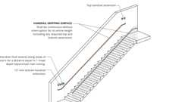

**Handrail Continuity and Extensions (CA)**

[**1123A.6.2.3 *Handrail Extensions***](https://up.codes/viewer/california/ca-building-code-2025/chapter/11A/housing-accessibility#1123A.6.2.3)

Diagram

*At the top of*[*stair*](https://up.codes/viewer/california/ca-building-code-2025/chapter/2/definitions#stair_)[*flights*](https://up.codes/viewer/california/ca-building-code-2025/chapter/2/definitions#flight_)*,*[*handrails*](https://up.codes/viewer/california/ca-building-code-2025/chapter/2/definitions#handrail_)*shall extend a minimum of 12 inches (305 mm) horizontally above landings, beginning directly above the first*[*riser*](https://up.codes/viewer/california/ca-building-code-2025/chapter/2/definitions#riser_)[*nosing*](https://up.codes/viewer/california/ca-building-code-2025/chapter/2/definitions#nosing_)*. Extensions shall return to a*[*wall*](https://up.codes/viewer/california/ca-building-code-2025/chapter/2/definitions#wall_)*,*[*guard*](https://up.codes/viewer/california/ca-building-code-2025/chapter/11B/accessibility-to-public-buildings-public-accommodations-commercial-buildings-and#guard)*or the walking surface, or shall be continuous to the*[*handrail*](https://up.codes/viewer/california/ca-building-code-2025/chapter/2/definitions#handrail_)*of an adjacent*[*stair*](https://up.codes/viewer/california/ca-building-code-2025/chapter/2/definitions#stair_)[*flight*](https://up.codes/viewer/california/ca-building-code-2025/chapter/2/definitions#flight_)*.*

*At the bottom of*[*stair*](https://up.codes/viewer/california/ca-building-code-2025/chapter/2/definitions#stair_)[*flights*](https://up.codes/viewer/california/ca-building-code-2025/chapter/2/definitions#flight_)*,*[*handrails*](https://up.codes/viewer/california/ca-building-code-2025/chapter/2/definitions#handrail_)*shall extend at the*[*slope*](https://up.codes/viewer/california/ca-building-code-2025/chapter/J/grading#slope_)*of the*[*stair*](https://up.codes/viewer/california/ca-building-code-2025/chapter/2/definitions#stair_)[*flight*](https://up.codes/viewer/california/ca-building-code-2025/chapter/2/definitions#flight_)*for a distance equal to one*[*tread*](https://up.codes/viewer/california/ca-building-code-2025/chapter/2/definitions#tread_)*depth beyond the last*[*riser*](https://up.codes/viewer/california/ca-building-code-2025/chapter/2/definitions#riser_)[*nosing*](https://up.codes/viewer/california/ca-building-code-2025/chapter/2/definitions#nosing_)*. Such extension shall continue with 12 inches (305 mm) minimum horizontal extension, shall be continuous to the*[*handrail*](https://up.codes/viewer/california/ca-building-code-2025/chapter/2/definitions#handrail_)*of an adjacent*[*stair*](https://up.codes/viewer/california/ca-building-code-2025/chapter/2/definitions#stair_)[*flight*](https://up.codes/viewer/california/ca-building-code-2025/chapter/2/definitions#flight_)*, or shall return to a*[*wall*](https://up.codes/viewer/california/ca-building-code-2025/chapter/2/definitions#wall_)*,*[*guard*](https://up.codes/viewer/california/ca-building-code-2025/chapter/11B/accessibility-to-public-buildings-public-accommodations-commercial-buildings-and#guard)*or the walking surface.*[*Handrail*](https://up.codes/viewer/california/ca-building-code-2025/chapter/2/definitions#handrail_)*horizontal extensions shall be in the same direction as the*[*stair*](https://up.codes/viewer/california/ca-building-code-2025/chapter/2/definitions#stair_)[*flights*](https://up.codes/viewer/california/ca-building-code-2025/chapter/2/definitions#flight_)*. (See*[*Figures*](https://up.codes/viewer/california/ca-building-code-2025/chapter/11B/accessibility-to-public-buildings-public-accommodations-commercial-buildings-and#figure)[*11A-6A*](https://up.codes/viewer/california/ca-building-code-2025/chapter/11A/housing-accessibility#11A-6A)*and 11A-6E.)*

***Exception:***[*Stairways*](https://up.codes/viewer/california/ca-building-code-2025/chapter/2/definitions#stairway_)*within an*[*individual dwelling unit*](https://up.codes/viewer/california/ca-building-code-2025/chapter/7/fire-and-smoke-protection-features#712.1.2)*.*

**UpCodes Diagrams (2)**

Primary

**CA 11A: Figure 11A-6E Stair Handrails**



**Handrail Continuity and Extensions (CA)**

[**1123A.6.2.4 *Handrail Projections***](https://up.codes/viewer/california/ca-building-code-2025/chapter/11A/housing-accessibility#1123A.6.2.4)

Diagram

[*Handrails*](https://up.codes/viewer/california/ca-building-code-2025/chapter/2/definitions#handrail_)*projecting from a*[*wall*](https://up.codes/viewer/california/ca-building-code-2025/chapter/2/definitions#wall_)*shall have a*[*space*](https://up.codes/viewer/california/ca-building-code-2025/chapter/2/definitions#space_)*of 11/2inches (38.1 mm) minimum between the*[*wall*](https://up.codes/viewer/california/ca-building-code-2025/chapter/2/definitions#wall_)*and the*[*handrail*](https://up.codes/viewer/california/ca-building-code-2025/chapter/2/definitions#handrail_)*.*

[*Handrails*](https://up.codes/viewer/california/ca-building-code-2025/chapter/2/definitions#handrail_)*may be located in a recess if the recess is a maximum of 3 inches (76.2 mm) deep and extends at least 18 inches (457 mm) above the top of the rail. Any*[*wall*](https://up.codes/viewer/california/ca-building-code-2025/chapter/2/definitions#wall_)*or other surface adjacent to the*[*handrail*](https://up.codes/viewer/california/ca-building-code-2025/chapter/2/definitions#handrail_)*shall be free of sharp or abrasive*[*elements*](https://up.codes/viewer/california/ca-building-code-2025/chapter/2/definitions#element_dsa_ac_)*. (See*[*Figure*](https://up.codes/viewer/california/ca-building-code-2025/chapter/11B/accessibility-to-public-buildings-public-accommodations-commercial-buildings-and#figure)*11A-6B.)*

**UpCodes Diagram (1)**

Primary

**CA 11A: Figure 11A-6B Handrails**

[**1123A.6.2.5 *Handrail Gripping Surfaces***](https://up.codes/viewer/california/ca-building-code-2025/chapter/11A/housing-accessibility#1123A.6.2.5)

[*Handrail*](https://up.codes/viewer/california/ca-building-code-2025/chapter/2/definitions#handrail_)*gripping surfaces shall be continuous along their length, and shall not be obstructed along their tops or sides. The bottoms of*[*handrail*](https://up.codes/viewer/california/ca-building-code-2025/chapter/2/definitions#handrail_)*gripping surfaces shall not be obstructed for more than 20 percent of their length. When provided, horizontal projections shall occur 11/2inches (38 mm) minimum below the bottom of the*[*handrail*](https://up.codes/viewer/california/ca-building-code-2025/chapter/2/definitions#handrail_)*gripping surface. The distance between horizontal projections and the bottom of the gripping surface shall be permitted to be reduced by 1/8inch (3.2 mm) for each 1/2inch (12.7 mm) of additional*[*handrail*](https://up.codes/viewer/california/ca-building-code-2025/chapter/2/definitions#handrail_)*perimeter dimension that exceeds 4 inches (102 mm).*

[*Handrail*](https://up.codes/viewer/california/ca-building-code-2025/chapter/2/definitions#handrail_)*gripping surfaces and any surfaces adjacent to them shall be free of sharp or abrasive*[*elements*](https://up.codes/viewer/california/ca-building-code-2025/chapter/2/definitions#element_dsa_ac_)*, and shall have rounded edges.*

[**1123A.6.2.6 *Cross Section***](https://up.codes/viewer/california/ca-building-code-2025/chapter/11A/housing-accessibility#1123A.6.2.6)

[*Handrail*](https://up.codes/viewer/california/ca-building-code-2025/chapter/2/definitions#handrail_)*gripping surfaces shall comply with this section, or the shape shall provide equivalent gripping surface.*

1. ***Circular cross section.****The*[*handrail*](https://up.codes/viewer/california/ca-building-code-2025/chapter/2/definitions#handrail_)*gripping surfaces with a circular cross section shall not be less than 1*[*1*](https://up.codes/viewer/california/ca-building-code-2025/chapter/1/administration#1)*/4inches (31.75 mm) nor more than 2 inches (50.8 mm) in cross-sectional dimension.*
2. ***Noncircular cross section.***[*Handrail*](https://up.codes/viewer/california/ca-building-code-2025/chapter/2/definitions#handrail_)*gripping surfaces with a noncircular cross section shall have a perimeter dimension of 4 inches (102 mm) minimum and 61/4inches (159 mm) maximum, and a cross-section dimension of 2*[*1*](https://up.codes/viewer/california/ca-building-code-2025/chapter/1/administration#1)*/*[*4*](https://up.codes/viewer/california/ca-building-code-2025/chapter/4/special-detailed-requirements-based-on-occupancy-and-use#4)*inches (57 mm) maximum.*

[**1123A.6.2.7 *Fittings***](https://up.codes/viewer/california/ca-building-code-2025/chapter/11A/housing-accessibility#1123A.6.2.7)

[*Handrails*](https://up.codes/viewer/california/ca-building-code-2025/chapter/2/definitions#handrail_)*shall not rotate within their fittings.*

[**Section 1124A *Elevators and Platform (Wheelchair) Lifts***](https://up.codes/viewer/california/ca-building-code-2025/chapter/11A/housing-accessibility#1124A)

Diagram

**UpCodes Diagrams (2)**

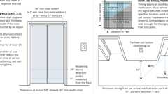

**Elevator Door Req.**

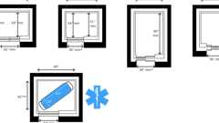

**Elevator Car Dimensions**

[**1124A.1 *General***](https://up.codes/viewer/california/ca-building-code-2025/chapter/11A/housing-accessibility#1124A.1)

*Elevators provided in covered multifamily buildings shall be accessible. Elevators required to be accessible shall comply with this chapter, ASME A17.1 (Safety Code for Elevators and Escalators), Title 8 of the California Code of Regulations, under "Elevator Safety Orders," and any other applicable safety regulations of other*[*administrative authorities*](https://up.codes/viewer/california/ca-building-code-2025/chapter/2/definitions#administrative_authority_dsa_ac_)*having*[*jurisdiction*](https://up.codes/viewer/california/ca-building-code-2025/chapter/2/definitions#jurisdiction_)*.*

***Exception:****Private elevators serving only one*[*dwelling unit*](https://up.codes/viewer/california/ca-building-code-2025/chapter/2/definitions#dwelling_unit_)*.*

[**1124A.2 *Location***](https://up.codes/viewer/california/ca-building-code-2025/chapter/11A/housing-accessibility#1124A.2)

[*Passenger elevators*](https://up.codes/viewer/california/ca-building-code-2025/chapter/2/definitions#elevator_passenger_hcd_1_hcd_2_)*shall be located on a major*[*accessible route*](https://up.codes/viewer/california/ca-building-code-2025/chapter/2/definitions#accessible_route_dsa_ac_hcd_1_ac_)*and provisions shall be made to ensure that they remain accessible and usable at all times that the building is occupied.*

[**1124A.3 *Size of Cab and Control Locations***](https://up.codes/viewer/california/ca-building-code-2025/chapter/11A/housing-accessibility#1124A.3)

[**1124A.3.1 *General***](https://up.codes/viewer/california/ca-building-code-2025/chapter/11A/housing-accessibility#1124A.3.1)

*Elevators serving covered multifamily buildings shall be sized to accommodate a*[*wheelchair*](https://up.codes/viewer/california/ca-building-code-2025/chapter/2/definitions#wheelchair_hcd_1_ac_dsa_ac_)*in accordance with this section.*

***Exception:****When the*[*enforcing agency*](https://up.codes/viewer/california/ca-building-code-2025/chapter/2/definitions#enforcing_agency_)*determines that*[*compliance*](https://up.codes/viewer/california/ca-building-code-2025/chapter/31/special-construction#3113.1.1)*with any requirement of this section would create an*[*unreasonable hardship*](https://up.codes/viewer/california/ca-building-code-2025/chapter/2/definitions#unreasonable_hardship_)*, an exception to the requirement shall be granted when*[*equivalent facilitation*](https://up.codes/viewer/california/ca-building-code-2025/chapter/11B/accessibility-to-public-buildings-public-accommodations-commercial-buildings-and#equivalent_facilitation)*is provided, and where it can be demonstrated that a person using a*[*wheelchair*](https://up.codes/viewer/california/ca-building-code-2025/chapter/2/definitions#wheelchair_hcd_1_ac_dsa_ac_)*can enter and operate the elevator.*

[**1124A.3.2 *Car Inside***](https://up.codes/viewer/california/ca-building-code-2025/chapter/11A/housing-accessibility#1124A.3.2)

*The elevator car shall be designed to comply with one of the following:*

1. ***Door centered on the***[***wall***](https://up.codes/viewer/california/ca-building-code-2025/chapter/2/definitions#wall_)***.****When the door is centered on the car*[*wall*](https://up.codes/viewer/california/ca-building-code-2025/chapter/2/definitions#wall_)*, it shall provide a*[*clear*](https://up.codes/viewer/california/ca-building-code-2025/chapter/2/definitions#clear_dsa_ac_)*width of 42 inches (1067 mm) minimum, and the*[*clear*](https://up.codes/viewer/california/ca-building-code-2025/chapter/2/definitions#clear_dsa_ac_)*distance between car side*[*walls*](https://up.codes/viewer/california/ca-building-code-2025/chapter/2/definitions#wall_)*shall be 80 inches (2032 mm) minimum. The*[*clear*](https://up.codes/viewer/california/ca-building-code-2025/chapter/2/definitions#clear_dsa_ac_)*distance between the back*[*wall*](https://up.codes/viewer/california/ca-building-code-2025/chapter/2/definitions#wall_)*and the return panel shall be 51 inches (1295 mm) minimum. The*[*clear*](https://up.codes/viewer/california/ca-building-code-2025/chapter/2/definitions#clear_dsa_ac_)*distance between the back*[*wall*](https://up.codes/viewer/california/ca-building-code-2025/chapter/2/definitions#wall_)*and the inside face of the door shall be 54 inches (1372 mm) minimum.*
2. ***Door not centered on the***[***wall***](https://up.codes/viewer/california/ca-building-code-2025/chapter/2/definitions#wall_)***.****When the door is not centered on the car*[*wall*](https://up.codes/viewer/california/ca-building-code-2025/chapter/2/definitions#wall_)*, it shall provide a*[*clear*](https://up.codes/viewer/california/ca-building-code-2025/chapter/2/definitions#clear_dsa_ac_)*width of 36 inches (914 mm) minimum, and the*[*clear*](https://up.codes/viewer/california/ca-building-code-2025/chapter/2/definitions#clear_dsa_ac_)*distance between car side*[*walls*](https://up.codes/viewer/california/ca-building-code-2025/chapter/2/definitions#wall_)*shall be 68 inches (1727 mm) minimum. The*[*clear*](https://up.codes/viewer/california/ca-building-code-2025/chapter/2/definitions#clear_dsa_ac_)*distance between the back*[*wall*](https://up.codes/viewer/california/ca-building-code-2025/chapter/2/definitions#wall_)*and the return panel shall be 51 inches (1295 mm) minimum. The*[*clear*](https://up.codes/viewer/california/ca-building-code-2025/chapter/2/definitions#clear_dsa_ac_)*distance between the back*[*wall*](https://up.codes/viewer/california/ca-building-code-2025/chapter/2/definitions#wall_)*and the inside face of the door shall be 54 inches (1372 mm) minimum.*
3. ***Door at any***[***location***](https://up.codes/viewer/california/ca-building-code-2025/chapter/L/earthquake-recording-instrumentation#L101.2)***.****An elevator door with 36 inches (914 mm) minimum*[*clear*](https://up.codes/viewer/california/ca-building-code-2025/chapter/2/definitions#clear_dsa_ac_)*width may be installed at any*[*location*](https://up.codes/viewer/california/ca-building-code-2025/chapter/L/earthquake-recording-instrumentation#L101.2)*if one of the following is met:*
   1. *3.1.   The car inside, with the door closed, shall provide a turning*[*clear*](https://up.codes/viewer/california/ca-building-code-2025/chapter/2/definitions#clear_dsa_ac_)[*space*](https://up.codes/viewer/california/ca-building-code-2025/chapter/2/definitions#space_)*at least 60 inches (1524 mm) in diameter to allow for the turning of a*[*wheelchair*](https://up.codes/viewer/california/ca-building-code-2025/chapter/2/definitions#wheelchair_hcd_1_ac_dsa_ac_)*.*
   2. *3.2.   The*[*clear*](https://up.codes/viewer/california/ca-building-code-2025/chapter/2/definitions#clear_dsa_ac_)*distance between car side*[*walls*](https://up.codes/viewer/california/ca-building-code-2025/chapter/2/definitions#wall_)*shall be 54 inches (1372 mm) minimum. The*[*clear*](https://up.codes/viewer/california/ca-building-code-2025/chapter/2/definitions#clear_dsa_ac_)*distance between the back*[*wall*](https://up.codes/viewer/california/ca-building-code-2025/chapter/2/definitions#wall_)*and the return panel shall be 80 inches (2032 mm) minimum. The*[*clear*](https://up.codes/viewer/california/ca-building-code-2025/chapter/2/definitions#clear_dsa_ac_)*distance between the back*[*wall*](https://up.codes/viewer/california/ca-building-code-2025/chapter/2/definitions#wall_)*and the inside face of the door shall be 80 inches (2032 mm) minimum.*

***Note:****See*[*Table*](https://up.codes/viewer/california/ca-building-code-2025/chapter/11B/accessibility-to-public-buildings-public-accommodations-commercial-buildings-and#table)*1124A.3.2 and*[*Figure*](https://up.codes/viewer/california/ca-building-code-2025/chapter/11B/accessibility-to-public-buildings-public-accommodations-commercial-buildings-and#figure)*11A-7A.*

[*TABLE*](https://up.codes/viewer/california/ca-building-code-2025/chapter/11B/accessibility-to-public-buildings-public-accommodations-commercial-buildings-and#table)*1124A.3.2 —*

*ELEVATOR CAR*[*DIMENSIONS*](https://up.codes/viewer/california/ca-building-code-2025/chapter/23/wood#2301.2)

|  |  |  |  |  |
| --- | --- | --- | --- | --- |
|  | ***MINIMUM***[***DIMENSIONS***](https://up.codes/viewer/california/ca-building-code-2025/chapter/23/wood#2301.2) | | | |
| ***DOOR***  [***LOCATION***](https://up.codes/viewer/california/ca-building-code-2025/chapter/L/earthquake-recording-instrumentation#L101.2) | ***DOOR***[***CLEAR***](https://up.codes/viewer/california/ca-building-code-2025/chapter/2/definitions#clear_dsa_ac_)***WIDTH*** | ***INSIDE CAR,***  ***SIDE TO SIDE*** | ***INSIDE CAR,***  ***BACK***[***WALL***](https://up.codes/viewer/california/ca-building-code-2025/chapter/2/definitions#wall_)***TO FRONT RETURN*** | ***INSIDE CAR,***  ***BACK***[***WALL***](https://up.codes/viewer/california/ca-building-code-2025/chapter/2/definitions#wall_)***TO INSIDE FACE OF DOOR*** |
| ***Centered*** | *42 inches*  *(1067 mm)* | *80 inches*  *(2032 mm)* | *51 inches*  *(1295 mm)* | *54 inches*  *(1372 mm)* |
| ***Side***  ***(off-centered)*** | *36 inches*  *(914 mm)1* | *68 inches*  *(1727 mm)* | *51 inches*  *(1295 mm)* | *54 inches*  *(1372 mm)* |
| ***Any*** | *36 inches*  *(914 mm)1* | *54 inches*  *(1372 mm)* | *80 inches*  *(2032 mm)* | *80 inches*  *(2032 mm)* |
| ***Any*** | *36 inches*  *(914 mm)2* | *60 inches*  *(1524 mm)2* | *60 inches*  *(1524 mm)2* | *60 inches*  *(1524 mm)2* |

1. *A tolerance of minus 5/8inch (15.9 mm) is permitted.*
2. *Other car configurations that provide a turning*[*space*](https://up.codes/viewer/california/ca-building-code-2025/chapter/2/definitions#space_)*complying with*[*Section 1138A.1.3*](https://up.codes/viewer/california/ca-building-code-2025/chapter/11A/housing-accessibility#1138A.1.3)*with the door closed shall be permitted.*

[**1124A.3.3 *Car Controls***](https://up.codes/viewer/california/ca-building-code-2025/chapter/11A/housing-accessibility#1124A.3.3)

[**1124A.3.3.1 *Car Control Location***](https://up.codes/viewer/california/ca-building-code-2025/chapter/11A/housing-accessibility#1124A.3.3.1)

*Elevator floor buttons shall be located within one of the reach ranges specified in*[*Section 1138A.3*](https://up.codes/viewer/california/ca-building-code-2025/chapter/11A/housing-accessibility#1138A.3)*. Except for photoelectric tube bypass switches, emergency controls, including the emergency stop and alarm, shall be grouped in or adjacent to the bottom of the panel and shall be no lower than 35 inches (889 mm) from the floor. For multiple controls, only one set must comply with these height requirements. Floor buttons shall be provided with visual indicators to show when each call is registered. The visual indicators shall be extinguished when each call is answered.*

[**1124A.3.3.2 *Car Control Buttons***](https://up.codes/viewer/california/ca-building-code-2025/chapter/11A/housing-accessibility#1124A.3.3.2)

Diagram

[*Passenger elevator*](https://up.codes/viewer/california/ca-building-code-2025/chapter/2/definitions#elevator_passenger_hcd_1_hcd_2_)*car controls shall have a minimum dimension of 3/4inch (19.1 mm) and shall be raised 1/8inch (3.2 mm) plus or minus 1/32inch (0.8 mm) above the surrounding surface.*

*Control buttons shall be illuminated, shall have square shoulders and shall be activated by a mechanical motion that is detectable.*

*All control buttons shall be designated by a 5/8-inch-minimum (15.9 mm) raised*[*characters*](https://up.codes/viewer/california/ca-building-code-2025/chapter/2/definitions#characters_)*and standard raised symbols that comply with Sections*[*1143A.6*](https://up.codes/viewer/california/ca-building-code-2025/chapter/11A/housing-accessibility#1143A.6)*and 1143A.7 immediately to the left of the control button. Contracted*[*Grade*](https://up.codes/viewer/california/ca-building-code-2025/chapter/J/grading#grade_)*2 Braille that conforms to*[*Section 1143A.7*](https://up.codes/viewer/california/ca-building-code-2025/chapter/11A/housing-accessibility#1143A.7)*shall be located immediately below the numeral, character or symbol. A minimum*[*clear*](https://up.codes/viewer/california/ca-building-code-2025/chapter/2/definitions#clear_dsa_ac_)[*space*](https://up.codes/viewer/california/ca-building-code-2025/chapter/2/definitions#space_)*of 3/8inch (9.5 mm) or other suitable means of*[*separation*](https://up.codes/viewer/california/ca-building-code-2025/chapter/9/fire-protection-and-life-safety-systems#911.1.2)*shall be provided between rows of control buttons. (See*[*Figure*](https://up.codes/viewer/california/ca-building-code-2025/chapter/11B/accessibility-to-public-buildings-public-accommodations-commercial-buildings-and#figure)*11A-7B.)*

*The raised*[*characters*](https://up.codes/viewer/california/ca-building-code-2025/chapter/2/definitions#characters_)*and symbols shall be white on a black background. Controls and emergency*[*equipment*](https://up.codes/viewer/california/ca-building-code-2025/chapter/2/definitions#equipment_dsa_ss_dsa_ss_cc_oshpd_1_2_4_5_)*identified by raised symbols shall include, but not be limited to, "door open," "door close," "alarm bell," "emergency stop" and "telephone." The call button for the main entry floor shall be designated by a raised star at the left of the floor designation.*

**UpCodes Diagram (1)**

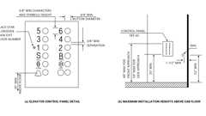Primary

**CA 11A: Figure 11A-7B Elevator Control Panel**

[**1124A.3.4 *Emergency Telephone***](https://up.codes/viewer/california/ca-building-code-2025/chapter/11A/housing-accessibility#1124A.3.4)

*When an emergency telephone system is installed, the emergency telephone handset shall be positioned no higher than 48 inches (1219 mm) above the floor, and the handset cord shall be a minimum of 29 inches (737 mm) in length. If the telephone system is located in a closed compartment, the compartment door*[*hardware*](https://up.codes/viewer/california/ca-building-code-2025/chapter/2/definitions#hardware_)*shall conform to the provisions of*[*Section 1138A.4.4*](https://up.codes/viewer/california/ca-building-code-2025/chapter/11A/housing-accessibility#1138A.4.4)*. Emergency intercommunication shall not require voice communication.*

[**1124A.4 *Hall Call Buttons***](https://up.codes/viewer/california/ca-building-code-2025/chapter/11A/housing-accessibility#1124A.4)

*Call*[*operation*](https://up.codes/viewer/california/ca-building-code-2025/chapter/30/elevators-and-conveying-systems#3008.1.4)*buttons and keypads shall be located within one of the reach ranges specified in*[*Section 1138A.3*](https://up.codes/viewer/california/ca-building-code-2025/chapter/11A/housing-accessibility#1138A.3)*, measured to the centerline of the highest*[*operable part*](https://up.codes/viewer/california/ca-building-code-2025/chapter/2/definitions#operable_part_)*. Buttons shall have square shoulders, shall be a minimum of 3/4inch (19.1 mm) in*[*size*](https://up.codes/viewer/california/ca-building-code-2025/chapter/9/fire-protection-and-life-safety-systems#911.1.3)*, and shall be raised 1/8inch (3.2 mm) plus or minus 1/32inch (0.8 mm) above the surrounding surface. The button designating the "Up" direction shall be on top. A*[*clear*](https://up.codes/viewer/california/ca-building-code-2025/chapter/2/definitions#clear_dsa_ac_)*floor or ground*[*space*](https://up.codes/viewer/california/ca-building-code-2025/chapter/2/definitions#space_)*complying with*[*Section 1138A.1.4*](https://up.codes/viewer/california/ca-building-code-2025/chapter/11A/housing-accessibility#1138A.1.4)*shall be provided at call controls.*

*Visual indication shall be provided to show each call registered and extinguished when answered. Objects adjacent to, and below, hall call buttons shall not project more than 4 inches (101.6 mm) from the*[*wall*](https://up.codes/viewer/california/ca-building-code-2025/chapter/2/definitions#wall_)*. Hall call buttons shall be internally illuminated with a white light over the entire surface of the button.*

[**1124A.5 *Minimum Illumination***](https://up.codes/viewer/california/ca-building-code-2025/chapter/11A/housing-accessibility#1124A.5)

*The minimum illumination at the car controls threshold and the landing when the car and landing doors are open shall not be less than 5 foot-candles (54 lx).*

[**1124A.6 *Hall Lantern***](https://up.codes/viewer/california/ca-building-code-2025/chapter/11A/housing-accessibility#1124A.6)

*A visual and audible signal shall be provided at each hoistway*[*entrance*](https://up.codes/viewer/california/ca-building-code-2025/chapter/2/definitions#entrance_hcd_1_hcd_2_hcd_1_ac_and_dsa_ac_)*indicating to the prospective passenger the car answering the call and its direction of travel as follows:*

1. *The visual signal for each direction shall be a minimum of 2 1/2inches (63.5 mm) high by 2 1/2inches (63.5 mm) wide, and visible from the proximity of the hall call button.*
2. *The audible signal shall sound once for the "up" direction and twice for the "down" direction or of a configuration which distinguishes between up and down elevator travel. Audible signals shall have a frequency of 1500 Hz maximum. Verbal*[*annunciators*](https://up.codes/viewer/california/ca-building-code-2025/chapter/2/definitions#annunciator_)*shall have a frequency of 300 Hz minimum and 3000 Hz maximum. The audible signal and verbal*[*annunciator*](https://up.codes/viewer/california/ca-building-code-2025/chapter/2/definitions#annunciator_)*shall be 10 dB minimum above ambient, but shall not exceed 80 dB, measured at the hall call button.*
3. *The center line of the fixture shall be located a minimum of 6 feet (1829 mm) in height above the finish floor.*
4. *The use of in-car lanterns, located in or on the car doorjambs, visible from the proximity of the hall call buttons and conforming to the above requirements of this section, shall be acceptable.*

* ***Note:*** *The use of arrow shapes are preferred for visible signals.*

[**1124A.7 *Door Delay***](https://up.codes/viewer/california/ca-building-code-2025/chapter/11A/housing-accessibility#1124A.7)

Diagram

**UpCodes Diagram (1)**



**Elevator Door Req.**

[**1124A.7.1 *Hall Call***](https://up.codes/viewer/california/ca-building-code-2025/chapter/11A/housing-accessibility#1124A.7.1)

Diagram

*The minimum acceptable time from notification that a car is answering a call (lantern and audible signal) until the doors of the car start to close shall be calculated by the following equations, but shall be no less than 5 seconds:*

*T = D / (1.5 ft/s) or T = D / (445 mm/s)*

*Where T is the total time in seconds and D is the distance from a point in the*[*lobby*](https://up.codes/viewer/california/ca-building-code-2025/chapter/2/definitions#lobby_sfm_hcd_1_hcd_2_)*or landing area 60 inches (1524 mm) directly in front of the farthest call button controlling that car to the centerline of its hoistway door (see*[*Figure*](https://up.codes/viewer/california/ca-building-code-2025/chapter/11B/accessibility-to-public-buildings-public-accommodations-commercial-buildings-and#figure)*11A-7D). For cars with in-car lanterns, T begins when the lantern is visible from the vicinity of hall call buttons and an audible signal is sounded.*

**UpCodes Diagram (1)**

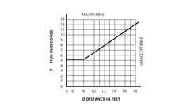

**CA 11A: Figure 11A-7D Graph of Timing Equation**

[**1124A.7.2 *Door Delay for Car Calls***](https://up.codes/viewer/california/ca-building-code-2025/chapter/11A/housing-accessibility#1124A.7.2)

*The minimum acceptable time for the door to remain fully open after receiving a call shall not be less than 5 seconds.*

[**1124A.8 *Doorjamb Marking***](https://up.codes/viewer/california/ca-building-code-2025/chapter/11A/housing-accessibility#1124A.8)

Diagram

*The floor level at all elevator hoistway*[*entrances*](https://up.codes/viewer/california/ca-building-code-2025/chapter/2/definitions#entrance_hcd_1_hcd_2_hcd_1_ac_and_dsa_ac_)*shall be designated by raised*[*characters*](https://up.codes/viewer/california/ca-building-code-2025/chapter/2/definitions#characters_)*provided on both jambs.*[*Characters*](https://up.codes/viewer/california/ca-building-code-2025/chapter/2/definitions#characters_)*shall be 2 inches (50.8 mm) in height located 48 inches (1219 mm) minimum above the finish floor, measured from the baseline of the lowest Braille cells, and 60 inches (1524 mm) maximum above the finish floor, measured from the baseline of the highest line of raised*[*characters*](https://up.codes/viewer/california/ca-building-code-2025/chapter/2/definitions#characters_)*.*

*On the main entry level, a raised five-pointed star shall be placed to the left of the raised character. The outside diameter of the star shall be 2 inches (50.8 mm) and all points shall be of equal length. The raised*[*characters*](https://up.codes/viewer/california/ca-building-code-2025/chapter/2/definitions#characters_)*and the star shall be white on a black background. Contracted*[*Grade*](https://up.codes/viewer/california/ca-building-code-2025/chapter/J/grading#grade_)*2 Braille, conforming to*[*Section 1143A.7*](https://up.codes/viewer/california/ca-building-code-2025/chapter/11A/housing-accessibility#1143A.7)*, shall be placed below the corresponding raised*[*characters*](https://up.codes/viewer/california/ca-building-code-2025/chapter/2/definitions#characters_)*and the star. The Braille translation for the star shall state "MAIN". The raised*[*characters*](https://up.codes/viewer/california/ca-building-code-2025/chapter/2/definitions#characters_)*shall comply with*[*Section 1143A.6*](https://up.codes/viewer/california/ca-building-code-2025/chapter/11A/housing-accessibility#1143A.6)*. (See*[*Figure*](https://up.codes/viewer/california/ca-building-code-2025/chapter/11B/accessibility-to-public-buildings-public-accommodations-commercial-buildings-and#figure)*11A-7C.)*

**UpCodes Diagram (1)**

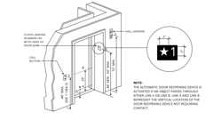Primary

**CA 11A: Figure 11A-7C Hoistway and Elevator Entrances**

[**1124A.9 *Door Protective and Reopening Devices***](https://up.codes/viewer/california/ca-building-code-2025/chapter/11A/housing-accessibility#1124A.9)

*Doors closed by*[*automatic*](https://up.codes/viewer/california/ca-building-code-2025/chapter/2/definitions#automatic_)*means shall be provided with a door-reopening device that will function to stop and reopen a car door and adjacent hoistway door in case the car door is obstructed while closing.*

*This reopening device shall also be capable of sensing an object or person in the path of a closing door without requiring contact for activation at a nominal 5 inches and 29 inches (127 mm and 737 mm) above the floor.*

*Door-reopening devices shall remain effective for a period of not less than 20 seconds. After such an interval, the doors may close in accordance with the requirements of ASME A17.1.*

[**1124A.10 *Operation and Leveling***](https://up.codes/viewer/california/ca-building-code-2025/chapter/11A/housing-accessibility#1124A.10)

*The elevator shall be*[*automatic*](https://up.codes/viewer/california/ca-building-code-2025/chapter/2/definitions#automatic_)*and be provided with a self-leveling feature that will automatically bring the car to the floor landings within a tolerance of plus or minus 1/2inch (12.7 mm) under rated loading to zero loading conditions. This self-leveling shall, within its*[*zone*](https://up.codes/viewer/california/ca-building-code-2025/chapter/2/definitions#zone_)*, be entirely*[*automatic*](https://up.codes/viewer/california/ca-building-code-2025/chapter/2/definitions#automatic_)*and independent of the operating device and shall correct the overtravel or undertravel. The car shall also be maintained approximately level with the landing, irrespective of load.*

*The clearance between the car*[*platform*](https://up.codes/viewer/california/ca-building-code-2025/chapter/2/definitions#platform_)*sill and the edge of the hoistway landing shall be no greater than 11/4inches (31.75 mm).*

[**1124A.11 *Platform (Wheelchair) Lifts***](https://up.codes/viewer/california/ca-building-code-2025/chapter/11A/housing-accessibility#1124A.11)

Diagram

**UpCodes Diagrams (2)**

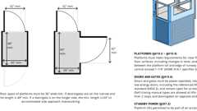

**Vertical Platform Lifts**

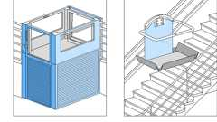

**Platform Lift Types**

[**1124A.11.1 *General***](https://up.codes/viewer/california/ca-building-code-2025/chapter/11A/housing-accessibility#1124A.11.1)

[*Platform*](https://up.codes/viewer/california/ca-building-code-2025/chapter/2/definitions#platform_)*(*[*wheelchair*](https://up.codes/viewer/california/ca-building-code-2025/chapter/2/definitions#wheelchair_hcd_1_ac_dsa_ac_)*) lifts may be provided between levels, in lieu of*[*passenger elevators*](https://up.codes/viewer/california/ca-building-code-2025/chapter/2/definitions#elevator_passenger_hcd_1_hcd_2_)*, when the vertical distance between landings, as well as the*[*structural design*](https://up.codes/viewer/california/ca-building-code-2025/chapter/30/elevators-and-conveying-systems#3001.6)*and safeguards are as allowed by ASME A18.1 (Safety Standard for*[*Platform Lifts*](https://up.codes/viewer/california/ca-building-code-2025/chapter/2/definitions#platform_%28wheelchair%29_lift_)*and*[*Stairway*](https://up.codes/viewer/california/ca-building-code-2025/chapter/2/definitions#stairway_)*Chair Lifts), California Code of Regulations, Title 8 (Elevator Safety Orders), and any applicable safety regulations of other*[*administrative authorities*](https://up.codes/viewer/california/ca-building-code-2025/chapter/2/definitions#administrative_authority_dsa_ac_)*having*[*jurisdiction*](https://up.codes/viewer/california/ca-building-code-2025/chapter/2/definitions#jurisdiction_)*.*

*If lifts are provided, they shall be designed and constructed to facilitate unassisted entry,*[*operation*](https://up.codes/viewer/california/ca-building-code-2025/chapter/30/elevators-and-conveying-systems#3008.1.4)*and*[*exit*](https://up.codes/viewer/california/ca-building-code-2025/chapter/2/definitions#exit_)*from the lift, and shall comply with restrictions and enhancements of this section in conjunction with Title 8 of the California Code of Regulations.*

[**1124A.11.2 *Size and Clear Floor Space***](https://up.codes/viewer/california/ca-building-code-2025/chapter/11A/housing-accessibility#1124A.11.2)

[*Platform*](https://up.codes/viewer/california/ca-building-code-2025/chapter/2/definitions#platform_)*(*[*wheelchair*](https://up.codes/viewer/california/ca-building-code-2025/chapter/2/definitions#wheelchair_hcd_1_ac_dsa_ac_)*) lifts shall be of sufficient*[*size*](https://up.codes/viewer/california/ca-building-code-2025/chapter/9/fire-protection-and-life-safety-systems#911.1.3)*to accommodate a*[*wheelchair*](https://up.codes/viewer/california/ca-building-code-2025/chapter/2/definitions#wheelchair_hcd_1_ac_dsa_ac_)*in accordance with*[*Section 1138A.1.4*](https://up.codes/viewer/california/ca-building-code-2025/chapter/11A/housing-accessibility#1138A.1.4)*.*

[**1124A.11.3 *Lift Access***](https://up.codes/viewer/california/ca-building-code-2025/chapter/11A/housing-accessibility#1124A.11.3)

*There shall be a level and*[*clear*](https://up.codes/viewer/california/ca-building-code-2025/chapter/2/definitions#clear_dsa_ac_)*floor area or landing at each floor or level served by*[*platform*](https://up.codes/viewer/california/ca-building-code-2025/chapter/2/definitions#platform_)*(*[*wheelchair*](https://up.codes/viewer/california/ca-building-code-2025/chapter/2/definitions#wheelchair_hcd_1_ac_dsa_ac_)*) lifts.*[*Clear*](https://up.codes/viewer/california/ca-building-code-2025/chapter/2/definitions#clear_dsa_ac_)*floor areas or landings shall meet the applicable "*[*accessible route*](https://up.codes/viewer/california/ca-building-code-2025/chapter/2/definitions#accessible_route_dsa_ac_hcd_1_ac_)*" requirements.*

[**1124A.11.4 *Standby Power***](https://up.codes/viewer/california/ca-building-code-2025/chapter/11A/housing-accessibility#1124A.11.4)

Diagram

*To ensure continued*[*operation*](https://up.codes/viewer/california/ca-building-code-2025/chapter/30/elevators-and-conveying-systems#3008.1.4)*in case of primary power loss,*[*platform*](https://up.codes/viewer/california/ca-building-code-2025/chapter/2/definitions#platform_)*(*[*wheelchair*](https://up.codes/viewer/california/ca-building-code-2025/chapter/2/definitions#wheelchair_hcd_1_ac_dsa_ac_)*) lifts shall be provided with standby power or with self-rechargeable battery power that provides sufficient power to operate all*[*platform lift*](https://up.codes/viewer/california/ca-building-code-2025/chapter/2/definitions#platform_%28wheelchair%29_lift_)*functions for a minimum of five upward and downward trips.*

**UpCodes Diagram (1)**

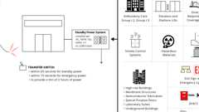

**Standby Power Systems**

[**1124A.11.5 *Openness***](https://up.codes/viewer/california/ca-building-code-2025/chapter/11A/housing-accessibility#1124A.11.5)

[*Platform*](https://up.codes/viewer/california/ca-building-code-2025/chapter/2/definitions#platform_)*(*[*wheelchair*](https://up.codes/viewer/california/ca-building-code-2025/chapter/2/definitions#wheelchair_hcd_1_ac_dsa_ac_)*) lifts on an*[*accessible means of egress*](https://up.codes/viewer/california/ca-building-code-2025/chapter/2/definitions#accessible_means_of_egress_)*shall not be installed in a fully enclosed hoistway.*

[**1124A.11.6 *Doors and Gates***](https://up.codes/viewer/california/ca-building-code-2025/chapter/11A/housing-accessibility#1124A.11.6)

*Lifts shall have low energy*[*power-operated doors*](https://up.codes/viewer/california/ca-building-code-2025/chapter/2/definitions#door_power_operated_)*or gates, which shall remain open for 20 seconds minimum. End doors shall have 32 inches (813 mm) minimum*[*clear*](https://up.codes/viewer/california/ca-building-code-2025/chapter/2/definitions#clear_dsa_ac_)*opening width. Side doors*[*clear*](https://up.codes/viewer/california/ca-building-code-2025/chapter/2/definitions#clear_dsa_ac_)*opening width shall be 42 inches (1067 mm) minimum.*

***Exception:****Lifts having doors or gates on opposite sides shall be permitted to have*[*self-closing*](https://up.codes/viewer/california/ca-building-code-2025/chapter/2/definitions#self_closing_)*manual doors or gates.*

[**1124A.11.7 *Restriction Sign***](https://up.codes/viewer/california/ca-building-code-2025/chapter/11A/housing-accessibility#1124A.11.7)

*A*[*sign*](https://up.codes/viewer/california/ca-building-code-2025/chapter/2/definitions#sign_hcd_1_ac_dsa_ac_)*complying with*[*Section 1143A*](https://up.codes/viewer/california/ca-building-code-2025/chapter/11A/housing-accessibility#1143A)*shall be securely fastened in a conspicuous place at each landing and on the*[*platform*](https://up.codes/viewer/california/ca-building-code-2025/chapter/2/definitions#platform_)*. The*[*sign*](https://up.codes/viewer/california/ca-building-code-2025/chapter/2/definitions#sign_hcd_1_ac_dsa_ac_)*shall state "No Freight" in letters not less than 5/8 inch (16 mm) high and include the "*[*International Symbol of Accessibility*](https://up.codes/viewer/california/ca-building-code-2025/chapter/2/definitions#international_symbol_of_accessibility_)*."*

[**Section 1125A *Hazards on Accessible Routes***](https://up.codes/viewer/california/ca-building-code-2025/chapter/11A/housing-accessibility#1125A)

Diagram

**UpCodes Diagrams (2)**

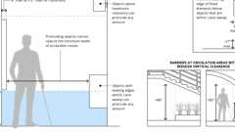

**Protruding Object Limits**

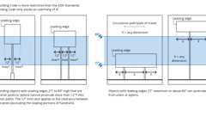

**Post Mounted Objects**

[**1125A.1 *Warning Curbs***](https://up.codes/viewer/california/ca-building-code-2025/chapter/11A/housing-accessibility#1125A.1)

*Abrupt changes in level exceeding 4 inches (101.6 mm) in vertical dimension, such as changes in level at planters or fountains located in or adjacent to*[*walks*](https://up.codes/viewer/california/ca-building-code-2025/chapter/2/definitions#walk_dsa_ac_)*, halls,*[*corridors*](https://up.codes/viewer/california/ca-building-code-2025/chapter/2/definitions#corridor_)*, passageways,*[*aisles*](https://up.codes/viewer/california/ca-building-code-2025/chapter/2/definitions#aisle_)*,*[*pedestrian ways*](https://up.codes/viewer/california/ca-building-code-2025/chapter/2/definitions#pedestrian_way_)*and other circulation*[*spaces*](https://up.codes/viewer/california/ca-building-code-2025/chapter/2/definitions#space_)*shall be identified by curbs projecting at least 6 inches (152.4 mm) in height above the*[*walk*](https://up.codes/viewer/california/ca-building-code-2025/chapter/2/definitions#walk_dsa_ac_)*or*[*sidewalk*](https://up.codes/viewer/california/ca-building-code-2025/chapter/2/definitions#sidewalk_)*surface to warn the blind of a potential drop-off.*

***Exception:****When a guardrail or*[*handrail*](https://up.codes/viewer/california/ca-building-code-2025/chapter/2/definitions#handrail_)*is provided with edge*[*protection*](https://up.codes/viewer/california/ca-building-code-2025/chapter/22/steel#2201.3)*in accordance with*[*Section 1012.10.1*](https://up.codes/viewer/california/ca-building-code-2025/chapter/10/means-of-egress#1012.10.1)*.*

[**1125A.2 *Headroom Clearance***](https://up.codes/viewer/california/ca-building-code-2025/chapter/11A/housing-accessibility#1125A.2)

Diagram

[*Walks*](https://up.codes/viewer/california/ca-building-code-2025/chapter/2/definitions#walk_dsa_ac_)*, halls,*[*corridors*](https://up.codes/viewer/california/ca-building-code-2025/chapter/2/definitions#corridor_)*, passageways,*[*aisles*](https://up.codes/viewer/california/ca-building-code-2025/chapter/2/definitions#aisle_)*,*[*pedestrian ways*](https://up.codes/viewer/california/ca-building-code-2025/chapter/2/definitions#pedestrian_way_)*and other circulation*[*spaces*](https://up.codes/viewer/california/ca-building-code-2025/chapter/2/definitions#space_)*which are part of the required egress system shall have a minimum*[*clear*](https://up.codes/viewer/california/ca-building-code-2025/chapter/2/definitions#clear_dsa_ac_)*headroom as required in*[*Section 1003.2*](https://up.codes/viewer/california/ca-building-code-2025/chapter/10/means-of-egress#1003.2)*. Other*[*walks*](https://up.codes/viewer/california/ca-building-code-2025/chapter/2/definitions#walk_dsa_ac_)*,*[*pedestrian ways*](https://up.codes/viewer/california/ca-building-code-2025/chapter/2/definitions#pedestrian_way_)*and circulation*[*spaces*](https://up.codes/viewer/california/ca-building-code-2025/chapter/2/definitions#space_)*shall have a minimum*[*clear*](https://up.codes/viewer/california/ca-building-code-2025/chapter/2/definitions#clear_dsa_ac_)*headroom of 80 inches (2032 mm). If the vertical clearance of an area adjoining an*[*accessible route*](https://up.codes/viewer/california/ca-building-code-2025/chapter/2/definitions#accessible_route_dsa_ac_hcd_1_ac_)*is reduced to less than 80 inches (2032 mm), a guardrail or other barrier having its leading edge at or below 27 inches (686 mm) above the finished floor shall be provided.*

***Exception:****Doorways and archways less than 24 inches (610 mm) in depth may have a minimum*[*clear*](https://up.codes/viewer/california/ca-building-code-2025/chapter/2/definitions#clear_dsa_ac_)*headroom of 80 inches (2032 mm). (See*[*Section 1126A*](https://up.codes/viewer/california/ca-building-code-2025/chapter/11A/housing-accessibility#1126A)*for door requirements.)*

**UpCodes Diagrams (2)**



**Protruding Object Limits**

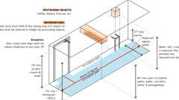

**Protruding Objects: Headroom**

[**1125A.3 *Overhanging Obstructions***](https://up.codes/viewer/california/ca-building-code-2025/chapter/11A/housing-accessibility#1125A.3)

Diagram

*Any obstruction that overhangs a*[*pedestrian way*](https://up.codes/viewer/california/ca-building-code-2025/chapter/2/definitions#pedestrian_way_)*shall be a minimum of 80 inches (2032 mm) above the walking surface as measured from the bottom of the obstruction. (See*[*Figure*](https://up.codes/viewer/california/ca-building-code-2025/chapter/11B/accessibility-to-public-buildings-public-accommodations-commercial-buildings-and#figure)*11A-1B.) Where a guy support is used parallel to a*[*path of travel*](https://up.codes/viewer/california/ca-building-code-2025/chapter/2/definitions#path_of_travel_dsa_ac_)*, including, but not limited to,*[*sidewalks*](https://up.codes/viewer/california/ca-building-code-2025/chapter/2/definitions#sidewalk_)*, a guy brace,*[*sidewalk*](https://up.codes/viewer/california/ca-building-code-2025/chapter/2/definitions#sidewalk_)*guy or similar device shall be used to prevent an overhanging obstruction (see*[*Section 1125A.2*](https://up.codes/viewer/california/ca-building-code-2025/chapter/11A/housing-accessibility#1125A.2)*for required headroom clearance).*

***Exception:****Door closers and door stops shall be permitted to be 78 inches (1981 mm) minimum above the finish floor or ground.*

**UpCodes Diagrams (2)**

Primary

**CA 11A: Figure 11A-1B Headroom Clearance and Overhanging Obstruction**



**Protruding Object Limits**

[**1125A.4 *Free-Standing Signs***](https://up.codes/viewer/california/ca-building-code-2025/chapter/11A/housing-accessibility#1125A.4)

*Wherever*[*signs*](https://up.codes/viewer/california/ca-building-code-2025/chapter/2/definitions#sign_hcd_1_ac_dsa_ac_)*mounted on posts or pylons protrude from the posts or pylons and the bottom edge of the*[*sign*](https://up.codes/viewer/california/ca-building-code-2025/chapter/2/definitions#sign_hcd_1_ac_dsa_ac_)*is less than 80 inches (2032 mm) above the finished floor or ground level, the edges of such*[*signs*](https://up.codes/viewer/california/ca-building-code-2025/chapter/2/definitions#sign_hcd_1_ac_dsa_ac_)*shall be rounded or eased and the corners shall have a minimum radius of 0.125 inches. (See*[*Section 1125A.2*](https://up.codes/viewer/california/ca-building-code-2025/chapter/11A/housing-accessibility#1125A.2)*for required headroom clearance).*

[**Section 1126A *Doors, Gates and Windows***](https://up.codes/viewer/california/ca-building-code-2025/chapter/11A/housing-accessibility#1126A)

Diagram

**UpCodes Diagram (1)**



**Walks & Sidewalks on Accessible Routes - Level Areas**

[**1126A.1 *Width and Height of Doors and Gates***](https://up.codes/viewer/california/ca-building-code-2025/chapter/11A/housing-accessibility#1126A.1)

Diagram

*Doorways which provide access to*[*common use areas*](https://up.codes/viewer/california/ca-building-code-2025/chapter/2/definitions#common_use_areas_hcd_1_ac_)*or*[*covered multifamily dwellings*](https://up.codes/viewer/california/ca-building-code-2025/chapter/2/definitions#covered_multifamily_dwellings_hcd_1_ac_)*shall comply with the following:*

1. [*Permit*](https://up.codes/viewer/california/ca-building-code-2025/chapter/2/definitions#permit_)*the*[*installation*](https://up.codes/viewer/california/ca-building-code-2025/chapter/27/electrical#2702.1.3)*of a door or gate not less than 36 inches (914 mm) in width, not less than 80 inches (2032 mm) in height, and provide a*[*clear*](https://up.codes/viewer/california/ca-building-code-2025/chapter/2/definitions#clear_dsa_ac_)*opening of not less than 32 inches (813 mm), measured with the door positioned at an angle of 90 degrees from its closed position.*
2. *Doors or gates shall be capable of opening at least 90 degrees.*
3. *A pair of doors or gates, manual or*[*automatic*](https://up.codes/viewer/california/ca-building-code-2025/chapter/2/definitions#automatic_)*, shall have at least one leaf which provides a*[*clear*](https://up.codes/viewer/california/ca-building-code-2025/chapter/2/definitions#clear_dsa_ac_)*width of not less than 32 inches (813 mm), measured with the door or gate positioned at an angle of 90 degrees from its closed position.*
4. *The width of any component in the egress system shall not be less than the minimum width required by*[*Section 1005*](https://up.codes/viewer/california/ca-building-code-2025/chapter/10/means-of-egress#1005)*.*
5. *Revolving doors or gates shall not be used as required*[*entrances*](https://up.codes/viewer/california/ca-building-code-2025/chapter/2/definitions#entrance_hcd_1_hcd_2_hcd_1_ac_and_dsa_ac_)*for*[*persons with disabilities*](https://up.codes/viewer/california/ca-building-code-2025/chapter/2/definitions#persons_with_disabilities_hcd_1_ac_)*, and shall not be part of an*[*accessible route*](https://up.codes/viewer/california/ca-building-code-2025/chapter/2/definitions#accessible_route_dsa_ac_hcd_1_ac_)*.*

**UpCodes Diagram (1)**

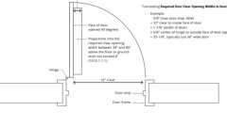

**Doors: Min. Required Clear Opening Width**

[**1126A.2 *Level Floor or Landing***](https://up.codes/viewer/california/ca-building-code-2025/chapter/11A/housing-accessibility#1126A.2)

*The floor or landing on each side of an*[*exit*](https://up.codes/viewer/california/ca-building-code-2025/chapter/2/definitions#exit_)*door or gate shall be level. (See*[*Chapter 10*](https://up.codes/viewer/california/ca-building-code-2025/chapter/10/means-of-egress#10)*.)*

[**1126A.2.1 *Thresholds and Changes in Elevation***](https://up.codes/viewer/california/ca-building-code-2025/chapter/11A/housing-accessibility#1126A.2.1)

Diagram

*The floor or landing shall not be more than 1/2inch (12.7 mm) lower than the top of the threshold of the doorway. (See*[*Figure*](https://up.codes/viewer/california/ca-building-code-2025/chapter/11B/accessibility-to-public-buildings-public-accommodations-commercial-buildings-and#figure)*11A-8I.)*

*Changes in level between 1/4inch (6.35 mm) and 1/2inch (12.7 mm) shall be beveled with a*[*slope*](https://up.codes/viewer/california/ca-building-code-2025/chapter/J/grading#slope_)*no greater than 1 unit vertical in 2 units horizontal (50-percent*[*slope*](https://up.codes/viewer/california/ca-building-code-2025/chapter/J/grading#slope_)*). Changes in level greater than 1/2inch (12.7 mm) shall be accomplished by means of a*[*ramp*](https://up.codes/viewer/california/ca-building-code-2025/chapter/2/definitions#ramp_)*. (See*[*Section 1122A*](https://up.codes/viewer/california/ca-building-code-2025/chapter/11A/housing-accessibility#1122A)*.)*

**UpCodes Diagrams (2)**

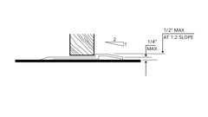Primary

**CA 11A: Figure 11A-8I Thresholds**

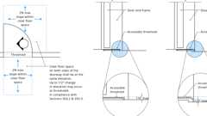Primary

**Surfaces and Thresholds at Doors**

[**1126A.3 *Maneuvering Clearances***](https://up.codes/viewer/california/ca-building-code-2025/chapter/11A/housing-accessibility#1126A.3)

Diagram

**UpCodes Diagrams (6)**



**Accessible Unit Doors (CA 11A)**

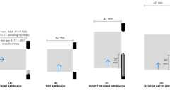

**Maneuvering Clearances: Sliding, Folding Doors**



**Maneuvering Clearances: Doors (CA 11A)**

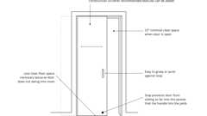

**Sliding Pocket Door (FHA)**

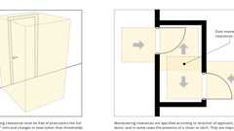

**Door Maneuvering Clearances**



**Walks & Sidewalks on Accessible Routes - Level Areas**

[**1126A.3.1 *General***](https://up.codes/viewer/california/ca-building-code-2025/chapter/11A/housing-accessibility#1126A.3.1)

*The minimum maneuvering clearance at doors or gates shall comply with Sections*[*1126A.3.2*](https://up.codes/viewer/california/ca-building-code-2025/chapter/11A/housing-accessibility#1126A.3.2)*,*[*1126A.3.3*](https://up.codes/viewer/california/ca-building-code-2025/chapter/11A/housing-accessibility#1126A.3.3)*and*[*1126A.3.4*](https://up.codes/viewer/california/ca-building-code-2025/chapter/11A/housing-accessibility#1126A.3.4)*. The floor or landing area within the required maneuvering clearance shall be level and*[*clear*](https://up.codes/viewer/california/ca-building-code-2025/chapter/2/definitions#clear_dsa_ac_)*. The required length shall be measured at right angles to the plane of the door or gate in its closed position. Maneuvering clearances shall extend the full width of the doorway and the required latch side or hinge side clearances (strike edge maneuvering clearances).*

[**1126A.3.2 *Swinging Doors and Gates***](https://up.codes/viewer/california/ca-building-code-2025/chapter/11A/housing-accessibility#1126A.3.2)

Diagram

**UpCodes Diagrams (2)**

Primary

**Maneuvering Clearances: Doors (CA 11A)**



**Accessible Unit Doors (CA 11A)**

[**1126A.3.2.1 *Front Approach***](https://up.codes/viewer/california/ca-building-code-2025/chapter/11A/housing-accessibility#1126A.3.2.1)

Diagram

*The following provisions shall apply to swinging doors or gates with front approach:*

1. ***Pull side approach.****The level floor or landing shall extend in the direction of the door or gate swing at least 60 inches (1524 mm). (See*[*Figure*](https://up.codes/viewer/california/ca-building-code-2025/chapter/11B/accessibility-to-public-buildings-public-accommodations-commercial-buildings-and#figure)*11A-8A(a).)*
2. ***Push side approach.****The level floor or landing shall extend in the direction of the door or gate swing at least 48 inches (1219 mm). (See*[*Figure*](https://up.codes/viewer/california/ca-building-code-2025/chapter/11B/accessibility-to-public-buildings-public-accommodations-commercial-buildings-and#figure)*11A-8A(a).)*
3. ***Doors and gates with push side approach having both a closer and a latch.****Doors or gates with push side approach having both a closer and a latch shall be provided with a*[*clear*](https://up.codes/viewer/california/ca-building-code-2025/chapter/2/definitions#clear_dsa_ac_)*and*[*level area*](https://up.codes/viewer/california/ca-building-code-2025/chapter/2/definitions#level_area_hcd_1_ac_)*extending a minimum of 12 inches (305 mm) past the strike edge on the approach side of the door or gate. (See*[*Figure*](https://up.codes/viewer/california/ca-building-code-2025/chapter/11B/accessibility-to-public-buildings-public-accommodations-commercial-buildings-and#figure)*11A-8A(a).)*
4. ***Strike edge maneuvering***[***space***](https://up.codes/viewer/california/ca-building-code-2025/chapter/2/definitions#space_)***.****The width of the*[*level area*](https://up.codes/viewer/california/ca-building-code-2025/chapter/2/definitions#level_area_hcd_1_ac_)*on the side to which the door or gate swings shall extend at least 24 inches (610 mm) past the strike edge for exterior doors or gates and at least 18 inches (457 mm) past the strike edge for interior doors or gates. (See*[*Figure*](https://up.codes/viewer/california/ca-building-code-2025/chapter/11B/accessibility-to-public-buildings-public-accommodations-commercial-buildings-and#figure)*11A-8A(a).)*

***Note:****See*[*Section 1132A.5*](https://up.codes/viewer/california/ca-building-code-2025/chapter/11A/housing-accessibility#1132A.5)*for maneuvering clearances at*[*primary entry*](https://up.codes/viewer/california/ca-building-code-2025/chapter/2/definitions#primary_entry_hcd_1_ac_)*doors and all required*[*exit*](https://up.codes/viewer/california/ca-building-code-2025/chapter/2/definitions#exit_)*doors to*[*covered multifamily dwellings*](https://up.codes/viewer/california/ca-building-code-2025/chapter/2/definitions#covered_multifamily_dwellings_hcd_1_ac_)*.*

**UpCodes Diagram (1)**

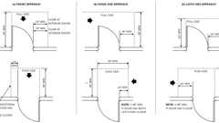Primary

**CA 11A: Figure 11A-8A Maneuvering Clearance at Swinging Doors**

[**1126A.3.2.2 *Hinge Side Approach***](https://up.codes/viewer/california/ca-building-code-2025/chapter/11A/housing-accessibility#1126A.3.2.2)

*The following provisions shall apply to swinging doors or gates with hinge side approach:*

1. ***Pull side approach.****Doors or gates with pull side approach shall be provided with a level floor or landing not less than 60 inches (1524 mm) in depth. A*[*clear*](https://up.codes/viewer/california/ca-building-code-2025/chapter/2/definitions#clear_dsa_ac_)*and*[*level area*](https://up.codes/viewer/california/ca-building-code-2025/chapter/2/definitions#level_area_hcd_1_ac_)*shall extend a minimum of 36 inches (914 mm) past the strike edge on the approach side of the door or gate. (See*[*Figure*](https://up.codes/viewer/california/ca-building-code-2025/chapter/11B/accessibility-to-public-buildings-public-accommodations-commercial-buildings-and#figure)*11A-8A(b).)*
2. ***Push side approach.****Doors or gates with push side approach shall have a level floor or landing not less than 44 inches (1118 mm) in depth, and shall be provided with a*[*clear*](https://up.codes/viewer/california/ca-building-code-2025/chapter/2/definitions#clear_dsa_ac_)*and*[*level area*](https://up.codes/viewer/california/ca-building-code-2025/chapter/2/definitions#level_area_hcd_1_ac_)*extending a minimum of 54 inches (1372 mm) from the strike edge of the door or gate jamb past the hinge side of the door or gate. Doors or gates with a latch and closer shall have a level floor or landing not less than 48 inches (1219 mm) depth at the push side of the door or gate. (See*[*Figure*](https://up.codes/viewer/california/ca-building-code-2025/chapter/11B/accessibility-to-public-buildings-public-accommodations-commercial-buildings-and#figure)*11A-8A(b).)*

[**1126A.3.2.3 *Latch Side Approach***](https://up.codes/viewer/california/ca-building-code-2025/chapter/11A/housing-accessibility#1126A.3.2.3)

*The following provisions shall apply to swinging doors or gates with latch side approach:*

1. ***Pull side approach.****Doors or gates with pull side approach shall have a level floor or landing not less than 60 inches (1524 mm) in depth, and shall be provided with a*[*clear*](https://up.codes/viewer/california/ca-building-code-2025/chapter/2/definitions#clear_dsa_ac_)*and*[*level area*](https://up.codes/viewer/california/ca-building-code-2025/chapter/2/definitions#level_area_hcd_1_ac_)*extending a minimum of 24 inches (610 mm) past the strike edge on the approach side of the door or gate. (See*[*Figure*](https://up.codes/viewer/california/ca-building-code-2025/chapter/11B/accessibility-to-public-buildings-public-accommodations-commercial-buildings-and#figure)*11A-8A(c).)*
2. ***Push side approach.****Doors or gates with push side approach shall have a level floor or landing not less than 44 inches (1118 mm) in depth, and shall be provided with a*[*clear*](https://up.codes/viewer/california/ca-building-code-2025/chapter/2/definitions#clear_dsa_ac_)*and*[*level area*](https://up.codes/viewer/california/ca-building-code-2025/chapter/2/definitions#level_area_hcd_1_ac_)*extending a minimum of 24 inches (610 mm) past the strike edge on the approach side of the door or gate. Doors or gates with a closer shall have a level floor or landing not less than 48 inches (1219 mm) depth at the push side of the door or gate. (See*[*Figure*](https://up.codes/viewer/california/ca-building-code-2025/chapter/11B/accessibility-to-public-buildings-public-accommodations-commercial-buildings-and#figure)*11A-8A(c).)*

[**1126A.3.3 *Space Between Consecutive Doors or Gates***](https://up.codes/viewer/california/ca-building-code-2025/chapter/11A/housing-accessibility#1126A.3.3)

Diagram

*The minimum*[*space*](https://up.codes/viewer/california/ca-building-code-2025/chapter/2/definitions#space_)*between two hinged or pivoted doors or gates in series, serving other than a required*[*exit*](https://up.codes/viewer/california/ca-building-code-2025/chapter/2/definitions#exit_)[*stairway*](https://up.codes/viewer/california/ca-building-code-2025/chapter/2/definitions#stairway_)*, shall provide a minimum of 48 inches (1219 mm) plus the width of the door or gate swinging into the*[*space*](https://up.codes/viewer/california/ca-building-code-2025/chapter/2/definitions#space_)*. Doors or gates in a series shall swing either in the same direction or away from the*[*space*](https://up.codes/viewer/california/ca-building-code-2025/chapter/2/definitions#space_)*between the doors or gates. (See*[*Figures*](https://up.codes/viewer/california/ca-building-code-2025/chapter/11B/accessibility-to-public-buildings-public-accommodations-commercial-buildings-and#figure)*11A-8G and 11A-8H.)*

*Where the door or gate opens into a*[*stair*](https://up.codes/viewer/california/ca-building-code-2025/chapter/2/definitions#stair_)*or*[*smokeproof enclosure*](https://up.codes/viewer/california/ca-building-code-2025/chapter/2/definitions#smokeproof_enclosure_)*, the landing need not have a minimum length of 60 inches (1524 mm). (See*[*Figure*](https://up.codes/viewer/california/ca-building-code-2025/chapter/11B/accessibility-to-public-buildings-public-accommodations-commercial-buildings-and#figure)*11A-8H.)*

**UpCodes Diagrams (3)**

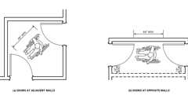Primary

**CA 11A: Figure 11A-8H Vestibule (Serving Other Than a Required Exit Stairway)**

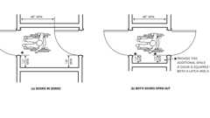Primary

**CA 11A: Figure 11A-8G Vestibule**

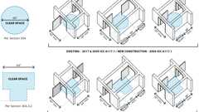

**Doors in Series: Accessibility**

[**1126A.3.4 *Doorways Without Doors or Gates, Sliding Doors and Folding Doors***](https://up.codes/viewer/california/ca-building-code-2025/chapter/11A/housing-accessibility#1126A.3.4)

Diagram

*Doorways less than 36 inches (914 mm) wide without doors or gates, sliding doors or folding doors shall have maneuvering clearances complying with this section.*

**UpCodes Diagrams (3)**

Primary

**Maneuvering Clearances: Sliding, Folding Doors**

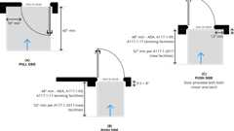

**Recessed Doors and Gates**



**Sliding Pocket Door (FHA)**

[**1126A.3.4.1 *Front Approach***](https://up.codes/viewer/california/ca-building-code-2025/chapter/11A/housing-accessibility#1126A.3.4.1)

Diagram

*The level floor or landing shall extend at least 48 inches (1219 mm) on each side, perpendicular to the doorway. Strike edge maneuvering clearance for front approach is not required. (See*[*Figure*](https://up.codes/viewer/california/ca-building-code-2025/chapter/11B/accessibility-to-public-buildings-public-accommodations-commercial-buildings-and#figure)*11A-8B(a).)*

**UpCodes Diagram (1)**

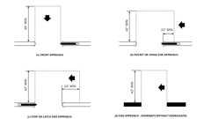Primary

**CA 11A: Figure 11A-8B Maneuvering Clearance at Doorways, Sliding Doors, and Folding Doors**

[**1126A.3.4.2 *Side Approach***](https://up.codes/viewer/california/ca-building-code-2025/chapter/11A/housing-accessibility#1126A.3.4.2)

Diagram

*Doorways without doors or gates, and side approach, shall be provided with level floor or landing extending 42 inches (1067 mm) minimum on each side, perpendicular to the doorway. Strike edge maneuvering clearance is not required. (See*[*Figure*](https://up.codes/viewer/california/ca-building-code-2025/chapter/11B/accessibility-to-public-buildings-public-accommodations-commercial-buildings-and#figure)*11A-8B(d).)*

**UpCodes Diagram (1)**

Primary

**CA 11A: Figure 11A-8B Maneuvering Clearance at Doorways, Sliding Doors, and Folding Doors**

[**1126A.3.4.3 *Pocket/Hinge Side Approach***](https://up.codes/viewer/california/ca-building-code-2025/chapter/11A/housing-accessibility#1126A.3.4.3)

Diagram

*Doors with pocket or hinge approach shall be provided with a level floor or landing not less than 42 inches (1067 mm) in depth. The level floor or landing shall extend a minimum of 22 inches (559 mm) beyond the pocket/hinge side. (See*[*Figure*](https://up.codes/viewer/california/ca-building-code-2025/chapter/11B/accessibility-to-public-buildings-public-accommodations-commercial-buildings-and#figure)*11A-8B(b).)*

**UpCodes Diagram (1)**

Primary

**CA 11A: Figure 11A-8B Maneuvering Clearance at Doorways, Sliding Doors, and Folding Doors**

[**1126A.3.4.4 *Stop/Latch Side Approach***](https://up.codes/viewer/california/ca-building-code-2025/chapter/11A/housing-accessibility#1126A.3.4.4)

Diagram

*Doors with stop or latch approach shall have a level floor or landing not less than 42 inches (1067 mm) in depth. The level floor or landing shall extend a minimum of 24 inches (610 mm) beyond the stop/latch side. (See*[*Figure*](https://up.codes/viewer/california/ca-building-code-2025/chapter/11B/accessibility-to-public-buildings-public-accommodations-commercial-buildings-and#figure)*11A-8B(c).)*

**UpCodes Diagram (1)**

Primary

**CA 11A: Figure 11A-8B Maneuvering Clearance at Doorways, Sliding Doors, and Folding Doors**

[**1126A.3.4.5 *Recessed Doors or Gates***](https://up.codes/viewer/california/ca-building-code-2025/chapter/11A/housing-accessibility#1126A.3.4.5)

Diagram

*Maneuvering clearances for forward approach shall be provided when any obstruction within 18 inches (457 mm) of the latch side of an interior doorway, or within 24 inches (610 mm) of the latch side of an exterior doorway, projects more than 8 inches (203 mm) beyond the face of the door or gate, measured perpendicular to the face of the door or gate. (See*[*Figure*](https://up.codes/viewer/california/ca-building-code-2025/chapter/11B/accessibility-to-public-buildings-public-accommodations-commercial-buildings-and#figure)*11A-8C.)*

**UpCodes Diagrams (2)**

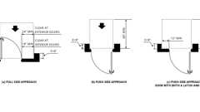Primary

**CA 11A: Figure 11A-8C Maneuvering Clearances at Recessed Doors**

Primary

**Recessed Doors and Gates**

[**1126A.4 *Closer-Effort to Operate Doors or Gates***](https://up.codes/viewer/california/ca-building-code-2025/chapter/11A/housing-accessibility#1126A.4)

*Maximum effort to operate doors or gates shall not exceed 81/2pounds (38 N) for exterior doors or gates and 5 pounds (22 N) for interior doors or gates, such pull or push effort being applied at right angles to hinged doors or gates and at the center plane of sliding or folding doors. Compensating devices or*[*automatic door*](https://up.codes/viewer/california/ca-building-code-2025/chapter/2/definitions#automatic_door_)*or gate operators may be utilized to meet these standards. When*[*fire doors*](https://up.codes/viewer/california/ca-building-code-2025/chapter/2/definitions#fire_door_)*are required, the maximum effort to operate the door may be increased to the minimum allowable by the appropriate*[*enforcement*](https://up.codes/viewer/california/ca-building-code-2025/chapter/2/definitions#enforcement_hcd_1_hcd_2_)*agency, not to exceed 15 pounds (66.7 N).*

[**1126A.4.1 *Door or Gate Closer***](https://up.codes/viewer/california/ca-building-code-2025/chapter/11A/housing-accessibility#1126A.4.1)

*If a door or gate has a closer, the sweep period of the closer shall be adjusted so that from an open position of 90 degrees, the door or gate will take 5 seconds minimum to move to a position of 12 degrees from the latch.*

[**1126A.4.2 *Spring Hinges***](https://up.codes/viewer/california/ca-building-code-2025/chapter/11A/housing-accessibility#1126A.4.2)

*Spring hinges shall be adjusted so that from the open position of 70 degrees, the door or gate shall move to the closed position in 1.5 seconds minimum.*

[**1126A.5 *Type of Latch and Lock***](https://up.codes/viewer/california/ca-building-code-2025/chapter/11A/housing-accessibility#1126A.5)

*The type of latch and lock required for all doors or gates shall be in accordance with*[*Section 1126A.6*](https://up.codes/viewer/california/ca-building-code-2025/chapter/11A/housing-accessibility#1126A.6)*and*[*Chapter 10*](https://up.codes/viewer/california/ca-building-code-2025/chapter/10/means-of-egress#10)*.*

[**1126A.6 *Hand-Activated Door or Gate Hardware***](https://up.codes/viewer/california/ca-building-code-2025/chapter/11A/housing-accessibility#1126A.6)

*Hand-activated door or gate latching, locking and opening*[*hardware*](https://up.codes/viewer/california/ca-building-code-2025/chapter/2/definitions#hardware_)*shall be centered between 30 inches (762 mm) and 44 inches (1118 mm) above the floor. Latching and locking doors or gates that are hand-activated and on an*[*accessible route*](https://up.codes/viewer/california/ca-building-code-2025/chapter/2/definitions#accessible_route_dsa_ac_hcd_1_ac_)*shall be operable with a single effort by lever type*[*hardware, panic*](https://up.codes/viewer/california/ca-building-code-2025/chapter/2/definitions#panic_hardware_)*bars, push-pull activating bars or other*[*hardware*](https://up.codes/viewer/california/ca-building-code-2025/chapter/2/definitions#hardware_)*designed to provide passage without requiring the ability to grasp the opening*[*hardware*](https://up.codes/viewer/california/ca-building-code-2025/chapter/2/definitions#hardware_)*. Locked*[*exit*](https://up.codes/viewer/california/ca-building-code-2025/chapter/2/definitions#exit_)*doors or gates shall operate consistent with*[*Section 1126A.4*](https://up.codes/viewer/california/ca-building-code-2025/chapter/11A/housing-accessibility#1126A.4)*, in the direction of egress. When sliding doors are in the fully open position, operating*[*hardware*](https://up.codes/viewer/california/ca-building-code-2025/chapter/2/definitions#hardware_)*shall be exposed and usable from both sides.*

***Exception:****Access gates in barrier*[*walls*](https://up.codes/viewer/california/ca-building-code-2025/chapter/2/definitions#wall_)*and fences protecting*[*pools*](https://up.codes/viewer/california/ca-building-code-2025/chapter/2/definitions#pool_)*, spas and hot tubs shall be permitted to have*[*operable parts*](https://up.codes/viewer/california/ca-building-code-2025/chapter/2/definitions#operable_part_)*of the release of latch on self-latching devices at 54 inches (1372 mm) maximum above the finish floor or ground provided the self-latching devices are not also self-locking devices operated by means of a key, electronic opener or integral combination lock.*

[**1126A.6.1 *Lever Type Hardware***](https://up.codes/viewer/california/ca-building-code-2025/chapter/11A/housing-accessibility#1126A.6.1)

Diagram

*The lever or lever of actuated latches or locks shall be curved with a return to within 1/2inch (12.7 mm) of the door or gate to prevent catching on the clothing of persons during egress.*

***Exception:***[*Group R*](https://up.codes/viewer/california/ca-building-code-2025/chapter/P/sleeping-lofts#group_r)*and U occupancies with an*[*occupant load*](https://up.codes/viewer/california/ca-building-code-2025/chapter/2/definitions#occupant_load_)*of 10 or less.*

**UpCodes Diagram (1)**

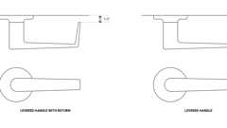

**Levered Handles (CA 11A)**

[**1126A.7 *Smooth Surface***](https://up.codes/viewer/california/ca-building-code-2025/chapter/11A/housing-accessibility#1126A.7)

Diagram

*Swinging door or gate surfaces within 10 inches (254 mm) of the finish floor or ground measured vertically shall have a smooth surface on the push side extending the full width of the door or gate. Parts creating horizontal or vertical*[*joints*](https://up.codes/viewer/california/ca-building-code-2025/chapter/7/fire-and-smoke-protection-features#712.1.5)*in these surfaces shall be within 1/16inch (1.6 mm) of the same plane as the other and be free of sharp or abrasive edges. Cavities created by added*[*kick plates*](https://up.codes/viewer/california/ca-building-code-2025/chapter/2/definitions#kick_plate_)*shall be capped.*

***Exceptions:***

1. [*Automatic doors*](https://up.codes/viewer/california/ca-building-code-2025/chapter/2/definitions#automatic_door_)*or gates.*
2. *Tempered glass doors without stiles and having a bottom rail or shoe with the top leading edge tapered at 60 degrees minimum from the horizontal.*
3. *Doors or gates that do not extend to within 10 inches (254 mm) of the finish floor or ground.*

**UpCodes Diagram (1)**

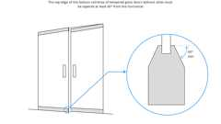

**Door Surface Excpt. - Tempered Glass Door**

[**1126A.8 *Windows***](https://up.codes/viewer/california/ca-building-code-2025/chapter/11A/housing-accessibility#1126A.8)

*Where glazed*[*openings*](https://up.codes/viewer/california/ca-building-code-2025/chapter/7/fire-and-smoke-protection-features#712.1.13)*are provided in accessible rooms or*[*spaces*](https://up.codes/viewer/california/ca-building-code-2025/chapter/2/definitions#space_)*for*[*operation*](https://up.codes/viewer/california/ca-building-code-2025/chapter/30/elevators-and-conveying-systems#3008.1.4)*by occupants, at least one opening shall comply with*[*Section 1138A.4*](https://up.codes/viewer/california/ca-building-code-2025/chapter/11A/housing-accessibility#1138A.4)*.*

*Each glazed opening required by the*[*enforcing agency*](https://up.codes/viewer/california/ca-building-code-2025/chapter/2/definitions#enforcing_agency_)*to be operable shall comply with*[*Section 1138A.4*](https://up.codes/viewer/california/ca-building-code-2025/chapter/11A/housing-accessibility#1138A.4)*.*

[**Section 1127A *Common Use Facilities***](https://up.codes/viewer/california/ca-building-code-2025/chapter/11A/housing-accessibility#1127A)

Diagram

***Note:****For*[*public use*](https://up.codes/viewer/california/ca-building-code-2025/chapter/2/definitions#public_use_dsa_ac_)[*facilities*](https://up.codes/viewer/california/ca-building-code-2025/chapter/2/definitions#facility_)*, see*[*Chapter 11B*](https://up.codes/viewer/california/ca-building-code-2025/chapter/11B/accessibility-to-public-buildings-public-accommodations-commercial-buildings-and#11B)*of this code.*

**UpCodes Diagram (1)**

Primary

**Common vs. Public Use Area (11A)**

[**1127A.1 *General***](https://up.codes/viewer/california/ca-building-code-2025/chapter/11A/housing-accessibility#1127A.1)

Diagram

*When provided,*[*common use areas*](https://up.codes/viewer/california/ca-building-code-2025/chapter/2/definitions#common_use_areas_hcd_1_ac_)*and*[*facilities*](https://up.codes/viewer/california/ca-building-code-2025/chapter/2/definitions#facility_)*in covered multifamily housing developments shall be accessible to*[*persons with disabilities*](https://up.codes/viewer/california/ca-building-code-2025/chapter/2/definitions#persons_with_disabilities_hcd_1_ac_)*.*[*Common use*](https://up.codes/viewer/california/ca-building-code-2025/chapter/2/definitions#common_use_)[*facilities*](https://up.codes/viewer/california/ca-building-code-2025/chapter/2/definitions#facility_)*include, but are not limited to,*[*lobbies*](https://up.codes/viewer/california/ca-building-code-2025/chapter/2/definitions#lobby_sfm_hcd_1_hcd_2_)*, toilet and bathing*[*facilities*](https://up.codes/viewer/california/ca-building-code-2025/chapter/2/definitions#facility_)*, laundry*[*facilities*](https://up.codes/viewer/california/ca-building-code-2025/chapter/2/definitions#facility_)*, community rooms, clubhouses, health and fitness*[*facilities*](https://up.codes/viewer/california/ca-building-code-2025/chapter/2/definitions#facility_)*, game rooms and portions of*[*common use*](https://up.codes/viewer/california/ca-building-code-2025/chapter/2/definitions#common_use_)*tenant*[*storage*](https://up.codes/viewer/california/ca-building-code-2025/chapter/9/fire-protection-and-life-safety-systems#911.1.5)*. All*[*entrances*](https://up.codes/viewer/california/ca-building-code-2025/chapter/2/definitions#entrance_hcd_1_hcd_2_hcd_1_ac_and_dsa_ac_)*, doors, fixtures and controls shall be on an*[*accessible route*](https://up.codes/viewer/california/ca-building-code-2025/chapter/2/definitions#accessible_route_dsa_ac_hcd_1_ac_)*.*[*Facilities*](https://up.codes/viewer/california/ca-building-code-2025/chapter/2/definitions#facility_)*and fixtures required to be accessible shall comply with the following provisions:*

1. ***Doors.****Doors to accessible*[*bathrooms*](https://up.codes/viewer/california/ca-building-code-2025/chapter/2/definitions#bathroom_)*shall comply with*[*Section 1126A*](https://up.codes/viewer/california/ca-building-code-2025/chapter/11A/housing-accessibility#1126A)*. Doors shall not swing into the floor*[*space*](https://up.codes/viewer/california/ca-building-code-2025/chapter/2/definitions#space_)*required for any fixture.*
2. [***Clear floor space***](https://up.codes/viewer/california/ca-building-code-2025/chapter/2/definitions#clear_floor_space_dsa_ac_hcd_1_ac_)***.****All fixtures and controls shall be on an*[*accessible route*](https://up.codes/viewer/california/ca-building-code-2025/chapter/2/definitions#accessible_route_dsa_ac_hcd_1_ac_)*.*[*Clear floor spaces*](https://up.codes/viewer/california/ca-building-code-2025/chapter/2/definitions#clear_floor_space_dsa_ac_hcd_1_ac_)*at fixtures and controls, the*[*accessible route*](https://up.codes/viewer/california/ca-building-code-2025/chapter/2/definitions#accessible_route_dsa_ac_hcd_1_ac_)*and the turning*[*space*](https://up.codes/viewer/california/ca-building-code-2025/chapter/2/definitions#space_)*may overlap. This*[*clear*](https://up.codes/viewer/california/ca-building-code-2025/chapter/2/definitions#clear_dsa_ac_)[*space*](https://up.codes/viewer/california/ca-building-code-2025/chapter/2/definitions#space_)*shall comply with Sections*[*1138A.1.4*](https://up.codes/viewer/california/ca-building-code-2025/chapter/11A/housing-accessibility#1138A.1.4)*and 1138A.3.*
3. ***Water closets.****Where a toilet stall is provided, it shall comply with*[*Section 1127A.2.1*](https://up.codes/viewer/california/ca-building-code-2025/chapter/11A/housing-accessibility#1127A.2.1)*or*[*1127A.2.2*](https://up.codes/viewer/california/ca-building-code-2025/chapter/11A/housing-accessibility#1127A.2.2)*, and its water closet shall comply with*[*Section 1127A.2.3*](https://up.codes/viewer/california/ca-building-code-2025/chapter/11A/housing-accessibility#1127A.2.3)*.*
4. [***Lavatory***](https://up.codes/viewer/california/ca-building-code-2025/chapter/2/definitions#lavatory_)***and mirrors.****Where a*[*lavatory*](https://up.codes/viewer/california/ca-building-code-2025/chapter/2/definitions#lavatory_)*and/or mirror is provided, it shall comply with Sections*[*1127A.3*](https://up.codes/viewer/california/ca-building-code-2025/chapter/11A/housing-accessibility#1127A.3)*and/or*[*1127A.8.3*](https://up.codes/viewer/california/ca-building-code-2025/chapter/11A/housing-accessibility#1127A.8.3)*.*
5. ***Controls and dispensers.****Where controls, dispensers, receptacles or other types of*[*equipment*](https://up.codes/viewer/california/ca-building-code-2025/chapter/2/definitions#equipment_dsa_ss_dsa_ss_cc_oshpd_1_2_4_5_)*are provided, at least one of each shall be on an*[*accessible route*](https://up.codes/viewer/california/ca-building-code-2025/chapter/2/definitions#accessible_route_dsa_ac_hcd_1_ac_)*and shall comply with Sections*[*1127A.8*](https://up.codes/viewer/california/ca-building-code-2025/chapter/11A/housing-accessibility#1127A.8)*and 1138A.3.*
6. ***Bathing and shower***[***facilities***](https://up.codes/viewer/california/ca-building-code-2025/chapter/2/definitions#facility_)***.****Where bathtubs or showers are provided, at least one fixture of each type provided shall be accessible per room. For bathtubs, see*[*Section 1127A.5.2*](https://up.codes/viewer/california/ca-building-code-2025/chapter/11A/housing-accessibility#1127A.5.2)*. For shower compartments, see*[*Section 1127A.5.3*](https://up.codes/viewer/california/ca-building-code-2025/chapter/11A/housing-accessibility#1127A.5.3)*.*
7. ***Toilet***[***facilities***](https://up.codes/viewer/california/ca-building-code-2025/chapter/2/definitions#facility_)***.****Toilet*[*facilities*](https://up.codes/viewer/california/ca-building-code-2025/chapter/2/definitions#facility_)*shall comply with*[*Section 1127A.2*](https://up.codes/viewer/california/ca-building-code-2025/chapter/11A/housing-accessibility#1127A.2)*.*
8. ***Laundry***[***facilities***](https://up.codes/viewer/california/ca-building-code-2025/chapter/2/definitions#facility_)***.****Laundry*[*facilities*](https://up.codes/viewer/california/ca-building-code-2025/chapter/2/definitions#facility_)*shall comply with*[*Section 1127A.10*](https://up.codes/viewer/california/ca-building-code-2025/chapter/11A/housing-accessibility#1127A.10)*.*
9. [***Storage***](https://up.codes/viewer/california/ca-building-code-2025/chapter/9/fire-protection-and-life-safety-systems#911.1.5)[***facilities***](https://up.codes/viewer/california/ca-building-code-2025/chapter/2/definitions#facility_)***.***[*Storage*](https://up.codes/viewer/california/ca-building-code-2025/chapter/9/fire-protection-and-life-safety-systems#911.1.5)[*facilities*](https://up.codes/viewer/california/ca-building-code-2025/chapter/2/definitions#facility_)*shall comply with*[*Section 1127A.11*](https://up.codes/viewer/california/ca-building-code-2025/chapter/11A/housing-accessibility#1127A.11)*.*
10. ***Fixed or built-in seating,***[***tables***](https://up.codes/viewer/california/ca-building-code-2025/chapter/11B/accessibility-to-public-buildings-public-accommodations-commercial-buildings-and#table)***and counters.****Fixed or built-in seating,*[*tables*](https://up.codes/viewer/california/ca-building-code-2025/chapter/11B/accessibility-to-public-buildings-public-accommodations-commercial-buildings-and#table)*and counters shall comply with*[*Section 1127A.12*](https://up.codes/viewer/california/ca-building-code-2025/chapter/11A/housing-accessibility#1127A.12)*.*

**UpCodes Diagrams (2)**

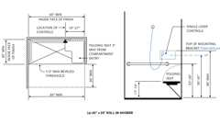

**CA 11A: Figure 11A-9H Standard Roll-in Shower - Part (a)**

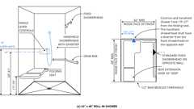

**CA 11A: Figure 11A-9H Standard Roll-in Shower - Part (b)**

**Building products (9)**

[[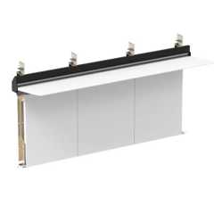](https://up.codes/product/integrated-plumbing-system-aerofoil?viewer_juris_key=california)](https://up.codes/product/integrated-plumbing-system-aerofoil?viewer_juris_key=california)

**[Integrated Plumbing System / Aerofoil - TSL.IPS.AERO](https://up.codes/product/integrated-plumbing-system-aerofoil?viewer_juris_key=california)**

**[The Splash Lab](https://up.codes/product/integrated-plumbing-system-aerofoil?viewer_juris_key=california)**

[[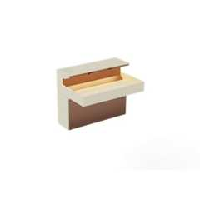](https://up.codes/product/lumashelf-integrated-sink?viewer_juris_key=california)](https://up.codes/product/lumashelf-integrated-sink?viewer_juris_key=california)

**[Lumashelf Integrated Sink - TSL.LUMA](https://up.codes/product/lumashelf-integrated-sink?viewer_juris_key=california)**

**[The Splash Lab](https://up.codes/product/lumashelf-integrated-sink?viewer_juris_key=california)**

[[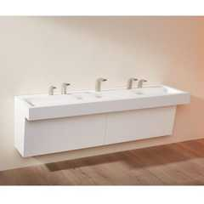](https://up.codes/product/monolith-a-series?viewer_juris_key=california)](https://up.codes/product/monolith-a-series?viewer_juris_key=california)

**[Monolith A Series - TSL.MON.A](https://up.codes/product/monolith-a-series?viewer_juris_key=california)**

**[The Splash Lab](https://up.codes/product/monolith-a-series?viewer_juris_key=california)**

[[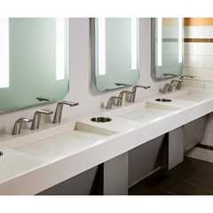](https://up.codes/product/monolith-b-series?viewer_juris_key=california)](https://up.codes/product/monolith-b-series?viewer_juris_key=california)

**[Monolith B Series - TSL.MON.B](https://up.codes/product/monolith-b-series?viewer_juris_key=california)**

**[The Splash Lab](https://up.codes/product/monolith-b-series?viewer_juris_key=california)**

[[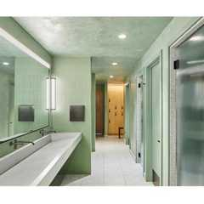](https://up.codes/product/monolith-c-series?viewer_juris_key=california)](https://up.codes/product/monolith-c-series?viewer_juris_key=california)

**[Monolith C Series - TSL.MON.C](https://up.codes/product/monolith-c-series?viewer_juris_key=california)**

**[The Splash Lab](https://up.codes/product/monolith-c-series?viewer_juris_key=california)**

[[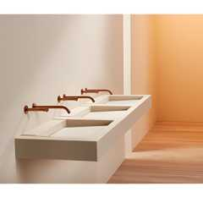](https://up.codes/product/monolith-d-series?viewer_juris_key=california)](https://up.codes/product/monolith-d-series?viewer_juris_key=california)

**[Monolith D Series - TSL.MON.D](https://up.codes/product/monolith-d-series?viewer_juris_key=california)**

**[The Splash Lab](https://up.codes/product/monolith-d-series?viewer_juris_key=california)**

[[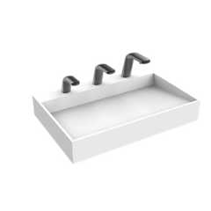](https://up.codes/product/nano-plus-sink?viewer_juris_key=california)](https://up.codes/product/nano-plus-sink?viewer_juris_key=california)

**[Nano Plus Sink - TSL.NANO.P](https://up.codes/product/nano-plus-sink?viewer_juris_key=california)**

**[The Splash Lab](https://up.codes/product/nano-plus-sink?viewer_juris_key=california)**

[[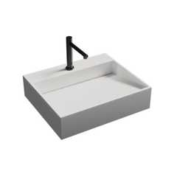](https://up.codes/product/nano-smallest-ada-sink?viewer_juris_key=california)](https://up.codes/product/nano-smallest-ada-sink?viewer_juris_key=california)

**[Nano Smallest ADA Sink - TSL.NANO](https://up.codes/product/nano-smallest-ada-sink?viewer_juris_key=california)**

**[The Splash Lab](https://up.codes/product/nano-smallest-ada-sink?viewer_juris_key=california)**

[[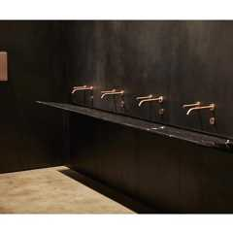](https://up.codes/product/the-aerofoil-basin?viewer_juris_key=california)](https://up.codes/product/the-aerofoil-basin?viewer_juris_key=california)

**[The Aerofoil Basin - TSL.AERO](https://up.codes/product/the-aerofoil-basin?viewer_juris_key=california)**

**[The Splash Lab](https://up.codes/product/the-aerofoil-basin?viewer_juris_key=california)**

[**1127A.2 *Toilet Facilities***](https://up.codes/viewer/california/ca-building-code-2025/chapter/11A/housing-accessibility#1127A.2)

Diagram

*When*[*common use*](https://up.codes/viewer/california/ca-building-code-2025/chapter/2/definitions#common_use_)*toilet*[*facilities*](https://up.codes/viewer/california/ca-building-code-2025/chapter/2/definitions#facility_)*are provided for residents or guests, at least one percent of the total number of fixtures but not less than one of each type shall comply with this section.*

**UpCodes Diagram (1)**

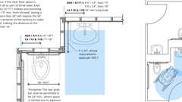

**Grab Bar - Recessed Lavatory**

**Building products (23)**

[[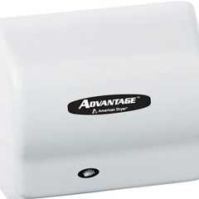](https://up.codes/product/advantage-ad-hand-dryer?viewer_juris_key=california)](https://up.codes/product/advantage-ad-hand-dryer?viewer_juris_key=california)

**[Advantage AD](https://up.codes/product/advantage-ad-hand-dryer?viewer_juris_key=california)**

**[World Dryer](https://up.codes/product/advantage-ad-hand-dryer?viewer_juris_key=california)**

[[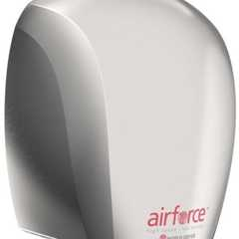](https://up.codes/product/airforce-j-970-efficient-hygienic-high-speed-hand-dryer?viewer_juris_key=california)](https://up.codes/product/airforce-j-970-efficient-hygienic-high-speed-hand-dryer?viewer_juris_key=california)

**[Airforce®](https://up.codes/product/airforce-j-970-efficient-hygienic-high-speed-hand-dryer?viewer_juris_key=california)**

**[World Dryer](https://up.codes/product/airforce-j-970-efficient-hygienic-high-speed-hand-dryer?viewer_juris_key=california)**

[[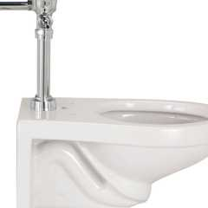](https://up.codes/product/ecovantage-1-28-gpf-wall-mounted-one-piece-elongated-toilet-with-left-hand-lever?viewer_juris_key=california)](https://up.codes/product/ecovantage-1-28-gpf-wall-mounted-one-piece-elongated-toilet-with-left-hand-lever?viewer_juris_key=california)

**[EcoVantage 1.28 GPF Wall Mounted One Piece Elongated Toilet with Left Hand Lever - Less Seat - Z5615.258.00.00.00](https://up.codes/product/ecovantage-1-28-gpf-wall-mounted-one-piece-elongated-toilet-with-left-hand-lever?viewer_juris_key=california)**

**[Zurn](https://up.codes/product/ecovantage-1-28-gpf-wall-mounted-one-piece-elongated-toilet-with-left-hand-lever?viewer_juris_key=california)**

[[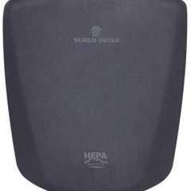](https://up.codes/product/verdedri-q-972a2-hepa-filtered-energy-efficient-hand-dryers?viewer_juris_key=california)](https://up.codes/product/verdedri-q-972a2-hepa-filtered-energy-efficient-hand-dryers?viewer_juris_key=california)

**[HEPA-filtered VERDEdri®](https://up.codes/product/verdedri-q-972a2-hepa-filtered-energy-efficient-hand-dryers?viewer_juris_key=california)**

**[World Dryer](https://up.codes/product/verdedri-q-972a2-hepa-filtered-energy-efficient-hand-dryers?viewer_juris_key=california)**

[[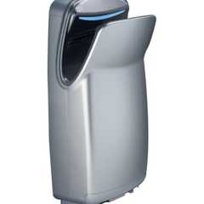](https://up.codes/product/hepa-filtered-vmax-v2-high-speed-vertical-hand-dryer?viewer_juris_key=california)](https://up.codes/product/hepa-filtered-vmax-v2-high-speed-vertical-hand-dryer?viewer_juris_key=california)

**[HEPA-filtered VMax® V2](https://up.codes/product/hepa-filtered-vmax-v2-high-speed-vertical-hand-dryer?viewer_juris_key=california)**

**[World Dryer](https://up.codes/product/hepa-filtered-vmax-v2-high-speed-vertical-hand-dryer?viewer_juris_key=california)**

[[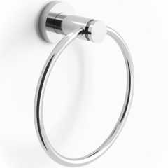](https://up.codes/product/loft-6-diameter-wall-mounted-towel-ring-22-0-3?viewer_juris_key=california)](https://up.codes/product/loft-6-diameter-wall-mounted-towel-ring-22-0-3?viewer_juris_key=california)

**[Loft 6" Diameter Wall Mounted Towel Ring](https://up.codes/product/loft-6-diameter-wall-mounted-towel-ring-22-0-3?viewer_juris_key=california)**

**[Watermark Designs](https://up.codes/product/loft-6-diameter-wall-mounted-towel-ring-22-0-3?viewer_juris_key=california)**

[[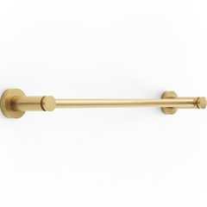](https://up.codes/product/loft-wall-mounted-18-center-to-center-towel-bar-23-0-1?viewer_juris_key=california)](https://up.codes/product/loft-wall-mounted-18-center-to-center-towel-bar-23-0-1?viewer_juris_key=california)

**[Loft Wall Mounted 18" Center-to-Center Towel Bar](https://up.codes/product/loft-wall-mounted-18-center-to-center-towel-bar-23-0-1?viewer_juris_key=california)**

**[Watermark Designs](https://up.codes/product/loft-wall-mounted-18-center-to-center-towel-bar-23-0-1?viewer_juris_key=california)**

[[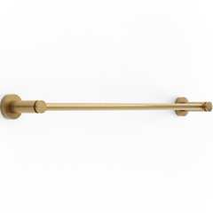](https://up.codes/product/loft-wall-mounted-24-center-to-center-towel-bar-23-0-1a?viewer_juris_key=california)](https://up.codes/product/loft-wall-mounted-24-center-to-center-towel-bar-23-0-1a?viewer_juris_key=california)

**[Loft Wall Mounted 24" Center-to-Center Towel Bar](https://up.codes/product/loft-wall-mounted-24-center-to-center-towel-bar-23-0-1a?viewer_juris_key=california)**

**[Watermark Designs](https://up.codes/product/loft-wall-mounted-24-center-to-center-towel-bar-23-0-1a?viewer_juris_key=california)**

[[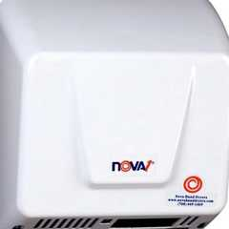](https://up.codes/product/smartdri-k48-971p-high-efficiency-intelligent-hand-dryers?viewer_juris_key=california)](https://up.codes/product/smartdri-k48-971p-high-efficiency-intelligent-hand-dryers?viewer_juris_key=california)

**[Nova® 1](https://up.codes/product/smartdri-k48-971p-high-efficiency-intelligent-hand-dryers?viewer_juris_key=california)**

**[World Dryer](https://up.codes/product/smartdri-k48-971p-high-efficiency-intelligent-hand-dryers?viewer_juris_key=california)**

[[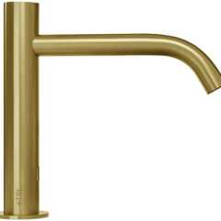](https://up.codes/product/radius-deck-mounted-sensor-faucet-large?viewer_juris_key=california)](https://up.codes/product/radius-deck-mounted-sensor-faucet-large?viewer_juris_key=california)

**[Radius Deck Mounted Sensor Faucet / Large - TSL.960](https://up.codes/product/radius-deck-mounted-sensor-faucet-large?viewer_juris_key=california)**

**[The Splash Lab](https://up.codes/product/radius-deck-mounted-sensor-faucet-large?viewer_juris_key=california)**

[[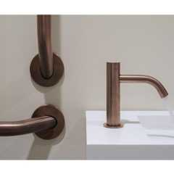](https://up.codes/product/radius-deck-mounted-sensor-faucet-small?viewer_juris_key=california)](https://up.codes/product/radius-deck-mounted-sensor-faucet-small?viewer_juris_key=california)

**[Radius Deck Mounted Sensor Faucet / Small - TSL.990](https://up.codes/product/radius-deck-mounted-sensor-faucet-small?viewer_juris_key=california)**

**[The Splash Lab](https://up.codes/product/radius-deck-mounted-sensor-faucet-small?viewer_juris_key=california)**

[[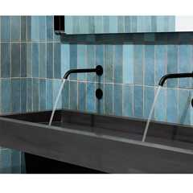](https://up.codes/product/radius-sensor-faucet-large?viewer_juris_key=california)](https://up.codes/product/radius-sensor-faucet-large?viewer_juris_key=california)

**[Radius Sensor Faucet / Large - TSL.882](https://up.codes/product/radius-sensor-faucet-large?viewer_juris_key=california)**

**[The Splash Lab](https://up.codes/product/radius-sensor-faucet-large?viewer_juris_key=california)**

[[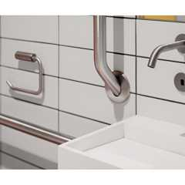](https://up.codes/product/radius-sensor-faucet-small?viewer_juris_key=california)](https://up.codes/product/radius-sensor-faucet-small?viewer_juris_key=california)

**[Radius Sensor Faucet / Small - TSL.884](https://up.codes/product/radius-sensor-faucet-small?viewer_juris_key=california)**

**[The Splash Lab](https://up.codes/product/radius-sensor-faucet-small?viewer_juris_key=california)**

[[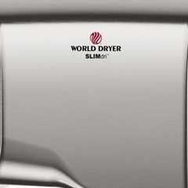](https://up.codes/product/slimdri-l-972-surface-mounted-ada-compliant-hand-dryers?viewer_juris_key=california)](https://up.codes/product/slimdri-l-972-surface-mounted-ada-compliant-hand-dryers?viewer_juris_key=california)

**[SLIMdri®](https://up.codes/product/slimdri-l-972-surface-mounted-ada-compliant-hand-dryers?viewer_juris_key=california)**

**[World Dryer](https://up.codes/product/slimdri-l-972-surface-mounted-ada-compliant-hand-dryers?viewer_juris_key=california)**

[[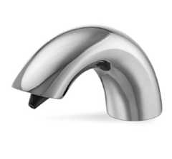](https://up.codes/product/sensor-soap-dispensers?viewer_juris_key=california)](https://up.codes/product/sensor-soap-dispensers?viewer_juris_key=california)

**[Sensor Soap Dispensers](https://up.codes/product/sensor-soap-dispensers?viewer_juris_key=california)**

**[Hadrian Solutions ULC](https://up.codes/product/sensor-soap-dispensers?viewer_juris_key=california)**

[[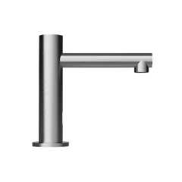](https://up.codes/product/straight-spout-faucet-small?viewer_juris_key=california)](https://up.codes/product/straight-spout-faucet-small?viewer_juris_key=california)

**[Straight Spout Faucet / Small - TSL.980](https://up.codes/product/straight-spout-faucet-small?viewer_juris_key=california)**

**[The Splash Lab](https://up.codes/product/straight-spout-faucet-small?viewer_juris_key=california)**

[[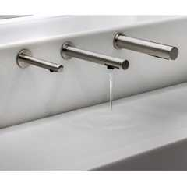](https://up.codes/product/the-channel-faucet?viewer_juris_key=california)](https://up.codes/product/the-channel-faucet?viewer_juris_key=california)

**[The Channel Faucet - TSL.C.050](https://up.codes/product/the-channel-faucet?viewer_juris_key=california)**

**[The Splash Lab](https://up.codes/product/the-channel-faucet?viewer_juris_key=california)**

[[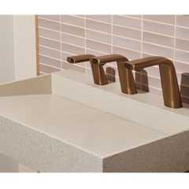](https://up.codes/product/the-ribbon-faucet?viewer_juris_key=california)](https://up.codes/product/the-ribbon-faucet?viewer_juris_key=california)

**[The Ribbon Faucet - TSL.R.020](https://up.codes/product/the-ribbon-faucet?viewer_juris_key=california)**

**[The Splash Lab](https://up.codes/product/the-ribbon-faucet?viewer_juris_key=california)**

[[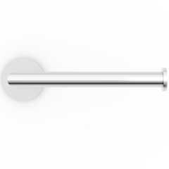](https://up.codes/product/titanium-wall-mounted-paper-holder-22-0-4?viewer_juris_key=california)](https://up.codes/product/titanium-wall-mounted-paper-holder-22-0-4?viewer_juris_key=california)

**[Titanium Wall Mounted Paper Holder](https://up.codes/product/titanium-wall-mounted-paper-holder-22-0-4?viewer_juris_key=california)**

**[Watermark Designs](https://up.codes/product/titanium-wall-mounted-paper-holder-22-0-4?viewer_juris_key=california)**

[[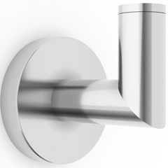](https://up.codes/product/titanium-wall-mounted-robe-hook-22-0-5?viewer_juris_key=california)](https://up.codes/product/titanium-wall-mounted-robe-hook-22-0-5?viewer_juris_key=california)

**[Titanium Wall Mounted Robe Hook](https://up.codes/product/titanium-wall-mounted-robe-hook-22-0-5?viewer_juris_key=california)**

**[Watermark Designs](https://up.codes/product/titanium-wall-mounted-robe-hook-22-0-5?viewer_juris_key=california)**

[[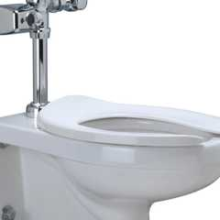](https://up.codes/product/zurn-one-1-1-gpf-wall-mounted-one-piece-elongated-toilet-with-battery-powered-fl?viewer_juris_key=california)](https://up.codes/product/zurn-one-1-1-gpf-wall-mounted-one-piece-elongated-toilet-with-battery-powered-fl?viewer_juris_key=california)

**[Wall Hung Zurn One Toilet System with 1.1 GPF Battery Powered Sensor Flush Valve - Z.WC1.S](https://up.codes/product/zurn-one-1-1-gpf-wall-mounted-one-piece-elongated-toilet-with-battery-powered-fl?viewer_juris_key=california)**

**[Zurn](https://up.codes/product/zurn-one-1-1-gpf-wall-mounted-one-piece-elongated-toilet-with-battery-powered-fl?viewer_juris_key=california)**

[[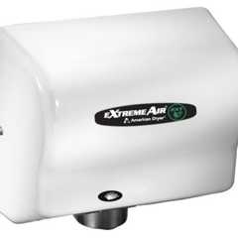](https://up.codes/product/extremeair-ext-eco-friendly-user-friendly-hand-dryer?viewer_juris_key=california)](https://up.codes/product/extremeair-ext-eco-friendly-user-friendly-hand-dryer?viewer_juris_key=california)

**[eXtremeAir® EXT](https://up.codes/product/extremeair-ext-eco-friendly-user-friendly-hand-dryer?viewer_juris_key=california)**

**[World Dryer](https://up.codes/product/extremeair-ext-eco-friendly-user-friendly-hand-dryer?viewer_juris_key=california)**

[[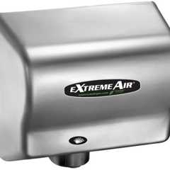](https://up.codes/product/extremeair-gxt-functional-fit-hand-dryer?viewer_juris_key=california)](https://up.codes/product/extremeair-gxt-functional-fit-hand-dryer?viewer_juris_key=california)

**[eXtremeAir® GXT](https://up.codes/product/extremeair-gxt-functional-fit-hand-dryer?viewer_juris_key=california)**

**[World Dryer](https://up.codes/product/extremeair-gxt-functional-fit-hand-dryer?viewer_juris_key=california)**

[**1127A.2.1 *Multiple-Accommodation Toilet Facilities***](https://up.codes/viewer/california/ca-building-code-2025/chapter/11A/housing-accessibility#1127A.2.1)

Diagram

*Multiple-accommodation toilet*[*facilities*](https://up.codes/viewer/california/ca-building-code-2025/chapter/2/definitions#facility_)*shall have the following:*

***Note:****(See*[*Figures*](https://up.codes/viewer/california/ca-building-code-2025/chapter/11B/accessibility-to-public-buildings-public-accommodations-commercial-buildings-and#figure)[*11A-9A*](https://up.codes/viewer/california/ca-building-code-2025/chapter/11A/housing-accessibility#11A-9A)*and*[*11A-9B*](https://up.codes/viewer/california/ca-building-code-2025/chapter/11A/housing-accessibility#11A-9B)*.)*

1. [***Wheelchair***](https://up.codes/viewer/california/ca-building-code-2025/chapter/2/definitions#wheelchair_hcd_1_ac_dsa_ac_)***turning***[***space***](https://up.codes/viewer/california/ca-building-code-2025/chapter/2/definitions#space_)***.****Turning*[*space*](https://up.codes/viewer/california/ca-building-code-2025/chapter/2/definitions#space_)*of sufficient*[*size*](https://up.codes/viewer/california/ca-building-code-2025/chapter/9/fire-protection-and-life-safety-systems#911.1.3)*to inscribe a circle with a diameter not less than 60 inches (1524 mm) or a T-shaped*[*space*](https://up.codes/viewer/california/ca-building-code-2025/chapter/2/definitions#space_)*shall be provided within the toilet*[*facility*](https://up.codes/viewer/california/ca-building-code-2025/chapter/2/definitions#facility_)*. The*[*wheelchair*](https://up.codes/viewer/california/ca-building-code-2025/chapter/2/definitions#wheelchair_hcd_1_ac_dsa_ac_)*turning*[*space*](https://up.codes/viewer/california/ca-building-code-2025/chapter/2/definitions#space_)*shall comply with*[*Section 1138A.1.3*](https://up.codes/viewer/california/ca-building-code-2025/chapter/11A/housing-accessibility#1138A.1.3)*. Other than the door to the accessible water closet compartment, a door, in any position, may encroach into this*[*space*](https://up.codes/viewer/california/ca-building-code-2025/chapter/2/definitions#space_)*by not more than 12 inches (305 mm).*
2. [***Clear***](https://up.codes/viewer/california/ca-building-code-2025/chapter/2/definitions#clear_dsa_ac_)[***space***](https://up.codes/viewer/california/ca-building-code-2025/chapter/2/definitions#space_)***at fixtures.****Doors shall not swing into the*[*clear floor space*](https://up.codes/viewer/california/ca-building-code-2025/chapter/2/definitions#clear_floor_space_dsa_ac_hcd_1_ac_)*required for any fixture. Required*[*clear floor space*](https://up.codes/viewer/california/ca-building-code-2025/chapter/2/definitions#clear_floor_space_dsa_ac_hcd_1_ac_)*, clearance at fixtures, and turning*[*space*](https://up.codes/viewer/california/ca-building-code-2025/chapter/2/definitions#space_)*shall be permitted to overlap.*
3. ***Accessible water closet compartment.****Accessible water closet compartments shall be 60 inches (1524 mm) wide minimum measured perpendicular to the side*[*wall*](https://up.codes/viewer/california/ca-building-code-2025/chapter/2/definitions#wall_)*, 56 inches (1422 mm) deep minimum for*[*wall*](https://up.codes/viewer/california/ca-building-code-2025/chapter/2/definitions#wall_)*hung water closets and 59 inches (1499 mm) deep minimum for floor mounted water closets measured perpendicular to the rear*[*wall*](https://up.codes/viewer/california/ca-building-code-2025/chapter/2/definitions#wall_)*. (See*[*Figure*](https://up.codes/viewer/california/ca-building-code-2025/chapter/11B/accessibility-to-public-buildings-public-accommodations-commercial-buildings-and#figure)*11A-9A(c).)*
   * *Water closet fixtures located in accessible water closet compartments shall be positioned with a*[*wall*](https://up.codes/viewer/california/ca-building-code-2025/chapter/2/definitions#wall_)*or partition to the rear and to one side. The centerline of the water closet shall be 17 inches (432 mm) minimum to 18 inches (457 mm) maximum from the side*[*wall*](https://up.codes/viewer/california/ca-building-code-2025/chapter/2/definitions#wall_)*or partition.*
   * *In ambulatory accessible toilet compartments specified in Item*[*6*](https://up.codes/viewer/california/ca-building-code-2025/chapter/6/types-of-construction#6)*of this section, the water closet shall be 17 inches (432 mm) minimum and 19 inches (483 mm) maximum from the side*[*wall*](https://up.codes/viewer/california/ca-building-code-2025/chapter/2/definitions#wall_)*or partition. (See*[*Figure*](https://up.codes/viewer/california/ca-building-code-2025/chapter/11B/accessibility-to-public-buildings-public-accommodations-commercial-buildings-and#figure)*11A-9A (d).)*
   * *Clearance around a water closet shall be 60 inches (1524 mm) minimum measured perpendicular from the side*[*wall*](https://up.codes/viewer/california/ca-building-code-2025/chapter/2/definitions#wall_)*and 56 inches (1422 mm) minimum measured perpendicular from the rear*[*wall*](https://up.codes/viewer/california/ca-building-code-2025/chapter/2/definitions#wall_)*. The required clearance around the water closet shall be permitted to overlap the water closet, associated*[*grab bars*](https://up.codes/viewer/california/ca-building-code-2025/chapter/2/definitions#grab_bar_dsa_ac_hcd_1_ac_)*, dispensers, sanitary napkin disposal units, coat hooks, shelves,*[*accessible routes*](https://up.codes/viewer/california/ca-building-code-2025/chapter/2/definitions#accessible_route_dsa_ac_hcd_1_ac_)*,*[*clear floor space*](https://up.codes/viewer/california/ca-building-code-2025/chapter/2/definitions#clear_floor_space_dsa_ac_hcd_1_ac_)*and clearances required at other fixtures, and the turning*[*space*](https://up.codes/viewer/california/ca-building-code-2025/chapter/2/definitions#space_)*. No other fixtures or obstructions shall be located within the required water closet clearance.*
   * *A minimum 48 inches (1219 mm) deep and 60 inches (1524 mm) wide*[*clear*](https://up.codes/viewer/california/ca-building-code-2025/chapter/2/definitions#clear_dsa_ac_)*maneuvering*[*space*](https://up.codes/viewer/california/ca-building-code-2025/chapter/2/definitions#space_)*shall be provided in front of the water closet if the compartment has an end-opening door (facing the water closet). A minimum 60 inches (1524 mm) deep and 60 inches (1524 mm) wide*[*clear*](https://up.codes/viewer/california/ca-building-code-2025/chapter/2/definitions#clear_dsa_ac_)*maneuvering*[*space*](https://up.codes/viewer/california/ca-building-code-2025/chapter/2/definitions#space_)*shall be provided in a compartment with the door located at the side. (See*[*Figure*](https://up.codes/viewer/california/ca-building-code-2025/chapter/11B/accessibility-to-public-buildings-public-accommodations-commercial-buildings-and#figure)*11A-9A.)*
4. [***Grab bars***](https://up.codes/viewer/california/ca-building-code-2025/chapter/2/definitions#grab_bar_dsa_ac_hcd_1_ac_)***.***[*Grab bars*](https://up.codes/viewer/california/ca-building-code-2025/chapter/2/definitions#grab_bar_dsa_ac_hcd_1_ac_)*shall be provided on the side*[*wall*](https://up.codes/viewer/california/ca-building-code-2025/chapter/2/definitions#wall_)*closest to the water closet and on the rear*[*wall*](https://up.codes/viewer/california/ca-building-code-2025/chapter/2/definitions#wall_)*.*[*Grab bars*](https://up.codes/viewer/california/ca-building-code-2025/chapter/2/definitions#grab_bar_dsa_ac_hcd_1_ac_)*shall comply with this section and*[*Section 1127A.4*](https://up.codes/viewer/california/ca-building-code-2025/chapter/11A/housing-accessibility#1127A.4)*.*
   * *The side*[*wall*](https://up.codes/viewer/california/ca-building-code-2025/chapter/2/definitions#wall_)[*grab bar*](https://up.codes/viewer/california/ca-building-code-2025/chapter/2/definitions#grab_bar_dsa_ac_hcd_1_ac_)*shall be 42 inches (1067 mm) long minimum, located 12 inches (305 mm) maximum from the rear*[*wall*](https://up.codes/viewer/california/ca-building-code-2025/chapter/2/definitions#wall_)*and extend 54 inches (1372 mm) minimum from the rear*[*wall*](https://up.codes/viewer/california/ca-building-code-2025/chapter/2/definitions#wall_)*. The front end of the side*[*grab bar*](https://up.codes/viewer/california/ca-building-code-2025/chapter/2/definitions#grab_bar_dsa_ac_hcd_1_ac_)*shall be positioned 24 inches (610 mm) minimum in front of the water closet.*
   * *The rear*[*wall*](https://up.codes/viewer/california/ca-building-code-2025/chapter/2/definitions#wall_)[*grab bar*](https://up.codes/viewer/california/ca-building-code-2025/chapter/2/definitions#grab_bar_dsa_ac_hcd_1_ac_)*shall be 36 inches (914 mm) long minimum and extend from the centerline of the water closet 12 inches (305 mm) minimum on one side and 24 inches (610 mm) minimum on the other side.*

***Exceptions:***

* + *The rear*[*grab bar*](https://up.codes/viewer/california/ca-building-code-2025/chapter/2/definitions#grab_bar_dsa_ac_hcd_1_ac_)*shall be permitted to be 24 inches (610 mm) long minimum, centered on the water closet, when*[*wall*](https://up.codes/viewer/california/ca-building-code-2025/chapter/2/definitions#wall_)[*space*](https://up.codes/viewer/california/ca-building-code-2025/chapter/2/definitions#space_)*does not*[*permit*](https://up.codes/viewer/california/ca-building-code-2025/chapter/2/definitions#permit_)*a length of 36 inches (914 mm) minimum due to the*[*location*](https://up.codes/viewer/california/ca-building-code-2025/chapter/L/earthquake-recording-instrumentation#L101.2)*of a recessed fixture adjacent to the water closet.*
  + *When the*[*enforcing agency*](https://up.codes/viewer/california/ca-building-code-2025/chapter/2/definitions#enforcing_agency_)*requires flush controls for flush valves to be located in a position that conflicts with the*[*location*](https://up.codes/viewer/california/ca-building-code-2025/chapter/L/earthquake-recording-instrumentation#L101.2)*of the rear*[*grab bar*](https://up.codes/viewer/california/ca-building-code-2025/chapter/2/definitions#grab_bar_dsa_ac_hcd_1_ac_)*, then the rear*[*grab bar*](https://up.codes/viewer/california/ca-building-code-2025/chapter/2/definitions#grab_bar_dsa_ac_hcd_1_ac_)*shall be permitted to be split or shifted to the open side of the toilet area.*

1. ***Compartment doors.****Compartment doors shall comply with*[*Section 1126A*](https://up.codes/viewer/california/ca-building-code-2025/chapter/11A/housing-accessibility#1126A)*and the following:*
   * *5.1.   The water closet compartment shall be equipped with a door that has an*[*automatic*](https://up.codes/viewer/california/ca-building-code-2025/chapter/2/definitions#automatic_)*-closing device, and shall have a*[*clear*](https://up.codes/viewer/california/ca-building-code-2025/chapter/2/definitions#clear_dsa_ac_)*, unobstructed opening width of 32 inches (813 mm) when located at the end and 34 inches (864 mm) when located at the side with the door positioned at an angle of 90 degrees from its closed position.*
   * *5.2.   When standard compartment doors are used, with a minimum 9-inch (228.6 mm) clearance for footrests underneath and a*[*self-closing*](https://up.codes/viewer/california/ca-building-code-2025/chapter/2/definitions#self_closing_)*device, clearance at the strike edge as specified in*[*Section 1126A.3.2*](https://up.codes/viewer/california/ca-building-code-2025/chapter/11A/housing-accessibility#1126A.3.2)*is not required.*
   * *5.3.   The inside and outside of the compartment door shall be equipped with a loop or U-shaped handle immediately below the latch. The latch shall be flip-over style, sliding or other*[*hardware*](https://up.codes/viewer/california/ca-building-code-2025/chapter/2/definitions#hardware_)*not requiring the user to grasp or twist.*
   * *5.4.   Except for door-opening widths and door swings, a*[*clear*](https://up.codes/viewer/california/ca-building-code-2025/chapter/2/definitions#clear_dsa_ac_)*, unobstructed access of not less than 44 inches (1118 mm) shall be provided to water closet compartments designed for use by*[*persons with disabilities*](https://up.codes/viewer/california/ca-building-code-2025/chapter/2/definitions#persons_with_disabilities_hcd_1_ac_)*, and the*[*space*](https://up.codes/viewer/california/ca-building-code-2025/chapter/2/definitions#space_)*immediately in front of a water closet compartment shall not be less than 48 inches (1219 mm) as measured at right angles to compartment door in its closed position.*
   * *5.5.   Doors shall be located in the front or in the side*[*wall*](https://up.codes/viewer/california/ca-building-code-2025/chapter/2/definitions#wall_)*or partition farthest from the water closet. Where located in the front partition, the door opening shall be 4 inches (102 mm) maximum from the side*[*wall*](https://up.codes/viewer/california/ca-building-code-2025/chapter/2/definitions#wall_)*or partition. Where located in the side*[*wall*](https://up.codes/viewer/california/ca-building-code-2025/chapter/2/definitions#wall_)*or partition, the door opening shall be 4 inches (102 mm) maximum from the front*[*wall*](https://up.codes/viewer/california/ca-building-code-2025/chapter/2/definitions#wall_)*or partition.*
2. ***Ambulatory accessible compartments.****When six or more toilet compartments are provided within a multiple-accommodation toilet room, or when the combination of urinals and water closets totals six or more fixtures, at least one compartment shall comply with Section 1127A.2.1, Items 2 and 3. At least one additional ambulatory compartment shall have a depth of 60 inches (1524 mm) minimum, and a width of 35 inches (890 mm) minimum and 37 inches (940 mm) maximum.*
   * *The ambulatory accessible compartment shall have a*[*self-closing*](https://up.codes/viewer/california/ca-building-code-2025/chapter/2/definitions#self_closing_)*door, which shall not swing into the minimum required compartment area.*[*Grab bars*](https://up.codes/viewer/california/ca-building-code-2025/chapter/2/definitions#grab_bar_dsa_ac_hcd_1_ac_)*, complying with Sections*[*1127A.4.2*](https://up.codes/viewer/california/ca-building-code-2025/chapter/11A/housing-accessibility#1127A.4.2)*,*[*1127A.4.3*](https://up.codes/viewer/california/ca-building-code-2025/chapter/11A/housing-accessibility#1127A.4.3)*,*[*1127A.4.4*](https://up.codes/viewer/california/ca-building-code-2025/chapter/11A/housing-accessibility#1127A.4.4)*and*[*1127A.4.5*](https://up.codes/viewer/california/ca-building-code-2025/chapter/11A/housing-accessibility#1127A.4.5)*, shall be installed on each compartment side*[*wall*](https://up.codes/viewer/california/ca-building-code-2025/chapter/2/definitions#wall_)*. (See*[*Figure*](https://up.codes/viewer/california/ca-building-code-2025/chapter/11B/accessibility-to-public-buildings-public-accommodations-commercial-buildings-and#figure)*11A-9A (d).)*

**UpCodes Diagram (1)**

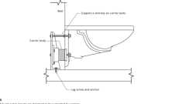

**Wall Hung Toilet Carrier**

**Building products (3)**

[[](https://up.codes/product/ecovantage-1-28-gpf-wall-mounted-one-piece-elongated-toilet-with-left-hand-lever?viewer_juris_key=california)](https://up.codes/product/ecovantage-1-28-gpf-wall-mounted-one-piece-elongated-toilet-with-left-hand-lever?viewer_juris_key=california)

**[EcoVantage 1.28 GPF Wall Mounted One Piece Elongated Toilet with Left Hand Lever - Less Seat - Z5615.258.00.00.00](https://up.codes/product/ecovantage-1-28-gpf-wall-mounted-one-piece-elongated-toilet-with-left-hand-lever?viewer_juris_key=california)**

**[Zurn](https://up.codes/product/ecovantage-1-28-gpf-wall-mounted-one-piece-elongated-toilet-with-left-hand-lever?viewer_juris_key=california)**

[[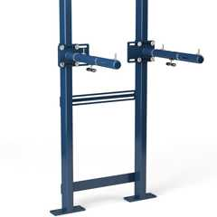](https://up.codes/product/universal-lavatory-carrier?viewer_juris_key=california)](https://up.codes/product/universal-lavatory-carrier?viewer_juris_key=california)

**[Universal Lavatory Carrier - Z1231EZ](https://up.codes/product/universal-lavatory-carrier?viewer_juris_key=california)**

**[Zurn](https://up.codes/product/universal-lavatory-carrier?viewer_juris_key=california)**

[[](https://up.codes/product/zurn-one-1-1-gpf-wall-mounted-one-piece-elongated-toilet-with-battery-powered-fl?viewer_juris_key=california)](https://up.codes/product/zurn-one-1-1-gpf-wall-mounted-one-piece-elongated-toilet-with-battery-powered-fl?viewer_juris_key=california)

**[Wall Hung Zurn One Toilet System with 1.1 GPF Battery Powered Sensor Flush Valve - Z.WC1.S](https://up.codes/product/zurn-one-1-1-gpf-wall-mounted-one-piece-elongated-toilet-with-battery-powered-fl?viewer_juris_key=california)**

**[Zurn](https://up.codes/product/zurn-one-1-1-gpf-wall-mounted-one-piece-elongated-toilet-with-battery-powered-fl?viewer_juris_key=california)**

[**1127A.2.2 *Single-Accommodation Toilet Facilities***](https://up.codes/viewer/california/ca-building-code-2025/chapter/11A/housing-accessibility#1127A.2.2)

Diagram

*Single-accommodation toilet*[*facilities*](https://up.codes/viewer/california/ca-building-code-2025/chapter/2/definitions#facility_)*shall comply with the following:*

***Note:****See*[*Figures*](https://up.codes/viewer/california/ca-building-code-2025/chapter/11B/accessibility-to-public-buildings-public-accommodations-commercial-buildings-and#figure)[*11A-9A*](https://up.codes/viewer/california/ca-building-code-2025/chapter/11A/housing-accessibility#11A-9A)*and*[*11A-9B*](https://up.codes/viewer/california/ca-building-code-2025/chapter/11A/housing-accessibility#11A-9B)*.*

1. [***Wheelchair***](https://up.codes/viewer/california/ca-building-code-2025/chapter/2/definitions#wheelchair_hcd_1_ac_dsa_ac_)***clearance.****There shall be sufficient*[*space*](https://up.codes/viewer/california/ca-building-code-2025/chapter/2/definitions#space_)*in the toilet room for a*[*wheelchair*](https://up.codes/viewer/california/ca-building-code-2025/chapter/2/definitions#wheelchair_hcd_1_ac_dsa_ac_)*measuring 30 inches (762 mm) wide by 48 inches (1219 mm) long to enter the room and*[*permit*](https://up.codes/viewer/california/ca-building-code-2025/chapter/2/definitions#permit_)*the door to close. There shall be in the room a*[*clear*](https://up.codes/viewer/california/ca-building-code-2025/chapter/2/definitions#clear_dsa_ac_)*turning*[*space*](https://up.codes/viewer/california/ca-building-code-2025/chapter/2/definitions#space_)*of at least 60 inches (1524 mm) in diameter or a T-shaped*[*space*](https://up.codes/viewer/california/ca-building-code-2025/chapter/2/definitions#space_)*complying with*[*Section 1138A.1.3*](https://up.codes/viewer/california/ca-building-code-2025/chapter/11A/housing-accessibility#1138A.1.3)*.*
   * *Required*[*clear floor space*](https://up.codes/viewer/california/ca-building-code-2025/chapter/2/definitions#clear_floor_space_dsa_ac_hcd_1_ac_)*, clearance at fixtures and turning*[*space*](https://up.codes/viewer/california/ca-building-code-2025/chapter/2/definitions#space_)*shall be permitted to overlap.*
2. ***Encroachment of doors.****Doors shall not encroach into the turning*[*space*](https://up.codes/viewer/california/ca-building-code-2025/chapter/2/definitions#space_)*specified in Item 1 of this section by more than 12 inches (305 mm).*
3. ***Accessible water closet.****A water closet fixture located in a single-accommodation toilet*[*facility*](https://up.codes/viewer/california/ca-building-code-2025/chapter/2/definitions#facility_)*shall be positioned with a*[*wall*](https://up.codes/viewer/california/ca-building-code-2025/chapter/2/definitions#wall_)*or partition to the rear and to one side. The centerline of the water closet shall be 17 inches (432 mm) minimum to 18 inches (457 mm) maximum from the side*[*wall*](https://up.codes/viewer/california/ca-building-code-2025/chapter/2/definitions#wall_)*or partition.*
   * *Clearance around a water closet shall be 60 inches (1524 mm) minimum measured perpendicular from the side*[*wall*](https://up.codes/viewer/california/ca-building-code-2025/chapter/2/definitions#wall_)*and 56 inches (1422 mm) minimum measured perpendicular from the rear*[*wall*](https://up.codes/viewer/california/ca-building-code-2025/chapter/2/definitions#wall_)*. The required clearance around the water closet shall be permitted to overlap the water closet, associated*[*grab bars*](https://up.codes/viewer/california/ca-building-code-2025/chapter/2/definitions#grab_bar_dsa_ac_hcd_1_ac_)*, dispensers, sanitary napkin disposal units, coat hooks, shelves,*[*accessible routes*](https://up.codes/viewer/california/ca-building-code-2025/chapter/2/definitions#accessible_route_dsa_ac_hcd_1_ac_)*,*[*clear floor space*](https://up.codes/viewer/california/ca-building-code-2025/chapter/2/definitions#clear_floor_space_dsa_ac_hcd_1_ac_)*and clearances required at other fixtures, and the turning*[*space*](https://up.codes/viewer/california/ca-building-code-2025/chapter/2/definitions#space_)*. No other fixtures or obstructions shall be located within the required water closet clearance.*
   * *A minimum 48 inches (1219 mm) deep and 60 inches (1524 mm) wide*[*clear*](https://up.codes/viewer/california/ca-building-code-2025/chapter/2/definitions#clear_dsa_ac_)*maneuvering*[*space*](https://up.codes/viewer/california/ca-building-code-2025/chapter/2/definitions#space_)*shall be provided in front of the water closet.*
4. [***Grab bars***](https://up.codes/viewer/california/ca-building-code-2025/chapter/2/definitions#grab_bar_dsa_ac_hcd_1_ac_)***.***[*Grab bars*](https://up.codes/viewer/california/ca-building-code-2025/chapter/2/definitions#grab_bar_dsa_ac_hcd_1_ac_)*shall be provided on the side*[*wall*](https://up.codes/viewer/california/ca-building-code-2025/chapter/2/definitions#wall_)*closest to the water closet and on the rear*[*wall*](https://up.codes/viewer/california/ca-building-code-2025/chapter/2/definitions#wall_)*.*[*Grab bars*](https://up.codes/viewer/california/ca-building-code-2025/chapter/2/definitions#grab_bar_dsa_ac_hcd_1_ac_)*shall comply with this section and*[*Section 1127A.4*](https://up.codes/viewer/california/ca-building-code-2025/chapter/11A/housing-accessibility#1127A.4)*.*
   * *The side*[*wall*](https://up.codes/viewer/california/ca-building-code-2025/chapter/2/definitions#wall_)[*grab bar*](https://up.codes/viewer/california/ca-building-code-2025/chapter/2/definitions#grab_bar_dsa_ac_hcd_1_ac_)*shall be 42 inches (1067 mm) long minimum, located 12 inches (305 mm) maximum from the rear*[*wall*](https://up.codes/viewer/california/ca-building-code-2025/chapter/2/definitions#wall_)*and extend 54 inches (1372 mm) minimum from the rear*[*wall*](https://up.codes/viewer/california/ca-building-code-2025/chapter/2/definitions#wall_)*. The front end of the side*[*grab bar*](https://up.codes/viewer/california/ca-building-code-2025/chapter/2/definitions#grab_bar_dsa_ac_hcd_1_ac_)*shall be positioned 24 inches (610 mm) minimum in front of the water closet.*
   * *The rear*[*wall*](https://up.codes/viewer/california/ca-building-code-2025/chapter/2/definitions#wall_)[*grab bar*](https://up.codes/viewer/california/ca-building-code-2025/chapter/2/definitions#grab_bar_dsa_ac_hcd_1_ac_)*shall be 36 inches (914 mm) long minimum and extend from the centerline of the water closet 12 inches (305 mm) minimum on one side and 24 inches (610 mm) minimum on the other side.*

***Exceptions:***

* + 1. *The rear*[*grab bar*](https://up.codes/viewer/california/ca-building-code-2025/chapter/2/definitions#grab_bar_dsa_ac_hcd_1_ac_)*shall be permitted to be 24 inches (610 mm) long minimum, centered on the water closet, when*[*wall*](https://up.codes/viewer/california/ca-building-code-2025/chapter/2/definitions#wall_)[*space*](https://up.codes/viewer/california/ca-building-code-2025/chapter/2/definitions#space_)*does not*[*permit*](https://up.codes/viewer/california/ca-building-code-2025/chapter/2/definitions#permit_)*a length of 36 inches (914 mm) minimum due to the*[*location*](https://up.codes/viewer/california/ca-building-code-2025/chapter/L/earthquake-recording-instrumentation#L101.2)*of a recessed fixture adjacent to the water closet.*
    2. *When the*[*enforcing agency*](https://up.codes/viewer/california/ca-building-code-2025/chapter/2/definitions#enforcing_agency_)*requires flush controls for flush valves to be located in a position that conflicts with the*[*location*](https://up.codes/viewer/california/ca-building-code-2025/chapter/L/earthquake-recording-instrumentation#L101.2)*of the rear*[*grab bar*](https://up.codes/viewer/california/ca-building-code-2025/chapter/2/definitions#grab_bar_dsa_ac_hcd_1_ac_)*, then the rear*[*grab bar*](https://up.codes/viewer/california/ca-building-code-2025/chapter/2/definitions#grab_bar_dsa_ac_hcd_1_ac_)*shall be permitted to be split or shifted to the open side of the toilet area.*

1. [***Accessible route***](https://up.codes/viewer/california/ca-building-code-2025/chapter/2/definitions#accessible_route_dsa_ac_hcd_1_ac_)***.****All doors, fixtures and controls shall be on an*[*accessible route*](https://up.codes/viewer/california/ca-building-code-2025/chapter/2/definitions#accessible_route_dsa_ac_hcd_1_ac_)*. The minimum*[*clear*](https://up.codes/viewer/california/ca-building-code-2025/chapter/2/definitions#clear_dsa_ac_)*width of an*[*accessible route*](https://up.codes/viewer/california/ca-building-code-2025/chapter/2/definitions#accessible_route_dsa_ac_hcd_1_ac_)*shall be 36 inches (914 mm) except at doors (See*[*Section 1126A*](https://up.codes/viewer/california/ca-building-code-2025/chapter/11A/housing-accessibility#1126A)*). If a person in a*[*wheelchair*](https://up.codes/viewer/california/ca-building-code-2025/chapter/2/definitions#wheelchair_hcd_1_ac_dsa_ac_)*must make a turn around an obstruction, the minimum*[*clear*](https://up.codes/viewer/california/ca-building-code-2025/chapter/2/definitions#clear_dsa_ac_)*width of the*[*accessible route*](https://up.codes/viewer/california/ca-building-code-2025/chapter/2/definitions#accessible_route_dsa_ac_hcd_1_ac_)*shall be as specified in*[*Section 1138A.1.5*](https://up.codes/viewer/california/ca-building-code-2025/chapter/11A/housing-accessibility#1138A.1.5)*.*

**UpCodes Diagrams (3)**

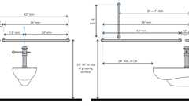

**Water Closet Grab Bars**



**Grab Bar - Recessed Lavatory**

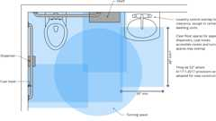

**Toilet Room Fixture Clearance Overlaps**

[**1127A.2.3 *Water Closets***](https://up.codes/viewer/california/ca-building-code-2025/chapter/11A/housing-accessibility#1127A.2.3)

Diagram

*Water closets required to be accessible shall comply with the following:*

***Note:****See*[*Figure*](https://up.codes/viewer/california/ca-building-code-2025/chapter/11B/accessibility-to-public-buildings-public-accommodations-commercial-buildings-and#figure)*11A-9B.*

1. ***Height.****The height of accessible water closets shall be a minimum of 17 inches (432 mm) to a maximum of 19 inches (483 mm) measured to the top of a maximum 2-inch-high (50.8 mm) toilet seat.*
2. ***Controls.****Flush controls shall be hand operated or*[*automatic*](https://up.codes/viewer/california/ca-building-code-2025/chapter/2/definitions#automatic_)*. Hand operated controls shall be operable with one hand and shall not require tight grasping, pinching or twisting. Controls for the flush valves shall be mounted on the open side of the water closet no more than 44 inches (1118 mm) above the floor. The force required to activate controls shall be no greater than 5 pounds (22.2 N).*
3. ***Toilet seats.****Seats shall not be sprung to return to a lifted position.*

**UpCodes Diagram (1)**



**Grab Bar - Recessed Lavatory**

[**1127A.2.4 *Accessible Urinals***](https://up.codes/viewer/california/ca-building-code-2025/chapter/11A/housing-accessibility#1127A.2.4)

Diagram

*When urinals are provided, at least one shall comply with the following:*

1. ***Height and***[***wall***](https://up.codes/viewer/california/ca-building-code-2025/chapter/2/definitions#wall_)***projection****. Urinals shall be floor mounted (stall type) or*[*wall*](https://up.codes/viewer/california/ca-building-code-2025/chapter/2/definitions#wall_)*hung. The rim of the*[*wall*](https://up.codes/viewer/california/ca-building-code-2025/chapter/2/definitions#wall_)*hung urinals shall be 17 inches (432 mm) maximum above the finish floor. Urinals (floor mounted and*[*wall*](https://up.codes/viewer/california/ca-building-code-2025/chapter/2/definitions#wall_)*hung) shall be131/2inches (343 mm) deep minimum measured from the outer face of the rim to the back of the fixture.*
2. ***Flush controls****. Flush controls shall be hand operated or*[*automatic*](https://up.codes/viewer/california/ca-building-code-2025/chapter/2/definitions#automatic_)*. Hand operated controls shall be operable with one hand, shall not require tight grasping, pinching or twisting of the wrist and shall be mounted no more than 44 inches (1118 mm) above the floor. The force required to activate controls shall be no greater than 5 pounds (22.2 N). Electronic*[*automatic*](https://up.codes/viewer/california/ca-building-code-2025/chapter/2/definitions#automatic_)*flushing controls are preferable.*
3. [***Clear floor space***](https://up.codes/viewer/california/ca-building-code-2025/chapter/2/definitions#clear_floor_space_dsa_ac_hcd_1_ac_)***.****A*[*clear floor space*](https://up.codes/viewer/california/ca-building-code-2025/chapter/2/definitions#clear_floor_space_dsa_ac_hcd_1_ac_)*30 inches by 48 inches (762 mm by 1219 mm) shall be provided in front of the urinal to allow forward approach. The*[*clear floor space*](https://up.codes/viewer/california/ca-building-code-2025/chapter/2/definitions#clear_floor_space_dsa_ac_hcd_1_ac_)*shall comply with*[*Section 1138A.1.4*](https://up.codes/viewer/california/ca-building-code-2025/chapter/11A/housing-accessibility#1138A.1.4)*.*

**UpCodes Diagram (1)**

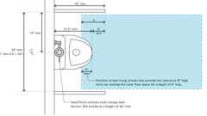

**Urinals and Partitions (CA)**

[**1127A.3 *Accessible Lavatories***](https://up.codes/viewer/california/ca-building-code-2025/chapter/11A/housing-accessibility#1127A.3)

Diagram

*When*[*common use*](https://up.codes/viewer/california/ca-building-code-2025/chapter/2/definitions#common_use_)[*lavatories*](https://up.codes/viewer/california/ca-building-code-2025/chapter/2/definitions#lavatory_)*are provided for residents or guests, at least one, and not less than 1 percent of all*[*lavatories*](https://up.codes/viewer/california/ca-building-code-2025/chapter/2/definitions#lavatory_)*, shall comply with the following:*

1. [***Location***](https://up.codes/viewer/california/ca-building-code-2025/chapter/L/earthquake-recording-instrumentation#L101.2)***.***[*Lavatories*](https://up.codes/viewer/california/ca-building-code-2025/chapter/2/definitions#lavatory_)*shall be installed with the centerline of the fixture a minimum of 18 inches (457 mm) horizontally from an adjoining*[*wall*](https://up.codes/viewer/california/ca-building-code-2025/chapter/2/definitions#wall_)*, partition or fixture. The top of the fixture rim shall be a maximum of 34 inches (864 mm) above the finished floor.*
2. ***Floor***[***space***](https://up.codes/viewer/california/ca-building-code-2025/chapter/2/definitions#space_)***.****A*[*clear floor space*](https://up.codes/viewer/california/ca-building-code-2025/chapter/2/definitions#clear_floor_space_dsa_ac_hcd_1_ac_)*at least 30 inches by 48 inches (762 mm by 1219 mm) shall be provided in front of accessible*[*lavatories*](https://up.codes/viewer/california/ca-building-code-2025/chapter/2/definitions#lavatory_)*to allow forward approach. Such*[*clear floor space*](https://up.codes/viewer/california/ca-building-code-2025/chapter/2/definitions#clear_floor_space_dsa_ac_hcd_1_ac_)*shall adjoin or overlap an*[*accessible route*](https://up.codes/viewer/california/ca-building-code-2025/chapter/2/definitions#accessible_route_dsa_ac_hcd_1_ac_)*or another*[*clear floor space*](https://up.codes/viewer/california/ca-building-code-2025/chapter/2/definitions#clear_floor_space_dsa_ac_hcd_1_ac_)*.*
3. ***Knee and toe***[***space***](https://up.codes/viewer/california/ca-building-code-2025/chapter/2/definitions#space_)***.****A*[*clear*](https://up.codes/viewer/california/ca-building-code-2025/chapter/2/definitions#clear_dsa_ac_)*and obstructed knee and toe*[*space*](https://up.codes/viewer/california/ca-building-code-2025/chapter/2/definitions#space_)*, complying with*[*Section 1138A.2*](https://up.codes/viewer/california/ca-building-code-2025/chapter/11A/housing-accessibility#1138A.2)*, shall be provided underneath the*[*lavatory*](https://up.codes/viewer/california/ca-building-code-2025/chapter/2/definitions#lavatory_)*. The knee and toe*[*space*](https://up.codes/viewer/california/ca-building-code-2025/chapter/2/definitions#space_)*shall be centered on the fixture. The*[*clear floor space*](https://up.codes/viewer/california/ca-building-code-2025/chapter/2/definitions#clear_floor_space_dsa_ac_hcd_1_ac_)*required by Item 2 shall not extend into the knee and toe*[*space*](https://up.codes/viewer/california/ca-building-code-2025/chapter/2/definitions#space_)*more than 19 inches (483 mm). (See*[*Figure*](https://up.codes/viewer/california/ca-building-code-2025/chapter/11B/accessibility-to-public-buildings-public-accommodations-commercial-buildings-and#figure)*11A-9D.)*
4. ***Finished floor.****The finished floor beneath the*[*lavatory*](https://up.codes/viewer/california/ca-building-code-2025/chapter/2/definitions#lavatory_)*shall be extended to the*[*wall*](https://up.codes/viewer/california/ca-building-code-2025/chapter/2/definitions#wall_)*.*
5. ***Plumbing***[***protection***](https://up.codes/viewer/california/ca-building-code-2025/chapter/22/steel#2201.3)***.****Water supply and*[*drain*](https://up.codes/viewer/california/ca-building-code-2025/chapter/2/definitions#drain_)*pipes under*[*lavatories*](https://up.codes/viewer/california/ca-building-code-2025/chapter/2/definitions#lavatory_)*shall be insulated or otherwise covered to protect against contact. There shall be no sharp or abrasive surfaces under*[*lavatories*](https://up.codes/viewer/california/ca-building-code-2025/chapter/2/definitions#lavatory_)*.*
6. [***Lavatory***](https://up.codes/viewer/california/ca-building-code-2025/chapter/2/definitions#lavatory_)***faucet controls****. Faucet controls and*[*operation*](https://up.codes/viewer/california/ca-building-code-2025/chapter/30/elevators-and-conveying-systems#3008.1.4)*mechanisms shall be operable with one hand and shall not require tight grasping, pinching or twisting of the wrist. The force required to activate controls shall be no greater than 5 pounds (22.2N). Lever operated, push type and electronically controlled mechanisms are examples of acceptable*[*designs*](https://up.codes/viewer/california/ca-building-code-2025/chapter/22A/steel#2210A.1.1)*. Hand operated metering faucets are allowed if the faucet remains open for at least 10 seconds.*

**UpCodes Diagrams (2)**

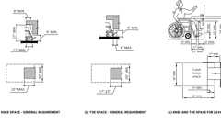Primary

**CA 11A: Figure 11A-9D Knee and Toe Space**



**Grab Bar - Recessed Lavatory**

**Building products (33)**

[[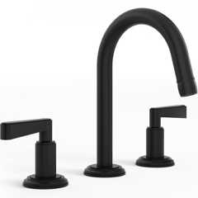](https://up.codes/product/anika-deck-mounted-3-hole-lavatory-set-30-2-tr24?viewer_juris_key=california)](https://up.codes/product/anika-deck-mounted-3-hole-lavatory-set-30-2-tr24?viewer_juris_key=california)

**[Anika Deck Mounted 3-Hole Lavatory Set](https://up.codes/product/anika-deck-mounted-3-hole-lavatory-set-30-2-tr24?viewer_juris_key=california)**

**[Watermark Designs](https://up.codes/product/anika-deck-mounted-3-hole-lavatory-set-30-2-tr24?viewer_juris_key=california)**

[[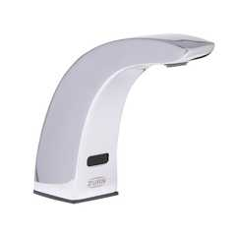](https://up.codes/product/aquasense-4-in-base-sensor-faucet-with-gear-driven-ceramic-cartridge?viewer_juris_key=california)](https://up.codes/product/aquasense-4-in-base-sensor-faucet-with-gear-driven-ceramic-cartridge?viewer_juris_key=california)

**[AquaSense® 4 in. Base Sensor Faucet With Gear-driven Ceramic Cartridge - ZG6915](https://up.codes/product/aquasense-4-in-base-sensor-faucet-with-gear-driven-ceramic-cartridge?viewer_juris_key=california)**

**[Zurn](https://up.codes/product/aquasense-4-in-base-sensor-faucet-with-gear-driven-ceramic-cartridge?viewer_juris_key=california)**

[[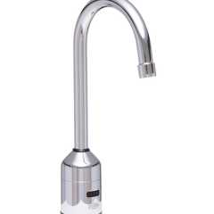](https://up.codes/product/aquasense-5-3-8-in-gooseneck-sensor-faucet-with-gear-driven-ceramic-cartridge?viewer_juris_key=california)](https://up.codes/product/aquasense-5-3-8-in-gooseneck-sensor-faucet-with-gear-driven-ceramic-cartridge?viewer_juris_key=california)

**[AquaSense® 5-3/8 in. Gooseneck Sensor Faucet With Gear-driven Ceramic Cartridge - ZG6920](https://up.codes/product/aquasense-5-3-8-in-gooseneck-sensor-faucet-with-gear-driven-ceramic-cartridge?viewer_juris_key=california)**

**[Zurn](https://up.codes/product/aquasense-5-3-8-in-gooseneck-sensor-faucet-with-gear-driven-ceramic-cartridge?viewer_juris_key=california)**

[[](https://up.codes/product/aquasense-sensor-faucet-with-gear-driven-ceramic-cartridge?viewer_juris_key=california)](https://up.codes/product/aquasense-sensor-faucet-with-gear-driven-ceramic-cartridge?viewer_juris_key=california)

**[AquaSense® Sensor Faucet With Gear-driven Ceramic Cartridge - ZG6913](https://up.codes/product/aquasense-sensor-faucet-with-gear-driven-ceramic-cartridge?viewer_juris_key=california)**

**[Zurn](https://up.codes/product/aquasense-sensor-faucet-with-gear-driven-ceramic-cartridge?viewer_juris_key=california)**

[[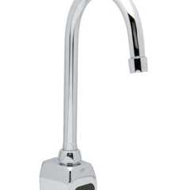](https://up.codes/product/aquasense-wall-mount-5-3-8-in-gooseneck-sensor-faucet-with-gear-driven-ceramic-c?viewer_juris_key=california)](https://up.codes/product/aquasense-wall-mount-5-3-8-in-gooseneck-sensor-faucet-with-gear-driven-ceramic-c?viewer_juris_key=california)

**[AquaSense® Wall Mount 5-3/8 in. Gooseneck Sensor Faucet With Gear-driven Ceramic Cartridge - ZG6922](https://up.codes/product/aquasense-wall-mount-5-3-8-in-gooseneck-sensor-faucet-with-gear-driven-ceramic-c?viewer_juris_key=california)**

**[Zurn](https://up.codes/product/aquasense-wall-mount-5-3-8-in-gooseneck-sensor-faucet-with-gear-driven-ceramic-c?viewer_juris_key=california)**

[[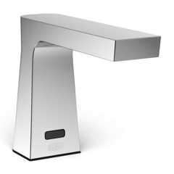](https://up.codes/product/camaya-series-sensor-faucet-with-gear-driven-ceramic-cartridge-hydropower?viewer_juris_key=california)](https://up.codes/product/camaya-series-sensor-faucet-with-gear-driven-ceramic-cartridge-hydropower?viewer_juris_key=california)

**[Camaya Series® Sensor Faucet with Gear-driven Ceramic Cartridge, Hydropower - ZG6953](https://up.codes/product/camaya-series-sensor-faucet-with-gear-driven-ceramic-cartridge-hydropower?viewer_juris_key=california)**

**[Zurn](https://up.codes/product/camaya-series-sensor-faucet-with-gear-driven-ceramic-cartridge-hydropower?viewer_juris_key=california)**

[[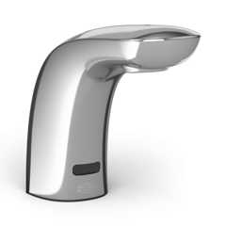](https://up.codes/product/cumberland-series-sensor-faucet-with-gear-driven-ceramic-cartridge?viewer_juris_key=california)](https://up.codes/product/cumberland-series-sensor-faucet-with-gear-driven-ceramic-cartridge?viewer_juris_key=california)

**[Cumberland Series® Sensor Faucet With Gear-driven Ceramic Cartridge - ZG6956](https://up.codes/product/cumberland-series-sensor-faucet-with-gear-driven-ceramic-cartridge?viewer_juris_key=california)**

**[Zurn](https://up.codes/product/cumberland-series-sensor-faucet-with-gear-driven-ceramic-cartridge?viewer_juris_key=california)**

[[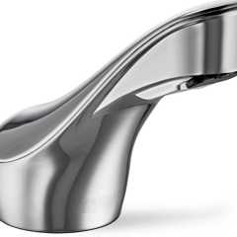](https://up.codes/product/fulmer-series-sensor-faucet-with-gear-driven-ceramic-cartridge?viewer_juris_key=california)](https://up.codes/product/fulmer-series-sensor-faucet-with-gear-driven-ceramic-cartridge?viewer_juris_key=california)

**[Fulmer Series® Sensor Faucet With Gear-driven Ceramic Cartridge - ZG6951](https://up.codes/product/fulmer-series-sensor-faucet-with-gear-driven-ceramic-cartridge?viewer_juris_key=california)**

**[Zurn](https://up.codes/product/fulmer-series-sensor-faucet-with-gear-driven-ceramic-cartridge?viewer_juris_key=california)**

[[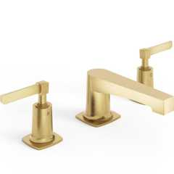](https://up.codes/product/h-line-3-hole-deck-mounted-widespread-lavatory-set-115-2-mz4?viewer_juris_key=california)](https://up.codes/product/h-line-3-hole-deck-mounted-widespread-lavatory-set-115-2-mz4?viewer_juris_key=california)

**[H-Line 3-Hole Deck Mounted Widespread Lavatory Set](https://up.codes/product/h-line-3-hole-deck-mounted-widespread-lavatory-set-115-2-mz4?viewer_juris_key=california)**

**[Watermark Designs](https://up.codes/product/h-line-3-hole-deck-mounted-widespread-lavatory-set-115-2-mz4?viewer_juris_key=california)**

[[](https://up.codes/product/integrated-plumbing-system-aerofoil?viewer_juris_key=california)](https://up.codes/product/integrated-plumbing-system-aerofoil?viewer_juris_key=california)

**[Integrated Plumbing System / Aerofoil - TSL.IPS.AERO](https://up.codes/product/integrated-plumbing-system-aerofoil?viewer_juris_key=california)**

**[The Splash Lab](https://up.codes/product/integrated-plumbing-system-aerofoil?viewer_juris_key=california)**

[[](https://up.codes/product/loft-6-diameter-wall-mounted-towel-ring-22-0-3?viewer_juris_key=california)](https://up.codes/product/loft-6-diameter-wall-mounted-towel-ring-22-0-3?viewer_juris_key=california)

**[Loft 6" Diameter Wall Mounted Towel Ring](https://up.codes/product/loft-6-diameter-wall-mounted-towel-ring-22-0-3?viewer_juris_key=california)**

**[Watermark Designs](https://up.codes/product/loft-6-diameter-wall-mounted-towel-ring-22-0-3?viewer_juris_key=california)**

[[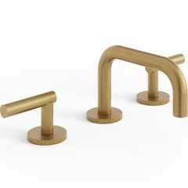](https://up.codes/product/loft-deck-mounted-3-hole-lavatory-set-23-2-17-l8?viewer_juris_key=california)](https://up.codes/product/loft-deck-mounted-3-hole-lavatory-set-23-2-17-l8?viewer_juris_key=california)

**[Loft Deck Mounted 3-Hole Lavatory Set](https://up.codes/product/loft-deck-mounted-3-hole-lavatory-set-23-2-17-l8?viewer_juris_key=california)**

**[Watermark Designs](https://up.codes/product/loft-deck-mounted-3-hole-lavatory-set-23-2-17-l8?viewer_juris_key=california)**

[[](https://up.codes/product/loft-wall-mounted-18-center-to-center-towel-bar-23-0-1?viewer_juris_key=california)](https://up.codes/product/loft-wall-mounted-18-center-to-center-towel-bar-23-0-1?viewer_juris_key=california)

**[Loft Wall Mounted 18" Center-to-Center Towel Bar](https://up.codes/product/loft-wall-mounted-18-center-to-center-towel-bar-23-0-1?viewer_juris_key=california)**

**[Watermark Designs](https://up.codes/product/loft-wall-mounted-18-center-to-center-towel-bar-23-0-1?viewer_juris_key=california)**

[[](https://up.codes/product/loft-wall-mounted-24-center-to-center-towel-bar-23-0-1a?viewer_juris_key=california)](https://up.codes/product/loft-wall-mounted-24-center-to-center-towel-bar-23-0-1a?viewer_juris_key=california)

**[Loft Wall Mounted 24" Center-to-Center Towel Bar](https://up.codes/product/loft-wall-mounted-24-center-to-center-towel-bar-23-0-1a?viewer_juris_key=california)**

**[Watermark Designs](https://up.codes/product/loft-wall-mounted-24-center-to-center-towel-bar-23-0-1a?viewer_juris_key=california)**

[[](https://up.codes/product/lumashelf-integrated-sink?viewer_juris_key=california)](https://up.codes/product/lumashelf-integrated-sink?viewer_juris_key=california)

**[Lumashelf Integrated Sink - TSL.LUMA](https://up.codes/product/lumashelf-integrated-sink?viewer_juris_key=california)**

**[The Splash Lab](https://up.codes/product/lumashelf-integrated-sink?viewer_juris_key=california)**

[[](https://up.codes/product/monolith-a-series?viewer_juris_key=california)](https://up.codes/product/monolith-a-series?viewer_juris_key=california)

**[Monolith A Series - TSL.MON.A](https://up.codes/product/monolith-a-series?viewer_juris_key=california)**

**[The Splash Lab](https://up.codes/product/monolith-a-series?viewer_juris_key=california)**

[[](https://up.codes/product/monolith-b-series?viewer_juris_key=california)](https://up.codes/product/monolith-b-series?viewer_juris_key=california)

**[Monolith B Series - TSL.MON.B](https://up.codes/product/monolith-b-series?viewer_juris_key=california)**

**[The Splash Lab](https://up.codes/product/monolith-b-series?viewer_juris_key=california)**

[[](https://up.codes/product/monolith-c-series?viewer_juris_key=california)](https://up.codes/product/monolith-c-series?viewer_juris_key=california)

**[Monolith C Series - TSL.MON.C](https://up.codes/product/monolith-c-series?viewer_juris_key=california)**

**[The Splash Lab](https://up.codes/product/monolith-c-series?viewer_juris_key=california)**

[[](https://up.codes/product/monolith-d-series?viewer_juris_key=california)](https://up.codes/product/monolith-d-series?viewer_juris_key=california)

**[Monolith D Series - TSL.MON.D](https://up.codes/product/monolith-d-series?viewer_juris_key=california)**

**[The Splash Lab](https://up.codes/product/monolith-d-series?viewer_juris_key=california)**

[[](https://up.codes/product/nano-plus-sink?viewer_juris_key=california)](https://up.codes/product/nano-plus-sink?viewer_juris_key=california)

**[Nano Plus Sink - TSL.NANO.P](https://up.codes/product/nano-plus-sink?viewer_juris_key=california)**

**[The Splash Lab](https://up.codes/product/nano-plus-sink?viewer_juris_key=california)**

[[](https://up.codes/product/nano-smallest-ada-sink?viewer_juris_key=california)](https://up.codes/product/nano-smallest-ada-sink?viewer_juris_key=california)

**[Nano Smallest ADA Sink - TSL.NANO](https://up.codes/product/nano-smallest-ada-sink?viewer_juris_key=california)**

**[The Splash Lab](https://up.codes/product/nano-smallest-ada-sink?viewer_juris_key=california)**

[[](https://up.codes/product/radius-deck-mounted-sensor-faucet-large?viewer_juris_key=california)](https://up.codes/product/radius-deck-mounted-sensor-faucet-large?viewer_juris_key=california)

**[Radius Deck Mounted Sensor Faucet / Large - TSL.960](https://up.codes/product/radius-deck-mounted-sensor-faucet-large?viewer_juris_key=california)**

**[The Splash Lab](https://up.codes/product/radius-deck-mounted-sensor-faucet-large?viewer_juris_key=california)**

[[](https://up.codes/product/radius-deck-mounted-sensor-faucet-small?viewer_juris_key=california)](https://up.codes/product/radius-deck-mounted-sensor-faucet-small?viewer_juris_key=california)

**[Radius Deck Mounted Sensor Faucet / Small - TSL.990](https://up.codes/product/radius-deck-mounted-sensor-faucet-small?viewer_juris_key=california)**

**[The Splash Lab](https://up.codes/product/radius-deck-mounted-sensor-faucet-small?viewer_juris_key=california)**

[[](https://up.codes/product/radius-sensor-faucet-large?viewer_juris_key=california)](https://up.codes/product/radius-sensor-faucet-large?viewer_juris_key=california)

**[Radius Sensor Faucet / Large - TSL.882](https://up.codes/product/radius-sensor-faucet-large?viewer_juris_key=california)**

**[The Splash Lab](https://up.codes/product/radius-sensor-faucet-large?viewer_juris_key=california)**

[[](https://up.codes/product/radius-sensor-faucet-small?viewer_juris_key=california)](https://up.codes/product/radius-sensor-faucet-small?viewer_juris_key=california)

**[Radius Sensor Faucet / Small - TSL.884](https://up.codes/product/radius-sensor-faucet-small?viewer_juris_key=california)**

**[The Splash Lab](https://up.codes/product/radius-sensor-faucet-small?viewer_juris_key=california)**

[[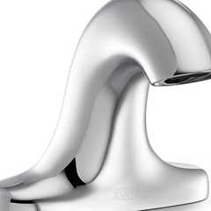](https://up.codes/product/serio-series-4-in-base-sensor-faucet-with-gear-driven-ceramic-cartridge?viewer_juris_key=california)](https://up.codes/product/serio-series-4-in-base-sensor-faucet-with-gear-driven-ceramic-cartridge?viewer_juris_key=california)

**[Serio Series® 4 in. Base Sensor Faucet With Gear-driven Ceramic Cartridge - ZG6955](https://up.codes/product/serio-series-4-in-base-sensor-faucet-with-gear-driven-ceramic-cartridge?viewer_juris_key=california)**

**[Zurn](https://up.codes/product/serio-series-4-in-base-sensor-faucet-with-gear-driven-ceramic-cartridge?viewer_juris_key=california)**

[[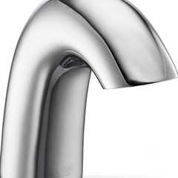](https://up.codes/product/serio-series-sensor-faucet-with-gear-driven-ceramic-cartridge?viewer_juris_key=california)](https://up.codes/product/serio-series-sensor-faucet-with-gear-driven-ceramic-cartridge?viewer_juris_key=california)

**[Serio Series® Sensor Faucet With Gear-driven Ceramic Cartridge - ZG6950](https://up.codes/product/serio-series-sensor-faucet-with-gear-driven-ceramic-cartridge?viewer_juris_key=california)**

**[Zurn](https://up.codes/product/serio-series-sensor-faucet-with-gear-driven-ceramic-cartridge?viewer_juris_key=california)**

[[](https://up.codes/product/straight-spout-faucet-small?viewer_juris_key=california)](https://up.codes/product/straight-spout-faucet-small?viewer_juris_key=california)

**[Straight Spout Faucet / Small - TSL.980](https://up.codes/product/straight-spout-faucet-small?viewer_juris_key=california)**

**[The Splash Lab](https://up.codes/product/straight-spout-faucet-small?viewer_juris_key=california)**

[[](https://up.codes/product/the-aerofoil-basin?viewer_juris_key=california)](https://up.codes/product/the-aerofoil-basin?viewer_juris_key=california)

**[The Aerofoil Basin - TSL.AERO](https://up.codes/product/the-aerofoil-basin?viewer_juris_key=california)**

**[The Splash Lab](https://up.codes/product/the-aerofoil-basin?viewer_juris_key=california)**

[[](https://up.codes/product/the-channel-faucet?viewer_juris_key=california)](https://up.codes/product/the-channel-faucet?viewer_juris_key=california)

**[The Channel Faucet - TSL.C.050](https://up.codes/product/the-channel-faucet?viewer_juris_key=california)**

**[The Splash Lab](https://up.codes/product/the-channel-faucet?viewer_juris_key=california)**

[[](https://up.codes/product/the-ribbon-faucet?viewer_juris_key=california)](https://up.codes/product/the-ribbon-faucet?viewer_juris_key=california)

**[The Ribbon Faucet - TSL.R.020](https://up.codes/product/the-ribbon-faucet?viewer_juris_key=california)**

**[The Splash Lab](https://up.codes/product/the-ribbon-faucet?viewer_juris_key=california)**

[[](https://up.codes/product/titanium-wall-mounted-paper-holder-22-0-4?viewer_juris_key=california)](https://up.codes/product/titanium-wall-mounted-paper-holder-22-0-4?viewer_juris_key=california)

**[Titanium Wall Mounted Paper Holder](https://up.codes/product/titanium-wall-mounted-paper-holder-22-0-4?viewer_juris_key=california)**

**[Watermark Designs](https://up.codes/product/titanium-wall-mounted-paper-holder-22-0-4?viewer_juris_key=california)**

[[](https://up.codes/product/titanium-wall-mounted-robe-hook-22-0-5?viewer_juris_key=california)](https://up.codes/product/titanium-wall-mounted-robe-hook-22-0-5?viewer_juris_key=california)

**[Titanium Wall Mounted Robe Hook](https://up.codes/product/titanium-wall-mounted-robe-hook-22-0-5?viewer_juris_key=california)**

**[Watermark Designs](https://up.codes/product/titanium-wall-mounted-robe-hook-22-0-5?viewer_juris_key=california)**

[**1127A.4 *Grab Bars, Tub and Shower Seats, Fasteners and Mounting Devices***](https://up.codes/viewer/california/ca-building-code-2025/chapter/11A/housing-accessibility#1127A.4)

[**1127A.4.1 *General***](https://up.codes/viewer/california/ca-building-code-2025/chapter/11A/housing-accessibility#1127A.4.1)

[*Grab bars*](https://up.codes/viewer/california/ca-building-code-2025/chapter/2/definitions#grab_bar_dsa_ac_hcd_1_ac_)*, tub and shower seats, fasteners and mounting devices required by this chapter shall comply with this section.*

[**1127A.4.2 *Location***](https://up.codes/viewer/california/ca-building-code-2025/chapter/11A/housing-accessibility#1127A.4.2)

[*Grab bars*](https://up.codes/viewer/california/ca-building-code-2025/chapter/2/definitions#grab_bar_dsa_ac_hcd_1_ac_)*shall be installed in a horizontal position, 33 inches (838 mm) minimum and 36 inches (914 mm) maximum above the finish floor measured to the top of the gripping surface.*

***Exception:****The height of the lower*[*grab bar*](https://up.codes/viewer/california/ca-building-code-2025/chapter/2/definitions#grab_bar_dsa_ac_hcd_1_ac_)*on the back*[*wall*](https://up.codes/viewer/california/ca-building-code-2025/chapter/2/definitions#wall_)*of a bathtub shall comply with*[*Section 1127A.5.2*](https://up.codes/viewer/california/ca-building-code-2025/chapter/11A/housing-accessibility#1127A.5.2)*.*

[**1127A.4.3 *Diameter or Width***](https://up.codes/viewer/california/ca-building-code-2025/chapter/11A/housing-accessibility#1127A.4.3)

Diagram

*The diameter or width of the gripping surfaces of a*[*grab bar*](https://up.codes/viewer/california/ca-building-code-2025/chapter/2/definitions#grab_bar_dsa_ac_hcd_1_ac_)*shall comply with the following:*

***Note:****See*[*Figure*](https://up.codes/viewer/california/ca-building-code-2025/chapter/11B/accessibility-to-public-buildings-public-accommodations-commercial-buildings-and#figure)*11A-9C.*

1. ***Circular cross section.***[*Grab bars*](https://up.codes/viewer/california/ca-building-code-2025/chapter/2/definitions#grab_bar_dsa_ac_hcd_1_ac_)*with circular cross section shall have an outside diameter of 11/4inches (32 mm) minimum and 2 inches (51 mm) maximum.*
2. ***Noncircular cross section.***[*Grab bars*](https://up.codes/viewer/california/ca-building-code-2025/chapter/2/definitions#grab_bar_dsa_ac_hcd_1_ac_)*with noncircular cross section shall have a cross-section dimension of 2 inches (51 mm) maximum. The perimeter dimension of*[*grab bars*](https://up.codes/viewer/california/ca-building-code-2025/chapter/2/definitions#grab_bar_dsa_ac_hcd_1_ac_)*with non-circular cross section shall be 4 inches (102 mm) minimum and 4.8 inches (122 mm) maximum.*
3. ***Alternate configuration.****L-shaped or U-shaped*[*grab bars*](https://up.codes/viewer/california/ca-building-code-2025/chapter/2/definitions#grab_bar_dsa_ac_hcd_1_ac_)*shall be permitted.*

**UpCodes Diagram (1)**

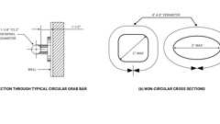Primary

**CA 11A: Figure 11A-9C Grab Bars**

[**1127A.4.4 *Structural Strength***](https://up.codes/viewer/california/ca-building-code-2025/chapter/11A/housing-accessibility#1127A.4.4)

*The structural*[*strength*](https://up.codes/viewer/california/ca-building-code-2025/chapter/2/definitions#strength_)*of*[*grab bars*](https://up.codes/viewer/california/ca-building-code-2025/chapter/2/definitions#grab_bar_dsa_ac_hcd_1_ac_)*, tub and shower seats, fasteners and mounting devices shall meet the following specifications:*

1. *Bending stress in a*[*grab bar*](https://up.codes/viewer/california/ca-building-code-2025/chapter/2/definitions#grab_bar_dsa_ac_hcd_1_ac_)*or seat induced by the maximum bending moment from the*[*application*](https://up.codes/viewer/california/ca-building-code-2025/chapter/25/gypsum-panel-products-and-plaster#2501.1.1)*of a 250-pound (1112 N) point load shall be less than the allowable stress for the material of the*[*grab bar*](https://up.codes/viewer/california/ca-building-code-2025/chapter/2/definitions#grab_bar_dsa_ac_hcd_1_ac_)*or seat.*
2. *Shear stress induced in a*[*grab bar*](https://up.codes/viewer/california/ca-building-code-2025/chapter/2/definitions#grab_bar_dsa_ac_hcd_1_ac_)*or seat by the*[*application*](https://up.codes/viewer/california/ca-building-code-2025/chapter/25/gypsum-panel-products-and-plaster#2501.1.1)*of a 250-pound (1112 N) point load shall be less than the allowable shear stress for the material of the*[*grab bar*](https://up.codes/viewer/california/ca-building-code-2025/chapter/2/definitions#grab_bar_dsa_ac_hcd_1_ac_)*or seat, and if its mounting bracket or other support is considered to be fully restrained, then direct and torsional shear stresses shall not exceed the allowable shear stress.*
3. *Shear force induced in a fastener or mounting device from the*[*application*](https://up.codes/viewer/california/ca-building-code-2025/chapter/25/gypsum-panel-products-and-plaster#2501.1.1)*of a 250-pound (1112 N) point load shall be less than the allowable lateral load of either the fastener or mounting device or the supporting structure, whichever is the smaller allowable load.*
4. *Tensile force induced in a fastener by a direct tension force of a 250-pound (1112 N) point load, plus the maximum moment from the*[*application*](https://up.codes/viewer/california/ca-building-code-2025/chapter/25/gypsum-panel-products-and-plaster#2501.1.1)*of a 250-pound (1112 N) point load, shall be less than the allowable withdrawal load between the fastener and supporting structure.*
5. [*Grab bars*](https://up.codes/viewer/california/ca-building-code-2025/chapter/2/definitions#grab_bar_dsa_ac_hcd_1_ac_)*shall not rotate within their fittings.*

[**1127A.4.5 *Surface***](https://up.codes/viewer/california/ca-building-code-2025/chapter/11A/housing-accessibility#1127A.4.5)

*A*[*grab bar*](https://up.codes/viewer/california/ca-building-code-2025/chapter/2/definitions#grab_bar_dsa_ac_hcd_1_ac_)*and any*[*wall*](https://up.codes/viewer/california/ca-building-code-2025/chapter/2/definitions#wall_)*or other surface adjacent to it shall be free of any sharp or abrasive*[*elements*](https://up.codes/viewer/california/ca-building-code-2025/chapter/2/definitions#element_dsa_ac_)*and shall have rounded edges.*

[**1127A.4.6 *Spacing***](https://up.codes/viewer/california/ca-building-code-2025/chapter/11A/housing-accessibility#1127A.4.6)

Diagram

*When*[*grab bars*](https://up.codes/viewer/california/ca-building-code-2025/chapter/2/definitions#grab_bar_dsa_ac_hcd_1_ac_)*are mounted adjacent to a*[*wall*](https://up.codes/viewer/california/ca-building-code-2025/chapter/2/definitions#wall_)*, the*[*space*](https://up.codes/viewer/california/ca-building-code-2025/chapter/2/definitions#space_)*between the*[*wall*](https://up.codes/viewer/california/ca-building-code-2025/chapter/2/definitions#wall_)*and the*[*grab bars*](https://up.codes/viewer/california/ca-building-code-2025/chapter/2/definitions#grab_bar_dsa_ac_hcd_1_ac_)*shall be 11/2inches (38 mm). (See*[*Figure*](https://up.codes/viewer/california/ca-building-code-2025/chapter/11B/accessibility-to-public-buildings-public-accommodations-commercial-buildings-and#figure)*11A-9C.) The*[*space*](https://up.codes/viewer/california/ca-building-code-2025/chapter/2/definitions#space_)*between the*[*grab bar*](https://up.codes/viewer/california/ca-building-code-2025/chapter/2/definitions#grab_bar_dsa_ac_hcd_1_ac_)*and projecting objects below and at the ends shall be 11/2inches (38 mm) minimum. The*[*space*](https://up.codes/viewer/california/ca-building-code-2025/chapter/2/definitions#space_)*between the*[*grab bar*](https://up.codes/viewer/california/ca-building-code-2025/chapter/2/definitions#grab_bar_dsa_ac_hcd_1_ac_)*and projecting objects above shall be 12 inches (305 mm) minimum.*

***Exceptions:***

1. *The*[*space*](https://up.codes/viewer/california/ca-building-code-2025/chapter/2/definitions#space_)*between the*[*grab bars*](https://up.codes/viewer/california/ca-building-code-2025/chapter/2/definitions#grab_bar_dsa_ac_hcd_1_ac_)*and shower controls, shower fittings and other*[*grab bars*](https://up.codes/viewer/california/ca-building-code-2025/chapter/2/definitions#grab_bar_dsa_ac_hcd_1_ac_)*above shall be permitted to be 11/2inches (38 mm) minimum.*
2. *For L-shaped or U-shaped*[*grab bars*](https://up.codes/viewer/california/ca-building-code-2025/chapter/2/definitions#grab_bar_dsa_ac_hcd_1_ac_)*the*[*space*](https://up.codes/viewer/california/ca-building-code-2025/chapter/2/definitions#space_)*between the*[*walls*](https://up.codes/viewer/california/ca-building-code-2025/chapter/2/definitions#wall_)*and the*[*grab bar*](https://up.codes/viewer/california/ca-building-code-2025/chapter/2/definitions#grab_bar_dsa_ac_hcd_1_ac_)*shall be 11/2inches (38 mm) minimum for a distance of 6 inches (152 mm) on either side of the inside corner between two adjacent*[*wall*](https://up.codes/viewer/california/ca-building-code-2025/chapter/2/definitions#wall_)*surfaces.*

**UpCodes Diagrams (2)**

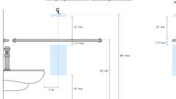

**Toilet Paper Dispenser: Non-Recessed (CA)**



**CA 11A: Figure 11A-9C Grab Bars**

[**1127A.5 *Bathing Facilities***](https://up.codes/viewer/california/ca-building-code-2025/chapter/11A/housing-accessibility#1127A.5)

[**1127A.5.1 *General***](https://up.codes/viewer/california/ca-building-code-2025/chapter/11A/housing-accessibility#1127A.5.1)

*When*[*common use*](https://up.codes/viewer/california/ca-building-code-2025/chapter/2/definitions#common_use_)*bathing*[*facilities*](https://up.codes/viewer/california/ca-building-code-2025/chapter/2/definitions#facility_)*are provided for residents or guests, including showers, bathtubs or lockers, at least one of each type of fixture in each*[*facility*](https://up.codes/viewer/california/ca-building-code-2025/chapter/2/definitions#facility_)*, and not less than 1 percent of all fixtures, shall comply with this section.*

[**1127A.5.2 *Bathtubs***](https://up.codes/viewer/california/ca-building-code-2025/chapter/11A/housing-accessibility#1127A.5.2)

Diagram

*Bathtubs required to be accessible shall comply with the following:*

**UpCodes Diagram (1)**

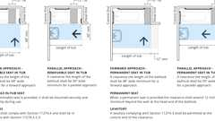Primary

**Common Use Bathtubs (CA 11A)**

**Building product (1)**

[[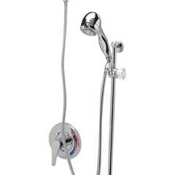](https://up.codes/product/temp-gard-iii-tub-and-hand-wall-shower-unit-w-24-slide-bar-60-metal-hose-npt-con?viewer_juris_key=california)](https://up.codes/product/temp-gard-iii-tub-and-hand-wall-shower-unit-w-24-slide-bar-60-metal-hose-npt-con?viewer_juris_key=california)

**[Temp-Gard® III Tub and Hand Wall Shower Unit w/ 24 Slide Bar 60 Metal Hose NPT Connections and Vacuum Breaker - Z7300-SS-MT-HW6](https://up.codes/product/temp-gard-iii-tub-and-hand-wall-shower-unit-w-24-slide-bar-60-metal-hose-npt-con?viewer_juris_key=california)**

**[Zurn](https://up.codes/product/temp-gard-iii-tub-and-hand-wall-shower-unit-w-24-slide-bar-60-metal-hose-npt-con?viewer_juris_key=california)**

[**1127A.5.2.1 *Floor Space***](https://up.codes/viewer/california/ca-building-code-2025/chapter/11A/housing-accessibility#1127A.5.2.1)

Diagram

*Clearance in front of bathtubs shall extend the length of the bathtub and shall be 48 inches (1219 mm) wide minimum for forward approach and 30 inches (762 mm) wide minimum for parallel approach. A*[*lavatory*](https://up.codes/viewer/california/ca-building-code-2025/chapter/2/definitions#lavatory_)*complying with*[*Section 1127A.3*](https://up.codes/viewer/california/ca-building-code-2025/chapter/11A/housing-accessibility#1127A.3)*shall be permitted at the control end of the clearance. When a*[*permanent*](https://up.codes/viewer/california/ca-building-code-2025/chapter/2/definitions#permanent_dsa_ac_)*seat is provided at the head end of the bathtub, the clearance shall extend 12 inches (305 mm) minimum beyond the*[*wall*](https://up.codes/viewer/california/ca-building-code-2025/chapter/2/definitions#wall_)*at the head end of the bathtub. (See*[*Figure*](https://up.codes/viewer/california/ca-building-code-2025/chapter/11B/accessibility-to-public-buildings-public-accommodations-commercial-buildings-and#figure)*11A-9E.)*

**UpCodes Diagram (1)**

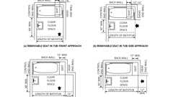Primary

**CA 11A: Figure 11A-9E Clear Floor Space at Bathtubs**

[**1127A.5.2.2 *Seat***](https://up.codes/viewer/california/ca-building-code-2025/chapter/11A/housing-accessibility#1127A.5.2.2)

*A removable in-tub seat or a*[*permanent*](https://up.codes/viewer/california/ca-building-code-2025/chapter/2/definitions#permanent_dsa_ac_)*seat at the head end of the tub shall be provided. The structural*[*strength*](https://up.codes/viewer/california/ca-building-code-2025/chapter/2/definitions#strength_)*of seats and their attachments shall comply with*[*Section 1127A.4.4*](https://up.codes/viewer/california/ca-building-code-2025/chapter/11A/housing-accessibility#1127A.4.4)*. Seats shall be mounted securely and shall not slip during use.*

* *The top of bathtub seats shall be 17 inches (432 mm) minimum and 19 inches (483 mm) maximum above the*[*bathroom*](https://up.codes/viewer/california/ca-building-code-2025/chapter/2/definitions#bathroom_)*finish floor. The depth of a removable in-tub seat shall be 15 inches (381 mm) minimum and 16 inches (406 mm) maximum.*[*Permanent*](https://up.codes/viewer/california/ca-building-code-2025/chapter/2/definitions#permanent_dsa_ac_)*seats at the head end of the bathtub shall be 15 inches (381 mm) deep minimum and shall extend from the back*[*wall*](https://up.codes/viewer/california/ca-building-code-2025/chapter/2/definitions#wall_)*to or beyond the outer edge of the bathtub. (See*[*Figure*](https://up.codes/viewer/california/ca-building-code-2025/chapter/11B/accessibility-to-public-buildings-public-accommodations-commercial-buildings-and#figure)*11A-9E.)*

[**1127A.5.2.3 *Grab Bars***](https://up.codes/viewer/california/ca-building-code-2025/chapter/11A/housing-accessibility#1127A.5.2.3)

[*Grab bars*](https://up.codes/viewer/california/ca-building-code-2025/chapter/2/definitions#grab_bar_dsa_ac_hcd_1_ac_)*complying with*[*Section 1127A.4*](https://up.codes/viewer/california/ca-building-code-2025/chapter/11A/housing-accessibility#1127A.4)*shall be provided in accordance with this section. (See*[*Figure*](https://up.codes/viewer/california/ca-building-code-2025/chapter/11B/accessibility-to-public-buildings-public-accommodations-commercial-buildings-and#figure)*11A-9F.) When separate*[*grab bars*](https://up.codes/viewer/california/ca-building-code-2025/chapter/2/definitions#grab_bar_dsa_ac_hcd_1_ac_)*are required on adjacent*[*walls*](https://up.codes/viewer/california/ca-building-code-2025/chapter/2/definitions#wall_)*at a common mounting height, an L-shaped or U-shaped*[*grab bar*](https://up.codes/viewer/california/ca-building-code-2025/chapter/2/definitions#grab_bar_dsa_ac_hcd_1_ac_)*meeting the dimensional requirements of this section shall be permitted.*

1. ***Bathtubs with***[***permanent***](https://up.codes/viewer/california/ca-building-code-2025/chapter/2/definitions#permanent_dsa_ac_)***seats.****Two horizontal*[*grab bars*](https://up.codes/viewer/california/ca-building-code-2025/chapter/2/definitions#grab_bar_dsa_ac_hcd_1_ac_)*shall be installed on the back*[*wall*](https://up.codes/viewer/california/ca-building-code-2025/chapter/2/definitions#wall_)*. One shall be located 33 inches (838 mm) minimum and 36 inches (914 mm) maximum above the finish floor measured to the top of the gripping surface, and the other shall be located 8 inches (203 mm) minimum and 10 inches (254 mm) maximum above the rim of the bathtub. Each*[*grab bar*](https://up.codes/viewer/california/ca-building-code-2025/chapter/2/definitions#grab_bar_dsa_ac_hcd_1_ac_)*shall be 48 inches (1219 mm) long minimum, and shall be installed 15 inches (381 mm) maximum from the head end*[*wall*](https://up.codes/viewer/california/ca-building-code-2025/chapter/2/definitions#wall_)*and 12 inches (305 mm) maximum from the control end*[*wall*](https://up.codes/viewer/california/ca-building-code-2025/chapter/2/definitions#wall_)*.*
   * *A*[*grab bar*](https://up.codes/viewer/california/ca-building-code-2025/chapter/2/definitions#grab_bar_dsa_ac_hcd_1_ac_)*24 inches (610 mm) long minimum shall be installed on the control end*[*wall*](https://up.codes/viewer/california/ca-building-code-2025/chapter/2/definitions#wall_)*at the front edge of the bathtub.*
2. ***Bathtubs with removable seats.****Two horizontal*[*grab bars*](https://up.codes/viewer/california/ca-building-code-2025/chapter/2/definitions#grab_bar_dsa_ac_hcd_1_ac_)*shall be installed on the back*[*wall*](https://up.codes/viewer/california/ca-building-code-2025/chapter/2/definitions#wall_)*. One shall be located 33 inches (838 mm) minimum and 36 inches (914 mm) maximum above the finish floor measured to the top of the gripping surface, and the other shall be located 8 inches (203 mm) minimum and 10 inches (254 mm) maximum above the rim of the bathtub. Each*[*grab bar*](https://up.codes/viewer/california/ca-building-code-2025/chapter/2/definitions#grab_bar_dsa_ac_hcd_1_ac_)*shall be 24 inches (610 mm) long minimum and shall be installed 24 inches (610 mm) maximum from the head end*[*wall*](https://up.codes/viewer/california/ca-building-code-2025/chapter/2/definitions#wall_)*and 12 inches (305 mm) maximum from the control end*[*wall*](https://up.codes/viewer/california/ca-building-code-2025/chapter/2/definitions#wall_)*.*
   * *A*[*grab bar*](https://up.codes/viewer/california/ca-building-code-2025/chapter/2/definitions#grab_bar_dsa_ac_hcd_1_ac_)*24 inches (610 mm) long minimum shall be installed on the control end*[*wall*](https://up.codes/viewer/california/ca-building-code-2025/chapter/2/definitions#wall_)*at the front edge of the bathtub. A*[*grab bar*](https://up.codes/viewer/california/ca-building-code-2025/chapter/2/definitions#grab_bar_dsa_ac_hcd_1_ac_)*12 inches (305 mm) long minimum shall be installed on the head end*[*wall*](https://up.codes/viewer/california/ca-building-code-2025/chapter/2/definitions#wall_)*at the front edge of the bathtub.*

[**1127A.5.2.4 *Controls***](https://up.codes/viewer/california/ca-building-code-2025/chapter/11A/housing-accessibility#1127A.5.2.4)

Diagram

*Faucets and controls (other than*[*drain*](https://up.codes/viewer/california/ca-building-code-2025/chapter/2/definitions#drain_)*stoppers) shall be located on an end*[*wall*](https://up.codes/viewer/california/ca-building-code-2025/chapter/2/definitions#wall_)*between the bathtub rim and*[*grab bar*](https://up.codes/viewer/california/ca-building-code-2025/chapter/2/definitions#grab_bar_dsa_ac_hcd_1_ac_)*, and between the open side of the bathtub and the centerline of the width of the bathtub. (See*[*Figure*](https://up.codes/viewer/california/ca-building-code-2025/chapter/11B/accessibility-to-public-buildings-public-accommodations-commercial-buildings-and#figure)*11A-9F.)*

*Controls shall be operable with one hand and shall not require tight grasping, pinching or twisting of the wrist. The force required to activate controls shall be no greater than 5 pounds (22.2 N).*

**UpCodes Diagram (1)**

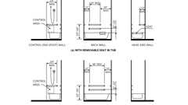Primary

**CA 11A: Figure 11A-9F Grab Bars at Bathtubs**

**Building products (2)**

[[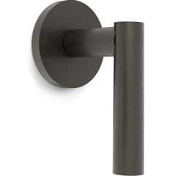](https://up.codes/product/loft-wall-mounted-trim-23-wtr-l8?viewer_juris_key=california)](https://up.codes/product/loft-wall-mounted-trim-23-wtr-l8?viewer_juris_key=california)

**[Loft Wall Mounted Trim](https://up.codes/product/loft-wall-mounted-trim-23-wtr-l8?viewer_juris_key=california)**

**[Watermark Designs](https://up.codes/product/loft-wall-mounted-trim-23-wtr-l8?viewer_juris_key=california)**

[[](https://up.codes/product/temp-gard-iii-tub-and-hand-wall-shower-unit-w-24-slide-bar-60-metal-hose-npt-con?viewer_juris_key=california)](https://up.codes/product/temp-gard-iii-tub-and-hand-wall-shower-unit-w-24-slide-bar-60-metal-hose-npt-con?viewer_juris_key=california)

**[Temp-Gard® III Tub and Hand Wall Shower Unit w/ 24 Slide Bar 60 Metal Hose NPT Connections and Vacuum Breaker - Z7300-SS-MT-HW6](https://up.codes/product/temp-gard-iii-tub-and-hand-wall-shower-unit-w-24-slide-bar-60-metal-hose-npt-con?viewer_juris_key=california)**

**[Zurn](https://up.codes/product/temp-gard-iii-tub-and-hand-wall-shower-unit-w-24-slide-bar-60-metal-hose-npt-con?viewer_juris_key=california)**

[**1127A.5.2.5 *Shower Spray Unit***](https://up.codes/viewer/california/ca-building-code-2025/chapter/11A/housing-accessibility#1127A.5.2.5)

*A shower spray unit with a hose at least 59 inches (1524 mm) long that can be used both as a fixed shower head and as a hand-held shower shall be provided.*

*The shower spray unit shall have an on/off control with a non-positive shut-off. If an adjustable-height shower head on a vertical bar is used, the bar shall be installed so as not to obstruct the use of the*[*grab bars*](https://up.codes/viewer/california/ca-building-code-2025/chapter/2/definitions#grab_bar_dsa_ac_hcd_1_ac_)*.*

**Building product (1)**

[[](https://up.codes/product/temp-gard-iii-tub-and-hand-wall-shower-unit-w-24-slide-bar-60-metal-hose-npt-con?viewer_juris_key=california)](https://up.codes/product/temp-gard-iii-tub-and-hand-wall-shower-unit-w-24-slide-bar-60-metal-hose-npt-con?viewer_juris_key=california)

**[Temp-Gard® III Tub and Hand Wall Shower Unit w/ 24 Slide Bar 60 Metal Hose NPT Connections and Vacuum Breaker - Z7300-SS-MT-HW6](https://up.codes/product/temp-gard-iii-tub-and-hand-wall-shower-unit-w-24-slide-bar-60-metal-hose-npt-con?viewer_juris_key=california)**

**[Zurn](https://up.codes/product/temp-gard-iii-tub-and-hand-wall-shower-unit-w-24-slide-bar-60-metal-hose-npt-con?viewer_juris_key=california)**

[**1127A.5.2.6 *Bathtub Enclosures***](https://up.codes/viewer/california/ca-building-code-2025/chapter/11A/housing-accessibility#1127A.5.2.6)

*When provided, enclosures for bathtubs shall not obstruct controls, faucets, shower and spray units, or obstruct transfer from*[*wheelchairs*](https://up.codes/viewer/california/ca-building-code-2025/chapter/2/definitions#wheelchair_hcd_1_ac_dsa_ac_)*onto bathtub seats or into bathtubs. Enclosures on bathtubs shall not have tracks installed on the rim of the open face of the bathtub.*

[**1127A.5.3 *Shower Compartments***](https://up.codes/viewer/california/ca-building-code-2025/chapter/11A/housing-accessibility#1127A.5.3)

Diagram

*Shower compartments required to be accessible shall comply with this section. (See*[*Figures*](https://up.codes/viewer/california/ca-building-code-2025/chapter/11B/accessibility-to-public-buildings-public-accommodations-commercial-buildings-and#figure)*11A-9H, 11A-9I, 11A-9J and 11A-9K.)*

**UpCodes Diagrams (2)**

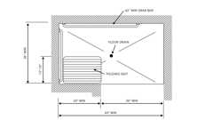Primary

**CA 11A: Figure 11A-9K Alternate Roll-in Shower**

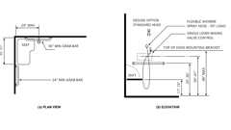Primary

**CA 11A: Figure 11A-9J Open Shower**

**Building product (1)**

[[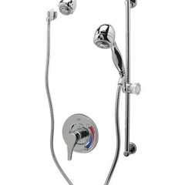](https://up.codes/product/temp-gard-iii-shower-unit-4?viewer_juris_key=california)](https://up.codes/product/temp-gard-iii-shower-unit-4?viewer_juris_key=california)

**[Temp-Gard® III Shower Unit - Z7300-SS-HW2-MT](https://up.codes/product/temp-gard-iii-shower-unit-4?viewer_juris_key=california)**

**[Zurn](https://up.codes/product/temp-gard-iii-shower-unit-4?viewer_juris_key=california)**

[**1127A.5.3.1 *Size and Clearance***](https://up.codes/viewer/california/ca-building-code-2025/chapter/11A/housing-accessibility#1127A.5.3.1)

Diagram

1. ***Standard roll-in shower compartments.****Standard roll-in shower compartments shall meet one of the following:*
   1. *1.1.   30 inches (762 mm) minimum in depth and 60 inches (1524 mm) minimum in width between*[*wall*](https://up.codes/viewer/california/ca-building-code-2025/chapter/2/definitions#wall_)*surfaces measured at center points of opposing sides, with a full opening width on the long side.*
      * *A*[*clear floor space*](https://up.codes/viewer/california/ca-building-code-2025/chapter/2/definitions#clear_floor_space_dsa_ac_hcd_1_ac_)*30 inches (914 mm) minimum by 60 inches (1524 mm) minimum shall be provided adjacent to the open face of the shower compartment.*
   2. *1.2.   42 inches (1067 mm) in width between*[*wall*](https://up.codes/viewer/california/ca-building-code-2025/chapter/2/definitions#wall_)*surfaces, and 48 inches (1219 mm) minimum in depth with an*[*entrance*](https://up.codes/viewer/california/ca-building-code-2025/chapter/2/definitions#entrance_hcd_1_hcd_2_hcd_1_ac_and_dsa_ac_)*opening of 42 inches (1067 mm).*
2. ***Alternate roll-in shower compartments.****Alternate roll-in shower compartments shall be 36 inches (914 mm) minimum in depth and 60 inches (1524 mm) minimum in width between*[*wall*](https://up.codes/viewer/california/ca-building-code-2025/chapter/2/definitions#wall_)*surfaces measured at center points of opposing sides. A 36-inch (914 mm) wide minimum entry shall be provided at one end of the long side of the compartment.*

**UpCodes Diagrams (2)**



**CA 11A: Figure 11A-9H Standard Roll-in Shower - Part (a)**



**CA 11A: Figure 11A-9H Standard Roll-in Shower - Part (b)**

[**1127A.5.3.2 *Thresholds***](https://up.codes/viewer/california/ca-building-code-2025/chapter/11A/housing-accessibility#1127A.5.3.2)

Diagram

[*Thresholds*](https://up.codes/viewer/california/ca-building-code-2025/chapter/10/means-of-egress#1010.1.6)*in roll-in shower compartments shall be*[*1*](https://up.codes/viewer/california/ca-building-code-2025/chapter/1/administration#1)*/*[*2*](https://up.codes/viewer/california/ca-building-code-2025/chapter/2/definitions#2)*inch (12.7 mm) maximum in height and shall be beveled with a*[*slope*](https://up.codes/viewer/california/ca-building-code-2025/chapter/J/grading#slope_)*no greater than one unit vertical in two units horizontal (50-percent*[*slope*](https://up.codes/viewer/california/ca-building-code-2025/chapter/J/grading#slope_)*). (See*[*Figure*](https://up.codes/viewer/california/ca-building-code-2025/chapter/11B/accessibility-to-public-buildings-public-accommodations-commercial-buildings-and#figure)*11A-1F.)*

***Exception:****Changes in level not exceeding 1/4inch (6.35 mm) shall be permitted to be vertical.*

**UpCodes Diagrams (3)**

Primary

**CA 11A: Figure 11A-1F Change in Level**



**CA 11A: Figure 11A-9H Standard Roll-in Shower - Part (a)**



**CA 11A: Figure 11A-9H Standard Roll-in Shower - Part (b)**

[**1127A.5.3.3 *Enclosures***](https://up.codes/viewer/california/ca-building-code-2025/chapter/11A/housing-accessibility#1127A.5.3.3)

*Enclosures, when provided for shower compartments, shall not obstruct controls, faucets, shower spray units and transfer from*[*wheelchairs*](https://up.codes/viewer/california/ca-building-code-2025/chapter/2/definitions#wheelchair_hcd_1_ac_dsa_ac_)*onto shower seats.*

[**1127A.5.3.4 *Floor***](https://up.codes/viewer/california/ca-building-code-2025/chapter/11A/housing-accessibility#1127A.5.3.4)

*Shower compartment floor surfaces shall be stable, firm and*[*slip resistant*](https://up.codes/viewer/california/ca-building-code-2025/chapter/2/definitions#slip_resistant_)*. The maximum*[*slope*](https://up.codes/viewer/california/ca-building-code-2025/chapter/J/grading#slope_)*of the floor shall be 1/4inch (6.35 mm) per foot (2.083 percent*[*slope*](https://up.codes/viewer/california/ca-building-code-2025/chapter/J/grading#slope_)*) in any direction. When*[*drains*](https://up.codes/viewer/california/ca-building-code-2025/chapter/2/definitions#drain_)*are provided, grate*[*openings*](https://up.codes/viewer/california/ca-building-code-2025/chapter/7/fire-and-smoke-protection-features#712.1.13)*shall be 1/4inch (6.35 mm) maximum and located flush with the floor surface.*

[**1127A.5.3.5 *Controls***](https://up.codes/viewer/california/ca-building-code-2025/chapter/11A/housing-accessibility#1127A.5.3.5)

*Controls, faucets and shower spray units in shower compartments shall be operable with one hand, and shall not require tight grasping, pinching or twisting of the wrist. The force required to activate*[*operable parts*](https://up.codes/viewer/california/ca-building-code-2025/chapter/2/definitions#operable_part_)*shall be*[*5*](https://up.codes/viewer/california/ca-building-code-2025/chapter/5/general-building-heights-and-areas#5)*pounds (22.2 N) maximum. All controls and faucets shall be of a single-lever*[*design*](https://up.codes/viewer/california/ca-building-code-2025/chapter/22A/steel#2210A.1.1)*.*

[**1127A.5.3.5.1 *Standard Roll-in Shower Compartments***](https://up.codes/viewer/california/ca-building-code-2025/chapter/11A/housing-accessibility#1127A.5.3.5.1)

Diagram

*In standard roll-in shower compartments,*[*operable parts*](https://up.codes/viewer/california/ca-building-code-2025/chapter/2/definitions#operable_part_)*of controls and faucets shall be installed on the back*[*wall*](https://up.codes/viewer/california/ca-building-code-2025/chapter/2/definitions#wall_)*of the compartment adjacent to the seat*[*wall*](https://up.codes/viewer/california/ca-building-code-2025/chapter/2/definitions#wall_)*, 19 inches (483 mm) minimum and 27 inches (686 mm) maximum from the seat*[*wall*](https://up.codes/viewer/california/ca-building-code-2025/chapter/2/definitions#wall_)*.*

[*Operable parts*](https://up.codes/viewer/california/ca-building-code-2025/chapter/2/definitions#operable_part_)*of controls and faucets shall be located above the*[*grab bar*](https://up.codes/viewer/california/ca-building-code-2025/chapter/2/definitions#grab_bar_dsa_ac_hcd_1_ac_)*, but no higher than 48 inches (1219 mm) above the shower floor, with their centerline at 39 inches (991 mm) minimum and 41 inches (1041 mm) maximum above the shower floor.*

[*Operable parts*](https://up.codes/viewer/california/ca-building-code-2025/chapter/2/definitions#operable_part_)*of the shower spray unit, including the handle, shall be installed on the back*[*wall*](https://up.codes/viewer/california/ca-building-code-2025/chapter/2/definitions#wall_)*adjacent to the seat*[*wall*](https://up.codes/viewer/california/ca-building-code-2025/chapter/2/definitions#wall_)*, 19 inches (483 mm) minimum and 27 inches (686 mm) maximum from the seat*[*wall*](https://up.codes/viewer/california/ca-building-code-2025/chapter/2/definitions#wall_)*.*

[*Operable parts*](https://up.codes/viewer/california/ca-building-code-2025/chapter/2/definitions#operable_part_)*of the shower spray unit, including the handle, shall be located above the*[*grab bar*](https://up.codes/viewer/california/ca-building-code-2025/chapter/2/definitions#grab_bar_dsa_ac_hcd_1_ac_)*, but no higher than 48 inches (1219 mm) above the shower floor (measured to the top of the mounting bracket).*

**UpCodes Diagrams (2)**



**CA 11A: Figure 11A-9H Standard Roll-in Shower - Part (a)**



**CA 11A: Figure 11A-9H Standard Roll-in Shower - Part (b)**

[**1127A.5.3.5.2 *Alternate Roll-in Shower Compartments***](https://up.codes/viewer/california/ca-building-code-2025/chapter/11A/housing-accessibility#1127A.5.3.5.2)

*In alternate roll-in shower compartments,*[*operable parts*](https://up.codes/viewer/california/ca-building-code-2025/chapter/2/definitions#operable_part_)*of controls and faucets shall be installed on the side*[*wall*](https://up.codes/viewer/california/ca-building-code-2025/chapter/2/definitions#wall_)*of the compartment adjacent to the seat*[*wall*](https://up.codes/viewer/california/ca-building-code-2025/chapter/2/definitions#wall_)*, 19 inches (483 mm) minimum and 27 inches (686 mm) maximum from the seat*[*wall*](https://up.codes/viewer/california/ca-building-code-2025/chapter/2/definitions#wall_)*.*

[*Operable parts*](https://up.codes/viewer/california/ca-building-code-2025/chapter/2/definitions#operable_part_)*of controls and faucets shall be located above the*[*grab bar*](https://up.codes/viewer/california/ca-building-code-2025/chapter/2/definitions#grab_bar_dsa_ac_hcd_1_ac_)*, but no higher than 48 inches (1219 mm) above the shower floor, with their centerline at 39 inches (991 mm) minimum and 41 inches (1041 mm) maximum above the shower floor.*

[*Operable parts*](https://up.codes/viewer/california/ca-building-code-2025/chapter/2/definitions#operable_part_)*of the shower spray unit, including the handle, shall be installed on the following*[*locations*](https://up.codes/viewer/california/ca-building-code-2025/chapter/L/earthquake-recording-instrumentation#L101.2)*:*

1. *On the side*[*wall*](https://up.codes/viewer/california/ca-building-code-2025/chapter/2/definitions#wall_)*of the compartment adjacent to the seat*[*wall*](https://up.codes/viewer/california/ca-building-code-2025/chapter/2/definitions#wall_)*, 17 inches (432 mm) minimum and 19 inches (483 mm) maximum from the seat*[*wall*](https://up.codes/viewer/california/ca-building-code-2025/chapter/2/definitions#wall_)*; or*
2. *On the back*[*wall*](https://up.codes/viewer/california/ca-building-code-2025/chapter/2/definitions#wall_)*opposite the seat, 15 inches (381 mm) maximum, left or right, of the centerline of the seat.*

[*Operable parts*](https://up.codes/viewer/california/ca-building-code-2025/chapter/2/definitions#operable_part_)*of the shower spray unit, including the handle, shall be located above the*[*grab bar*](https://up.codes/viewer/california/ca-building-code-2025/chapter/2/definitions#grab_bar_dsa_ac_hcd_1_ac_)*, but no higher than 48 inches (1219 mm) above the shower floor.*

[**1127A.5.3.6 *Hand-Held Shower Sprayer Unit***](https://up.codes/viewer/california/ca-building-code-2025/chapter/11A/housing-accessibility#1127A.5.3.6)

*A flexible hand-held shower spray unit with a hose at least 59 inches (1524 mm) long that can be used both as a fixed shower head and as a hand-held shower shall be provided.*

*The shower spray unit shall have an on/off control with a non-positive shut-off. If an adjustable-height shower head on a vertical bar is used, the bar shall be installed so as not to obstruct the use of*[*grab bars*](https://up.codes/viewer/california/ca-building-code-2025/chapter/2/definitions#grab_bar_dsa_ac_hcd_1_ac_)*.*

**Building product (1)**

[[](https://up.codes/product/temp-gard-iii-shower-unit-4?viewer_juris_key=california)](https://up.codes/product/temp-gard-iii-shower-unit-4?viewer_juris_key=california)

**[Temp-Gard® III Shower Unit - Z7300-SS-HW2-MT](https://up.codes/product/temp-gard-iii-shower-unit-4?viewer_juris_key=california)**

**[Zurn](https://up.codes/product/temp-gard-iii-shower-unit-4?viewer_juris_key=california)**

[**1127A.5.3.6.1 *Sprayer Unit Alternative***](https://up.codes/viewer/california/ca-building-code-2025/chapter/11A/housing-accessibility#1127A.5.3.6.1)

*When accessible shower*[*facilities*](https://up.codes/viewer/california/ca-building-code-2025/chapter/2/definitions#facility_)*are provided in areas subject to excessive vandalism, in lieu of providing the fixed flexible hose, two*[*wall*](https://up.codes/viewer/california/ca-building-code-2025/chapter/2/definitions#wall_)*-mounted shower heads shall be installed. Each shower head shall be installed so that it can be operated independently of the other and shall have swivel angle adjustments, both vertically and horizontally. One shower head shall be located at a height of 48 inches (1219 mm) maximum above the floor.*

[**1127A.5.3.7 *Shower Compartment Seats***](https://up.codes/viewer/california/ca-building-code-2025/chapter/11A/housing-accessibility#1127A.5.3.7)

Diagram

*A seat in a standard roll-in shower compartment shall be a folding type, installed on the side*[*wall*](https://up.codes/viewer/california/ca-building-code-2025/chapter/2/definitions#wall_)*adjacent to the controls. The seat shall extend from the back*[*wall*](https://up.codes/viewer/california/ca-building-code-2025/chapter/2/definitions#wall_)*to a point within 3 inches (76 mm) of the compartment entry. A seat in an alternate roll-in type shower compartment shall be a folding type, installed on the front*[*wall*](https://up.codes/viewer/california/ca-building-code-2025/chapter/2/definitions#wall_)*opposite the back*[*wall*](https://up.codes/viewer/california/ca-building-code-2025/chapter/2/definitions#wall_)*, and shall extend from the adjacent side*[*wall*](https://up.codes/viewer/california/ca-building-code-2025/chapter/2/definitions#wall_)*to a point within 3 inches (76 mm) of the compartment entry.*

*Shower compartment seats shall comply with*[*Section 1127A.4.4*](https://up.codes/viewer/california/ca-building-code-2025/chapter/11A/housing-accessibility#1127A.4.4)*and shall be located within 27 inches (686 mm) of the shower controls. The top of the seat shall be 17 inches (432 mm) minimum and 19 inches (483 mm) maximum above the*[*bathroom*](https://up.codes/viewer/california/ca-building-code-2025/chapter/2/definitions#bathroom_)*finish floor. When folded, the seat shall not extend more than 6 inches (152 mm) from the mounting*[*wall*](https://up.codes/viewer/california/ca-building-code-2025/chapter/2/definitions#wall_)*.*

**UpCodes Diagrams (2)**



**CA 11A: Figure 11A-9H Standard Roll-in Shower - Part (a)**



**CA 11A: Figure 11A-9H Standard Roll-in Shower - Part (b)**

[**1127A.5.3.7.1 *Rectangular Seats***](https://up.codes/viewer/california/ca-building-code-2025/chapter/11A/housing-accessibility#1127A.5.3.7.1)

*The rear edge of a rectangular seat shall be 21/2inches (64 mm) maximum from the seat*[*wall*](https://up.codes/viewer/california/ca-building-code-2025/chapter/2/definitions#wall_)*. The front edge of a rectangular seat shall be 15 inches (381 mm) minimum and 16 inches (406 mm) maximum from the seat*[*wall*](https://up.codes/viewer/california/ca-building-code-2025/chapter/2/definitions#wall_)*. The side edge of the seat shall be 11/2inches (38 mm) maximum from the adjacent*[*wall*](https://up.codes/viewer/california/ca-building-code-2025/chapter/2/definitions#wall_)*.*

[**1127A.5.3.7.2 *L-Shaped Seats***](https://up.codes/viewer/california/ca-building-code-2025/chapter/11A/housing-accessibility#1127A.5.3.7.2)

*The rear edge of an L-shaped seat shall be 2 1/2inches (64 mm) maximum from the seat*[*wall*](https://up.codes/viewer/california/ca-building-code-2025/chapter/2/definitions#wall_)*. The front edge of an L-shaped seat shall be 15 inches (381 mm) minimum and 16 inches (406 mm) maximum from the seat*[*wall*](https://up.codes/viewer/california/ca-building-code-2025/chapter/2/definitions#wall_)*. The rear edge of the "L" portion of the seat shall be 11/2inches (38 mm) maximum from the*[*wall*](https://up.codes/viewer/california/ca-building-code-2025/chapter/2/definitions#wall_)*. The front edge shall be 14 inches (356 mm) minimum and 15 inches (381 mm) maximum from the*[*wall*](https://up.codes/viewer/california/ca-building-code-2025/chapter/2/definitions#wall_)*. The end of the "L" shall be 22 inches (559 mm) minimum and 23 inches (584 mm) maximum from the main seat*[*wall*](https://up.codes/viewer/california/ca-building-code-2025/chapter/2/definitions#wall_)*.*

[**1127A.5.3.8 *Grab Bars***](https://up.codes/viewer/california/ca-building-code-2025/chapter/11A/housing-accessibility#1127A.5.3.8)

Diagram

*Accessible shower compartments shall be provided with*[*grab bars*](https://up.codes/viewer/california/ca-building-code-2025/chapter/2/definitions#grab_bar_dsa_ac_hcd_1_ac_)*, installed in accordance with*[*Section 1127A.5.3.8.1*](https://up.codes/viewer/california/ca-building-code-2025/chapter/11A/housing-accessibility#1127A.5.3.8.1)*or*[*Section 1127A.5.3.8.2*](https://up.codes/viewer/california/ca-building-code-2025/chapter/11A/housing-accessibility#1127A.5.3.8.2)*.*[*Grab bars*](https://up.codes/viewer/california/ca-building-code-2025/chapter/2/definitions#grab_bar_dsa_ac_hcd_1_ac_)*shall also comply with*[*Section 1127A.4*](https://up.codes/viewer/california/ca-building-code-2025/chapter/11A/housing-accessibility#1127A.4)*.*

*When multiple*[*grab bars*](https://up.codes/viewer/california/ca-building-code-2025/chapter/2/definitions#grab_bar_dsa_ac_hcd_1_ac_)*are used, required horizontal*[*grab bars*](https://up.codes/viewer/california/ca-building-code-2025/chapter/2/definitions#grab_bar_dsa_ac_hcd_1_ac_)*shall be installed at the same height above the finish floor. When separate*[*grab bars*](https://up.codes/viewer/california/ca-building-code-2025/chapter/2/definitions#grab_bar_dsa_ac_hcd_1_ac_)*are required on adjacent*[*walls*](https://up.codes/viewer/california/ca-building-code-2025/chapter/2/definitions#wall_)*at a common mounting height, L-shaped or U-shaped*[*grab bars*](https://up.codes/viewer/california/ca-building-code-2025/chapter/2/definitions#grab_bar_dsa_ac_hcd_1_ac_)*meeting the dimensional requirements of*[*Section 1127A.5.3.8.1*](https://up.codes/viewer/california/ca-building-code-2025/chapter/11A/housing-accessibility#1127A.5.3.8.1)*or*[*Section 1127A.5.3.8.2*](https://up.codes/viewer/california/ca-building-code-2025/chapter/11A/housing-accessibility#1127A.5.3.8.2)*shall be permitted. (See*[*Figure*](https://up.codes/viewer/california/ca-building-code-2025/chapter/11B/accessibility-to-public-buildings-public-accommodations-commercial-buildings-and#figure)*11A-9H or*[*Figure*](https://up.codes/viewer/california/ca-building-code-2025/chapter/11B/accessibility-to-public-buildings-public-accommodations-commercial-buildings-and#figure)*11A-9I.)*

**UpCodes Diagrams (3)**

Primary

**CA 11A: Figure 11A-9H Standard Roll-in Shower - Part (b)**

Primary

**CA 11A: Figure 11A-9H Standard Roll-in Shower - Part (a)**

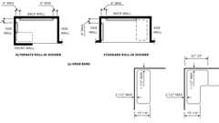Primary

**CA 11A: Figure 11A-9I Shower Seats and Grab Bars**

[**1127A.5.3.8.1 *Standard Roll-in Shower Compartments***](https://up.codes/viewer/california/ca-building-code-2025/chapter/11A/housing-accessibility#1127A.5.3.8.1)

Diagram

[*Grab bars*](https://up.codes/viewer/california/ca-building-code-2025/chapter/2/definitions#grab_bar_dsa_ac_hcd_1_ac_)*shall be installed on the back*[*wall*](https://up.codes/viewer/california/ca-building-code-2025/chapter/2/definitions#wall_)*and on the side*[*wall*](https://up.codes/viewer/california/ca-building-code-2025/chapter/2/definitions#wall_)*opposite the seat.*[*Grab bars*](https://up.codes/viewer/california/ca-building-code-2025/chapter/2/definitions#grab_bar_dsa_ac_hcd_1_ac_)*above the seat are not permitted.*[*Grab bars*](https://up.codes/viewer/california/ca-building-code-2025/chapter/2/definitions#grab_bar_dsa_ac_hcd_1_ac_)*shall be installed 6 inches (152 mm) maximum from adjacent*[*walls*](https://up.codes/viewer/california/ca-building-code-2025/chapter/2/definitions#wall_)*.*

**UpCodes Diagrams (2)**



**CA 11A: Figure 11A-9H Standard Roll-in Shower - Part (a)**



**CA 11A: Figure 11A-9H Standard Roll-in Shower - Part (b)**

[**1127A.5.3.8.2 *Alternate Roll-in Shower Compartments***](https://up.codes/viewer/california/ca-building-code-2025/chapter/11A/housing-accessibility#1127A.5.3.8.2)

Diagram

[*Grab bars*](https://up.codes/viewer/california/ca-building-code-2025/chapter/2/definitions#grab_bar_dsa_ac_hcd_1_ac_)*shall be installed on the back*[*wall*](https://up.codes/viewer/california/ca-building-code-2025/chapter/2/definitions#wall_)*and the side*[*wall*](https://up.codes/viewer/california/ca-building-code-2025/chapter/2/definitions#wall_)*farthest from the compartment entry.*[*Grab bars*](https://up.codes/viewer/california/ca-building-code-2025/chapter/2/definitions#grab_bar_dsa_ac_hcd_1_ac_)*above the seat are not permitted.*[*Grab bars*](https://up.codes/viewer/california/ca-building-code-2025/chapter/2/definitions#grab_bar_dsa_ac_hcd_1_ac_)*shall be installed 6 inches (152 mm) maximum from adjacent*[*walls*](https://up.codes/viewer/california/ca-building-code-2025/chapter/2/definitions#wall_)*.*

**UpCodes Diagram (1)**



**CA 11A: Figure 11A-9K Alternate Roll-in Shower**

[**1127A.5.3.9 *Soap Dish***](https://up.codes/viewer/california/ca-building-code-2025/chapter/11A/housing-accessibility#1127A.5.3.9)

*When a soap dish is provided, it shall be located on the control*[*wall*](https://up.codes/viewer/california/ca-building-code-2025/chapter/2/definitions#wall_)*at a maximum height of 40 inches (1016 mm) above the shower floor, and within the reach limits from the seat.*

[**1127A.5.3.10 *Open Showers***](https://up.codes/viewer/california/ca-building-code-2025/chapter/11A/housing-accessibility#1127A.5.3.10)

Diagram

*When no separate shower compartments are provided, the shower for*[*persons with disabilities*](https://up.codes/viewer/california/ca-building-code-2025/chapter/2/definitions#persons_with_disabilities_hcd_1_ac_)*shall be located in a corner with L-shaped*[*grab bars*](https://up.codes/viewer/california/ca-building-code-2025/chapter/2/definitions#grab_bar_dsa_ac_hcd_1_ac_)*extending along two adjacent*[*walls*](https://up.codes/viewer/california/ca-building-code-2025/chapter/2/definitions#wall_)*with a folding seat adjacent to the shower controls. (See*[*Figure*](https://up.codes/viewer/california/ca-building-code-2025/chapter/11B/accessibility-to-public-buildings-public-accommodations-commercial-buildings-and#figure)*11A-9J.)*

**UpCodes Diagram (1)**

Primary

**CA 11A: Figure 11A-9J Open Shower**

[**1127A.5.3.11 *Multiple Showers***](https://up.codes/viewer/california/ca-building-code-2025/chapter/11A/housing-accessibility#1127A.5.3.11)

*When two or more accessible showers are provided within the same*[*functional area*](https://up.codes/viewer/california/ca-building-code-2025/chapter/2/definitions#functional_area_dsa_ac_)*, there shall be at least one shower constructed opposite hand from the other or others (i.e., one left-hand control versus right-hand controls).*

[**1127A.6 *Lockers***](https://up.codes/viewer/california/ca-building-code-2025/chapter/11A/housing-accessibility#1127A.6)

[**1127A.6.1 *General***](https://up.codes/viewer/california/ca-building-code-2025/chapter/11A/housing-accessibility#1127A.6.1)

*Where lockers are provided for residents or guests, at least one locker and not less than 1 percent of all lockers shall be accessible to*[*persons with disabilities*](https://up.codes/viewer/california/ca-building-code-2025/chapter/2/definitions#persons_with_disabilities_hcd_1_ac_)*. An*[*accessible route*](https://up.codes/viewer/california/ca-building-code-2025/chapter/2/definitions#accessible_route_dsa_ac_hcd_1_ac_)*not less than 36 inches (914 mm) in*[*clear*](https://up.codes/viewer/california/ca-building-code-2025/chapter/2/definitions#clear_dsa_ac_)*width shall be provided to these lockers. See*[*Section 1138A*](https://up.codes/viewer/california/ca-building-code-2025/chapter/11A/housing-accessibility#1138A)*for required*[*clear*](https://up.codes/viewer/california/ca-building-code-2025/chapter/2/definitions#clear_dsa_ac_)[*space*](https://up.codes/viewer/california/ca-building-code-2025/chapter/2/definitions#space_)*, allowable reach ranges and requirements for control and operating mechanisms.*

[**1127A.7 *Signs***](https://up.codes/viewer/california/ca-building-code-2025/chapter/11A/housing-accessibility#1127A.7)

[**1127A.7.1 *General***](https://up.codes/viewer/california/ca-building-code-2025/chapter/11A/housing-accessibility#1127A.7.1)

*All accessible toilet and bathing*[*facilities*](https://up.codes/viewer/california/ca-building-code-2025/chapter/2/definitions#facility_)*shall be identified by the "*[*International Symbol of Accessibility*](https://up.codes/viewer/california/ca-building-code-2025/chapter/2/definitions#international_symbol_of_accessibility_)*."*[*Signs*](https://up.codes/viewer/california/ca-building-code-2025/chapter/2/definitions#sign_hcd_1_ac_dsa_ac_)*need not be provided for*[*facilities*](https://up.codes/viewer/california/ca-building-code-2025/chapter/2/definitions#facility_)*within a*[*dwelling unit*](https://up.codes/viewer/california/ca-building-code-2025/chapter/2/definitions#dwelling_unit_)*or*[*guestroom*](https://up.codes/viewer/california/ca-building-code-2025/chapter/2/definitions#guestroom_)*.*

[**1127A.7.2 *Identification Symbols***](https://up.codes/viewer/california/ca-building-code-2025/chapter/11A/housing-accessibility#1127A.7.2)

*Doorways leading to*[*sanitary facilities*](https://up.codes/viewer/california/ca-building-code-2025/chapter/2/definitions#sanitary_facility_hcd_1_hcd_1_ac_)*(toilet or bathing rooms) shall be identified by a geometric symbol in*[*compliance*](https://up.codes/viewer/california/ca-building-code-2025/chapter/31/special-construction#3113.1.1)*with this section. Geometric symbols shall be centered horizontally on the door at a height of 58 inches (1473 mm) minimum and 60 inches (1524 mm) maximum above the finish floor measured to the center of the symbol. When a door is provided, the symbol shall be mounted within 1 inch (25 mm) of the vertical centerline of the door.*[*Directional signs*](https://up.codes/viewer/california/ca-building-code-2025/chapter/2/definitions#directional_sign_dsa_ac_hcd_1_hcd_2_)*indicating the*[*location*](https://up.codes/viewer/california/ca-building-code-2025/chapter/L/earthquake-recording-instrumentation#L101.2)*of the nearest accessible toilet or bathing rooms shall be provided. Such*[*directional signs*](https://up.codes/viewer/california/ca-building-code-2025/chapter/2/definitions#directional_sign_dsa_ac_hcd_1_hcd_2_)*shall comply with Section 1143.5 and shall include the*[*International Symbol of Accessibility*](https://up.codes/viewer/california/ca-building-code-2025/chapter/2/definitions#international_symbol_of_accessibility_)*.*

*Edges of*[*accessibility*](https://up.codes/viewer/california/ca-building-code-2025/chapter/30/elevators-and-conveying-systems#3001.4)*signage shall be rounded, chamfered or eased. Corners shall have a minimum radius of 1/8inch (3.2 mm). See*[*Section 1143A*](https://up.codes/viewer/california/ca-building-code-2025/chapter/11A/housing-accessibility#1143A)*for additional signage requirements applicable to*[*sanitary facilities*](https://up.codes/viewer/california/ca-building-code-2025/chapter/2/definitions#sanitary_facility_hcd_1_hcd_1_ac_)*.*

[**1127A.7.2.1 *Men's Sanitary Facilities***](https://up.codes/viewer/california/ca-building-code-2025/chapter/11A/housing-accessibility#1127A.7.2.1)

*Men's*[*sanitary facilities*](https://up.codes/viewer/california/ca-building-code-2025/chapter/2/definitions#sanitary_facility_hcd_1_hcd_1_ac_)*shall be identified by an equilateral triangle, 1/4 inch (6.4 mm) thick with edges 12 inches (305 mm) long and a vertex pointing upward. The triangle symbol shall contrast with the door, either light on a dark background or dark on a light background.*

[**1127A.7.2.2 *Women's Sanitary Facilities***](https://up.codes/viewer/california/ca-building-code-2025/chapter/11A/housing-accessibility#1127A.7.2.2)

*Women's*[*sanitary facilities*](https://up.codes/viewer/california/ca-building-code-2025/chapter/2/definitions#sanitary_facility_hcd_1_hcd_1_ac_)*shall be identified by a circle, 1/4inch (6.4 mm) thick and 12 inches (305 mm) in diameter. The circle symbol shall contrast with the door, either light on a dark background or dark on a light background.*

[**1127A.7.2.3 *Unisex Sanitary Facilities***](https://up.codes/viewer/california/ca-building-code-2025/chapter/11A/housing-accessibility#1127A.7.2.3)

*Unisex*[*sanitary facilities*](https://up.codes/viewer/california/ca-building-code-2025/chapter/2/definitions#sanitary_facility_hcd_1_hcd_1_ac_)*shall be identified by a circle, 1/4inch (6.4 mm) thick and 12 inches (305 mm) in diameter with a 1/4inch (6.4 mm) thick triangle superimposed on the circle and within the 12-inch (305 mm) diameter. The triangle symbol shall contrast with the circle symbol, either light on a dark background or dark on a light background. The circle symbol shall contrast with the door, either light on a dark background or dark on a light background.*

[**1127A.8 *Toilet Room Fixtures and Accessories***](https://up.codes/viewer/california/ca-building-code-2025/chapter/11A/housing-accessibility#1127A.8)

Diagram

**UpCodes Diagram (1)**

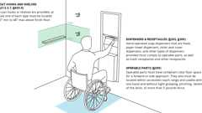

**Mounting Heights: Bathroom Accessories**

[**1127A.8.1 *Towel, Sanitary Napkins, Waste Receptacles***](https://up.codes/viewer/california/ca-building-code-2025/chapter/11A/housing-accessibility#1127A.8.1)

*Where towel, sanitary napkins, waste receptacles and other similar*[*dispensing*](https://up.codes/viewer/california/ca-building-code-2025/chapter/2/definitions#dispensing_)*and disposal fixtures are provided, at least one of each type shall be located with all*[*operable parts*](https://up.codes/viewer/california/ca-building-code-2025/chapter/2/definitions#operable_part_)*, including coin slots, within 40 inches (1016 mm) from the finished floor. Controls and operating mechanisms shall comply with*[*Section 1138A.4*](https://up.codes/viewer/california/ca-building-code-2025/chapter/11A/housing-accessibility#1138A.4)*.*

[**1127A.8.2 *Toilet Tissue Dispensers***](https://up.codes/viewer/california/ca-building-code-2025/chapter/11A/housing-accessibility#1127A.8.2)

Diagram

*Toilet tissue dispensers shall be located on the*[*wall*](https://up.codes/viewer/california/ca-building-code-2025/chapter/2/definitions#wall_)*or partition closest to the water closet, 7 inches (180 mm) minimum and 9 inches (230 mm) maximum in front of the water closet measured to the centerline of the dispenser. The outlet of the dispenser shall be below the*[*grab bar*](https://up.codes/viewer/california/ca-building-code-2025/chapter/2/definitions#grab_bar_dsa_ac_hcd_1_ac_)*, 19 inches (483 mm) minimum above the finish floor. The outlet of the dispenser shall not be located behind*[*grab bars*](https://up.codes/viewer/california/ca-building-code-2025/chapter/2/definitions#grab_bar_dsa_ac_hcd_1_ac_)*. Dispensers shall not be of a type that controls delivery or that does not allow continuous paper flow. (See*[*Figure*](https://up.codes/viewer/california/ca-building-code-2025/chapter/11B/accessibility-to-public-buildings-public-accommodations-commercial-buildings-and#figure)*11A-9B.)*

**UpCodes Diagrams (2)**

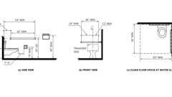Primary

**CA 11A: Figure 11A-9B Water Closets**

Primary

**Toilet Paper Dispenser: Non-Recessed (CA)**

[**1127A.8.3 *Mirrors***](https://up.codes/viewer/california/ca-building-code-2025/chapter/11A/housing-accessibility#1127A.8.3)

*Where mirrors are provided, at least one shall be accessible. Mirrors located above*[*lavatories*](https://up.codes/viewer/california/ca-building-code-2025/chapter/2/definitions#lavatory_)*or countertops shall be installed with the bottom edge of the reflecting surface 40 inches (1016 mm) maximum above the finish floor. Mirrors not located above*[*lavatories*](https://up.codes/viewer/california/ca-building-code-2025/chapter/2/definitions#lavatory_)*or countertops shall be installed with the bottom edge of the reflecting surface 35 inches (889 mm) maximum above the finish floor.*

[**1127A.9 *Space Allowances and Reach Ranges in Common Use Areas***](https://up.codes/viewer/california/ca-building-code-2025/chapter/11A/housing-accessibility#1127A.9)

[*Space*](https://up.codes/viewer/california/ca-building-code-2025/chapter/2/definitions#space_)*allowances and reach ranges in*[*common use areas*](https://up.codes/viewer/california/ca-building-code-2025/chapter/2/definitions#common_use_areas_hcd_1_ac_)*shall comply with*[*Section 1138A*](https://up.codes/viewer/california/ca-building-code-2025/chapter/11A/housing-accessibility#1138A)*.*

[**1127A.10 *Common Accessible Laundry Rooms***](https://up.codes/viewer/california/ca-building-code-2025/chapter/11A/housing-accessibility#1127A.10)

[**1127A.10.1 *General***](https://up.codes/viewer/california/ca-building-code-2025/chapter/11A/housing-accessibility#1127A.10.1)

*Where*[*common use*](https://up.codes/viewer/california/ca-building-code-2025/chapter/2/definitions#common_use_)*laundry rooms are provided, at least one of each type of appliance provided in each laundry area shall be accessible, shall be on an*[*accessible route*](https://up.codes/viewer/california/ca-building-code-2025/chapter/2/definitions#accessible_route_dsa_ac_hcd_1_ac_)*and shall comply with this section. Such appliances include clothes washing machines, dryers, soap dispensers and any related features such as wash*[*sinks*](https://up.codes/viewer/california/ca-building-code-2025/chapter/2/definitions#sink_)*,*[*tables*](https://up.codes/viewer/california/ca-building-code-2025/chapter/11B/accessibility-to-public-buildings-public-accommodations-commercial-buildings-and#table)*and*[*storage*](https://up.codes/viewer/california/ca-building-code-2025/chapter/9/fire-protection-and-life-safety-systems#911.1.5)*areas.*

*Where laundry rooms are provided on floors of an elevator building, each laundry room shall be accessible. Where there is one laundry room on a*[*ground floor*](https://up.codes/viewer/california/ca-building-code-2025/chapter/2/definitions#ground_floor_)*in each building, each laundry room shall be accessible. Where there is a laundry room on the*[*ground floor*](https://up.codes/viewer/california/ca-building-code-2025/chapter/2/definitions#ground_floor_)*of a building and another located in the*[*basement*](https://up.codes/viewer/california/ca-building-code-2025/chapter/2/definitions#basement_)*, it is acceptable to have only the*[*ground floor*](https://up.codes/viewer/california/ca-building-code-2025/chapter/2/definitions#ground_floor_)*laundry room accessible.*

[**1127A.10.2 *Clear Floor Space***](https://up.codes/viewer/california/ca-building-code-2025/chapter/11A/housing-accessibility#1127A.10.2)

*There shall be a minimum*[*clear*](https://up.codes/viewer/california/ca-building-code-2025/chapter/2/definitions#clear_dsa_ac_)[*space*](https://up.codes/viewer/california/ca-building-code-2025/chapter/2/definitions#space_)*30 inches perpendicular by 48 inches parallel (762 mm by 1219 mm) in front of clothes washers and dryers required to be accessible. There shall be a minimum*[*clear*](https://up.codes/viewer/california/ca-building-code-2025/chapter/2/definitions#clear_dsa_ac_)[*space*](https://up.codes/viewer/california/ca-building-code-2025/chapter/2/definitions#space_)*30 inches by 48 inches (762 mm by 1219 mm) provided for at least one of each type of fixture or appliance provided in the laundry room (e.g., soap dispensers, wash*[*sinks*](https://up.codes/viewer/california/ca-building-code-2025/chapter/2/definitions#sink_)*,*[*tables*](https://up.codes/viewer/california/ca-building-code-2025/chapter/11B/accessibility-to-public-buildings-public-accommodations-commercial-buildings-and#table)*,*[*storage*](https://up.codes/viewer/california/ca-building-code-2025/chapter/9/fire-protection-and-life-safety-systems#911.1.5)*areas).*

[**1127A.10.3 *Controls and Operating Mechanisms***](https://up.codes/viewer/california/ca-building-code-2025/chapter/11A/housing-accessibility#1127A.10.3)

*Clothes washers and dryers including stacked clothes washers and dryers required to be accessible shall have controls and operating mechanisms (including doors, coin slots, lint screens, detergent and bleach compartments) within the reach range of a seated user. Controls and operating mechanisms shall be located no higher than 48 inches (1219 mm), and no lower than 15 inches (381 mm), above the finished floor measured to the center of the grip. If the reach is over an obstruction (for example, washer or dryer), operating mechanisms shall be located within the reach ranges specified in*[*Section 1138A.3*](https://up.codes/viewer/california/ca-building-code-2025/chapter/11A/housing-accessibility#1138A.3)*. Controls and operating mechanisms that do not satisfy these specifications are acceptable, provided that comparable mechanisms, controls or outlets that perform the same functions are provided within the same area and are accessible.*

*Controls and operating mechanisms shall be operable with one hand and not require tight grasping, pinching or twisting of the wrist. The force required to activate controls and operating mechanisms shall be no greater than 5 pounds (22.2 N).*

[**1127A.10.4 *Washing Machines and Clothes Dryers***](https://up.codes/viewer/california/ca-building-code-2025/chapter/11A/housing-accessibility#1127A.10.4)

Diagram

[*Washing machines and clothes dryers*](https://up.codes/viewer/california/ca-building-code-2025/chapter/11B/accessibility-to-public-buildings-public-accommodations-commercial-buildings-and#11B-809.1.3)*in accessible*[*common use*](https://up.codes/viewer/california/ca-building-code-2025/chapter/2/definitions#common_use_)*laundry rooms shall be front loading.*

*The bottom of the opening to the laundry compartment shall be located 15 inches (381 mm) minimum and 36 inches (914 mm) maximum above the finish floor.*

**UpCodes Diagram (1)**

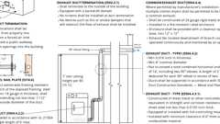

**Clothes Dryer Exhaust (CA)**

[**1127A.11 *Storage***](https://up.codes/viewer/california/ca-building-code-2025/chapter/11A/housing-accessibility#1127A.11)

**Building products (2)**

[[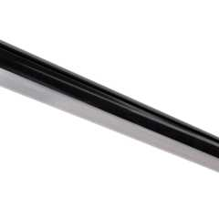](https://up.codes/product/48-lighted-closet-rod-tunable-white-aluminum-profile-frosted-lens-black-lcr-t?viewer_juris_key=california)](https://up.codes/product/48-lighted-closet-rod-tunable-white-aluminum-profile-frosted-lens-black-lcr-t?viewer_juris_key=california)

**[Lighted Closet Rod - Tunable-white, Aluminum Profile, Frosted Lens, White - LCR-T](https://up.codes/product/48-lighted-closet-rod-tunable-white-aluminum-profile-frosted-lens-black-lcr-t?viewer_juris_key=california)**

**[Task Lighting and Power](https://up.codes/product/48-lighted-closet-rod-tunable-white-aluminum-profile-frosted-lens-black-lcr-t?viewer_juris_key=california)**

[[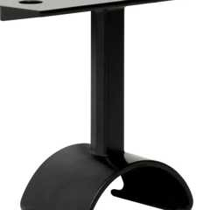](https://up.codes/product/top-mounted-support-lighted-closet-rod-black-l-lcr-hs?viewer_juris_key=california)](https://up.codes/product/top-mounted-support-lighted-closet-rod-black-l-lcr-hs?viewer_juris_key=california)

**[Top-Mounted Support, Lighted Closet Rod - L-LCR-HS](https://up.codes/product/top-mounted-support-lighted-closet-rod-black-l-lcr-hs?viewer_juris_key=california)**

**[Task Lighting and Power](https://up.codes/product/top-mounted-support-lighted-closet-rod-black-l-lcr-hs?viewer_juris_key=california)**

[**1127A.11.1 *General***](https://up.codes/viewer/california/ca-building-code-2025/chapter/11A/housing-accessibility#1127A.11.1)

*If fixed*[*storage*](https://up.codes/viewer/california/ca-building-code-2025/chapter/9/fire-protection-and-life-safety-systems#911.1.5)[*facilities*](https://up.codes/viewer/california/ca-building-code-2025/chapter/2/definitions#facility_)*such as cabinets, shelves, closets or drawers are provided where access is required by Sections*[*1.8.2.1.2*](https://up.codes/viewer/california/ca-building-code-2025/chapter/1/administration#1.8.2.1.2)*and*[*1102A*](https://up.codes/viewer/california/ca-building-code-2025/chapter/11A/housing-accessibility#1102A)*, at least one of each type of*[*facility*](https://up.codes/viewer/california/ca-building-code-2025/chapter/2/definitions#facility_)*provided shall comply with this section. Additional*[*storage*](https://up.codes/viewer/california/ca-building-code-2025/chapter/9/fire-protection-and-life-safety-systems#911.1.5)*may be provided outside of the reach ranges specified in*[*Section 1138A.3*](https://up.codes/viewer/california/ca-building-code-2025/chapter/11A/housing-accessibility#1138A.3)*.*

[**1127A.11.2 *Clear Floor Space***](https://up.codes/viewer/california/ca-building-code-2025/chapter/11A/housing-accessibility#1127A.11.2)

*A*[*clear floor space*](https://up.codes/viewer/california/ca-building-code-2025/chapter/2/definitions#clear_floor_space_dsa_ac_hcd_1_ac_)*at least 30 inches by 48 inches (762 mm by 1219 mm) complying with*[*Section 1138A.1.4*](https://up.codes/viewer/california/ca-building-code-2025/chapter/11A/housing-accessibility#1138A.1.4)*that allows either a forward or parallel approach by a person using a*[*wheelchair*](https://up.codes/viewer/california/ca-building-code-2025/chapter/2/definitions#wheelchair_hcd_1_ac_dsa_ac_)*shall be provided at accessible*[*storage*](https://up.codes/viewer/california/ca-building-code-2025/chapter/9/fire-protection-and-life-safety-systems#911.1.5)[*facilities*](https://up.codes/viewer/california/ca-building-code-2025/chapter/2/definitions#facility_)*.*

[**1127A.11.3 *Height***](https://up.codes/viewer/california/ca-building-code-2025/chapter/11A/housing-accessibility#1127A.11.3)

Diagram

*Accessible*[*storage*](https://up.codes/viewer/california/ca-building-code-2025/chapter/9/fire-protection-and-life-safety-systems#911.1.5)[*spaces*](https://up.codes/viewer/california/ca-building-code-2025/chapter/2/definitions#space_)*and clothes rods shall be within at least one of the reach ranges specified in*[*Section 1138A.3*](https://up.codes/viewer/california/ca-building-code-2025/chapter/11A/housing-accessibility#1138A.3)*. (See*[*Figure*](https://up.codes/viewer/california/ca-building-code-2025/chapter/11B/accessibility-to-public-buildings-public-accommodations-commercial-buildings-and#figure)*11A-1J and*[*Figure*](https://up.codes/viewer/california/ca-building-code-2025/chapter/11B/accessibility-to-public-buildings-public-accommodations-commercial-buildings-and#figure)*11A-1I.)*

**UpCodes Diagrams (2)**

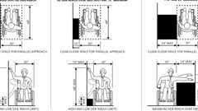Primary

**CA 11A: Figure 11A-1J Side Reach**

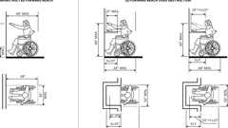Primary

**CA 11A: Figure 11A-1I Forward Reach**

[**1127A.11.4 *Hardware***](https://up.codes/viewer/california/ca-building-code-2025/chapter/11A/housing-accessibility#1127A.11.4)

[*Hardware*](https://up.codes/viewer/california/ca-building-code-2025/chapter/2/definitions#hardware_)*for accessible*[*storage*](https://up.codes/viewer/california/ca-building-code-2025/chapter/9/fire-protection-and-life-safety-systems#911.1.5)[*facilities*](https://up.codes/viewer/california/ca-building-code-2025/chapter/2/definitions#facility_)*shall comply with*[*Section 1138A.4*](https://up.codes/viewer/california/ca-building-code-2025/chapter/11A/housing-accessibility#1138A.4)*. Touch latches and U-shaped pulls are acceptable.*

[**1127A.12 *Fixed or Built-In Seating, Tables and Counters***](https://up.codes/viewer/california/ca-building-code-2025/chapter/11A/housing-accessibility#1127A.12)

[**1127A.12.1 *Minimum Seating***](https://up.codes/viewer/california/ca-building-code-2025/chapter/11A/housing-accessibility#1127A.12.1)

*Where fixed or built-in seating,*[*tables*](https://up.codes/viewer/california/ca-building-code-2025/chapter/11B/accessibility-to-public-buildings-public-accommodations-commercial-buildings-and#table)*or counters are provided for residents or guests, 5 percent, but not less than one, shall be accessible as provided in this section.*

[**1127A.12.2 *Clear Floor Space***](https://up.codes/viewer/california/ca-building-code-2025/chapter/11A/housing-accessibility#1127A.12.2)

*When seating*[*spaces*](https://up.codes/viewer/california/ca-building-code-2025/chapter/2/definitions#space_)*for persons in*[*wheelchairs*](https://up.codes/viewer/california/ca-building-code-2025/chapter/2/definitions#wheelchair_hcd_1_ac_dsa_ac_)*are provided at fixed*[*tables*](https://up.codes/viewer/california/ca-building-code-2025/chapter/11B/accessibility-to-public-buildings-public-accommodations-commercial-buildings-and#table)*or counters,*[*clear floor space*](https://up.codes/viewer/california/ca-building-code-2025/chapter/2/definitions#clear_floor_space_dsa_ac_hcd_1_ac_)*complying with*[*Section 1138A.1.4*](https://up.codes/viewer/california/ca-building-code-2025/chapter/11A/housing-accessibility#1138A.1.4)*positioned for a forward approach shall be provided. Such*[*clear floor space*](https://up.codes/viewer/california/ca-building-code-2025/chapter/2/definitions#clear_floor_space_dsa_ac_hcd_1_ac_)*shall not overlap the required knee and toe*[*space*](https://up.codes/viewer/california/ca-building-code-2025/chapter/2/definitions#space_)*by more than 19 inches (483 mm). (See*[*Figure*](https://up.codes/viewer/california/ca-building-code-2025/chapter/11B/accessibility-to-public-buildings-public-accommodations-commercial-buildings-and#figure)*11A-1K.)*

[**1127A.12.3 *Knee and Toe Space***](https://up.codes/viewer/california/ca-building-code-2025/chapter/11A/housing-accessibility#1127A.12.3)

Diagram

*When seating for persons in*[*wheelchairs*](https://up.codes/viewer/california/ca-building-code-2025/chapter/2/definitions#wheelchair_hcd_1_ac_dsa_ac_)*is provided at fixed*[*tables*](https://up.codes/viewer/california/ca-building-code-2025/chapter/11B/accessibility-to-public-buildings-public-accommodations-commercial-buildings-and#table)*or counters, knee and toe*[*space*](https://up.codes/viewer/california/ca-building-code-2025/chapter/2/definitions#space_)*complying with*[*Section 1138A.2*](https://up.codes/viewer/california/ca-building-code-2025/chapter/11A/housing-accessibility#1138A.2)*shall be provided. (See*[*Figure*](https://up.codes/viewer/california/ca-building-code-2025/chapter/11B/accessibility-to-public-buildings-public-accommodations-commercial-buildings-and#figure)*11A-1K.)*

**UpCodes Diagram (1)**

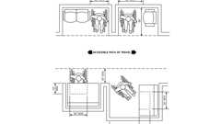Primary

**CA 11A: Figure 11A-1K Minimum Clearances for Seating and Table**

[**1127A.12.4 *Height of Work Surfaces***](https://up.codes/viewer/california/ca-building-code-2025/chapter/11A/housing-accessibility#1127A.12.4)

*The tops of*[*tables*](https://up.codes/viewer/california/ca-building-code-2025/chapter/11B/accessibility-to-public-buildings-public-accommodations-commercial-buildings-and#table)*and counters shall be 28 inches to 34 inches (711 mm to 864 mm) from the finish floor.*

***Exception:****When food or drink is served for consumption at a counter exceeding 34 inches (864 mm) in height, only a portion of the main counter, 60 inches (1524 mm) minimum in length, shall be provided in*[*compliance*](https://up.codes/viewer/california/ca-building-code-2025/chapter/31/special-construction#3113.1.1)*with this section.*

[**1127A.13 *Electric Vehicle Charging Stations***](https://up.codes/viewer/california/ca-building-code-2025/chapter/11A/housing-accessibility#1127A.13)

***(***[***Reserved***](https://up.codes/viewer/california/ca-building-code-2025/chapter/11B/accessibility-to-public-buildings-public-accommodations-commercial-buildings-and#reserved)***)***

[**Division IV *— Dwelling Unit Features***](https://up.codes/viewer/california/ca-building-code-2025/chapter/11A/housing-accessibility#divider_11A_IV)

[**Section 1128A *Covered Dwelling Units***](https://up.codes/viewer/california/ca-building-code-2025/chapter/11A/housing-accessibility#1128A)

[**1128A.1 *General***](https://up.codes/viewer/california/ca-building-code-2025/chapter/11A/housing-accessibility#1128A.1)

*Covered multifamily*[*dwelling units*](https://up.codes/viewer/california/ca-building-code-2025/chapter/2/definitions#dwelling_unit_)*shall be*[*adaptable*](https://up.codes/viewer/california/ca-building-code-2025/chapter/2/definitions#adaptable_dsa_ac_)*and accessible into and throughout the*[*dwelling unit*](https://up.codes/viewer/california/ca-building-code-2025/chapter/2/definitions#dwelling_unit_)*as provided in this division.*

* ***Note:****See Sections*[*1101A*](https://up.codes/viewer/california/ca-building-code-2025/chapter/11A/housing-accessibility#1101A)*"*[*Application*](https://up.codes/viewer/california/ca-building-code-2025/chapter/25/gypsum-panel-products-and-plaster#2501.1.1)*" and*[*1102A*](https://up.codes/viewer/california/ca-building-code-2025/chapter/11A/housing-accessibility#1102A)*"Building*[*Accessibility*](https://up.codes/viewer/california/ca-building-code-2025/chapter/30/elevators-and-conveying-systems#3001.4)*" for*[*dwelling units*](https://up.codes/viewer/california/ca-building-code-2025/chapter/2/definitions#dwelling_unit_)*required to comply with this division.*

[**Section 1129A**](https://up.codes/viewer/california/ca-building-code-2025/chapter/11A/housing-accessibility#1129A)

[***RESERVED***](https://up.codes/viewer/california/ca-building-code-2025/chapter/11B/accessibility-to-public-buildings-public-accommodations-commercial-buildings-and#reserved)

[**Section 1130A *Accessible Route Within Covered Multifamily Dwelling Units***](https://up.codes/viewer/california/ca-building-code-2025/chapter/11A/housing-accessibility#1130A)

Diagram

**UpCodes Diagram (1)**

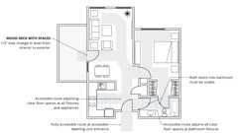

**Routes in Dwelling Units (FHA)**

[**1130A.1 *General***](https://up.codes/viewer/california/ca-building-code-2025/chapter/11A/housing-accessibility#1130A.1)

*An*[*accessible route*](https://up.codes/viewer/california/ca-building-code-2025/chapter/2/definitions#accessible_route_dsa_ac_hcd_1_ac_)*shall be provided through all rooms and*[*spaces*](https://up.codes/viewer/california/ca-building-code-2025/chapter/2/definitions#space_)*of the*[*dwelling unit*](https://up.codes/viewer/california/ca-building-code-2025/chapter/2/definitions#dwelling_unit_)*. The*[*accessible route*](https://up.codes/viewer/california/ca-building-code-2025/chapter/2/definitions#accessible_route_dsa_ac_hcd_1_ac_)*shall pass through the*[*primary entry*](https://up.codes/viewer/california/ca-building-code-2025/chapter/2/definitions#primary_entry_hcd_1_ac_)*door, and shall connect with all additional exterior doors, required*[*clear floor spaces*](https://up.codes/viewer/california/ca-building-code-2025/chapter/2/definitions#clear_floor_space_dsa_ac_hcd_1_ac_)*at kitchen appliances and*[*bathroom*](https://up.codes/viewer/california/ca-building-code-2025/chapter/2/definitions#bathroom_)*fixtures. For the purpose of this section, "*[*accessible routes*](https://up.codes/viewer/california/ca-building-code-2025/chapter/2/definitions#accessible_route_dsa_ac_hcd_1_ac_)*" may include hallways,*[*corridors*](https://up.codes/viewer/california/ca-building-code-2025/chapter/2/definitions#corridor_)*and*[*ramps*](https://up.codes/viewer/california/ca-building-code-2025/chapter/2/definitions#ramp_)*.*

***Exception:****An*[*accessible route*](https://up.codes/viewer/california/ca-building-code-2025/chapter/2/definitions#accessible_route_dsa_ac_hcd_1_ac_)*is not required from the interior of the unit into a*[*basement*](https://up.codes/viewer/california/ca-building-code-2025/chapter/2/definitions#basement_)*or garage, except as provided in*[*Section 1105A.1*](https://up.codes/viewer/california/ca-building-code-2025/chapter/11A/housing-accessibility#1105A.1)*.*

[**1130A.2 *Width***](https://up.codes/viewer/california/ca-building-code-2025/chapter/11A/housing-accessibility#1130A.2)

*The*[*accessible route*](https://up.codes/viewer/california/ca-building-code-2025/chapter/2/definitions#accessible_route_dsa_ac_hcd_1_ac_)*into and throughout covered multifamily*[*dwelling units*](https://up.codes/viewer/california/ca-building-code-2025/chapter/2/definitions#dwelling_unit_)*shall be at least 36 inches (914 mm) wide.*

[**Section 1131A *Changes in Level on Accessible Routes***](https://up.codes/viewer/california/ca-building-code-2025/chapter/11A/housing-accessibility#1131A)

[**1131A.1 *Changes in Level Not Exceeding 1/2 Inch***](https://up.codes/viewer/california/ca-building-code-2025/chapter/11A/housing-accessibility#1131A.1)

*Abrupt changes in level along any*[*accessible route*](https://up.codes/viewer/california/ca-building-code-2025/chapter/2/definitions#accessible_route_dsa_ac_hcd_1_ac_)*shall not exceed 1/2 inch (12.7 mm). When changes in level do occur, they shall be beveled with a*[*slope*](https://up.codes/viewer/california/ca-building-code-2025/chapter/J/grading#slope_)*no greater than 1 unit vertical in 2 units horizontal (50-percent*[*slope*](https://up.codes/viewer/california/ca-building-code-2025/chapter/J/grading#slope_)*). Changes in level not exceeding 1/4inch (6.35 mm) may be vertical.*

[**1131A.2 *Changes Greater Than 1/2 Inch***](https://up.codes/viewer/california/ca-building-code-2025/chapter/11A/housing-accessibility#1131A.2)

*Changes in level greater than 1/2inch (12.7 mm) shall be made by means of a sloped surface not greater than 1 unit vertical in 20 units horizontal (5-percent*[*slope*](https://up.codes/viewer/california/ca-building-code-2025/chapter/J/grading#slope_)*), or a*[*ramp*](https://up.codes/viewer/california/ca-building-code-2025/chapter/2/definitions#ramp_)*, elevator or*[*platform (wheelchair) lift*](https://up.codes/viewer/california/ca-building-code-2025/chapter/2/definitions#platform_%28wheelchair%29_lift_)*. See*[*Section 1122A*](https://up.codes/viewer/california/ca-building-code-2025/chapter/11A/housing-accessibility#1122A)*for*[*ramps*](https://up.codes/viewer/california/ca-building-code-2025/chapter/2/definitions#ramp_)*and*[*Section 1124A.11*](https://up.codes/viewer/california/ca-building-code-2025/chapter/11A/housing-accessibility#1124A.11)*for*[*platform*](https://up.codes/viewer/california/ca-building-code-2025/chapter/2/definitions#platform_)*(*[*wheelchair*](https://up.codes/viewer/california/ca-building-code-2025/chapter/2/definitions#wheelchair_hcd_1_ac_dsa_ac_)*) lifts.*

[**Section 1132A *Doors***](https://up.codes/viewer/california/ca-building-code-2025/chapter/11A/housing-accessibility#1132A)

Diagram

**UpCodes Diagrams (4)**



**Accessible Unit Doors (CA 11A)**

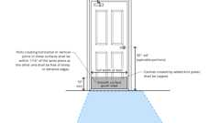

**Door Hardware Req. (11A)**



**Accessible Route Components**



**Levered Handles (CA 11A)**

[**1132A.1 *Primary Entry Doors and Required Exit Doors***](https://up.codes/viewer/california/ca-building-code-2025/chapter/11A/housing-accessibility#1132A.1)

*The width and height of*[*primary entry*](https://up.codes/viewer/california/ca-building-code-2025/chapter/2/definitions#primary_entry_hcd_1_ac_)*doors and all required*[*exit*](https://up.codes/viewer/california/ca-building-code-2025/chapter/2/definitions#exit_)*doors shall comply with*[*Section 1126A.1*](https://up.codes/viewer/california/ca-building-code-2025/chapter/11A/housing-accessibility#1126A.1)*. The requirements of Sections*[*1126A.3*](https://up.codes/viewer/california/ca-building-code-2025/chapter/11A/housing-accessibility#1126A.3)*shall apply to maneuvering clearances at the side of the door exposed to common or*[*public use*](https://up.codes/viewer/california/ca-building-code-2025/chapter/2/definitions#public_use_dsa_ac_)[*spaces*](https://up.codes/viewer/california/ca-building-code-2025/chapter/2/definitions#space_)*(e.g., entry or*[*exit*](https://up.codes/viewer/california/ca-building-code-2025/chapter/2/definitions#exit_)*doors which open from the covered multifamily*[*dwelling unit*](https://up.codes/viewer/california/ca-building-code-2025/chapter/2/definitions#dwelling_unit_)*into a*[*corridor*](https://up.codes/viewer/california/ca-building-code-2025/chapter/2/definitions#corridor_)*, hallway or*[*lobby*](https://up.codes/viewer/california/ca-building-code-2025/chapter/2/definitions#lobby_sfm_hcd_1_hcd_2_)*, or directly to the outside).*

[**1132A.2 *Interior Doors and Secondary Exterior Doors***](https://up.codes/viewer/california/ca-building-code-2025/chapter/11A/housing-accessibility#1132A.2)

*Except as allowed by*[*Section 1109A.2*](https://up.codes/viewer/california/ca-building-code-2025/chapter/11A/housing-accessibility#1109A.2)*, interior doors intended for user passage and secondary exterior doors shall comply with this section. The provisions of this section shall apply to the*[*dwelling unit*](https://up.codes/viewer/california/ca-building-code-2025/chapter/2/definitions#dwelling_unit_)*side of doors leading from the interior of the*[*dwelling unit*](https://up.codes/viewer/california/ca-building-code-2025/chapter/2/definitions#dwelling_unit_)*to an unfinished*[*basement*](https://up.codes/viewer/california/ca-building-code-2025/chapter/2/definitions#basement_)*or an attached garage.*

[**1132A.3 *Width and Height of Interior Doors and Secondary Exterior Doors***](https://up.codes/viewer/california/ca-building-code-2025/chapter/11A/housing-accessibility#1132A.3)

*Doors shall comply with the following:*

1. *Doors shall not be less than 6 feet 8 inches (2032 mm) in height.*
2. *Swinging doors shall provide a net*[*clear*](https://up.codes/viewer/california/ca-building-code-2025/chapter/2/definitions#clear_dsa_ac_)*opening width of not less than 32 inches (813 mm), measured with the door or doors positioned at an angle of 90 degrees from the closed position.*
3. *Swinging doors shall be capable of opening at least 90 degrees.*
4. *A nominal 32-inch (813 mm)*[*clear*](https://up.codes/viewer/california/ca-building-code-2025/chapter/2/definitions#clear_dsa_ac_)*opening provided by a standard 6-foot wide (1829 mm) sliding patio door assembly is acceptable.*
5. *A pair of doors, manual or*[*automatic*](https://up.codes/viewer/california/ca-building-code-2025/chapter/2/definitions#automatic_)*, must have at least one leaf which provides a*[*clear*](https://up.codes/viewer/california/ca-building-code-2025/chapter/2/definitions#clear_dsa_ac_)*width of not less than 32 inches (813 mm), measured with the door positioned at an angle of 90 degrees from its closed position.*
6. *The width of any component in the*[*means of egress*](https://up.codes/viewer/california/ca-building-code-2025/chapter/2/definitions#means_of_egress_)*system shall not be less than the minimum width required by*[*Section 1005*](https://up.codes/viewer/california/ca-building-code-2025/chapter/10/means-of-egress#1005)*.*

[**1132A.4 *Level Floor or Landing***](https://up.codes/viewer/california/ca-building-code-2025/chapter/11A/housing-accessibility#1132A.4)

Diagram

*See also*[*Chapter 10*](https://up.codes/viewer/california/ca-building-code-2025/chapter/10/means-of-egress#10)*. The floor or landing on each side of a door shall be level.*[*Primary entry*](https://up.codes/viewer/california/ca-building-code-2025/chapter/2/definitions#primary_entry_hcd_1_ac_)*doors, required*[*exit*](https://up.codes/viewer/california/ca-building-code-2025/chapter/2/definitions#exit_)*doors or secondary exterior doors with changes in height between the interior surface or floor level and the exterior surface or floor level shall comply with the following:*

1. *Exterior landings of impervious*[*construction*](https://up.codes/viewer/california/ca-building-code-2025/chapter/4/special-detailed-requirements-based-on-occupancy-and-use#407.1.1)*(e.g.,*[*concrete*](https://up.codes/viewer/california/ca-building-code-2025/chapter/2/definitions#concrete_)*,*[*brick*](https://up.codes/viewer/california/ca-building-code-2025/chapter/2/definitions#brick_)*, flagstone) serving*[*primary entry*](https://up.codes/viewer/california/ca-building-code-2025/chapter/2/definitions#primary_entry_hcd_1_ac_)*doors and required*[*exit*](https://up.codes/viewer/california/ca-building-code-2025/chapter/2/definitions#exit_)*doors are limited to not more than 1/2inch (12.7 mm) of change in height between floor surfaces. Changes in level shall comply with*[*Section 1131A*](https://up.codes/viewer/california/ca-building-code-2025/chapter/11A/housing-accessibility#1131A)*.*
2. *Exterior landings of pervious*[*construction*](https://up.codes/viewer/california/ca-building-code-2025/chapter/4/special-detailed-requirements-based-on-occupancy-and-use#407.1.1)*(e.g., wood decking with*[*spaces*](https://up.codes/viewer/california/ca-building-code-2025/chapter/2/definitions#space_)*) shall be the same level as the interior landing, except that secondary exterior doors may have no more than 1/2inch (12.7 mm) of change in height between floor surfaces. Changes in level shall comply with*[*Section 1131A*](https://up.codes/viewer/california/ca-building-code-2025/chapter/11A/housing-accessibility#1131A)*.*
3. *Secondary exterior doors onto*[*decks*](https://up.codes/viewer/california/ca-building-code-2025/chapter/2/definitions#deck_)*, patios or balcony surfaces constructed of impervious*[*materials*](https://up.codes/viewer/california/ca-building-code-2025/chapter/4/special-detailed-requirements-based-on-occupancy-and-use#414.1.2)*(e.g.,*[*concrete*](https://up.codes/viewer/california/ca-building-code-2025/chapter/2/definitions#concrete_)*,*[*brick*](https://up.codes/viewer/california/ca-building-code-2025/chapter/2/definitions#brick_)*, flagstone) may have a maximum change in height from the interior landing of 4 inches (101.6 mm). Changes in height greater than 1/2inch (12.7 mm) shall be accomplished by means of a*[*ramp*](https://up.codes/viewer/california/ca-building-code-2025/chapter/2/definitions#ramp_)*complying with*[*Section 1114A*](https://up.codes/viewer/california/ca-building-code-2025/chapter/11A/housing-accessibility#1114A)*or by means of a*[*platform*](https://up.codes/viewer/california/ca-building-code-2025/chapter/2/definitions#platform_)*constructed to the level of the floor as illustrated in*[*Figure*](https://up.codes/viewer/california/ca-building-code-2025/chapter/11B/accessibility-to-public-buildings-public-accommodations-commercial-buildings-and#figure)*11A-8J.*
4. *Secondary exterior doors onto*[*decks*](https://up.codes/viewer/california/ca-building-code-2025/chapter/2/definitions#deck_)*, patios or balcony surfaces constructed of impervious*[*materials*](https://up.codes/viewer/california/ca-building-code-2025/chapter/4/special-detailed-requirements-based-on-occupancy-and-use#414.1.2)*(e.g.,*[*concrete*](https://up.codes/viewer/california/ca-building-code-2025/chapter/2/definitions#concrete_)*,*[*brick*](https://up.codes/viewer/california/ca-building-code-2025/chapter/2/definitions#brick_)*, flagstone) may have a maximum change in height from the interior landing of 1 inch (25.4 mm), provided a*[*ramp*](https://up.codes/viewer/california/ca-building-code-2025/chapter/2/definitions#ramp_)*with a maximum*[*slope*](https://up.codes/viewer/california/ca-building-code-2025/chapter/J/grading#slope_)*of 1:8 is permanently installed. (See*[*Figure*](https://up.codes/viewer/california/ca-building-code-2025/chapter/11B/accessibility-to-public-buildings-public-accommodations-commercial-buildings-and#figure)*11A-8K.)*
5. *In buildings containing covered multifamily*[*dwelling units*](https://up.codes/viewer/california/ca-building-code-2025/chapter/2/definitions#dwelling_unit_)*, the floor or landing immediately outside the entry may be sloped up to 1/4inch (6.35 mm) per foot (12 inches) (305 mm), in a direction away from the primary*[*entrance*](https://up.codes/viewer/california/ca-building-code-2025/chapter/2/definitions#entrance_hcd_1_hcd_2_hcd_1_ac_and_dsa_ac_)*of the*[*dwelling unit*](https://up.codes/viewer/california/ca-building-code-2025/chapter/2/definitions#dwelling_unit_)*for*[*drainage*](https://up.codes/viewer/california/ca-building-code-2025/chapter/32/encroachments-into-the-public-right-of-way#3201.4)*.*

**UpCodes Diagrams (2)**

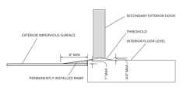Primary

**CA 11A: Figure 11A-8K Ramp at Secondary Exterior Door**

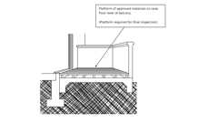Primary

**CA 11A: Figure 11A-8J Platform at Secondary Exterior Door**

**Building products (5)**

[[](https://up.codes/product/back-up-pavers-4-x-2-x-7?viewer_juris_key=california)](https://up.codes/product/back-up-pavers-4-x-2-x-7?viewer_juris_key=california)

**[Back Up Pavers 4 x 2¼ x 7⅝](https://up.codes/product/back-up-pavers-4-x-2-x-7?viewer_juris_key=california)**

**[Interstate Brick](https://up.codes/product/back-up-pavers-4-x-2-x-7?viewer_juris_key=california)**

[[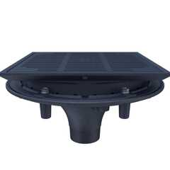](https://up.codes/product/z150f-high-performance-promenade-deck-drain-with-rotatable-frame-and-heel-proof?viewer_juris_key=california)](https://up.codes/product/z150f-high-performance-promenade-deck-drain-with-rotatable-frame-and-heel-proof?viewer_juris_key=california)

**[High Performance Promenade Deck Drain with Rotatable Frame and Heel-Proof Grate - Z150F](https://up.codes/product/z150f-high-performance-promenade-deck-drain-with-rotatable-frame-and-heel-proof?viewer_juris_key=california)**

**[Zurn](https://up.codes/product/z150f-high-performance-promenade-deck-drain-with-rotatable-frame-and-heel-proof?viewer_juris_key=california)**

[[](https://up.codes/product/modular-paver-4-x-2-x-7?viewer_juris_key=california)](https://up.codes/product/modular-paver-4-x-2-x-7?viewer_juris_key=california)

**[Modular Paver 4 x 2¼ x 7⅝](https://up.codes/product/modular-paver-4-x-2-x-7?viewer_juris_key=california)**

**[Interstate Brick](https://up.codes/product/modular-paver-4-x-2-x-7?viewer_juris_key=california)**

[[](https://up.codes/product/modular-solid-4-x-2-x-8?viewer_juris_key=california)](https://up.codes/product/modular-solid-4-x-2-x-8?viewer_juris_key=california)

**[Modular Solid 4 x 2¼ x 8](https://up.codes/product/modular-solid-4-x-2-x-8?viewer_juris_key=california)**

**[Interstate Brick](https://up.codes/product/modular-solid-4-x-2-x-8?viewer_juris_key=california)**

[[](https://up.codes/product/true-paver-4-x-2-x-8?viewer_juris_key=california)](https://up.codes/product/true-paver-4-x-2-x-8?viewer_juris_key=california)

**[True Paver 4 x 2¼ x 8](https://up.codes/product/true-paver-4-x-2-x-8?viewer_juris_key=california)**

**[Interstate Brick](https://up.codes/product/true-paver-4-x-2-x-8?viewer_juris_key=california)**

[**1132A.4.1 *Thresholds***](https://up.codes/viewer/california/ca-building-code-2025/chapter/11A/housing-accessibility#1132A.4.1)

Diagram

[*Thresholds*](https://up.codes/viewer/california/ca-building-code-2025/chapter/10/means-of-egress#1010.1.6)*at the*[*primary entry*](https://up.codes/viewer/california/ca-building-code-2025/chapter/2/definitions#primary_entry_hcd_1_ac_)*and required*[*exit*](https://up.codes/viewer/california/ca-building-code-2025/chapter/2/definitions#exit_)*doors shall be no higher than 1/2inch (12.7 mm).*[*Thresholds*](https://up.codes/viewer/california/ca-building-code-2025/chapter/10/means-of-egress#1010.1.6)*at secondary exterior doors, including sliding door tracks, shall be no higher than 3/4inch (19.05 mm). Changes in height at interior door*[*thresholds*](https://up.codes/viewer/california/ca-building-code-2025/chapter/10/means-of-egress#1010.1.6)*(e.g., floor material changes at door*[*thresholds*](https://up.codes/viewer/california/ca-building-code-2025/chapter/10/means-of-egress#1010.1.6)*) shall not exceed 1/2inch (12.7 mm).*[*Thresholds*](https://up.codes/viewer/california/ca-building-code-2025/chapter/10/means-of-egress#1010.1.6)*shall comply with the following:*

1. [*Thresholds*](https://up.codes/viewer/california/ca-building-code-2025/chapter/10/means-of-egress#1010.1.6)*with a change in height of not more than 1/4inch (6.35 mm) may be vertical.*
2. [*Thresholds*](https://up.codes/viewer/california/ca-building-code-2025/chapter/10/means-of-egress#1010.1.6)*with a change in height between 1/4inch (6.35 mm) and 3/4inch (19.05 mm) shall be beveled with a*[*slope*](https://up.codes/viewer/california/ca-building-code-2025/chapter/J/grading#slope_)*no greater than 1 unit vertical in 2 units horizontal (50-percent*[*slope*](https://up.codes/viewer/california/ca-building-code-2025/chapter/J/grading#slope_)*).*

**UpCodes Diagram (1)**

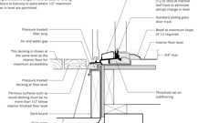

**Sliding Glass Doors at Wood Deck**

[**1132A.5 *Maneuvering Clearances at Doors***](https://up.codes/viewer/california/ca-building-code-2025/chapter/11A/housing-accessibility#1132A.5)

Diagram

**UpCodes Diagrams (2)**

Primary

**Accessible Unit Doors (CA 11A)**

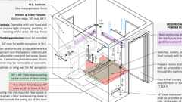

**Powder Room**

[**1132A.5.1 *General***](https://up.codes/viewer/california/ca-building-code-2025/chapter/11A/housing-accessibility#1132A.5.1)

*The floor or landing on the*[*dwelling unit*](https://up.codes/viewer/california/ca-building-code-2025/chapter/2/definitions#dwelling_unit_)*side of the*[*primary entry*](https://up.codes/viewer/california/ca-building-code-2025/chapter/2/definitions#primary_entry_hcd_1_ac_)*door and any required*[*exit*](https://up.codes/viewer/california/ca-building-code-2025/chapter/2/definitions#exit_)*door shall have a minimum length of not less than 44 inches (1118 mm).*[*Section 1126A.3*](https://up.codes/viewer/california/ca-building-code-2025/chapter/11A/housing-accessibility#1126A.3)*shall apply to maneuvering clearances at the side of the door exposed to common or*[*public use*](https://up.codes/viewer/california/ca-building-code-2025/chapter/2/definitions#public_use_dsa_ac_)[*spaces*](https://up.codes/viewer/california/ca-building-code-2025/chapter/2/definitions#space_)*.*

*Maneuvering clearances at interior doors shall provide a minimum length on both sides of the door of at least 42 inches (1067 mm) measured at a right angle to the plane of the door in its closed position.*

***Exception:****A 39-inch (991 mm) length is acceptable at interior doors when a minimum*[*clear*](https://up.codes/viewer/california/ca-building-code-2025/chapter/2/definitions#clear_dsa_ac_)*opening width of 34 inches (864 mm) is provided.*

[**1132A.5.2 *Strike Edge Maneuvering Space at Doors***](https://up.codes/viewer/california/ca-building-code-2025/chapter/11A/housing-accessibility#1132A.5.2)

*The width of the*[*level area*](https://up.codes/viewer/california/ca-building-code-2025/chapter/2/definitions#level_area_hcd_1_ac_)*on the side to which the door swings shall extend 18 inches (457 mm) past the strike edge for all doors. The width of the*[*level area*](https://up.codes/viewer/california/ca-building-code-2025/chapter/2/definitions#level_area_hcd_1_ac_)*at the exterior side of the*[*primary entry*](https://up.codes/viewer/california/ca-building-code-2025/chapter/2/definitions#primary_entry_hcd_1_ac_)*door and any required*[*exit*](https://up.codes/viewer/california/ca-building-code-2025/chapter/2/definitions#exit_)*doors shall comply with*[*Section 1126A*](https://up.codes/viewer/california/ca-building-code-2025/chapter/11A/housing-accessibility#1126A)*.*

* ***Notes:***
  1. *See*[*Section 1134A*](https://up.codes/viewer/california/ca-building-code-2025/chapter/11A/housing-accessibility#1134A)*for*[*bathrooms*](https://up.codes/viewer/california/ca-building-code-2025/chapter/2/definitions#bathroom_)*that are required to be accessible.*
  2. *Twenty-four inches (610 mm) is preferred for strike edge clearance.*

[**1132A.6 *Closer-Effort to Operate Doors***](https://up.codes/viewer/california/ca-building-code-2025/chapter/11A/housing-accessibility#1132A.6)

Diagram

*Maximum effort to operate doors shall not exceed 8 1/2pounds (38 N) for exterior doors and 5 pounds (22 N) for interior doors, such pull or push effort being applied at right angles to hinged doors and at the center plane of sliding or folding doors. Compensating devices or*[*automatic door*](https://up.codes/viewer/california/ca-building-code-2025/chapter/2/definitions#automatic_door_)*operators may be utilized to meet these standards. When*[*fire doors*](https://up.codes/viewer/california/ca-building-code-2025/chapter/2/definitions#fire_door_)*are required, the maximum effort to operate the door may be increased to the minimum allowable by the appropriate*[*enforcement*](https://up.codes/viewer/california/ca-building-code-2025/chapter/2/definitions#enforcement_hcd_1_hcd_2_)*agency, not to exceed 15 pounds (66.7 N).*

**UpCodes Diagram (1)**



**Door Hardware Req. (11A)**

[**1132A.7 *Type of Lock or Latch***](https://up.codes/viewer/california/ca-building-code-2025/chapter/11A/housing-accessibility#1132A.7)

*The type of latch and lock required for all doors shall be in accordance with*[*Section 1132A.8*](https://up.codes/viewer/california/ca-building-code-2025/chapter/11A/housing-accessibility#1132A.8)*and*[*Chapter 10*](https://up.codes/viewer/california/ca-building-code-2025/chapter/10/means-of-egress#10)*,*[*Section 1010*](https://up.codes/viewer/california/ca-building-code-2025/chapter/10/means-of-egress#1010)*.*

[**1132A.8 *Hand-Activated Door Hardware***](https://up.codes/viewer/california/ca-building-code-2025/chapter/11A/housing-accessibility#1132A.8)

Diagram

*Hand-activated door latching, locking and opening*[*hardware*](https://up.codes/viewer/california/ca-building-code-2025/chapter/2/definitions#hardware_)*shall be centered between 30 inches (762 mm) and 44 inches (1118 mm) above the floor. Latching and locking doors that are hand-activated and on an*[*accessible route*](https://up.codes/viewer/california/ca-building-code-2025/chapter/2/definitions#accessible_route_dsa_ac_hcd_1_ac_)*shall be operable with a single effort by lever-type*[*hardware, panic*](https://up.codes/viewer/california/ca-building-code-2025/chapter/2/definitions#panic_hardware_)*bars, push-pull activating bars or other*[*hardware*](https://up.codes/viewer/california/ca-building-code-2025/chapter/2/definitions#hardware_)*designed to provide passage without requiring the ability to grasp the opening*[*hardware*](https://up.codes/viewer/california/ca-building-code-2025/chapter/2/definitions#hardware_)*. Locked*[*exit*](https://up.codes/viewer/california/ca-building-code-2025/chapter/2/definitions#exit_)*doors shall operate consistent with*[*Section 1132A.6*](https://up.codes/viewer/california/ca-building-code-2025/chapter/11A/housing-accessibility#1132A.6)*, in the direction of egress.*

**UpCodes Diagrams (2)**

Primary

**Door Hardware Req. (11A)**



**Levered Handles (CA 11A)**

[**1132A.8.1 *Lever-Type Hardware***](https://up.codes/viewer/california/ca-building-code-2025/chapter/11A/housing-accessibility#1132A.8.1)

Diagram

*The lever or lever of actuated latches or locks shall be curved with a return to within 1/2inch (12.7 mm) of the door to prevent catching on the clothing of persons during egress in*[*Group R*](https://up.codes/viewer/california/ca-building-code-2025/chapter/P/sleeping-lofts#group_r)*and U occupancies with an*[*occupant load*](https://up.codes/viewer/california/ca-building-code-2025/chapter/2/definitions#occupant_load_)*greater than 10.*

**UpCodes Diagram (1)**

Primary

**Levered Handles (CA 11A)**

[**1132A.9 *Smooth Surface***](https://up.codes/viewer/california/ca-building-code-2025/chapter/11A/housing-accessibility#1132A.9)

Diagram

*Swinging door or gate surfaces within 10 inches (254 mm) of the finish floor or ground measured vertically shall have a smooth surface on the push side extending the full width of the door or gate. Parts creating horizontal or vertical*[*joints*](https://up.codes/viewer/california/ca-building-code-2025/chapter/7/fire-and-smoke-protection-features#712.1.5)*in these surfaces shall be within 1/16inch (1.6 mm) of the same plane as the other and be free of sharp or abrasive edges. Cavities created by added*[*kick plates*](https://up.codes/viewer/california/ca-building-code-2025/chapter/2/definitions#kick_plate_)*shall be capped.*

***Exceptions:***

1. [*Automatic doors*](https://up.codes/viewer/california/ca-building-code-2025/chapter/2/definitions#automatic_door_)*.*
2. *Tempered glass doors without stiles and having a bottom rail or shoe with the top leading edge tapered at 60 degrees minimum from the horizontal.*
3. *Doors or gates that do not extend to within 10 inches (254 mm) of the finish floor.*

**UpCodes Diagrams (2)**



**Door Surface Excpt. - Tempered Glass Door**



**Door Hardware Req. (11A)**

[**1132A.10 *Door Signal Devices***](https://up.codes/viewer/california/ca-building-code-2025/chapter/11A/housing-accessibility#1132A.10)

*Every primary*[*entrance*](https://up.codes/viewer/california/ca-building-code-2025/chapter/2/definitions#entrance_hcd_1_hcd_2_hcd_1_ac_and_dsa_ac_)*to a covered multifamily*[*dwelling unit*](https://up.codes/viewer/california/ca-building-code-2025/chapter/2/definitions#dwelling_unit_)*shall be provided with a door buzzer, bell, chime or equivalent. The activating mechanism shall be mounted a maximum of 48 inches (1219 mm) above the floor and connected to*[*permanent*](https://up.codes/viewer/california/ca-building-code-2025/chapter/2/definitions#permanent_dsa_ac_)*wiring.*

[**Section 1133A *Kitchens***](https://up.codes/viewer/california/ca-building-code-2025/chapter/11A/housing-accessibility#1133A)

Diagram

**UpCodes Diagrams (3)**

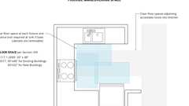

**Kitchens: Clearance Overlaps (FHA)**

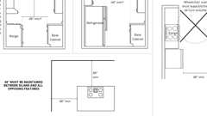

**Kitchen Countertop Clearances (CBC 11A)**

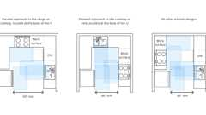

**U-Shaped Kitchens (CA 11A)**

**Building products (2)**

[[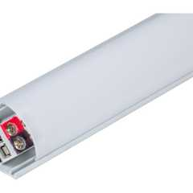](https://up.codes/product/37-7-8-300-lumens-ft-24-volt-standard-output-angled-linear-fixture-tunable-white?viewer_juris_key=california)](https://up.codes/product/37-7-8-300-lumens-ft-24-volt-standard-output-angled-linear-fixture-tunable-white?viewer_juris_key=california)

**[600 Lumens/Ft. Angled Linear Fixture, Tunable-White, 2700K–5000K - LT-P3](https://up.codes/product/37-7-8-300-lumens-ft-24-volt-standard-output-angled-linear-fixture-tunable-white?viewer_juris_key=california)**

**[Task Lighting and Power](https://up.codes/product/37-7-8-300-lumens-ft-24-volt-standard-output-angled-linear-fixture-tunable-white?viewer_juris_key=california)**

[[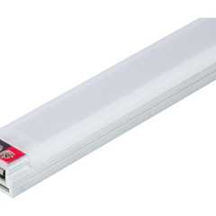](https://up.codes/product/14-1-2-120-lumens-ft-12-volt-accent-output-flat-linear-fixture-single-white-fits?viewer_juris_key=california)](https://up.codes/product/14-1-2-120-lumens-ft-12-volt-accent-output-flat-linear-fixture-single-white-fits?viewer_juris_key=california)

**[Flat Profile Linear Fixtures - Single-White - LS-P7](https://up.codes/product/14-1-2-120-lumens-ft-12-volt-accent-output-flat-linear-fixture-single-white-fits?viewer_juris_key=california)**

**[Task Lighting and Power](https://up.codes/product/14-1-2-120-lumens-ft-12-volt-accent-output-flat-linear-fixture-single-white-fits?viewer_juris_key=california)**

[**1133A.1 *General***](https://up.codes/viewer/california/ca-building-code-2025/chapter/11A/housing-accessibility#1133A.1)

*Kitchens shall be on an*[*accessible route*](https://up.codes/viewer/california/ca-building-code-2025/chapter/2/definitions#accessible_route_dsa_ac_hcd_1_ac_)*and shall comply with this section. (See*[*Figure*](https://up.codes/viewer/california/ca-building-code-2025/chapter/11B/accessibility-to-public-buildings-public-accommodations-commercial-buildings-and#figure)*11A-10A.)*

[**1133A.2 *Clear Floor Space***](https://up.codes/viewer/california/ca-building-code-2025/chapter/11A/housing-accessibility#1133A.2)

Diagram

[*Clear floor space*](https://up.codes/viewer/california/ca-building-code-2025/chapter/2/definitions#clear_floor_space_dsa_ac_hcd_1_ac_)*at kitchens shall comply with the following:*

1. *A*[*clear floor space*](https://up.codes/viewer/california/ca-building-code-2025/chapter/2/definitions#clear_floor_space_dsa_ac_hcd_1_ac_)*at least 30 inches (762 mm) by 48 inches (1219 mm) that allows a parallel approach by a person in a*[*wheelchair*](https://up.codes/viewer/california/ca-building-code-2025/chapter/2/definitions#wheelchair_hcd_1_ac_dsa_ac_)*shall be provided at the range or cooktop.*
2. *A*[*clear floor space*](https://up.codes/viewer/california/ca-building-code-2025/chapter/2/definitions#clear_floor_space_dsa_ac_hcd_1_ac_)*at least 30 inches (762 mm) by 48 inches (1219 mm) that allows either a parallel or forward approach shall be provided at the kitchen*[*sink*](https://up.codes/viewer/california/ca-building-code-2025/chapter/2/definitions#sink_)*and all other fixtures or appliances including the oven, dishwasher, refrigerator/freezer and trash compactor.*
3. *A*[*clear floor space*](https://up.codes/viewer/california/ca-building-code-2025/chapter/2/definitions#clear_floor_space_dsa_ac_hcd_1_ac_)*at least 30 inches (762 mm) by 48 inches (1219 mm) that allows either a parallel or a forward approach shall be provided at the work surface required by*[*Section 1133A.4*](https://up.codes/viewer/california/ca-building-code-2025/chapter/11A/housing-accessibility#1133A.4)*.*
4. *The centerline of the 30-inch (762 mm) by 48-inch (1219 mm)*[*clear floor space*](https://up.codes/viewer/california/ca-building-code-2025/chapter/2/definitions#clear_floor_space_dsa_ac_hcd_1_ac_)*provided for parallel or forward approach shall be aligned with the centerline of the work surface, appliance or fixture.*

**UpCodes Diagram (1)**



**Kitchens: Clearance Overlaps (FHA)**

[**1133A.2.1 *Clear Width***](https://up.codes/viewer/california/ca-building-code-2025/chapter/11A/housing-accessibility#1133A.2.1)

Diagram

*Kitchens shall have a minimum*[*clear*](https://up.codes/viewer/california/ca-building-code-2025/chapter/2/definitions#clear_dsa_ac_)*width measured between any cabinet, countertop or the face of any appliance (excluding handles and controls) that projects into the kitchen and the opposing cabinet, countertop, appliance or*[*wall*](https://up.codes/viewer/california/ca-building-code-2025/chapter/2/definitions#wall_)*as follows:*

1. *U-shaped kitchens, designed with parallel approach at a range or cooktop located at the*[*base*](https://up.codes/viewer/california/ca-building-code-2025/chapter/2/definitions#base_dsa_ss_dsa_ss_cc_oshpd_1_1r_2_4_5_)*of the U, shall have a minimum*[*clear*](https://up.codes/viewer/california/ca-building-code-2025/chapter/2/definitions#clear_dsa_ac_)*width of at least 60 inches (1524 mm). (See*[*Figure*](https://up.codes/viewer/california/ca-building-code-2025/chapter/11B/accessibility-to-public-buildings-public-accommodations-commercial-buildings-and#figure)*11A-10A.)*
2. *U-shaped kitchens, designed with a cooktop or*[*sink*](https://up.codes/viewer/california/ca-building-code-2025/chapter/2/definitions#sink_)*located at the*[*base*](https://up.codes/viewer/california/ca-building-code-2025/chapter/2/definitions#base_dsa_ss_dsa_ss_cc_oshpd_1_1r_2_4_5_)*of the U, which provides a knee and toe*[*space*](https://up.codes/viewer/california/ca-building-code-2025/chapter/2/definitions#space_)*in accordance with*[*Section 1133A.7*](https://up.codes/viewer/california/ca-building-code-2025/chapter/11A/housing-accessibility#1133A.7)*to allow for a forward approach, shall have a*[*clear*](https://up.codes/viewer/california/ca-building-code-2025/chapter/2/definitions#clear_dsa_ac_)*width of at least 48 inches (1219 mm). (See*[*Figure*](https://up.codes/viewer/california/ca-building-code-2025/chapter/11B/accessibility-to-public-buildings-public-accommodations-commercial-buildings-and#figure)*11A-10A.)*
3. *All other kitchen*[*designs*](https://up.codes/viewer/california/ca-building-code-2025/chapter/22A/steel#2210A.1.1)*shall provide a minimum*[*clear*](https://up.codes/viewer/california/ca-building-code-2025/chapter/2/definitions#clear_dsa_ac_)*width of at least 48 inches (1219 mm). (See*[*Figure*](https://up.codes/viewer/california/ca-building-code-2025/chapter/11B/accessibility-to-public-buildings-public-accommodations-commercial-buildings-and#figure)*11A-10A.)*

**UpCodes Diagrams (3)**

Primary

**U-Shaped Kitchens (CA 11A)**

Primary

**Kitchen Countertop Clearances (CBC 11A)**

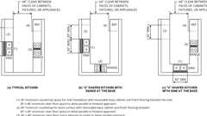Primary

**CA 11A: Figure 11A-10A Kitchen Specifications**

[**1133A.3 *Removable Base Cabinets***](https://up.codes/viewer/california/ca-building-code-2025/chapter/11A/housing-accessibility#1133A.3)

[*Sinks*](https://up.codes/viewer/california/ca-building-code-2025/chapter/2/definitions#sink_)*and work surfaces required by*[*Section 1133A.4*](https://up.codes/viewer/california/ca-building-code-2025/chapter/11A/housing-accessibility#1133A.4)*(see Item 1 and Item 2) shall be provided with knee and toe*[*space*](https://up.codes/viewer/california/ca-building-code-2025/chapter/2/definitions#space_)*complying with*[*Section 1133A.7*](https://up.codes/viewer/california/ca-building-code-2025/chapter/11A/housing-accessibility#1133A.7)*.*[*Base*](https://up.codes/viewer/california/ca-building-code-2025/chapter/2/definitions#base_dsa_ss_dsa_ss_cc_oshpd_1_1r_2_4_5_)*cabinets (including toeboard and shelving) directly under kitchen*[*sinks*](https://up.codes/viewer/california/ca-building-code-2025/chapter/2/definitions#sink_)*and work surfaces shall be removable without the use of specialized tools or specialized knowledge in order to provide knee and toe*[*space*](https://up.codes/viewer/california/ca-building-code-2025/chapter/2/definitions#space_)*. The finish floor beneath kitchen*[*sinks*](https://up.codes/viewer/california/ca-building-code-2025/chapter/2/definitions#sink_)*and work surfaces shall be extended to the*[*wall*](https://up.codes/viewer/california/ca-building-code-2025/chapter/2/definitions#wall_)*.*

[**1133A.4 *Countertops***](https://up.codes/viewer/california/ca-building-code-2025/chapter/11A/housing-accessibility#1133A.4)

*Kitchen countertops shall comply with this section and shall be provided with the following:*

1. *A minimum linear length of 30 inches (762 mm) of countertop shall be provided for the kitchen*[*sink*](https://up.codes/viewer/california/ca-building-code-2025/chapter/2/definitions#sink_)[*installation*](https://up.codes/viewer/california/ca-building-code-2025/chapter/27/electrical#2702.1.3)*.*
2. *A minimum linear length of 30 inches (762 mm) of countertop shall be provided for a work surface.*
3. [*Sinks*](https://up.codes/viewer/california/ca-building-code-2025/chapter/2/definitions#sink_)*and work surfaces may be a single integral unit a minimum of 60 inches (1524 mm) in length, or be separate components.*

***Exception:****Two 15-inch (381 mm) wide minimum breadboards may be provided in lieu of the required 30 inches (762 mm) of countertop work surface.*

[**1133A.4.1 *Repositionable Countertops***](https://up.codes/viewer/california/ca-building-code-2025/chapter/11A/housing-accessibility#1133A.4.1)

*Repositionable countertops shall be provided in a minimum of 5 percent of the covered multifamily*[*dwelling units*](https://up.codes/viewer/california/ca-building-code-2025/chapter/2/definitions#dwelling_unit_)*. Repositionable countertops shall comply with the following:*

1. [*Sinks*](https://up.codes/viewer/california/ca-building-code-2025/chapter/2/definitions#sink_)*and work surfaces required by*[*Section 1133A.4*](https://up.codes/viewer/california/ca-building-code-2025/chapter/11A/housing-accessibility#1133A.4)*shall be designed to enable repositioning to a minimum height of 28 inches (711 mm).*
2. [*Base*](https://up.codes/viewer/california/ca-building-code-2025/chapter/2/definitions#base_dsa_ss_dsa_ss_cc_oshpd_1_1r_2_4_5_)*cabinets directly under*[*sinks*](https://up.codes/viewer/california/ca-building-code-2025/chapter/2/definitions#sink_)*and work surfaces shall be removable as required in*[*Section 1133A.3*](https://up.codes/viewer/california/ca-building-code-2025/chapter/11A/housing-accessibility#1133A.3)*.*
3. *The sides of adjacent cabinets and the back*[*wall*](https://up.codes/viewer/california/ca-building-code-2025/chapter/2/definitions#wall_)*, which may become exposed to moisture or food*[*handling*](https://up.codes/viewer/california/ca-building-code-2025/chapter/2/definitions#handling_)*when a countertop is lowered, shall be constructed of durable, nonabsorbent*[*materials*](https://up.codes/viewer/california/ca-building-code-2025/chapter/4/special-detailed-requirements-based-on-occupancy-and-use#414.1.2)*appropriate for such uses.*
4. *Finished flooring shall be extended to the*[*wall*](https://up.codes/viewer/california/ca-building-code-2025/chapter/2/definitions#wall_)*beneath the*[*sink*](https://up.codes/viewer/california/ca-building-code-2025/chapter/2/definitions#sink_)*and work surface.*

***Exceptions:***

* 1. *Stone, cultured stone and tiled countertops may be used without meeting the repositioning requirements.*
  2. *Two 15-inch (381 mm) wide minimum breadboards may be provided in lieu of the required 30 inches (762 mm) of countertop work surface, and used without meeting the repositioning requirements.*

[**1133A.5 *Lower Shelving***](https://up.codes/viewer/california/ca-building-code-2025/chapter/11A/housing-accessibility#1133A.5)

*Lower shelving and/or drawer*[*space*](https://up.codes/viewer/california/ca-building-code-2025/chapter/2/definitions#space_)*shall be provided in the kitchen at a height of no more than 48 inches (1219 mm) above the floor.*

[**1133A.6 *Kitchen Sink Faucet Controls***](https://up.codes/viewer/california/ca-building-code-2025/chapter/11A/housing-accessibility#1133A.6)

*Faucet controls and operating mechanisms shall be operable with one hand and shall not require tight grasping, pinching or twisting of the wrist.*

*The force required to activate controls shall be no greater than 5 pounds (22.2 N). Lever-operated, push-type and electronically controlled mechanisms are examples of acceptable*[*designs*](https://up.codes/viewer/california/ca-building-code-2025/chapter/22A/steel#2210A.1.1)*.*[*Self-closing*](https://up.codes/viewer/california/ca-building-code-2025/chapter/2/definitions#self_closing_)*valves are allowed if the faucet remains open for at least 10 seconds.*

**Building products (2)**

[[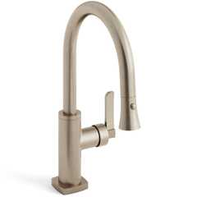](https://up.codes/product/h-line-low-gooseneck-kitchen-faucet-with-pull-down-spray-115-7-3pg4-mz4?viewer_juris_key=california)](https://up.codes/product/h-line-low-gooseneck-kitchen-faucet-with-pull-down-spray-115-7-3pg4-mz4?viewer_juris_key=california)

**[H-Line Low Gooseneck Kitchen Faucet With Pull Down Spray](https://up.codes/product/h-line-low-gooseneck-kitchen-faucet-with-pull-down-spray-115-7-3pg4-mz4?viewer_juris_key=california)**

**[Watermark Designs](https://up.codes/product/h-line-low-gooseneck-kitchen-faucet-with-pull-down-spray-115-7-3pg4-mz4?viewer_juris_key=california)**

[[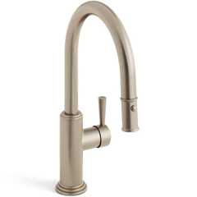](https://up.codes/product/stratford-1-hole-gooseneck-kitchen-faucet-with-pull-down-spray-321-7-3pg4-s1a?viewer_juris_key=california)](https://up.codes/product/stratford-1-hole-gooseneck-kitchen-faucet-with-pull-down-spray-321-7-3pg4-s1a?viewer_juris_key=california)

**[Stratford 1 Hole Gooseneck Kitchen Faucet With Pull Down Spray](https://up.codes/product/stratford-1-hole-gooseneck-kitchen-faucet-with-pull-down-spray-321-7-3pg4-s1a?viewer_juris_key=california)**

**[Watermark Designs](https://up.codes/product/stratford-1-hole-gooseneck-kitchen-faucet-with-pull-down-spray-321-7-3pg4-s1a?viewer_juris_key=california)**

[**1133A.7 *Knee and Toe Space***](https://up.codes/viewer/california/ca-building-code-2025/chapter/11A/housing-accessibility#1133A.7)

*Knee and toe*[*space*](https://up.codes/viewer/california/ca-building-code-2025/chapter/2/definitions#space_)*, when required by*[*Section 1133A*](https://up.codes/viewer/california/ca-building-code-2025/chapter/11A/housing-accessibility#1133A)*, shall comply with*[*Section 1138A.2*](https://up.codes/viewer/california/ca-building-code-2025/chapter/11A/housing-accessibility#1138A.2)*and the following:*

1. *The knee and toe*[*space*](https://up.codes/viewer/california/ca-building-code-2025/chapter/2/definitions#space_)*shall be*[*clear*](https://up.codes/viewer/california/ca-building-code-2025/chapter/2/definitions#clear_dsa_ac_)*and unobstructed, or removable*[*base*](https://up.codes/viewer/california/ca-building-code-2025/chapter/2/definitions#base_dsa_ss_dsa_ss_cc_oshpd_1_1r_2_4_5_)*cabinets in*[*compliance*](https://up.codes/viewer/california/ca-building-code-2025/chapter/31/special-construction#3113.1.1)*with*[*Section 1133A.3*](https://up.codes/viewer/california/ca-building-code-2025/chapter/11A/housing-accessibility#1133A.3)*shall be provided.*
2. *The knee and toe*[*space*](https://up.codes/viewer/california/ca-building-code-2025/chapter/2/definitions#space_)*shall be 30 inches (762 mm) wide minimum, centered on the*[*sink*](https://up.codes/viewer/california/ca-building-code-2025/chapter/2/definitions#sink_)*, countertop or appliance.*
3. *A*[*clear floor space*](https://up.codes/viewer/california/ca-building-code-2025/chapter/2/definitions#clear_floor_space_dsa_ac_hcd_1_ac_)*shall not extend into the knee and toe*[*space*](https://up.codes/viewer/california/ca-building-code-2025/chapter/2/definitions#space_)*more than 19 inches (483 mm).*

[**1133A.7.1 *Plumbing Protection***](https://up.codes/viewer/california/ca-building-code-2025/chapter/11A/housing-accessibility#1133A.7.1)

*Water supply and*[*drain*](https://up.codes/viewer/california/ca-building-code-2025/chapter/2/definitions#drain_)*pipes under kitchen*[*sinks*](https://up.codes/viewer/california/ca-building-code-2025/chapter/2/definitions#sink_)*shall be insulated or otherwise covered to protect against contact. There shall be no sharp or abrasive surfaces under kitchen*[*sinks*](https://up.codes/viewer/california/ca-building-code-2025/chapter/2/definitions#sink_)*.*

[**Section 1134A *Bathing and Toilet Facilities***](https://up.codes/viewer/california/ca-building-code-2025/chapter/11A/housing-accessibility#1134A)

Diagram

**UpCodes Diagrams (3)**

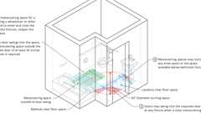

**Sufficient Maneuvering Space**



**Powder Room**

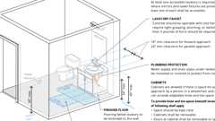

**Lavatories, Vanities, Mirrors and Towel Fixtures (CA 11A)**

[**1134A.1 *General***](https://up.codes/viewer/california/ca-building-code-2025/chapter/11A/housing-accessibility#1134A.1)

*All*[*bathrooms*](https://up.codes/viewer/california/ca-building-code-2025/chapter/2/definitions#bathroom_)*, bathing and toilet*[*facilities*](https://up.codes/viewer/california/ca-building-code-2025/chapter/2/definitions#facility_)*within covered multifamily*[*dwelling units*](https://up.codes/viewer/california/ca-building-code-2025/chapter/2/definitions#dwelling_unit_)*shall comply with this section.*

[**1134A.2 *Number of Complying Bathrooms***](https://up.codes/viewer/california/ca-building-code-2025/chapter/11A/housing-accessibility#1134A.2)

Diagram

[*Bathrooms*](https://up.codes/viewer/california/ca-building-code-2025/chapter/2/definitions#bathroom_)*shall be designed to comply with one of the following options:*

***Option 1.****All*[*bathrooms*](https://up.codes/viewer/california/ca-building-code-2025/chapter/2/definitions#bathroom_)*within the*[*dwelling unit*](https://up.codes/viewer/california/ca-building-code-2025/chapter/2/definitions#dwelling_unit_)*shall be designed to comply with the following:*

1. *Toilet, bathing and shower*[*facilities*](https://up.codes/viewer/california/ca-building-code-2025/chapter/2/definitions#facility_)*shall comply with*[*Section 1134A.4*](https://up.codes/viewer/california/ca-building-code-2025/chapter/11A/housing-accessibility#1134A.4)*.*
2. *Bathtubs shall comply with*[*Section 1134A.5*](https://up.codes/viewer/california/ca-building-code-2025/chapter/11A/housing-accessibility#1134A.5)*.*
3. *Showers shall comply with*[*Section 1134A.6*](https://up.codes/viewer/california/ca-building-code-2025/chapter/11A/housing-accessibility#1134A.6)*.*
4. *Water closets shall comply with*[*Section 1134A.7*](https://up.codes/viewer/california/ca-building-code-2025/chapter/11A/housing-accessibility#1134A.7)*.*
5. [*Lavatories*](https://up.codes/viewer/california/ca-building-code-2025/chapter/2/definitions#lavatory_)*, vanities, mirrors and towel fixtures shall comply with*[*Section 1134A.8*](https://up.codes/viewer/california/ca-building-code-2025/chapter/11A/housing-accessibility#1134A.8)*.*
6. [*Bathrooms*](https://up.codes/viewer/california/ca-building-code-2025/chapter/2/definitions#bathroom_)*shall be provided with an*[*accessible route*](https://up.codes/viewer/california/ca-building-code-2025/chapter/2/definitions#accessible_route_dsa_ac_hcd_1_ac_)*into and through the*[*bathroom*](https://up.codes/viewer/california/ca-building-code-2025/chapter/2/definitions#bathroom_)*.*
7. *If a door is provided, it shall comply with the requirements of*[*Section 1132A.5*](https://up.codes/viewer/california/ca-building-code-2025/chapter/11A/housing-accessibility#1132A.5)*.*
8. *A minimum 18-inch (457 mm)*[*clear*](https://up.codes/viewer/california/ca-building-code-2025/chapter/2/definitions#clear_dsa_ac_)*maneuvering*[*space*](https://up.codes/viewer/california/ca-building-code-2025/chapter/2/definitions#space_)*shall be provided on the swing side of the door at the strike edge of the door.*
9. *Switches, outlets and controls shall comply with*[*Section 1142A*](https://up.codes/viewer/california/ca-building-code-2025/chapter/11A/housing-accessibility#1142A)*.*
10. *Reinforced*[*walls*](https://up.codes/viewer/california/ca-building-code-2025/chapter/2/definitions#wall_)*to allow for the future*[*installation*](https://up.codes/viewer/california/ca-building-code-2025/chapter/27/electrical#2702.1.3)*of*[*grab bars*](https://up.codes/viewer/california/ca-building-code-2025/chapter/2/definitions#grab_bar_dsa_ac_hcd_1_ac_)*around the toilet, tub and shower shall comply with Sections*[*1134A.5*](https://up.codes/viewer/california/ca-building-code-2025/chapter/11A/housing-accessibility#1134A.5)*for bathtubs, 1134A.6 for showers and 1134A.7 for water closets.*

***Option 2.****Only one*[*bathroom*](https://up.codes/viewer/california/ca-building-code-2025/chapter/2/definitions#bathroom_)*within the*[*dwelling unit*](https://up.codes/viewer/california/ca-building-code-2025/chapter/2/definitions#dwelling_unit_)*shall be designed to comply with the following:*

1. *Toilet, bathing and shower*[*facilities*](https://up.codes/viewer/california/ca-building-code-2025/chapter/2/definitions#facility_)*shall comply with*[*Section 1134A.4*](https://up.codes/viewer/california/ca-building-code-2025/chapter/11A/housing-accessibility#1134A.4)*.*
2. *Bathtubs shall comply with*[*Section 1134A.5*](https://up.codes/viewer/california/ca-building-code-2025/chapter/11A/housing-accessibility#1134A.5)*.*
3. *Showers shall comply with*[*Section 1134A.6*](https://up.codes/viewer/california/ca-building-code-2025/chapter/11A/housing-accessibility#1134A.6)*.*
4. *Water closets shall comply with*[*Section 1134A.7*](https://up.codes/viewer/california/ca-building-code-2025/chapter/11A/housing-accessibility#1134A.7)*.*
5. [*Lavatories*](https://up.codes/viewer/california/ca-building-code-2025/chapter/2/definitions#lavatory_)*, vanities, mirrors and towel fixtures shall comply with*[*Section 1134A.8*](https://up.codes/viewer/california/ca-building-code-2025/chapter/11A/housing-accessibility#1134A.8)*.*
6. *Where both a tub and shower are provided in the*[*bathroom*](https://up.codes/viewer/california/ca-building-code-2025/chapter/2/definitions#bathroom_)*, at least one shall be made accessible.*[*Additional requirements*](https://up.codes/viewer/california/ca-building-code-2025/chapter/14/exterior-walls#1404.1.2)*apply to*[*dwelling units*](https://up.codes/viewer/california/ca-building-code-2025/chapter/2/definitions#dwelling_unit_)*containing two or more*[*bathrooms*](https://up.codes/viewer/california/ca-building-code-2025/chapter/2/definitions#bathroom_)*when a bathtub is provided as the accessible bathing fixture.*

*Where two or more*[*bathrooms*](https://up.codes/viewer/california/ca-building-code-2025/chapter/2/definitions#bathroom_)*are provided within the same*[*dwelling unit*](https://up.codes/viewer/california/ca-building-code-2025/chapter/2/definitions#dwelling_unit_)*and a bathtub is installed to comply with Option 2, Item 6 in one*[*bathroom*](https://up.codes/viewer/california/ca-building-code-2025/chapter/2/definitions#bathroom_)*and a shower stall is provided in a subsequent*[*bathroom*](https://up.codes/viewer/california/ca-building-code-2025/chapter/2/definitions#bathroom_)*, both the bathtub selected to comply with Option 2, Item 6 and at least one shower stall within the*[*dwelling unit*](https://up.codes/viewer/california/ca-building-code-2025/chapter/2/definitions#dwelling_unit_)*shall meet all the applicable*[*accessibility*](https://up.codes/viewer/california/ca-building-code-2025/chapter/30/elevators-and-conveying-systems#3001.4)*requirements provided in*[*Section 1134A*](https://up.codes/viewer/california/ca-building-code-2025/chapter/11A/housing-accessibility#1134A)*. (See*[*Section 1134A.5*](https://up.codes/viewer/california/ca-building-code-2025/chapter/11A/housing-accessibility#1134A.5)*for bathtubs, or*[*Section 1134A.6*](https://up.codes/viewer/california/ca-building-code-2025/chapter/11A/housing-accessibility#1134A.6)*for showers.)*

1. *When two or more*[*lavatories*](https://up.codes/viewer/california/ca-building-code-2025/chapter/2/definitions#lavatory_)*are provided, at least one shall be made accessible and comply with*[*Section 1134A.8*](https://up.codes/viewer/california/ca-building-code-2025/chapter/11A/housing-accessibility#1134A.8)*.*
2. [*Bathrooms*](https://up.codes/viewer/california/ca-building-code-2025/chapter/2/definitions#bathroom_)*shall be provided with an*[*accessible route*](https://up.codes/viewer/california/ca-building-code-2025/chapter/2/definitions#accessible_route_dsa_ac_hcd_1_ac_)*into and through the*[*bathroom*](https://up.codes/viewer/california/ca-building-code-2025/chapter/2/definitions#bathroom_)*.*
3. *If a door is provided, it shall comply with the requirements of*[*Section 1132A.5*](https://up.codes/viewer/california/ca-building-code-2025/chapter/11A/housing-accessibility#1132A.5)*.*
4. *A minimum 18-inch (457 mm)*[*clear*](https://up.codes/viewer/california/ca-building-code-2025/chapter/2/definitions#clear_dsa_ac_)*maneuvering*[*space*](https://up.codes/viewer/california/ca-building-code-2025/chapter/2/definitions#space_)*shall be provided on the swing side of the door at the strike edge of the door.*
5. *Switches, outlets and controls shall comply with*[*Section 1142A*](https://up.codes/viewer/california/ca-building-code-2025/chapter/11A/housing-accessibility#1142A)*.*
6. *Reinforced*[*walls*](https://up.codes/viewer/california/ca-building-code-2025/chapter/2/definitions#wall_)*to allow for the future*[*installation*](https://up.codes/viewer/california/ca-building-code-2025/chapter/27/electrical#2702.1.3)*of*[*grab bars*](https://up.codes/viewer/california/ca-building-code-2025/chapter/2/definitions#grab_bar_dsa_ac_hcd_1_ac_)*around the toilet, tub and shower shall comply with Sections*[*1134A.5*](https://up.codes/viewer/california/ca-building-code-2025/chapter/11A/housing-accessibility#1134A.5)*for bathtubs, 1134A.6 for showers and 1134A.7 for water closets.*

*When Option 2 is used, all additional*[*bathrooms*](https://up.codes/viewer/california/ca-building-code-2025/chapter/2/definitions#bathroom_)*must comply with Items 8 through 12 above.*

**UpCodes Diagram (1)**



**Powder Room**

[**1134A.3 *Powder Rooms***](https://up.codes/viewer/california/ca-building-code-2025/chapter/11A/housing-accessibility#1134A.3)

Diagram

*All*[*powder rooms*](https://up.codes/viewer/california/ca-building-code-2025/chapter/2/definitions#powder_room_)*shall be designed to comply with*[*Section 1134A.2*](https://up.codes/viewer/california/ca-building-code-2025/chapter/11A/housing-accessibility#1134A.2)*, Option 2, Items 8 through 12. When the*[*powder room*](https://up.codes/viewer/california/ca-building-code-2025/chapter/2/definitions#powder_room_)*is the only toilet*[*facility*](https://up.codes/viewer/california/ca-building-code-2025/chapter/2/definitions#facility_)*located on an accessible level, it shall comply with the Option 2 items listed above, plus all*[*additional requirements*](https://up.codes/viewer/california/ca-building-code-2025/chapter/14/exterior-walls#1404.1.2)*located in Sections*[*1134A.4*](https://up.codes/viewer/california/ca-building-code-2025/chapter/11A/housing-accessibility#1134A.4)*, 1134A.7 and 1134A.8.*

**UpCodes Diagram (1)**

Primary

**Powder Room**

[**1134A.4 *Sufficient Maneuvering Space***](https://up.codes/viewer/california/ca-building-code-2025/chapter/11A/housing-accessibility#1134A.4)

Diagram

*Bathing and toilet*[*facilities*](https://up.codes/viewer/california/ca-building-code-2025/chapter/2/definitions#facility_)*required to be*[*adaptable*](https://up.codes/viewer/california/ca-building-code-2025/chapter/2/definitions#adaptable_dsa_ac_)*shall provide sufficient maneuvering*[*space*](https://up.codes/viewer/california/ca-building-code-2025/chapter/2/definitions#space_)*for a person using a*[*wheelchair*](https://up.codes/viewer/california/ca-building-code-2025/chapter/2/definitions#wheelchair_hcd_1_ac_dsa_ac_)*or other mobility aid to enter and close the door, use the fixtures, reopen the door and*[*exit*](https://up.codes/viewer/california/ca-building-code-2025/chapter/2/definitions#exit_)*.*

*Where the door swings into the*[*bathroom*](https://up.codes/viewer/california/ca-building-code-2025/chapter/2/definitions#bathroom_)*or*[*powder room*](https://up.codes/viewer/california/ca-building-code-2025/chapter/2/definitions#powder_room_)*, there shall be a*[*clear*](https://up.codes/viewer/california/ca-building-code-2025/chapter/2/definitions#clear_dsa_ac_)*maneuvering*[*space*](https://up.codes/viewer/california/ca-building-code-2025/chapter/2/definitions#space_)*outside the swing of the door of at least 30 inches by 48 inches (762 mm by 1219 mm) within the room. The*[*clear*](https://up.codes/viewer/california/ca-building-code-2025/chapter/2/definitions#clear_dsa_ac_)*maneuvering*[*space*](https://up.codes/viewer/california/ca-building-code-2025/chapter/2/definitions#space_)*shall allow the user to position a*[*wheelchair*](https://up.codes/viewer/california/ca-building-code-2025/chapter/2/definitions#wheelchair_hcd_1_ac_dsa_ac_)*or other mobility aid*[*clear*](https://up.codes/viewer/california/ca-building-code-2025/chapter/2/definitions#clear_dsa_ac_)*of the path of the door as it is closed and to*[*permit*](https://up.codes/viewer/california/ca-building-code-2025/chapter/2/definitions#permit_)*use of fixtures.*

*Doors may swing into the required*[*clear*](https://up.codes/viewer/california/ca-building-code-2025/chapter/2/definitions#clear_dsa_ac_)[*space*](https://up.codes/viewer/california/ca-building-code-2025/chapter/2/definitions#space_)*at any fixture when a*[*clear*](https://up.codes/viewer/california/ca-building-code-2025/chapter/2/definitions#clear_dsa_ac_)*maneuvering*[*space*](https://up.codes/viewer/california/ca-building-code-2025/chapter/2/definitions#space_)*is provided outside the swing arc of the door so it can be closed.*

*Maneuvering*[*spaces*](https://up.codes/viewer/california/ca-building-code-2025/chapter/2/definitions#space_)*may include any knee*[*space*](https://up.codes/viewer/california/ca-building-code-2025/chapter/2/definitions#space_)*or toe*[*space*](https://up.codes/viewer/california/ca-building-code-2025/chapter/2/definitions#space_)*available below*[*bathroom*](https://up.codes/viewer/california/ca-building-code-2025/chapter/2/definitions#bathroom_)*fixtures.*

**UpCodes Diagram (1)**

Primary

**Sufficient Maneuvering Space**

[**1134A.5 *Bathtubs***](https://up.codes/viewer/california/ca-building-code-2025/chapter/11A/housing-accessibility#1134A.5)

Diagram

*Bathtubs required to be accessible shall comply with this section.*

1. ***Floor***[***space***](https://up.codes/viewer/california/ca-building-code-2025/chapter/2/definitions#space_)***.****There shall be a minimum*[*clear floor space*](https://up.codes/viewer/california/ca-building-code-2025/chapter/2/definitions#clear_floor_space_dsa_ac_hcd_1_ac_)*48 inches parallel by 30 inches perpendicular (1219 mm by 762 mm) to the side of a bathtub or bathtub-shower combination to provide for the maneuvering of a*[*wheelchair*](https://up.codes/viewer/california/ca-building-code-2025/chapter/2/definitions#wheelchair_hcd_1_ac_dsa_ac_)*and transfer to and from the bathing*[*facilities*](https://up.codes/viewer/california/ca-building-code-2025/chapter/2/definitions#facility_)*. The controls shall be on the*[*wall*](https://up.codes/viewer/california/ca-building-code-2025/chapter/2/definitions#wall_)*at the foot of the bathtub. The edge of the*[*clear floor space*](https://up.codes/viewer/california/ca-building-code-2025/chapter/2/definitions#clear_floor_space_dsa_ac_hcd_1_ac_)*shall be flush with the control*[*wall*](https://up.codes/viewer/california/ca-building-code-2025/chapter/2/definitions#wall_)*surface. The area under a*[*lavatory*](https://up.codes/viewer/california/ca-building-code-2025/chapter/2/definitions#lavatory_)*, located at the control end of the tub, may be included in the*[*clear floor space*](https://up.codes/viewer/california/ca-building-code-2025/chapter/2/definitions#clear_floor_space_dsa_ac_hcd_1_ac_)*provided the*[*lavatory*](https://up.codes/viewer/california/ca-building-code-2025/chapter/2/definitions#lavatory_)*is 19 inches (483 mm) maximum deep, and the knee and toe*[*space*](https://up.codes/viewer/california/ca-building-code-2025/chapter/2/definitions#space_)*comply with*[*Section 1134A.8*](https://up.codes/viewer/california/ca-building-code-2025/chapter/11A/housing-accessibility#1134A.8)*. Cabinets under*[*lavatories*](https://up.codes/viewer/california/ca-building-code-2025/chapter/2/definitions#lavatory_)*and toilets shall not encroach into the*[*clear floor space*](https://up.codes/viewer/california/ca-building-code-2025/chapter/2/definitions#clear_floor_space_dsa_ac_hcd_1_ac_)*.*
2. ***Reinforced***[***walls***](https://up.codes/viewer/california/ca-building-code-2025/chapter/2/definitions#wall_)***for***[***grab bars***](https://up.codes/viewer/california/ca-building-code-2025/chapter/2/definitions#grab_bar_dsa_ac_hcd_1_ac_)***.****A bathtub installed without surrounding*[*walls*](https://up.codes/viewer/california/ca-building-code-2025/chapter/2/definitions#wall_)*shall provide reinforced areas for the*[*installation*](https://up.codes/viewer/california/ca-building-code-2025/chapter/27/electrical#2702.1.3)*of floor-mounted*[*grab bars*](https://up.codes/viewer/california/ca-building-code-2025/chapter/2/definitions#grab_bar_dsa_ac_hcd_1_ac_)*.*
   * *Where a bathtub is installed with surrounding*[*walls*](https://up.codes/viewer/california/ca-building-code-2025/chapter/2/definitions#wall_)*,*[*grab bar*](https://up.codes/viewer/california/ca-building-code-2025/chapter/2/definitions#grab_bar_dsa_ac_hcd_1_ac_)[*reinforcement*](https://up.codes/viewer/california/ca-building-code-2025/chapter/19A/concrete#reinforcement)*shall be located on each end of the bathtub, 32 inches to 38 inches (813 mm to 965 mm) above the floor, extending a minimum of 24 inches (610 mm) from the front edge of the bathtub toward the back*[*wall*](https://up.codes/viewer/california/ca-building-code-2025/chapter/2/definitions#wall_)*of the bathtub. The*[*grab bar*](https://up.codes/viewer/california/ca-building-code-2025/chapter/2/definitions#grab_bar_dsa_ac_hcd_1_ac_)[*reinforcement*](https://up.codes/viewer/california/ca-building-code-2025/chapter/19A/concrete#reinforcement)*shall be a minimum of 6 inches (152.4 mm) nominal in height. (See*[*Figure*](https://up.codes/viewer/california/ca-building-code-2025/chapter/11B/accessibility-to-public-buildings-public-accommodations-commercial-buildings-and#figure)*11A-9G.)*
   * [*Grab bar*](https://up.codes/viewer/california/ca-building-code-2025/chapter/2/definitions#grab_bar_dsa_ac_hcd_1_ac_)[*reinforcement*](https://up.codes/viewer/california/ca-building-code-2025/chapter/19A/concrete#reinforcement)*shall be installed on the back*[*wall*](https://up.codes/viewer/california/ca-building-code-2025/chapter/2/definitions#wall_)*of the bathtub a maximum of 6 inches (152.4 mm) above the bathtub rim extending upward to at least 38 inches (965 mm) above the floor.*[*Grab bar*](https://up.codes/viewer/california/ca-building-code-2025/chapter/2/definitions#grab_bar_dsa_ac_hcd_1_ac_)[*backing*](https://up.codes/viewer/california/ca-building-code-2025/chapter/2/definitions#backing_)*shall be installed horizontally to*[*permit*](https://up.codes/viewer/california/ca-building-code-2025/chapter/2/definitions#permit_)*the*[*installation*](https://up.codes/viewer/california/ca-building-code-2025/chapter/27/electrical#2702.1.3)*of a 48-inch (1219 mm)*[*grab bar*](https://up.codes/viewer/california/ca-building-code-2025/chapter/2/definitions#grab_bar_dsa_ac_hcd_1_ac_)*with each end a maximum of 6 inches (152.4 mm) from the end*[*walls*](https://up.codes/viewer/california/ca-building-code-2025/chapter/2/definitions#wall_)*of the bathtub. The*[*grab bar*](https://up.codes/viewer/california/ca-building-code-2025/chapter/2/definitions#grab_bar_dsa_ac_hcd_1_ac_)[*reinforcement*](https://up.codes/viewer/california/ca-building-code-2025/chapter/19A/concrete#reinforcement)*shall be a minimum of 6 inches (152.4 mm) nominal in height.*
3. ***Bathtub controls.****Faucet controls and*[*operation*](https://up.codes/viewer/california/ca-building-code-2025/chapter/30/elevators-and-conveying-systems#3008.1.4)*mechanisms shall be operable with one hand and shall not require tight grasping, pinching or twisting of the wrist.*
   * *The force required to activate controls shall be no greater than 5 pounds (22.2 N). Lever operated, push type and electronically controlled mechanisms are examples of acceptable*[*designs*](https://up.codes/viewer/california/ca-building-code-2025/chapter/22A/steel#2210A.1.1)*.*
4. ***Shower unit.****A shower spray unit is not required in bathtubs.*
5. ***Bathtub enclosures.****Doors and panels of bathtub enclosures shall be substantially constructed from*[*approved*](https://up.codes/viewer/california/ca-building-code-2025/chapter/11B/accessibility-to-public-buildings-public-accommodations-commercial-buildings-and#approved)*, shatter-resistant*[*materials*](https://up.codes/viewer/california/ca-building-code-2025/chapter/4/special-detailed-requirements-based-on-occupancy-and-use#414.1.2)*. Hinged doors shall open outward.*[*Glazing*](https://up.codes/viewer/california/ca-building-code-2025/chapter/7/fire-and-smoke-protection-features#716.1.2)*used in doors and panels of bathtub enclosures shall be fully tempered, laminated safety glass or*[*approved*](https://up.codes/viewer/california/ca-building-code-2025/chapter/11B/accessibility-to-public-buildings-public-accommodations-commercial-buildings-and#approved)*plastic. When glass is used, it shall have minimum thickness of not less than 1/8inch (3.17 mm) when fully tempered, or 1/4inch (6.35 mm) when laminated, and shall pass the test requirements of this part,*[*Chapter 24*](https://up.codes/viewer/california/ca-building-code-2025/chapter/24/glass-and-glazing#24)*, Glass and*[*Glazing*](https://up.codes/viewer/california/ca-building-code-2025/chapter/7/fire-and-smoke-protection-features#716.1.2)*. Plastics used in doors and panels of bathtub enclosures shall be of a shatter-resistant type.*

**UpCodes Diagram (1)**

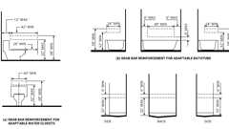Primary

**CA 11A: Figure 11A-9G Reinforcement for Grab Bars**

[**1134A.6 *Showers***](https://up.codes/viewer/california/ca-building-code-2025/chapter/11A/housing-accessibility#1134A.6)

Diagram

*Showers required to be accessible shall comply with this section.*

1. [***Size***](https://up.codes/viewer/california/ca-building-code-2025/chapter/9/fire-protection-and-life-safety-systems#911.1.3)***.****When one or more shower stalls are provided within the same*[*dwelling units*](https://up.codes/viewer/california/ca-building-code-2025/chapter/2/definitions#dwelling_unit_)*, at least one shower stall comply with one of the following requirements.*
   1. *1.1.   The shower stall shall measure at least 42 inches wide by 48 inches deep (1067 mm by 1219 mm) with an*[*entrance*](https://up.codes/viewer/california/ca-building-code-2025/chapter/2/definitions#entrance_hcd_1_hcd_2_hcd_1_ac_and_dsa_ac_)*opening of at least 36 inches (914 mm); or*
   2. *1.2.   The shower stall shall measure at least 30 inches deep by 60 inches wide (762 mm by 1524 mm) with an*[*entrance*](https://up.codes/viewer/california/ca-building-code-2025/chapter/2/definitions#entrance_hcd_1_hcd_2_hcd_1_ac_and_dsa_ac_)*opening of at least 60 inches (1524 mm). A water closet may project a maximum of 12 inches (305 mm) into the opening, provided that a minimum of 36 inches (914 mm)*[*clear*](https://up.codes/viewer/california/ca-building-code-2025/chapter/2/definitions#clear_dsa_ac_)[*space*](https://up.codes/viewer/california/ca-building-code-2025/chapter/2/definitions#space_)*is maintained between the water closet and the shower*[*wall*](https://up.codes/viewer/california/ca-building-code-2025/chapter/2/definitions#wall_)*as illustrated in*[*Figure*](https://up.codes/viewer/california/ca-building-code-2025/chapter/11B/accessibility-to-public-buildings-public-accommodations-commercial-buildings-and#figure)*11A-9L; or*
   3. *1.3.   Other shower stall configurations shall measure at least 36 inches deep by 60 inches wide (914 mm by 1524 mm) with an*[*entrance*](https://up.codes/viewer/california/ca-building-code-2025/chapter/2/definitions#entrance_hcd_1_hcd_2_hcd_1_ac_and_dsa_ac_)*opening of at least 36 inches (914 mm) when a*[*wall*](https://up.codes/viewer/california/ca-building-code-2025/chapter/2/definitions#wall_)*is installed on the opening side.*
2. [***Slope***](https://up.codes/viewer/california/ca-building-code-2025/chapter/J/grading#slope_)***.****The maximum*[*slope*](https://up.codes/viewer/california/ca-building-code-2025/chapter/J/grading#slope_)*of the shower floor shall be 1/2inch (12.7 mm) per foot in any direction and shall*[*slope*](https://up.codes/viewer/california/ca-building-code-2025/chapter/J/grading#slope_)*to a*[*drain*](https://up.codes/viewer/california/ca-building-code-2025/chapter/2/definitions#drain_)*. The floor surfaces shall be of Carborundum or grit-faced tile or of material providing equivalent slip resistance.*
3. ***Floor***[***space***](https://up.codes/viewer/california/ca-building-code-2025/chapter/2/definitions#space_)*. A*[*clear*](https://up.codes/viewer/california/ca-building-code-2025/chapter/2/definitions#clear_dsa_ac_)*maneuvering*[*space*](https://up.codes/viewer/california/ca-building-code-2025/chapter/2/definitions#space_)*at least 30 inches in width by 48 inches in length (762 mm by 1219 mm) shall be located outside the shower, flush and parallel to the control*[*wall*](https://up.codes/viewer/california/ca-building-code-2025/chapter/2/definitions#wall_)*.*
4. ***Reinforced***[***walls***](https://up.codes/viewer/california/ca-building-code-2025/chapter/2/definitions#wall_)***for***[***grab bars***](https://up.codes/viewer/california/ca-building-code-2025/chapter/2/definitions#grab_bar_dsa_ac_hcd_1_ac_)***.***[*Grab bar*](https://up.codes/viewer/california/ca-building-code-2025/chapter/2/definitions#grab_bar_dsa_ac_hcd_1_ac_)[*reinforcement*](https://up.codes/viewer/california/ca-building-code-2025/chapter/19A/concrete#reinforcement)*shall be installed continuous in the*[*walls*](https://up.codes/viewer/california/ca-building-code-2025/chapter/2/definitions#wall_)*of showers 32 inches to 38 inches (813 mm to 965 mm) above the floor. The*[*grab bar*](https://up.codes/viewer/california/ca-building-code-2025/chapter/2/definitions#grab_bar_dsa_ac_hcd_1_ac_)[*reinforcement*](https://up.codes/viewer/california/ca-building-code-2025/chapter/19A/concrete#reinforcement)*shall be a minimum of 6 inches (152.4 mm) nominal in height.*

*Glass-walled shower stalls shall provide*[*reinforcement*](https://up.codes/viewer/california/ca-building-code-2025/chapter/19A/concrete#reinforcement)*for*[*installation*](https://up.codes/viewer/california/ca-building-code-2025/chapter/27/electrical#2702.1.3)*of floor-mounted or ceiling-mounted*[*grab bars*](https://up.codes/viewer/california/ca-building-code-2025/chapter/2/definitions#grab_bar_dsa_ac_hcd_1_ac_)*.*

1. [***Thresholds***](https://up.codes/viewer/california/ca-building-code-2025/chapter/10/means-of-egress#1010.1.6)***.****When a threshold is used, it shall be a maximum of 2 inches (50.8 mm) in height and have a beveled or sloped angle not exceeding 1 unit vertical in 2 units horizontal (26.6 degrees from the horizontal).*[*Thresholds*](https://up.codes/viewer/california/ca-building-code-2025/chapter/10/means-of-egress#1010.1.6)*1/2inch (12.7 mm) or less in height may have a beveled or sloped angle not exceeding 1 unit vertical in 1 unit horizontal (45 degrees from the horizontal).*
2. ***Shower controls.****Faucet controls and*[*operation*](https://up.codes/viewer/california/ca-building-code-2025/chapter/30/elevators-and-conveying-systems#3008.1.4)*mechanisms shall be operable with one hand and shall not require tight grasping, pinching or twisting of the wrist. The force required to activate controls shall be no greater than 5 pounds (22.2 N). Lever operated, push-type and electronically controlled mechanisms are examples of acceptable*[*designs*](https://up.codes/viewer/california/ca-building-code-2025/chapter/22A/steel#2210A.1.1)*.*
3. ***Shower enclosures.****Doors and panels of shower enclosures shall be substantially constructed from*[*approved*](https://up.codes/viewer/california/ca-building-code-2025/chapter/11B/accessibility-to-public-buildings-public-accommodations-commercial-buildings-and#approved)*, shatter-resistant*[*materials*](https://up.codes/viewer/california/ca-building-code-2025/chapter/4/special-detailed-requirements-based-on-occupancy-and-use#414.1.2)*. Hinged shower doors shall open outward.*[*Glazing*](https://up.codes/viewer/california/ca-building-code-2025/chapter/7/fire-and-smoke-protection-features#716.1.2)*used in doors and panels of shower enclosures shall be fully tempered, laminated safety glass or*[*approved*](https://up.codes/viewer/california/ca-building-code-2025/chapter/11B/accessibility-to-public-buildings-public-accommodations-commercial-buildings-and#approved)*plastic. When glass is used, it shall have minimum thickness of not less than 1/8inch (3.17 mm) when fully tempered, or 1/4inch (6.35 mm) when laminated, and shall pass the test requirements of this part,*[*Chapter 24*](https://up.codes/viewer/california/ca-building-code-2025/chapter/24/glass-and-glazing#24)*, Glass and*[*Glazing*](https://up.codes/viewer/california/ca-building-code-2025/chapter/7/fire-and-smoke-protection-features#716.1.2)*. Plastics used in doors and panels of shower enclosures shall be of a shatter-resistant type.*

**UpCodes Diagram (1)**

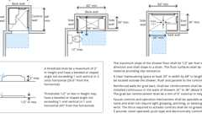Primary

**Accessible Showers (CA 11A)**

[**1134A.7 *Water Closets***](https://up.codes/viewer/california/ca-building-code-2025/chapter/11A/housing-accessibility#1134A.7)

Diagram

*Water closets in*[*bathrooms*](https://up.codes/viewer/california/ca-building-code-2025/chapter/2/definitions#bathroom_)*or*[*powder rooms*](https://up.codes/viewer/california/ca-building-code-2025/chapter/2/definitions#powder_room_)*required to be accessible shall comply with this section.*

1. ***Floor***[***space***](https://up.codes/viewer/california/ca-building-code-2025/chapter/2/definitions#space_)***and***[***location***](https://up.codes/viewer/california/ca-building-code-2025/chapter/L/earthquake-recording-instrumentation#L101.2)***.****The minimum floor*[*space*](https://up.codes/viewer/california/ca-building-code-2025/chapter/2/definitions#space_)*provided at a water closet shall be 48 inches (1219 mm) in*[*clear*](https://up.codes/viewer/california/ca-building-code-2025/chapter/2/definitions#clear_dsa_ac_)*width. The*[*clear floor space*](https://up.codes/viewer/california/ca-building-code-2025/chapter/2/definitions#clear_floor_space_dsa_ac_hcd_1_ac_)*shall extend past the front edge of the water closet at least 36 inches (914 mm). See*[*Figure*](https://up.codes/viewer/california/ca-building-code-2025/chapter/11B/accessibility-to-public-buildings-public-accommodations-commercial-buildings-and#figure)*11A-9M.*

***Exception:****The 48-inch (1219 mm) minimum*[*clear*](https://up.codes/viewer/california/ca-building-code-2025/chapter/2/definitions#clear_dsa_ac_)*width may be reduced to 36 inches (914 mm) for*[*lavatories*](https://up.codes/viewer/california/ca-building-code-2025/chapter/2/definitions#lavatory_)*, cabinets, wing*[*walls*](https://up.codes/viewer/california/ca-building-code-2025/chapter/2/definitions#wall_)*or privacy*[*walls*](https://up.codes/viewer/california/ca-building-code-2025/chapter/2/definitions#wall_)*located immediately adjacent to a water closet which extend no more than 24 inches (610 mm) in depth.*

*Water closets shall be located within*[*bathrooms*](https://up.codes/viewer/california/ca-building-code-2025/chapter/2/definitions#bathroom_)*in a manner that*[*permits*](https://up.codes/viewer/california/ca-building-code-2025/chapter/2/definitions#permit_)*a*[*grab bar*](https://up.codes/viewer/california/ca-building-code-2025/chapter/2/definitions#grab_bar_dsa_ac_hcd_1_ac_)*to be installed on at least one side of the fixture. The centerline of the water closet shall be 17 inches (432 mm) minimum to 18 inches (457 mm) maximum from a*[*grab bar*](https://up.codes/viewer/california/ca-building-code-2025/chapter/2/definitions#grab_bar_dsa_ac_hcd_1_ac_)[*wall*](https://up.codes/viewer/california/ca-building-code-2025/chapter/2/definitions#wall_)*or partition. In*[*locations*](https://up.codes/viewer/california/ca-building-code-2025/chapter/L/earthquake-recording-instrumentation#L101.2)*where water closets are adjacent to non-*[*grab bar*](https://up.codes/viewer/california/ca-building-code-2025/chapter/2/definitions#grab_bar_dsa_ac_hcd_1_ac_)[*walls*](https://up.codes/viewer/california/ca-building-code-2025/chapter/2/definitions#wall_)*, vanities,*[*lavatories*](https://up.codes/viewer/california/ca-building-code-2025/chapter/2/definitions#lavatory_)*or bathtubs, the centerline of the fixture shall be a minimum of 18 inches (457 mm) from the obstacle.*

1. *2.****Reinforced***[***walls***](https://up.codes/viewer/california/ca-building-code-2025/chapter/2/definitions#wall_)***for***[***grab bars***](https://up.codes/viewer/california/ca-building-code-2025/chapter/2/definitions#grab_bar_dsa_ac_hcd_1_ac_)***.****Where the water closet is not placed adjacent to a side*[*wall*](https://up.codes/viewer/california/ca-building-code-2025/chapter/2/definitions#wall_)*capable of accommodating a*[*grab bar*](https://up.codes/viewer/california/ca-building-code-2025/chapter/2/definitions#grab_bar_dsa_ac_hcd_1_ac_)*, the*[*bathroom*](https://up.codes/viewer/california/ca-building-code-2025/chapter/2/definitions#bathroom_)*shall have provisions for*[*installation*](https://up.codes/viewer/california/ca-building-code-2025/chapter/27/electrical#2702.1.3)*of floor-mounted, foldaway or similar alternative*[*grab bars*](https://up.codes/viewer/california/ca-building-code-2025/chapter/2/definitions#grab_bar_dsa_ac_hcd_1_ac_)*.*

*Where the water closet is placed adjacent to a side*[*wall*](https://up.codes/viewer/california/ca-building-code-2025/chapter/2/definitions#wall_)*,*[*reinforcement*](https://up.codes/viewer/california/ca-building-code-2025/chapter/19A/concrete#reinforcement)*shall be installed on both sides or one side and the back. If*[*reinforcement*](https://up.codes/viewer/california/ca-building-code-2025/chapter/19A/concrete#reinforcement)*is installed at the back, it shall be installed between 32 inches (813 mm) and 38 inches (965 mm) above the floor. The*[*grab bar*](https://up.codes/viewer/california/ca-building-code-2025/chapter/2/definitions#grab_bar_dsa_ac_hcd_1_ac_)[*reinforcement*](https://up.codes/viewer/california/ca-building-code-2025/chapter/19A/concrete#reinforcement)*shall be a minimum of 6 inches (152.4 mm) nominal in height. The*[*backing*](https://up.codes/viewer/california/ca-building-code-2025/chapter/2/definitions#backing_)*shall be a minimum of 40 inches (1016 mm) in length.*

[*Reinforcement*](https://up.codes/viewer/california/ca-building-code-2025/chapter/19A/concrete#reinforcement)*installed at the side of the water closet shall be installed 32 inches to 38 inches (813 mm to 965 mm) above the floor. The*[*reinforcement*](https://up.codes/viewer/california/ca-building-code-2025/chapter/19A/concrete#reinforcement)*shall be installed a maximum of 12 inches (305 mm) from the rear*[*wall*](https://up.codes/viewer/california/ca-building-code-2025/chapter/2/definitions#wall_)*and shall extend a minimum of 26 inches (660 mm) in front of the water closet. The*[*grab bar*](https://up.codes/viewer/california/ca-building-code-2025/chapter/2/definitions#grab_bar_dsa_ac_hcd_1_ac_)[*reinforcement*](https://up.codes/viewer/california/ca-building-code-2025/chapter/19A/concrete#reinforcement)*shall be a minimum of 6 inches (152.4 mm) nominal in height.*

1. *3.****Seat height.****The minimum height of water closet seats shall be 15 inches (381 mm) above the floor.*
2. *4.****Water closet controls.****Water closet controls shall be mounted no more than 44 inches (1118 mm) above the floor. The force required to activate controls shall be no greater than 5 pounds (22.2 N).*

**UpCodes Diagrams (2)**

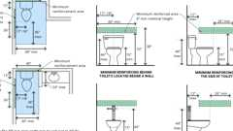Primary

**Grab Bar Reinforcement (CA 11A)**



**Grab Bar - Recessed Lavatory**

**Building product (1)**

[[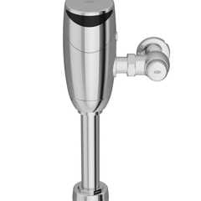](https://up.codes/product/zer6000av-hyd-top-mount-exposed-sensor-flush-valve-for-water-closet-with-gear-dr?viewer_juris_key=california)](https://up.codes/product/zer6000av-hyd-top-mount-exposed-sensor-flush-valve-for-water-closet-with-gear-dr?viewer_juris_key=california)

**[Top Mount Exposed Sensor Flush Valve for Water Closet With Gear-driven Ceramic Cartridge, Hydropower, AquaVantage® Diaphragm - ZER6000AV-HYD](https://up.codes/product/zer6000av-hyd-top-mount-exposed-sensor-flush-valve-for-water-closet-with-gear-dr?viewer_juris_key=california)**

**[Zurn](https://up.codes/product/zer6000av-hyd-top-mount-exposed-sensor-flush-valve-for-water-closet-with-gear-dr?viewer_juris_key=california)**

[**1134A.8 *Lavatories, Vanities, Mirrors and Towel Fixtures***](https://up.codes/viewer/california/ca-building-code-2025/chapter/11A/housing-accessibility#1134A.8)

Diagram

[*Bathrooms*](https://up.codes/viewer/california/ca-building-code-2025/chapter/2/definitions#bathroom_)*or*[*powder rooms*](https://up.codes/viewer/california/ca-building-code-2025/chapter/2/definitions#powder_room_)*required to be accessible shall have at least one accessible*[*lavatory*](https://up.codes/viewer/california/ca-building-code-2025/chapter/2/definitions#lavatory_)*. Where mirrors and towel fixtures are provided, at least one of each shall be accessible.*

1. [***Location***](https://up.codes/viewer/california/ca-building-code-2025/chapter/L/earthquake-recording-instrumentation#L101.2)***.****Vanities and*[*lavatories*](https://up.codes/viewer/california/ca-building-code-2025/chapter/2/definitions#lavatory_)*shall be installed with the centerline of the fixture a minimum of 18 inches (457 mm) horizontally from an adjoining*[*wall*](https://up.codes/viewer/california/ca-building-code-2025/chapter/2/definitions#wall_)*or fixture to allow for forward approach. When parallel approach is provided,*[*lavatories*](https://up.codes/viewer/california/ca-building-code-2025/chapter/2/definitions#lavatory_)*shall be installed with the centerline of the fixture a minimum of 24 inches (610 mm) horizontally from an adjoining*[*wall*](https://up.codes/viewer/california/ca-building-code-2025/chapter/2/definitions#wall_)*or fixture. The top of the fixture rim shall be a maximum of 34 inches (864 mm) above the finished floor.*
2. ***Floor***[***space***](https://up.codes/viewer/california/ca-building-code-2025/chapter/2/definitions#space_)***.****A*[*clear*](https://up.codes/viewer/california/ca-building-code-2025/chapter/2/definitions#clear_dsa_ac_)*maneuvering*[*space*](https://up.codes/viewer/california/ca-building-code-2025/chapter/2/definitions#space_)*at least 30 inches by 48 inches (762 mm by 1219 mm) shall be provided at*[*lavatories*](https://up.codes/viewer/california/ca-building-code-2025/chapter/2/definitions#lavatory_)*and shall be centered on the*[*lavatory*](https://up.codes/viewer/california/ca-building-code-2025/chapter/2/definitions#lavatory_)*.*
3. ***Cabinets.****Cabinets under*[*lavatories*](https://up.codes/viewer/california/ca-building-code-2025/chapter/2/definitions#lavatory_)*are acceptable provided the*[*bathroom*](https://up.codes/viewer/california/ca-building-code-2025/chapter/2/definitions#bathroom_)*has*[*space*](https://up.codes/viewer/california/ca-building-code-2025/chapter/2/definitions#space_)*to allow a parallel approach by a person in a*[*wheelchair*](https://up.codes/viewer/california/ca-building-code-2025/chapter/2/definitions#wheelchair_hcd_1_ac_dsa_ac_)*and the*[*lavatory*](https://up.codes/viewer/california/ca-building-code-2025/chapter/2/definitions#lavatory_)*cabinets are designed with*[*adaptable*](https://up.codes/viewer/california/ca-building-code-2025/chapter/2/definitions#adaptable_dsa_ac_)*knee and toe*[*space*](https://up.codes/viewer/california/ca-building-code-2025/chapter/2/definitions#space_)*.*
4. ***Knee and toe***[***space***](https://up.codes/viewer/california/ca-building-code-2025/chapter/2/definitions#space_)***.****Knee and toe*[*space*](https://up.codes/viewer/california/ca-building-code-2025/chapter/2/definitions#space_)*shall be provided by one of the following:*
   1. *4.1.   The*[*space*](https://up.codes/viewer/california/ca-building-code-2025/chapter/2/definitions#space_)*beneath the*[*lavatory*](https://up.codes/viewer/california/ca-building-code-2025/chapter/2/definitions#lavatory_)*shall be left*[*clear*](https://up.codes/viewer/california/ca-building-code-2025/chapter/2/definitions#clear_dsa_ac_)*and unobstructed;*
   2. *4.2.   Any cabinet beneath the*[*lavatory*](https://up.codes/viewer/california/ca-building-code-2025/chapter/2/definitions#lavatory_)*shall be removable without the use of specialized knowledge or specialized tools; or*
   3. *4.3.   Doors to the cabinet beneath the*[*lavatory*](https://up.codes/viewer/california/ca-building-code-2025/chapter/2/definitions#lavatory_)*shall be removable or openable to provide the required unobstructed knee and toe*[*space*](https://up.codes/viewer/california/ca-building-code-2025/chapter/2/definitions#space_)*.*

*The knee and toe*[*space*](https://up.codes/viewer/california/ca-building-code-2025/chapter/2/definitions#space_)*shall be centered on the fixture, and shall comply with*[*Section 1138A.2*](https://up.codes/viewer/california/ca-building-code-2025/chapter/11A/housing-accessibility#1138A.2)*. The*[*clear floor space*](https://up.codes/viewer/california/ca-building-code-2025/chapter/2/definitions#clear_floor_space_dsa_ac_hcd_1_ac_)*required by Item 2 shall not extend into the knee and toe*[*space*](https://up.codes/viewer/california/ca-building-code-2025/chapter/2/definitions#space_)*more than 19 inches (483 mm). (See*[*Figure*](https://up.codes/viewer/california/ca-building-code-2025/chapter/11B/accessibility-to-public-buildings-public-accommodations-commercial-buildings-and#figure)*11A-9D.)*

1. ***Finished floor.****The finished floor beneath the*[*lavatory*](https://up.codes/viewer/california/ca-building-code-2025/chapter/2/definitions#lavatory_)*shall be extended to the*[*wall*](https://up.codes/viewer/california/ca-building-code-2025/chapter/2/definitions#wall_)*.*
2. ***Plumbing***[***protection***](https://up.codes/viewer/california/ca-building-code-2025/chapter/22/steel#2201.3)***.****Water supply and*[*drain*](https://up.codes/viewer/california/ca-building-code-2025/chapter/2/definitions#drain_)*pipes under*[*lavatories*](https://up.codes/viewer/california/ca-building-code-2025/chapter/2/definitions#lavatory_)*shall be insulated or otherwise covered to protect against contact. There shall be no sharp or abrasive surfaces under*[*lavatories*](https://up.codes/viewer/california/ca-building-code-2025/chapter/2/definitions#lavatory_)*.*
3. [***Lavatory***](https://up.codes/viewer/california/ca-building-code-2025/chapter/2/definitions#lavatory_)***faucet controls.****Faucet controls and*[*operation*](https://up.codes/viewer/california/ca-building-code-2025/chapter/30/elevators-and-conveying-systems#3008.1.4)*mechanisms shall be operable with one hand and shall not require tight grasping, pinching or twisting of the wrist.*
   1. *The force required to activate controls shall be no greater than 5 pounds (22.2 N). Lever operated, push-type and electronically controlled mechanisms are examples of acceptable*[*designs*](https://up.codes/viewer/california/ca-building-code-2025/chapter/22A/steel#2210A.1.1)*.*[*Self-closing*](https://up.codes/viewer/california/ca-building-code-2025/chapter/2/definitions#self_closing_)*valves are allowed if the faucet remains open for at least 10 seconds.*
4. ***Mirrors and towel fixtures.****Where mirrors or towel fixtures are provided they shall be mounted with the bottom edge no higher than 40 inches (1016 mm) from the floor.*

**UpCodes Diagram (1)**

Primary

**Lavatories, Vanities, Mirrors and Towel Fixtures (CA 11A)**

**Building products (3)**

[[](https://up.codes/product/anika-deck-mounted-3-hole-lavatory-set-30-2-tr24?viewer_juris_key=california)](https://up.codes/product/anika-deck-mounted-3-hole-lavatory-set-30-2-tr24?viewer_juris_key=california)

**[Anika Deck Mounted 3-Hole Lavatory Set](https://up.codes/product/anika-deck-mounted-3-hole-lavatory-set-30-2-tr24?viewer_juris_key=california)**

**[Watermark Designs](https://up.codes/product/anika-deck-mounted-3-hole-lavatory-set-30-2-tr24?viewer_juris_key=california)**

[[](https://up.codes/product/h-line-3-hole-deck-mounted-widespread-lavatory-set-115-2-mz4?viewer_juris_key=california)](https://up.codes/product/h-line-3-hole-deck-mounted-widespread-lavatory-set-115-2-mz4?viewer_juris_key=california)

**[H-Line 3-Hole Deck Mounted Widespread Lavatory Set](https://up.codes/product/h-line-3-hole-deck-mounted-widespread-lavatory-set-115-2-mz4?viewer_juris_key=california)**

**[Watermark Designs](https://up.codes/product/h-line-3-hole-deck-mounted-widespread-lavatory-set-115-2-mz4?viewer_juris_key=california)**

[[](https://up.codes/product/loft-deck-mounted-3-hole-lavatory-set-23-2-17-l8?viewer_juris_key=california)](https://up.codes/product/loft-deck-mounted-3-hole-lavatory-set-23-2-17-l8?viewer_juris_key=california)

**[Loft Deck Mounted 3-Hole Lavatory Set](https://up.codes/product/loft-deck-mounted-3-hole-lavatory-set-23-2-17-l8?viewer_juris_key=california)**

**[Watermark Designs](https://up.codes/product/loft-deck-mounted-3-hole-lavatory-set-23-2-17-l8?viewer_juris_key=california)**

[**Section 1135A *Laundry Rooms***](https://up.codes/viewer/california/ca-building-code-2025/chapter/11A/housing-accessibility#1135A)

Diagram

**UpCodes Diagram (1)**



**Clothes Dryer Exhaust (CA)**

[**1135A.1 *General***](https://up.codes/viewer/california/ca-building-code-2025/chapter/11A/housing-accessibility#1135A.1)

*If clothes*[*washing machines and clothes dryers*](https://up.codes/viewer/california/ca-building-code-2025/chapter/11B/accessibility-to-public-buildings-public-accommodations-commercial-buildings-and#11B-809.1.3)*are provided in covered multifamily*[*dwelling units*](https://up.codes/viewer/california/ca-building-code-2025/chapter/2/definitions#dwelling_unit_)*, one of each type of appliance shall be provided. Where front-loading clothes washers are not provided, management shall provide*[*assistive devices*](https://up.codes/viewer/california/ca-building-code-2025/chapter/2/definitions#assistive_device_hcd_1_ac_)*, on request of the occupant, to*[*permit*](https://up.codes/viewer/california/ca-building-code-2025/chapter/2/definitions#permit_)*the use of top-loading clothes washers.*

[**Section 1136A *Electrical Receptacle,switch and Control Heights***](https://up.codes/viewer/california/ca-building-code-2025/chapter/11A/housing-accessibility#1136A)

Diagram

**UpCodes Diagram (1)**

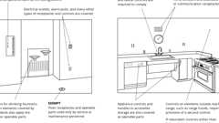

**Accessible Operable Parts**

[**1136A.1 *Receptacle Heights***](https://up.codes/viewer/california/ca-building-code-2025/chapter/11A/housing-accessibility#1136A.1)

Diagram

[*Electrical receptacle outlets*](https://up.codes/viewer/california/ca-building-code-2025/chapter/11B/accessibility-to-public-buildings-public-accommodations-commercial-buildings-and#11B-308.1.2)*on branch circuits of 30 amperes or less and communication system receptacles shall be located no more than 48 inches (1219 mm) measured from the top of the receptacle outlet box nor less than 15 inches (381 mm) measured from the bottom of the receptacle outlet box to the level of the finished floor or working*[*platform*](https://up.codes/viewer/california/ca-building-code-2025/chapter/2/definitions#platform_)*. If the reach is over a physical barrier or an obstruction (for example, a kitchen*[*base*](https://up.codes/viewer/california/ca-building-code-2025/chapter/2/definitions#base_dsa_ss_dsa_ss_cc_oshpd_1_1r_2_4_5_)*cabinet), receptacles shall be located within the reach ranges specified in*[*Section 1138A.3*](https://up.codes/viewer/california/ca-building-code-2025/chapter/11A/housing-accessibility#1138A.3)*. Physical barriers and obstructions shall not extend more than 25 inches (635 mm) from the*[*wall*](https://up.codes/viewer/california/ca-building-code-2025/chapter/2/definitions#wall_)*beneath the receptacle.*

*Cabinets shall be allowed to extend 24 inches from the*[*wall*](https://up.codes/viewer/california/ca-building-code-2025/chapter/2/definitions#wall_)*beneath a control or switch with an additional countertop extension of 11/2 inches for a maximum dimension of 25 1/2 inches (647.7 mm) in depth.*

Receptacle outlets that do not satisfy these specifications are acceptable provided that comparable receptacle outlets, that perform the same functions, are provided within the same area and are accessible.

***Exceptions:***

1. *Receptacle outlets installed as part of permanently installed baseboard heaters are exempt.*
2. *Required receptacle outlets shall be permitted in floors when adjacent to sliding panels or*[*walls*](https://up.codes/viewer/california/ca-building-code-2025/chapter/2/definitions#wall_)*.*
3. *Baseboard electrical outlets used in relocatable partitions, window*[*walls*](https://up.codes/viewer/california/ca-building-code-2025/chapter/2/definitions#wall_)*or other electrical convenience floor outlets are not subject to the minimum height requirements.*
4. *This section shall not apply to*[*existing buildings*](https://up.codes/viewer/california/ca-building-code-2025/chapter/2/definitions#building_existing_hcd_1_hcd_2_)*when the*[*enforcing agency*](https://up.codes/viewer/california/ca-building-code-2025/chapter/2/definitions#enforcing_agency_)*determines that*[*compliance*](https://up.codes/viewer/california/ca-building-code-2025/chapter/31/special-construction#3113.1.1)*with these standards would create an*[*unreasonable hardship*](https://up.codes/viewer/california/ca-building-code-2025/chapter/2/definitions#unreasonable_hardship_)*.*

**UpCodes Diagram (1)**

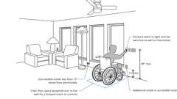Primary

**Accessible Switch, Outlet & Control Locations (CA)**

[**1136A.2 *Switch and Control Heights***](https://up.codes/viewer/california/ca-building-code-2025/chapter/11A/housing-accessibility#1136A.2)

Diagram

*Controls or switches intended to be used by the occupant of the room or area to control lighting and receptacle outlets, appliances, alarms or cooling, heating and ventilating*[*equipment*](https://up.codes/viewer/california/ca-building-code-2025/chapter/2/definitions#equipment_dsa_ss_dsa_ss_cc_oshpd_1_2_4_5_)*shall be located no more than 48 inches (1219 mm) measured from the top of the outlet box nor less than 15 inches (381 mm) measured from the bottom of the outlet box to the level of the finished floor or working*[*platform*](https://up.codes/viewer/california/ca-building-code-2025/chapter/2/definitions#platform_)*. If the reach is over a physical barrier or an obstruction (for example, a kitchen*[*base*](https://up.codes/viewer/california/ca-building-code-2025/chapter/2/definitions#base_dsa_ss_dsa_ss_cc_oshpd_1_1r_2_4_5_)*cabinet) switches and controls shall be located within the reach ranges specified in*[*Section 1138A.3*](https://up.codes/viewer/california/ca-building-code-2025/chapter/11A/housing-accessibility#1138A.3)*. Physical barriers or obstructions shall not extend more than 25 inches (635 mm) from the*[*wall*](https://up.codes/viewer/california/ca-building-code-2025/chapter/2/definitions#wall_)*beneath a control or switch.*

*Cabinets shall be allowed to extend 24 inches from the*[*wall*](https://up.codes/viewer/california/ca-building-code-2025/chapter/2/definitions#wall_)*beneath a control or switch with an additional countertop extension of 11/2 inches for a maximum dimension of 25 1/2 inches (647.7 mm) in depth.*

*Switches and controls that do not satisfy these specifications are acceptable provided that comparable controls or outlets, that perform the same functions, are provided within the same area and are accessible.*

***Exception:****Appliances (e.g., kitchen stoves, dishwashers, range hoods, microwave ovens and similar appliances) which have controls located on the appliance.*

**UpCodes Diagrams (2)**

Primary

**Accessible Switch, Outlet & Control Locations (CA)**

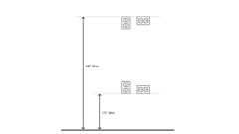Primary

**Outlet Mounting Height (CA 11A)**

[**Division V *Features Common to Exterior and Interior of Buildings***](https://up.codes/viewer/california/ca-building-code-2025/chapter/11A/housing-accessibility#divider_11A_V)

[**Section 1137A *Other Features and Facilities***](https://up.codes/viewer/california/ca-building-code-2025/chapter/11A/housing-accessibility#1137A)

[**1137A.1 *General***](https://up.codes/viewer/california/ca-building-code-2025/chapter/11A/housing-accessibility#1137A.1)

*This division shall apply to features and*[*facilities*](https://up.codes/viewer/california/ca-building-code-2025/chapter/2/definitions#facility_)*of*[*common use areas*](https://up.codes/viewer/california/ca-building-code-2025/chapter/2/definitions#common_use_areas_hcd_1_ac_)*on accessible floors or*[*sites*](https://up.codes/viewer/california/ca-building-code-2025/chapter/2/definitions#site_)*.*

***Note:****The provisions in this division are not applicable to*[*dwelling units*](https://up.codes/viewer/california/ca-building-code-2025/chapter/2/definitions#dwelling_unit_)*, unless otherwise specified.*

[**Section 1138A *Space Allowances and Reach Ranges***](https://up.codes/viewer/california/ca-building-code-2025/chapter/11A/housing-accessibility#1138A)

[**1138A.1 *Space Allowances***](https://up.codes/viewer/california/ca-building-code-2025/chapter/11A/housing-accessibility#1138A.1)

Diagram

**UpCodes Diagrams (2)**

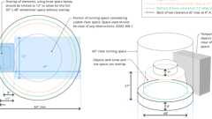

**Turning Space: 60” Round**

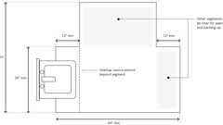

**T-Shaped Turning Space**

[**1138A.1.1 *Single Wheelchair Passage Width***](https://up.codes/viewer/california/ca-building-code-2025/chapter/11A/housing-accessibility#1138A.1.1)

Diagram

*The minimum*[*clear*](https://up.codes/viewer/california/ca-building-code-2025/chapter/2/definitions#clear_dsa_ac_)*width for single*[*wheelchair*](https://up.codes/viewer/california/ca-building-code-2025/chapter/2/definitions#wheelchair_hcd_1_ac_dsa_ac_)*passage shall be 36 inches (914 mm) continuously. (See*[*Figure*](https://up.codes/viewer/california/ca-building-code-2025/chapter/11B/accessibility-to-public-buildings-public-accommodations-commercial-buildings-and#figure)*11A-1E.)*

*See*[*Section 1113A*](https://up.codes/viewer/california/ca-building-code-2025/chapter/11A/housing-accessibility#1113A)*for minimum*[*clear*](https://up.codes/viewer/california/ca-building-code-2025/chapter/2/definitions#clear_dsa_ac_)*width of*[*sidewalks*](https://up.codes/viewer/california/ca-building-code-2025/chapter/2/definitions#sidewalk_)*, and*[*Section 1120A*](https://up.codes/viewer/california/ca-building-code-2025/chapter/11A/housing-accessibility#1120A)*for minimum*[*clear*](https://up.codes/viewer/california/ca-building-code-2025/chapter/2/definitions#clear_dsa_ac_)*width of interior*[*accessible routes*](https://up.codes/viewer/california/ca-building-code-2025/chapter/2/definitions#accessible_route_dsa_ac_hcd_1_ac_)*.*

***Exception:****32 inches (813 mm) in width is acceptable at a point not to exceed 24 inches (610 mm) in length. The segments with reduced width shall be separated by segments that are 48 inches (1219 mm) long minimum and 36 inches (914 mm) wide minimum.*

**UpCodes Diagram (1)**

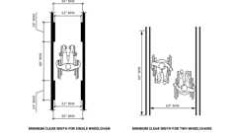Primary

**CA 11A: Figure 11A-1E Wheelchair Passage Width**

[**1138A.1.2 *Width for Two Wheelchairs Passing***](https://up.codes/viewer/california/ca-building-code-2025/chapter/11A/housing-accessibility#1138A.1.2)

Diagram

*The minimum width for two*[*wheelchairs*](https://up.codes/viewer/california/ca-building-code-2025/chapter/2/definitions#wheelchair_hcd_1_ac_dsa_ac_)*to pass is 60 inches (1524 mm) (See*[*Figure*](https://up.codes/viewer/california/ca-building-code-2025/chapter/11B/accessibility-to-public-buildings-public-accommodations-commercial-buildings-and#figure)*11A-1E).*

*An*[*accessible route*](https://up.codes/viewer/california/ca-building-code-2025/chapter/2/definitions#accessible_route_dsa_ac_hcd_1_ac_)*(exterior and interior) with a*[*clear*](https://up.codes/viewer/california/ca-building-code-2025/chapter/2/definitions#clear_dsa_ac_)*width less than 60 inches (1524 mm) shall provide passing*[*spaces*](https://up.codes/viewer/california/ca-building-code-2025/chapter/2/definitions#space_)*at intervals of 200 feet (60 960 mm) maximum. Passing*[*spaces*](https://up.codes/viewer/california/ca-building-code-2025/chapter/2/definitions#space_)*shall be either: a*[*space*](https://up.codes/viewer/california/ca-building-code-2025/chapter/2/definitions#space_)*60 inches (1524 mm) minimum by 60 inches (1524 mm) minimum; or, an intersection of two walking surfaces providing a T-shaped*[*space*](https://up.codes/viewer/california/ca-building-code-2025/chapter/2/definitions#space_)*complying with*[*Section 1138A.1.3.1*](https://up.codes/viewer/california/ca-building-code-2025/chapter/11A/housing-accessibility#1138A.1.3.1)*, where the*[*base*](https://up.codes/viewer/california/ca-building-code-2025/chapter/2/definitions#base_dsa_ss_dsa_ss_cc_oshpd_1_1r_2_4_5_)*and arms of the T-shaped*[*space*](https://up.codes/viewer/california/ca-building-code-2025/chapter/2/definitions#space_)*extend 48 inches (1219 mm) minimum beyond the intersection. (See*[*Figure*](https://up.codes/viewer/california/ca-building-code-2025/chapter/11B/accessibility-to-public-buildings-public-accommodations-commercial-buildings-and#figure)*11A-1L.)*

**UpCodes Diagram (1)**

Primary

**CA 11A: Figure 11A-1L Int. Accessible Route Over 200 Feet; Occ. Load 10+**

[**1138A.1.3 *Wheelchair Turning Space***](https://up.codes/viewer/california/ca-building-code-2025/chapter/11A/housing-accessibility#1138A.1.3)

Diagram

*The*[*space*](https://up.codes/viewer/california/ca-building-code-2025/chapter/2/definitions#space_)*required for a*[*wheelchair*](https://up.codes/viewer/california/ca-building-code-2025/chapter/2/definitions#wheelchair_hcd_1_ac_dsa_ac_)*to make a 180-degree turn shall be a circular*[*clear*](https://up.codes/viewer/california/ca-building-code-2025/chapter/2/definitions#clear_dsa_ac_)[*space*](https://up.codes/viewer/california/ca-building-code-2025/chapter/2/definitions#space_)*of 60 inches (1524 mm) diameter minimum (See*[*Figure*](https://up.codes/viewer/california/ca-building-code-2025/chapter/11B/accessibility-to-public-buildings-public-accommodations-commercial-buildings-and#figure)*11A-1D(a)); or a T-shaped*[*space*](https://up.codes/viewer/california/ca-building-code-2025/chapter/2/definitions#space_)*complying with*[*Section 1138A.1.3.1*](https://up.codes/viewer/california/ca-building-code-2025/chapter/11A/housing-accessibility#1138A.1.3.1)*. The circular turning*[*space*](https://up.codes/viewer/california/ca-building-code-2025/chapter/2/definitions#space_)*shall be permitted to include knee and toe clearance complying with*[*Section 1138A.2*](https://up.codes/viewer/california/ca-building-code-2025/chapter/11A/housing-accessibility#1138A.2)*.*

*If a person in a*[*wheelchair*](https://up.codes/viewer/california/ca-building-code-2025/chapter/2/definitions#wheelchair_hcd_1_ac_dsa_ac_)*must make a turn around an obstruction, the minimum*[*clear*](https://up.codes/viewer/california/ca-building-code-2025/chapter/2/definitions#clear_dsa_ac_)*width of the*[*accessible route*](https://up.codes/viewer/california/ca-building-code-2025/chapter/2/definitions#accessible_route_dsa_ac_hcd_1_ac_)*shall be as required in*[*Section 1138A.1.5*](https://up.codes/viewer/california/ca-building-code-2025/chapter/11A/housing-accessibility#1138A.1.5)*.*

**UpCodes Diagrams (2)**

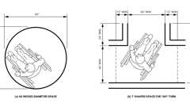Primary

**CA 11A: Figure 11A-1D Wheelchair Turning Space**



**Turning Space: 60” Round**

[**1138A.1.3.1 *T-Shaped Turning Space***](https://up.codes/viewer/california/ca-building-code-2025/chapter/11A/housing-accessibility#1138A.1.3.1)

Diagram

*A T-shaped turning*[*space*](https://up.codes/viewer/california/ca-building-code-2025/chapter/2/definitions#space_)*shall be within a 60 inch (1524 mm) square minimum with arms and*[*base*](https://up.codes/viewer/california/ca-building-code-2025/chapter/2/definitions#base_dsa_ss_dsa_ss_cc_oshpd_1_1r_2_4_5_)*36 inches (914 mm) wide minimum. Each arm of the T shall be*[*clear*](https://up.codes/viewer/california/ca-building-code-2025/chapter/2/definitions#clear_dsa_ac_)*of obstructions 12 inches (305 mm) minimum in each direction, and the*[*base*](https://up.codes/viewer/california/ca-building-code-2025/chapter/2/definitions#base_dsa_ss_dsa_ss_cc_oshpd_1_1r_2_4_5_)*shall be*[*clear*](https://up.codes/viewer/california/ca-building-code-2025/chapter/2/definitions#clear_dsa_ac_)*of obstructions 24 inches (610 mm) minimum. The*[*space*](https://up.codes/viewer/california/ca-building-code-2025/chapter/2/definitions#space_)*shall be permitted to include knee and toe clearance complying with*[*Section 1138A.2*](https://up.codes/viewer/california/ca-building-code-2025/chapter/11A/housing-accessibility#1138A.2)*only at the end of either the*[*base*](https://up.codes/viewer/california/ca-building-code-2025/chapter/2/definitions#base_dsa_ss_dsa_ss_cc_oshpd_1_1r_2_4_5_)*or one arm. (See*[*Figure*](https://up.codes/viewer/california/ca-building-code-2025/chapter/11B/accessibility-to-public-buildings-public-accommodations-commercial-buildings-and#figure)*11A-1D (b).)*

**UpCodes Diagram (1)**



**T-Shaped Turning Space**

[**1138A.1.3.2 *Surfaces of Turning Spaces***](https://up.codes/viewer/california/ca-building-code-2025/chapter/11A/housing-accessibility#1138A.1.3.2)

*Turning*[*spaces*](https://up.codes/viewer/california/ca-building-code-2025/chapter/2/definitions#space_)*for*[*wheelchairs*](https://up.codes/viewer/california/ca-building-code-2025/chapter/2/definitions#wheelchair_hcd_1_ac_dsa_ac_)*shall be stable, firm,*[*slip resistant*](https://up.codes/viewer/california/ca-building-code-2025/chapter/2/definitions#slip_resistant_)*, and shall comply with*[*Section 1110A.3*](https://up.codes/viewer/california/ca-building-code-2025/chapter/11A/housing-accessibility#1110A.3)*or*[*Section 1119A.2*](https://up.codes/viewer/california/ca-building-code-2025/chapter/11A/housing-accessibility#1119A.2)*. Changes in level are not permitted.*[*Slopes*](https://up.codes/viewer/california/ca-building-code-2025/chapter/J/grading#slope_)*not steeper than 1:48 shall be permitted.*

[**1138A.1.4 *Clear Floor or Ground Space for Wheelchairs***](https://up.codes/viewer/california/ca-building-code-2025/chapter/11A/housing-accessibility#1138A.1.4)

[**1138A.1.4.1 *Size and Approach***](https://up.codes/viewer/california/ca-building-code-2025/chapter/11A/housing-accessibility#1138A.1.4.1)

Diagram

*The minimum*[*clear*](https://up.codes/viewer/california/ca-building-code-2025/chapter/2/definitions#clear_dsa_ac_)*floor or ground*[*space*](https://up.codes/viewer/california/ca-building-code-2025/chapter/2/definitions#space_)*shall be 30 inches by 48 inches (762 mm by 1219 mm). The minimum*[*clear*](https://up.codes/viewer/california/ca-building-code-2025/chapter/2/definitions#clear_dsa_ac_)*floor or ground*[*space*](https://up.codes/viewer/california/ca-building-code-2025/chapter/2/definitions#space_)*may be positioned for forward or parallel approach to an object (See*[*Figure*](https://up.codes/viewer/california/ca-building-code-2025/chapter/11B/accessibility-to-public-buildings-public-accommodations-commercial-buildings-and#figure)*11A-1G).*[*Clear*](https://up.codes/viewer/california/ca-building-code-2025/chapter/2/definitions#clear_dsa_ac_)*floor or ground*[*space*](https://up.codes/viewer/california/ca-building-code-2025/chapter/2/definitions#space_)*may be part of the knee and toe*[*space*](https://up.codes/viewer/california/ca-building-code-2025/chapter/2/definitions#space_)*required under some objects unless otherwise specified.*

**UpCodes Diagrams (4)**

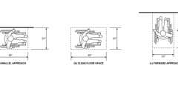Primary

**CA 11A: Figure 11A-1G Minimum Clear Floor Space for Wheelchairs**

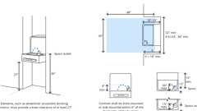

**Recessed Drinking Fountains (CA 11A)**



**Sufficient Maneuvering Space**



**Lavatories, Vanities, Mirrors and Towel Fixtures (CA 11A)**

[**1138A.1.4.2 *Relationship of Maneuvering Clearances to Wheelchair Spaces***](https://up.codes/viewer/california/ca-building-code-2025/chapter/11A/housing-accessibility#1138A.1.4.2)

Diagram

*One full unobstructed side of the*[*clear*](https://up.codes/viewer/california/ca-building-code-2025/chapter/2/definitions#clear_dsa_ac_)*floor or ground*[*space*](https://up.codes/viewer/california/ca-building-code-2025/chapter/2/definitions#space_)*for a*[*wheelchair*](https://up.codes/viewer/california/ca-building-code-2025/chapter/2/definitions#wheelchair_hcd_1_ac_dsa_ac_)*shall adjoin an*[*accessible route*](https://up.codes/viewer/california/ca-building-code-2025/chapter/2/definitions#accessible_route_dsa_ac_hcd_1_ac_)*or adjoin another*[*wheelchair*](https://up.codes/viewer/california/ca-building-code-2025/chapter/2/definitions#wheelchair_hcd_1_ac_dsa_ac_)[*clear floor space*](https://up.codes/viewer/california/ca-building-code-2025/chapter/2/definitions#clear_floor_space_dsa_ac_hcd_1_ac_)*.*

*If a*[*clear floor space*](https://up.codes/viewer/california/ca-building-code-2025/chapter/2/definitions#clear_floor_space_dsa_ac_hcd_1_ac_)*is located in an alcove or otherwise confined on all or a part of three sides, additional maneuvering clearances shall be provided in accordance with the following: (See*[*Figure*](https://up.codes/viewer/california/ca-building-code-2025/chapter/11B/accessibility-to-public-buildings-public-accommodations-commercial-buildings-and#figure)*11A-1H).*

1. ***Forward approach.****Alcoves shall be 36 inches (914 mm) wide minimum when the depth exceeds 24 inches (610 mm).*
2. ***Parallel approach.****Alcoves shall be 60 inches (1524 mm) wide minimum when the depth exceeds 15 inches (381 mm).*

**UpCodes Diagrams (2)**

Primary

**Recessed Drinking Fountains (CA 11A)**

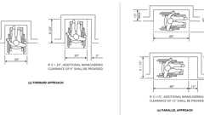Primary

**CA 11A: Figure 11A-1H Minimum Clear Floor Space in Alcoves**

[**1138A.1.4.3 *Surfaces of Wheelchair Spaces***](https://up.codes/viewer/california/ca-building-code-2025/chapter/11A/housing-accessibility#1138A.1.4.3)

[*Clear*](https://up.codes/viewer/california/ca-building-code-2025/chapter/2/definitions#clear_dsa_ac_)*floor or ground*[*spaces*](https://up.codes/viewer/california/ca-building-code-2025/chapter/2/definitions#space_)*for*[*wheelchairs*](https://up.codes/viewer/california/ca-building-code-2025/chapter/2/definitions#wheelchair_hcd_1_ac_dsa_ac_)*shall be stable, firm,*[*slip resistant*](https://up.codes/viewer/california/ca-building-code-2025/chapter/2/definitions#slip_resistant_)*, and shall comply with*[*Section 1110A.3*](https://up.codes/viewer/california/ca-building-code-2025/chapter/11A/housing-accessibility#1110A.3)*or*[*Section 1119A.2*](https://up.codes/viewer/california/ca-building-code-2025/chapter/11A/housing-accessibility#1119A.2)*. Changes in level are not permitted.*[*Slopes*](https://up.codes/viewer/california/ca-building-code-2025/chapter/J/grading#slope_)*not steeper than 1:48 shall be permitted.*

[**1138A.1.4.3.1 *Gratings***](https://up.codes/viewer/california/ca-building-code-2025/chapter/11A/housing-accessibility#1138A.1.4.3.1)

*Gratings located in ground and floor surfaces along*[*accessible routes*](https://up.codes/viewer/california/ca-building-code-2025/chapter/2/definitions#accessible_route_dsa_ac_hcd_1_ac_)*shall be limited to*[*spaces*](https://up.codes/viewer/california/ca-building-code-2025/chapter/2/definitions#space_)*no greater than 1/2-inch (12.7 mm) wide in one direction. If gratings have elongated*[*openings*](https://up.codes/viewer/california/ca-building-code-2025/chapter/7/fire-and-smoke-protection-features#712.1.13)*, they shall be placed so that the long dimension is perpendicular to the dominant direction of traffic.*

[**1138A.1.5 *Turn Around Obstruction***](https://up.codes/viewer/california/ca-building-code-2025/chapter/11A/housing-accessibility#1138A.1.5)

Diagram

*When the*[*accessible route*](https://up.codes/viewer/california/ca-building-code-2025/chapter/2/definitions#accessible_route_dsa_ac_hcd_1_ac_)*makes a 180 degree turn around an*[*element*](https://up.codes/viewer/california/ca-building-code-2025/chapter/2/definitions#element_dsa_ac_)*which is less than 48 inches (1219 mm) wide,*[*clear*](https://up.codes/viewer/california/ca-building-code-2025/chapter/2/definitions#clear_dsa_ac_)*width shall be 42 inches (1067 mm) minimum approaching the turn, 48 inches (1219 mm) minimum at the turn and 42 inches (1067 mm) minimum leaving the turn. When the*[*clear*](https://up.codes/viewer/california/ca-building-code-2025/chapter/2/definitions#clear_dsa_ac_)*width at the turn is 60 inches (1524 mm) minimum, the*[*clear*](https://up.codes/viewer/california/ca-building-code-2025/chapter/2/definitions#clear_dsa_ac_)*width when approaching and when leaving the turn shall be 36 inches (914 mm) minimum. (See*[*Figure*](https://up.codes/viewer/california/ca-building-code-2025/chapter/11B/accessibility-to-public-buildings-public-accommodations-commercial-buildings-and#figure)*11A-1C (b).)*

*When the*[*accessible route*](https://up.codes/viewer/california/ca-building-code-2025/chapter/2/definitions#accessible_route_dsa_ac_hcd_1_ac_)*makes a 90 degree turn around an*[*element*](https://up.codes/viewer/california/ca-building-code-2025/chapter/2/definitions#element_dsa_ac_)*which is more than 48 inches (1219 mm) wide,*[*clear*](https://up.codes/viewer/california/ca-building-code-2025/chapter/2/definitions#clear_dsa_ac_)*width shall be 36 inches (914 mm) minimum approaching the turn, at the turn and leaving the turn. (See*[*Figure*](https://up.codes/viewer/california/ca-building-code-2025/chapter/11B/accessibility-to-public-buildings-public-accommodations-commercial-buildings-and#figure)*11A-1C (a).)*

**UpCodes Diagram (1)**

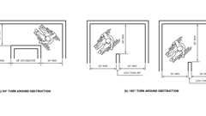Primary

**CA 11A: Figure 11A-1C Width of Accessible Route at Turns**

[**1138A.2 *Knee and Toe Space***](https://up.codes/viewer/california/ca-building-code-2025/chapter/11A/housing-accessibility#1138A.2)

Diagram

*When*[*space*](https://up.codes/viewer/california/ca-building-code-2025/chapter/2/definitions#space_)*beneath an*[*accessible element*](https://up.codes/viewer/california/ca-building-code-2025/chapter/2/definitions#accessible_element_dsa_ac_)*is included as part of a*[*clear floor space*](https://up.codes/viewer/california/ca-building-code-2025/chapter/2/definitions#clear_floor_space_dsa_ac_hcd_1_ac_)*, or turning*[*space*](https://up.codes/viewer/california/ca-building-code-2025/chapter/2/definitions#space_)*, the*[*space*](https://up.codes/viewer/california/ca-building-code-2025/chapter/2/definitions#space_)*shall comply with this section. Additional*[*space*](https://up.codes/viewer/california/ca-building-code-2025/chapter/2/definitions#space_)*shall not be prohibited beneath an*[*element*](https://up.codes/viewer/california/ca-building-code-2025/chapter/2/definitions#element_dsa_ac_)*but shall not be considered as part of the*[*clear floor space*](https://up.codes/viewer/california/ca-building-code-2025/chapter/2/definitions#clear_floor_space_dsa_ac_hcd_1_ac_)*or turning*[*space*](https://up.codes/viewer/california/ca-building-code-2025/chapter/2/definitions#space_)*. (See*[*Figure*](https://up.codes/viewer/california/ca-building-code-2025/chapter/11B/accessibility-to-public-buildings-public-accommodations-commercial-buildings-and#figure)*11A-9D.)*

**UpCodes Diagrams (3)**

Primary

**CA 11A: Figure 11A-9D Knee and Toe Space**



**Sufficient Maneuvering Space**



**Lavatories, Vanities, Mirrors and Towel Fixtures (CA 11A)**

[**1138A.2.1 *Knee Space***](https://up.codes/viewer/california/ca-building-code-2025/chapter/11A/housing-accessibility#1138A.2.1)

[*Space*](https://up.codes/viewer/california/ca-building-code-2025/chapter/2/definitions#space_)*under an*[*element*](https://up.codes/viewer/california/ca-building-code-2025/chapter/2/definitions#element_dsa_ac_)*between 9 inches (229 mm) and 27 inches (686 mm) above the finish floor shall be considered knee*[*space*](https://up.codes/viewer/california/ca-building-code-2025/chapter/2/definitions#space_)*. The knee*[*space*](https://up.codes/viewer/california/ca-building-code-2025/chapter/2/definitions#space_)*shall be*[*clear*](https://up.codes/viewer/california/ca-building-code-2025/chapter/2/definitions#clear_dsa_ac_)*and unobstructed.*

***Exceptions:***

1. *For*[*lavatories*](https://up.codes/viewer/california/ca-building-code-2025/chapter/2/definitions#lavatory_)*required to be accessible, the knee*[*space*](https://up.codes/viewer/california/ca-building-code-2025/chapter/2/definitions#space_)*shall be at least 29 inches (737 mm) high at the front face and reducing to not less than 27 inches (686 mm) at a point 8 inches (203.2 mm) back from the front edge.*
2. *For*[*lavatories*](https://up.codes/viewer/california/ca-building-code-2025/chapter/2/definitions#lavatory_)*and*[*sinks*](https://up.codes/viewer/california/ca-building-code-2025/chapter/2/definitions#sink_)*required to be accessible, the dip of the overflow shall not be considered in determining knee and toe clearances.*

[**1138A.2.1.1 *Minimum Width***](https://up.codes/viewer/california/ca-building-code-2025/chapter/11A/housing-accessibility#1138A.2.1.1)

*Knee*[*space*](https://up.codes/viewer/california/ca-building-code-2025/chapter/2/definitions#space_)*shall be 30 inches (762 mm) wide minimum.*

[**1138A.2.1.2 *Maximum Depth***](https://up.codes/viewer/california/ca-building-code-2025/chapter/11A/housing-accessibility#1138A.2.1.2)

*Knee*[*space*](https://up.codes/viewer/california/ca-building-code-2025/chapter/2/definitions#space_)*shall extend 25 inches (635 mm) maximum under an*[*element*](https://up.codes/viewer/california/ca-building-code-2025/chapter/2/definitions#element_dsa_ac_)*at 9 inches (229 mm) above the finish floor.*

[**1138A.2.1.3 *Minimum Depth***](https://up.codes/viewer/california/ca-building-code-2025/chapter/11A/housing-accessibility#1138A.2.1.3)

*When knee*[*space*](https://up.codes/viewer/california/ca-building-code-2025/chapter/2/definitions#space_)*is required under an*[*element*](https://up.codes/viewer/california/ca-building-code-2025/chapter/2/definitions#element_dsa_ac_)*as part of a*[*clear floor space*](https://up.codes/viewer/california/ca-building-code-2025/chapter/2/definitions#clear_floor_space_dsa_ac_hcd_1_ac_)*, the knee*[*space*](https://up.codes/viewer/california/ca-building-code-2025/chapter/2/definitions#space_)*shall be 11 inches (279 mm) deep minimum at 9 inches (229 mm) above the finish floor, and 8 inches (203 mm) deep minimum at 27 inches (686 mm) above the finish floor, measured from the front edge of the*[*element*](https://up.codes/viewer/california/ca-building-code-2025/chapter/2/definitions#element_dsa_ac_)*.*

***Exceptions:***

1. *Combined knee and toe*[*space*](https://up.codes/viewer/california/ca-building-code-2025/chapter/2/definitions#space_)*shall extend 19 inches (483 mm) minimum under*[*sinks*](https://up.codes/viewer/california/ca-building-code-2025/chapter/2/definitions#sink_)*required to be accessible.*
2. *Combined knee and toe*[*space*](https://up.codes/viewer/california/ca-building-code-2025/chapter/2/definitions#space_)*shall extend 19 inches (483 mm) minimum under built-in dining and work surfaces required to be accessible.*

[**1138A.2.1.4 *Clearance Reduction***](https://up.codes/viewer/california/ca-building-code-2025/chapter/11A/housing-accessibility#1138A.2.1.4)

*Between 9 inches (229 mm) and 27 inches (686 mm) above the finish floor, the knee*[*space*](https://up.codes/viewer/california/ca-building-code-2025/chapter/2/definitions#space_)*shall be permitted to be reduced at a rate of 1 inch (25 mm) in depth for each 6 inches (152 mm) in height.*

[**1138A.2.2 *Toe Space***](https://up.codes/viewer/california/ca-building-code-2025/chapter/11A/housing-accessibility#1138A.2.2)

[*Space*](https://up.codes/viewer/california/ca-building-code-2025/chapter/2/definitions#space_)*under an*[*element*](https://up.codes/viewer/california/ca-building-code-2025/chapter/2/definitions#element_dsa_ac_)*between the finish floor and 9 inches (229 mm) above the finish floor shall be considered toe*[*space*](https://up.codes/viewer/california/ca-building-code-2025/chapter/2/definitions#space_)*.*

[**1138A.2.2.1 *Minimum Width***](https://up.codes/viewer/california/ca-building-code-2025/chapter/11A/housing-accessibility#1138A.2.2.1)

*Toe*[*space*](https://up.codes/viewer/california/ca-building-code-2025/chapter/2/definitions#space_)*shall be 30 inches (762 mm) wide minimum.*

[**1138A.2.2.2 *Maximum Depth***](https://up.codes/viewer/california/ca-building-code-2025/chapter/11A/housing-accessibility#1138A.2.2.2)

*Toe*[*space*](https://up.codes/viewer/california/ca-building-code-2025/chapter/2/definitions#space_)*shall extend 25 inches (635 mm) maximum under an*[*element*](https://up.codes/viewer/california/ca-building-code-2025/chapter/2/definitions#element_dsa_ac_)*.*

[**1138A.2.2.3 *Minimum Depth***](https://up.codes/viewer/california/ca-building-code-2025/chapter/11A/housing-accessibility#1138A.2.2.3)

*When toe*[*space*](https://up.codes/viewer/california/ca-building-code-2025/chapter/2/definitions#space_)*is required under an*[*element*](https://up.codes/viewer/california/ca-building-code-2025/chapter/2/definitions#element_dsa_ac_)*as part of a*[*clear floor space*](https://up.codes/viewer/california/ca-building-code-2025/chapter/2/definitions#clear_floor_space_dsa_ac_hcd_1_ac_)*, the toe*[*space*](https://up.codes/viewer/california/ca-building-code-2025/chapter/2/definitions#space_)*shall extend 17 inches (432 mm) minimum under the*[*element*](https://up.codes/viewer/california/ca-building-code-2025/chapter/2/definitions#element_dsa_ac_)*, measured from the front edge of the*[*element*](https://up.codes/viewer/california/ca-building-code-2025/chapter/2/definitions#element_dsa_ac_)*.*

***Exceptions:***

1. *Combined knee and toe*[*space*](https://up.codes/viewer/california/ca-building-code-2025/chapter/2/definitions#space_)*shall extend 19 inches (483 mm) minimum under*[*sinks*](https://up.codes/viewer/california/ca-building-code-2025/chapter/2/definitions#sink_)*required to be accessible.*
2. *Combined knee and toe*[*space*](https://up.codes/viewer/california/ca-building-code-2025/chapter/2/definitions#space_)*shall extend 19 inches (483 mm) minimum under build-in dining and work surfaces required to be accessible.*

[**1138A.2.2.4 *Additional Clearance***](https://up.codes/viewer/california/ca-building-code-2025/chapter/11A/housing-accessibility#1138A.2.2.4)

[*Space*](https://up.codes/viewer/california/ca-building-code-2025/chapter/2/definitions#space_)*extending greater than 6 inches (152 mm) beyond the available knee*[*space*](https://up.codes/viewer/california/ca-building-code-2025/chapter/2/definitions#space_)*at 9 inches (229 mm) above the finish floor shall not be considered toe*[*space*](https://up.codes/viewer/california/ca-building-code-2025/chapter/2/definitions#space_)*.*

[**1138A.3 *Reach Ranges***](https://up.codes/viewer/california/ca-building-code-2025/chapter/11A/housing-accessibility#1138A.3)

Diagram

**UpCodes Diagram (1)**



**Accessible Switch, Outlet & Control Locations (CA)**

[**1138A.3.1 *Forward Reach***](https://up.codes/viewer/california/ca-building-code-2025/chapter/11A/housing-accessibility#1138A.3.1)

Diagram

1. ***Unobstructed.****When the*[*clear floor space*](https://up.codes/viewer/california/ca-building-code-2025/chapter/2/definitions#clear_floor_space_dsa_ac_hcd_1_ac_)*allows only forward approach to an object, the maximum high forward reach allowed shall be 48 inches (1219 mm) and the minimum low forward reach shall be no less than 15 inches (381 mm) above the finish floor. (See*[*Figure*](https://up.codes/viewer/california/ca-building-code-2025/chapter/11B/accessibility-to-public-buildings-public-accommodations-commercial-buildings-and#figure)*11A-1I(a)).*
2. ***Obstructed high reach.****When the high forward reach is over an obstruction, the*[*clear floor space*](https://up.codes/viewer/california/ca-building-code-2025/chapter/2/definitions#clear_floor_space_dsa_ac_hcd_1_ac_)*shall extend beneath the*[*element*](https://up.codes/viewer/california/ca-building-code-2025/chapter/2/definitions#element_dsa_ac_)*for a distance not less than the reach depth over the obstruction.*

*The high forward reach shall be 48 inches (1219 mm) maximum when the reach depth is 20 inches (508 mm) maximum. When the reach depth exceeds 20 inches (508 mm), but is not more than 25 inches (635 mm), the high forward reach shall be 44 inches (1118 mm) maximum. (See*[*Figure*](https://up.codes/viewer/california/ca-building-code-2025/chapter/11B/accessibility-to-public-buildings-public-accommodations-commercial-buildings-and#figure)*11A-1I(b).)*

**UpCodes Diagrams (2)**



**Outlet Mounting Height (CA 11A)**

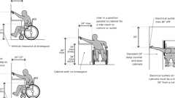

**Outlet Locations Over an Obstruction (FHA)**

[**1138A.3.2 *Side Reach***](https://up.codes/viewer/california/ca-building-code-2025/chapter/11A/housing-accessibility#1138A.3.2)

Diagram

1. ***Unobstructed.****When a*[*clear floor space*](https://up.codes/viewer/california/ca-building-code-2025/chapter/2/definitions#clear_floor_space_dsa_ac_hcd_1_ac_)*allows a parallel approach to an*[*element*](https://up.codes/viewer/california/ca-building-code-2025/chapter/2/definitions#element_dsa_ac_)*, and the side reach is unobstructed, the high side reach shall be 48 inches (1219 mm) maximum, and the low side reach shall be 15 inches (381 mm) minimum above the finish floor. (See*[*Figures*](https://up.codes/viewer/california/ca-building-code-2025/chapter/11B/accessibility-to-public-buildings-public-accommodations-commercial-buildings-and#figure)*11A-1J(a) and 11A-1J(b).)*

***Exceptions:***

* 1. *An obstruction shall be permitted between the*[*clear floor space*](https://up.codes/viewer/california/ca-building-code-2025/chapter/2/definitions#clear_floor_space_dsa_ac_hcd_1_ac_)*and the*[*element*](https://up.codes/viewer/california/ca-building-code-2025/chapter/2/definitions#element_dsa_ac_)*when the depth of the obstruction is 10 inches (254 mm) maximum.*
  2. *Bookshelves shall be permitted to be 54 inches (1372 mm) maximum above the finish floor. Bookshelves may be greater than 54 inches (1372 mm) above the finish floor when an attendant is available to assist*[*persons with disabilities*](https://up.codes/viewer/california/ca-building-code-2025/chapter/2/definitions#persons_with_disabilities_hcd_1_ac_)*.*

1. ***Obstructed high reach.****When a*[*clear floor space*](https://up.codes/viewer/california/ca-building-code-2025/chapter/2/definitions#clear_floor_space_dsa_ac_hcd_1_ac_)*allows a parallel approach to an*[*element*](https://up.codes/viewer/california/ca-building-code-2025/chapter/2/definitions#element_dsa_ac_)*and the high side reach is over an obstruction, the height of the obstruction shall be 34 inches (864 mm) maximum and the depth of the obstruction shall be 24 inches (610 mm) maximum.*
   1. *The high side reach shall be 48 inches (1219 mm) maximum for a reach depth of 10 inches (254 mm) maximum. When the reach depth exceeds 10 inches (254 mm), but no more than 24 inches (610 mm), the high side reach shall be 46 inches (1168 mm) maximum. (See*[*Figure*](https://up.codes/viewer/california/ca-building-code-2025/chapter/11B/accessibility-to-public-buildings-public-accommodations-commercial-buildings-and#figure)*11A-1J(c).)*

***Exception:****Kitchen countertops in*[*dwelling units*](https://up.codes/viewer/california/ca-building-code-2025/chapter/2/definitions#dwelling_unit_)*, and the top of*[*washing machines and clothes dryers*](https://up.codes/viewer/california/ca-building-code-2025/chapter/11B/accessibility-to-public-buildings-public-accommodations-commercial-buildings-and#11B-809.1.3)*shall be permitted to be 36 inches (914 mm) maximum above the finish floor.*

**UpCodes Diagrams (3)**

Primary

**CA 11A: Figure 11A-1J Side Reach**



**Outlet Mounting Height (CA 11A)**



**Outlet Locations Over an Obstruction (FHA)**

[**1138A.4 *Controls and Operating Mechanisms***](https://up.codes/viewer/california/ca-building-code-2025/chapter/11A/housing-accessibility#1138A.4)

***Note:****See also*[*Section 1142A*](https://up.codes/viewer/california/ca-building-code-2025/chapter/11A/housing-accessibility#1142A)*for receptacle, switch and control*[*installation*](https://up.codes/viewer/california/ca-building-code-2025/chapter/27/electrical#2702.1.3)*.*

[**1138A.4.1 *General***](https://up.codes/viewer/california/ca-building-code-2025/chapter/11A/housing-accessibility#1138A.4.1)

*Controls and operating mechanisms in*[*accessible spaces*](https://up.codes/viewer/california/ca-building-code-2025/chapter/2/definitions#accessible_space_dsa_ac_hcd_1_ac_)*, along*[*accessible routes*](https://up.codes/viewer/california/ca-building-code-2025/chapter/2/definitions#accessible_route_dsa_ac_hcd_1_ac_)*or as part of*[*accessible elements*](https://up.codes/viewer/california/ca-building-code-2025/chapter/2/definitions#accessible_element_dsa_ac_)*shall comply with this section.*

[**1138A.4.2 *Clear Floor Space***](https://up.codes/viewer/california/ca-building-code-2025/chapter/11A/housing-accessibility#1138A.4.2)

[*Clear floor space*](https://up.codes/viewer/california/ca-building-code-2025/chapter/2/definitions#clear_floor_space_dsa_ac_hcd_1_ac_)*complying with*[*Section 1138A.1.4*](https://up.codes/viewer/california/ca-building-code-2025/chapter/11A/housing-accessibility#1138A.1.4)*that allows a forward or parallel approach by a person using a*[*wheelchair*](https://up.codes/viewer/california/ca-building-code-2025/chapter/2/definitions#wheelchair_hcd_1_ac_dsa_ac_)*shall be provided at all controls and operating mechanisms.*

[**1138A.4.3 *Height***](https://up.codes/viewer/california/ca-building-code-2025/chapter/11A/housing-accessibility#1138A.4.3)

*Controls and operating mechanisms shall be located no higher than 48 inches (1219 mm), and no lower than 15 inches (381 mm), above the finished floor measured to the center of the grip. If the reach is over an obstruction (for example, washer or dryer), controls and operating mechanisms shall be located within the reach ranges specified in*[*Section 1138A.3*](https://up.codes/viewer/california/ca-building-code-2025/chapter/11A/housing-accessibility#1138A.3)*. Controls and operating mechanisms that do not satisfy these specifications are acceptable, provided that comparable mechanisms, controls or outlets, that perform the same functions, are provided within the same area and are accessible.*

[**1138A.4.4 *Operation***](https://up.codes/viewer/california/ca-building-code-2025/chapter/11A/housing-accessibility#1138A.4.4)

*Controls and operating mechanisms shall be operable with one hand and shall not require tight grasping, pinching or twisting of the wrist. The force required to activate controls and operating mechanisms shall be no greater than 5 pounds (22.2 N).*

**Building product (1)**

[[](https://up.codes/product/loft-wall-mounted-trim-23-wtr-l8?viewer_juris_key=california)](https://up.codes/product/loft-wall-mounted-trim-23-wtr-l8?viewer_juris_key=california)

**[Loft Wall Mounted Trim](https://up.codes/product/loft-wall-mounted-trim-23-wtr-l8?viewer_juris_key=california)**

**[Watermark Designs](https://up.codes/product/loft-wall-mounted-trim-23-wtr-l8?viewer_juris_key=california)**

[**Section 1139A *Accessible Drinking Fountains***](https://up.codes/viewer/california/ca-building-code-2025/chapter/11A/housing-accessibility#1139A)

**Building products (4)**

[[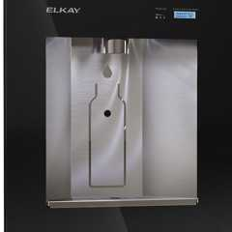](https://up.codes/product/liv-built-in-filtered-refrigerated-water-dispenser-remote-chiller-midnight?viewer_juris_key=california)](https://up.codes/product/liv-built-in-filtered-refrigerated-water-dispenser-remote-chiller-midnight?viewer_juris_key=california)

**[Liv® Built-in Filtered Refrigerated Water Dispenser Remote Chiller Midnight - LBWD06BKK](https://up.codes/product/liv-built-in-filtered-refrigerated-water-dispenser-remote-chiller-midnight?viewer_juris_key=california)**

**[Elkay](https://up.codes/product/liv-built-in-filtered-refrigerated-water-dispenser-remote-chiller-midnight?viewer_juris_key=california)**

[[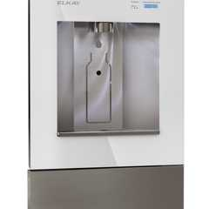](https://up.codes/product/liv-built-in-filtered-water-dispenser-non-refrigerated-aspen-white-2?viewer_juris_key=california)](https://up.codes/product/liv-built-in-filtered-water-dispenser-non-refrigerated-aspen-white-2?viewer_juris_key=california)

**[Liv® Built-in Filtered Water Dispenser Non-refrigerated Aspen White - LBWD00WHC](https://up.codes/product/liv-built-in-filtered-water-dispenser-non-refrigerated-aspen-white-2?viewer_juris_key=california)**

**[Elkay](https://up.codes/product/liv-built-in-filtered-water-dispenser-non-refrigerated-aspen-white-2?viewer_juris_key=california)**

[[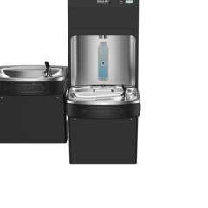](https://up.codes/product/pro-filtration-bottle-filling-station-bi-level-ada-cooler-refrigerated-ultra-cap?viewer_juris_key=california)](https://up.codes/product/pro-filtration-bottle-filling-station-bi-level-ada-cooler-refrigerated-ultra-cap?viewer_juris_key=california)

**[Pro Filtration® Bottle Filling Station & Bi-Level ADA Cooler Refrigerated Ultra-Capacity Lead Reduction - LZSTL8WSBPRO](https://up.codes/product/pro-filtration-bottle-filling-station-bi-level-ada-cooler-refrigerated-ultra-cap?viewer_juris_key=california)**

**[Elkay](https://up.codes/product/pro-filtration-bottle-filling-station-bi-level-ada-cooler-refrigerated-ultra-cap?viewer_juris_key=california)**

[[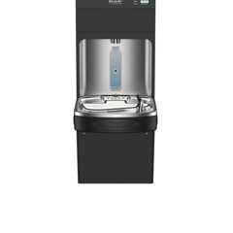](https://up.codes/product/pro-filtration-bottle-filling-station-single-ada-cooler-refrigerated-ultra-capac?viewer_juris_key=california)](https://up.codes/product/pro-filtration-bottle-filling-station-single-ada-cooler-refrigerated-ultra-capac?viewer_juris_key=california)

**[Pro Filtration® Bottle Filling Station & Single ADA Cooler Refrigerated Ultra-Capacity Lead Reduction - LZS8WSBPRO](https://up.codes/product/pro-filtration-bottle-filling-station-single-ada-cooler-refrigerated-ultra-capac?viewer_juris_key=california)**

**[Elkay](https://up.codes/product/pro-filtration-bottle-filling-station-single-ada-cooler-refrigerated-ultra-capac?viewer_juris_key=california)**

[**1139A.1 *General***](https://up.codes/viewer/california/ca-building-code-2025/chapter/11A/housing-accessibility#1139A.1)

Diagram

*Drinking fountains and water coolers in*[*common use areas*](https://up.codes/viewer/california/ca-building-code-2025/chapter/2/definitions#common_use_areas_hcd_1_ac_)*and/or*[*sites*](https://up.codes/viewer/california/ca-building-code-2025/chapter/2/definitions#site_)*shall comply with this section. A side approach drinking fountain is not acceptable. (See*[*Figure*](https://up.codes/viewer/california/ca-building-code-2025/chapter/11B/accessibility-to-public-buildings-public-accommodations-commercial-buildings-and#figure)*11A-11A.)*

**UpCodes Diagram (1)**

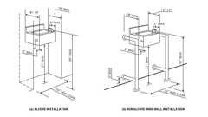Primary

**CA 11A: Figure 11A-11A Drinking Fountains**

[**1139A.2 *Accessible Route***](https://up.codes/viewer/california/ca-building-code-2025/chapter/11A/housing-accessibility#1139A.2)

*Drinking fountains and water coolers shall be on an*[*accessible route*](https://up.codes/viewer/california/ca-building-code-2025/chapter/2/definitions#accessible_route_dsa_ac_hcd_1_ac_)*.*

[**1139A.3 *Depth***](https://up.codes/viewer/california/ca-building-code-2025/chapter/11A/housing-accessibility#1139A.3)

*Drinking fountains shall be a minimum of 18 inches (457 mm) and a maximum of 19 inches (483 mm) in depth.*

[**1139A.4 *Clear Floor Space***](https://up.codes/viewer/california/ca-building-code-2025/chapter/11A/housing-accessibility#1139A.4)

*Drinking fountains shall be provided with 30 inches by 48 inches (762 mm by 1219 mm)*[*clear floor space*](https://up.codes/viewer/california/ca-building-code-2025/chapter/2/definitions#clear_floor_space_dsa_ac_hcd_1_ac_)*, centered on the unit. The*[*clear floor space*](https://up.codes/viewer/california/ca-building-code-2025/chapter/2/definitions#clear_floor_space_dsa_ac_hcd_1_ac_)*shall be positioned for a forward approach.*

[**1139A.4.1 *Knee and Toe Space***](https://up.codes/viewer/california/ca-building-code-2025/chapter/11A/housing-accessibility#1139A.4.1)

*Drinking fountains shall be provided with a*[*clear*](https://up.codes/viewer/california/ca-building-code-2025/chapter/2/definitions#clear_dsa_ac_)*and unobstructed knee and toe*[*space*](https://up.codes/viewer/california/ca-building-code-2025/chapter/2/definitions#space_)*. Knee and toe*[*space*](https://up.codes/viewer/california/ca-building-code-2025/chapter/2/definitions#space_)*shall comply with*[*Section 1138A.2*](https://up.codes/viewer/california/ca-building-code-2025/chapter/11A/housing-accessibility#1138A.2)*.*

[**1139A.5 *Spout Location***](https://up.codes/viewer/california/ca-building-code-2025/chapter/11A/housing-accessibility#1139A.5)

*The spout shall be located 15 inches (381 mm) minimum from the vertical support and 5 inches (127 mm) maximum from the front edge of the drinking fountain, including bumpers. Spout outlets shall be 36 inches (914 mm) maximum above the finish floor.*

[**1139A.6 *Water Flow***](https://up.codes/viewer/california/ca-building-code-2025/chapter/11A/housing-accessibility#1139A.6)

Diagram

*The spout shall provide a flow of water at least 4 inches (101.6 mm) high to allow the insertion of a cup or glass under the flow of water. The angle of the water stream shall be measured horizontally relative to the front face of the unit. When spouts are located less than 3 inches (76 mm) from the front of the unit, the angle of the water stream shall be 30 degrees maximum. When spouts are located between 3 inches (76 mm) and 5 inches (127 mm) maximum from the front of the unit, the angle of the water stream shall be 15 degrees maximum.*

**UpCodes Diagram (1)**

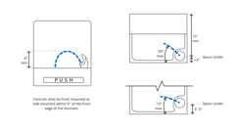

**Drinking Fountain - Water Flow**

[**1139A.7 *Controls and Operating Mechanisms***](https://up.codes/viewer/california/ca-building-code-2025/chapter/11A/housing-accessibility#1139A.7)

*The flow of water shall be activated by manually or electronically operated controls. The manually operated controls shall be front mounted or side mounted, located within 6 inches (152 mm) of the front edge of the fountain. The force required to activate controls shall be no greater than 5 pounds (22.2 N).*

[**1139A.8 *Location***](https://up.codes/viewer/california/ca-building-code-2025/chapter/11A/housing-accessibility#1139A.8)

Diagram

*Drinking fountains shall be located completely within alcoves, between wing*[*walls*](https://up.codes/viewer/california/ca-building-code-2025/chapter/2/definitions#wall_)*or otherwise positioned so as not to encroach into*[*pedestrian ways*](https://up.codes/viewer/california/ca-building-code-2025/chapter/2/definitions#pedestrian_way_)*. The alcove or otherwise protected area in which the drinking fountain is located shall not be less than 32 inches (813 mm) in width and 18 inches (457 mm) in depth. When the depth of the protected area where the drinking fountain is located exceeds 24 inches (610 mm), additional maneuvering clearance shall be provided in accordance with*[*Section 1138A.1.4.2*](https://up.codes/viewer/california/ca-building-code-2025/chapter/11A/housing-accessibility#1138A.1.4.2)*and*[*Figure*](https://up.codes/viewer/california/ca-building-code-2025/chapter/11B/accessibility-to-public-buildings-public-accommodations-commercial-buildings-and#figure)*11A-1H.*

*When provided, wing*[*walls*](https://up.codes/viewer/california/ca-building-code-2025/chapter/2/definitions#wall_)*shall project out from the supporting*[*wall*](https://up.codes/viewer/california/ca-building-code-2025/chapter/2/definitions#wall_)*at least as far as the drinking fountain to within 6 inches (152.4 mm) vertically from the finish floor.*

*Protruding objects located in alcoves or otherwise positioned so as to limit encroachment into*[*pedestrian ways*](https://up.codes/viewer/california/ca-building-code-2025/chapter/2/definitions#pedestrian_way_)*are permitted to project 4 inches (101.6 mm) into*[*walks*](https://up.codes/viewer/california/ca-building-code-2025/chapter/2/definitions#walk_dsa_ac_)*, halls,*[*corridors*](https://up.codes/viewer/california/ca-building-code-2025/chapter/2/definitions#corridor_)*, passageways or*[*aisles*](https://up.codes/viewer/california/ca-building-code-2025/chapter/2/definitions#aisle_)*. (See*[*Figure*](https://up.codes/viewer/california/ca-building-code-2025/chapter/11B/accessibility-to-public-buildings-public-accommodations-commercial-buildings-and#figure)*11A-11A.)*

**UpCodes Diagram (1)**



**Recessed Drinking Fountains (CA 11A)**

[**Section 1140A *Accessible Telephones***](https://up.codes/viewer/california/ca-building-code-2025/chapter/11A/housing-accessibility#1140A)

[**1140A.1 *General***](https://up.codes/viewer/california/ca-building-code-2025/chapter/11A/housing-accessibility#1140A.1)

*When public telephones are provided, they shall comply with this section. On floors where public telephones are provided, at least one telephone shall be accessible. On any floor where two or more banks of multiple telephones are provided, at least one telephone in each bank shall be accessible.*

[**1140A.2 *Clear Floor or Ground Space***](https://up.codes/viewer/california/ca-building-code-2025/chapter/11A/housing-accessibility#1140A.2)

*A*[*clear*](https://up.codes/viewer/california/ca-building-code-2025/chapter/2/definitions#clear_dsa_ac_)*floor or ground*[*space*](https://up.codes/viewer/california/ca-building-code-2025/chapter/2/definitions#space_)*at least 30 inches by 48 inches (762 mm by 1219 mm) that allows either a forward or parallel approach by a person using a*[*wheelchair*](https://up.codes/viewer/california/ca-building-code-2025/chapter/2/definitions#wheelchair_hcd_1_ac_dsa_ac_)*shall be provided at telephones. The*[*clear*](https://up.codes/viewer/california/ca-building-code-2025/chapter/2/definitions#clear_dsa_ac_)*floor or ground*[*space*](https://up.codes/viewer/california/ca-building-code-2025/chapter/2/definitions#space_)*shall comply with*[*Section 1138A.1.4*](https://up.codes/viewer/california/ca-building-code-2025/chapter/11A/housing-accessibility#1138A.1.4)*.*[*Bases*](https://up.codes/viewer/california/ca-building-code-2025/chapter/2/definitions#base_dsa_ss_dsa_ss_cc_oshpd_1_1r_2_4_5_)*, enclosures and fixed seats shall not impede approaches to telephones by people who use*[*wheelchairs*](https://up.codes/viewer/california/ca-building-code-2025/chapter/2/definitions#wheelchair_hcd_1_ac_dsa_ac_)*. (See*[*Figure*](https://up.codes/viewer/california/ca-building-code-2025/chapter/11B/accessibility-to-public-buildings-public-accommodations-commercial-buildings-and#figure)*11A-11B.)*

[*Clear*](https://up.codes/viewer/california/ca-building-code-2025/chapter/2/definitions#clear_dsa_ac_)*floor or ground*[*space*](https://up.codes/viewer/california/ca-building-code-2025/chapter/2/definitions#space_)*for*[*wheelchairs*](https://up.codes/viewer/california/ca-building-code-2025/chapter/2/definitions#wheelchair_hcd_1_ac_dsa_ac_)*may be part of the knee*[*space*](https://up.codes/viewer/california/ca-building-code-2025/chapter/2/definitions#space_)*required under some objects.*

[**1140A.3 *Relationship of Maneuvering Clearances to Wheelchair Spaces***](https://up.codes/viewer/california/ca-building-code-2025/chapter/11A/housing-accessibility#1140A.3)

*One full unobstructed side of the*[*clear*](https://up.codes/viewer/california/ca-building-code-2025/chapter/2/definitions#clear_dsa_ac_)*floor or ground*[*space*](https://up.codes/viewer/california/ca-building-code-2025/chapter/2/definitions#space_)*for a*[*wheelchair*](https://up.codes/viewer/california/ca-building-code-2025/chapter/2/definitions#wheelchair_hcd_1_ac_dsa_ac_)*shall adjoin another*[*wheelchair*](https://up.codes/viewer/california/ca-building-code-2025/chapter/2/definitions#wheelchair_hcd_1_ac_dsa_ac_)[*clear floor space*](https://up.codes/viewer/california/ca-building-code-2025/chapter/2/definitions#clear_floor_space_dsa_ac_hcd_1_ac_)*. If a*[*clear floor space*](https://up.codes/viewer/california/ca-building-code-2025/chapter/2/definitions#clear_floor_space_dsa_ac_hcd_1_ac_)*is located in an alcove or otherwise confined on all or part of three sides, additional maneuvering clearances shall be provided. (See*[*Section 1138A.1.4*](https://up.codes/viewer/california/ca-building-code-2025/chapter/11A/housing-accessibility#1138A.1.4)*.)*

[**1140A.4 *Mounting Height***](https://up.codes/viewer/california/ca-building-code-2025/chapter/11A/housing-accessibility#1140A.4)

Diagram

*The highest*[*operable part*](https://up.codes/viewer/california/ca-building-code-2025/chapter/2/definitions#operable_part_)*of the telephone shall be within the reach ranges specified in*[*Section 1138A.3*](https://up.codes/viewer/california/ca-building-code-2025/chapter/11A/housing-accessibility#1138A.3)*(See*[*Figure*](https://up.codes/viewer/california/ca-building-code-2025/chapter/11B/accessibility-to-public-buildings-public-accommodations-commercial-buildings-and#figure)*11A-11B.)*

**UpCodes Diagram (1)**

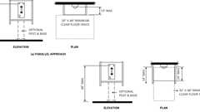Primary

**CA 11A: Figure 11A-11B Telephones**

[**1140A.5 *Enclosures***](https://up.codes/viewer/california/ca-building-code-2025/chapter/11A/housing-accessibility#1140A.5)

*If telephone enclosures are provided, they shall comply with Sections*[*1140A.5.1*](https://up.codes/viewer/california/ca-building-code-2025/chapter/11A/housing-accessibility#1140A.5.1)*and*[*1140A.5.2*](https://up.codes/viewer/california/ca-building-code-2025/chapter/11A/housing-accessibility#1140A.5.2)*. (See*[*Figure*](https://up.codes/viewer/california/ca-building-code-2025/chapter/11B/accessibility-to-public-buildings-public-accommodations-commercial-buildings-and#figure)*11A-11B.)*

[**1140A.5.1 *Parallel Approach***](https://up.codes/viewer/california/ca-building-code-2025/chapter/11A/housing-accessibility#1140A.5.1)

*Where a parallel approach is provided, the distance from the edge of the telephone enclosure to the face of the telephone unit shall be 10 inches (254 mm) maximum.*

[**1140A.5.2 *Forward Approach***](https://up.codes/viewer/california/ca-building-code-2025/chapter/11A/housing-accessibility#1140A.5.2)

*Where a forward approach is provided, the counter may extend beyond the face of the telephone 20 inches (508 mm) maximum into the required*[*clear*](https://up.codes/viewer/california/ca-building-code-2025/chapter/2/definitions#clear_dsa_ac_)*floor or ground*[*space*](https://up.codes/viewer/california/ca-building-code-2025/chapter/2/definitions#space_)*and the enclosure may extend beyond the face of the telephone 24 inches (610 mm) maximum. If an additional 6 inches (152 mm) in width of*[*clear floor space*](https://up.codes/viewer/california/ca-building-code-2025/chapter/2/definitions#clear_floor_space_dsa_ac_hcd_1_ac_)*is provided, creating a*[*clear floor space*](https://up.codes/viewer/california/ca-building-code-2025/chapter/2/definitions#clear_floor_space_dsa_ac_hcd_1_ac_)*of 36 inches by 48 inches (914 mm by 1219 mm), the enclosure may extend more than 24 inches (610 mm) beyond the face of the telephone.*

[**1140A.6 *Equipment for Hearing Impaired People***](https://up.codes/viewer/california/ca-building-code-2025/chapter/11A/housing-accessibility#1140A.6)

Diagram

*Telephones shall be equipped with a receiver that generates a magnetic field in the area of the receiver cap. A reasonable number of the public telephones provided, but always at least one on each floor or in each bank, whichever is more, in a building or*[*facility*](https://up.codes/viewer/california/ca-building-code-2025/chapter/2/definitions#facility_)*, shall be equipped with a volume control. Such telephones shall be capable of providing a gain adjustable up to*[*20*](https://up.codes/viewer/california/ca-building-code-2025/chapter/20/aluminum#20)*dB minimum. For incremental volume control, at least one intermediate*[*step*](https://up.codes/viewer/california/ca-building-code-2025/chapter/2/definitions#step_)*of 12 dB of gain minimum shall be provided. An*[*automatic*](https://up.codes/viewer/california/ca-building-code-2025/chapter/2/definitions#automatic_)*reset shall also be provided. Public telephones with volume control shall be hearing aid compatible and shall be identified by a*[*sign*](https://up.codes/viewer/california/ca-building-code-2025/chapter/2/definitions#sign_hcd_1_ac_dsa_ac_)*containing a depiction of a telephone handset with radiating sound waves. (See*[*Figure*](https://up.codes/viewer/california/ca-building-code-2025/chapter/11B/accessibility-to-public-buildings-public-accommodations-commercial-buildings-and#figure)*11A-11D.)*

**UpCodes Diagram (1)**

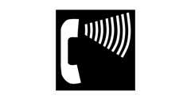Primary

**CA 11A: Figure 11A-11D Volume Control Telephones**

[**1140A.7 *Text Telephones (TTY)***](https://up.codes/viewer/california/ca-building-code-2025/chapter/11A/housing-accessibility#1140A.7)

*If a total of four or more public pay telephones are provided at the interior and exterior of a*[*site*](https://up.codes/viewer/california/ca-building-code-2025/chapter/2/definitions#site_)*, and if at least one of the total number provided is located in an interior*[*location*](https://up.codes/viewer/california/ca-building-code-2025/chapter/L/earthquake-recording-instrumentation#L101.2)*, at least one interior public*[*text telephone*](https://up.codes/viewer/california/ca-building-code-2025/chapter/2/definitions#text_telephone_)*shall be provided. TTYs provided at a public pay telephone shall be permanently affixed within, or adjacent to, the telephone enclosure. Where an acoustic coupler is used, the telephone cord shall be sufficiently long to allow connection of the TTY and the telephone receiver.*

[**1140A.7.1 *Signage***](https://up.codes/viewer/california/ca-building-code-2025/chapter/11A/housing-accessibility#1140A.7.1)

Diagram

[*Text telephones*](https://up.codes/viewer/california/ca-building-code-2025/chapter/2/definitions#text_telephone_)*shall be identified by the International TTY symbol (see*[*Figure*](https://up.codes/viewer/california/ca-building-code-2025/chapter/11B/accessibility-to-public-buildings-public-accommodations-commercial-buildings-and#figure)*11A-11C). If a*[*facility*](https://up.codes/viewer/california/ca-building-code-2025/chapter/2/definitions#facility_)*has a public*[*text telephone*](https://up.codes/viewer/california/ca-building-code-2025/chapter/2/definitions#text_telephone_)*, directional signage indicating the*[*location*](https://up.codes/viewer/california/ca-building-code-2025/chapter/L/earthquake-recording-instrumentation#L101.2)*of the nearest such telephone shall be placed adjacent to all banks of telephones that do not contain a*[*text telephone*](https://up.codes/viewer/california/ca-building-code-2025/chapter/2/definitions#text_telephone_)*. Such directional signage shall include the International TTY symbol. If a*[*facility*](https://up.codes/viewer/california/ca-building-code-2025/chapter/2/definitions#facility_)*has no banks of telephones, the directional signage shall be provided at the*[*entrance*](https://up.codes/viewer/california/ca-building-code-2025/chapter/2/definitions#entrance_hcd_1_hcd_2_hcd_1_ac_and_dsa_ac_)*or in a building directory.*

**UpCodes Diagram (1)**

Primary

**CA 11A: Figure 11A-11C International TTY Symbol**

[**1140A.7.2 *Height***](https://up.codes/viewer/california/ca-building-code-2025/chapter/11A/housing-accessibility#1140A.7.2)

*When in use, the touch surface of TTY keypads shall be 34 inches (864 mm) minimum above the finish floor.*

[**1140A.8 *Controls***](https://up.codes/viewer/california/ca-building-code-2025/chapter/11A/housing-accessibility#1140A.8)

*Telephones shall have push-button controls where service for such*[*equipment*](https://up.codes/viewer/california/ca-building-code-2025/chapter/2/definitions#equipment_dsa_ss_dsa_ss_cc_oshpd_1_2_4_5_)*is available. Controls and operating mechanisms shall comply with*[*Section 1138A.4*](https://up.codes/viewer/california/ca-building-code-2025/chapter/11A/housing-accessibility#1138A.4)*.*

[**1140A.9 *Cord Length***](https://up.codes/viewer/california/ca-building-code-2025/chapter/11A/housing-accessibility#1140A.9)

*The cord from the telephone to the handset shall be at least 29 inches (737 mm) long.*

[**1140A.10 *Telephone Books***](https://up.codes/viewer/california/ca-building-code-2025/chapter/11A/housing-accessibility#1140A.10)

*If telephone books are provided, they shall be located in a position that complies with the reach ranges in*[*Section 1138A.3*](https://up.codes/viewer/california/ca-building-code-2025/chapter/11A/housing-accessibility#1138A.3)*.*

[**1140A.11 *Shelf***](https://up.codes/viewer/california/ca-building-code-2025/chapter/11A/housing-accessibility#1140A.11)

*Public pay telephones required to accommodate a portable TTY shall be equipped with a shelf and an electrical outlet within or adjacent to the telephone enclosure. The telephone handset shall be capable of being placed flush on the surface of the shelf. The shelf shall be capable of accommodating a TTY and shall have 6 inches (152 mm) minimum vertical clearance above the area where the TTY is to be placed.*

[**Section 1141A *Accessible Swimming Pools***](https://up.codes/viewer/california/ca-building-code-2025/chapter/11A/housing-accessibility#1141A)

[**1141A.1 *General***](https://up.codes/viewer/california/ca-building-code-2025/chapter/11A/housing-accessibility#1141A.1)

[*Swimming pools*](https://up.codes/viewer/california/ca-building-code-2025/chapter/2/definitions#swimming_pool_)*in*[*common use areas*](https://up.codes/viewer/california/ca-building-code-2025/chapter/2/definitions#common_use_areas_hcd_1_ac_)*shall comply with the provisions of this section and*[*Chapter 31B*](https://up.codes/viewer/california/ca-building-code-2025/chapter/31B/dph-public-pools#31B)*.*

[**1141A.2 *Swimming Pool Deck Areas***](https://up.codes/viewer/california/ca-building-code-2025/chapter/11A/housing-accessibility#1141A.2)

[*Swimming pool*](https://up.codes/viewer/california/ca-building-code-2025/chapter/2/definitions#swimming_pool_)[*deck*](https://up.codes/viewer/california/ca-building-code-2025/chapter/2/definitions#deck_)*areas must be accessible, and a mechanism to assist*[*persons with disabilities*](https://up.codes/viewer/california/ca-building-code-2025/chapter/2/definitions#persons_with_disabilities_hcd_1_ac_)*gain entry into the*[*pool*](https://up.codes/viewer/california/ca-building-code-2025/chapter/2/definitions#pool_)*and*[*exit*](https://up.codes/viewer/california/ca-building-code-2025/chapter/2/definitions#exit_)*from the*[*pool*](https://up.codes/viewer/california/ca-building-code-2025/chapter/2/definitions#pool_)*shall be provided. Such a mechanism may consist of a*[*swimming pool*](https://up.codes/viewer/california/ca-building-code-2025/chapter/2/definitions#swimming_pool_)*lift device as long as the device meets all of the following criteria:*

1. *Has a seat that meets all of the following:*
   1. *The seat must be rigid;*
   2. *The seat must be not less than 17 inches (432 mm) and not more than 19 inches (483 mm), inclusive of any cushioned surface that might be provided, above the*[*pool*](https://up.codes/viewer/california/ca-building-code-2025/chapter/2/definitions#pool_)[*deck*](https://up.codes/viewer/california/ca-building-code-2025/chapter/2/definitions#deck_)*;*
   3. *The seat must have two armrests. The armrest on the side of the seat by which access is gained shall be either removable or fold*[*clear*](https://up.codes/viewer/california/ca-building-code-2025/chapter/2/definitions#clear_dsa_ac_)*of the seat;*
   4. *The seat must have a back support that is at least 12 inches (305 mm) tall; and*
   5. *The seat must have an occupant*[*restraint*](https://up.codes/viewer/california/ca-building-code-2025/chapter/2/definitions#restraint_sfm_)*for use by the occupant of the seat and the*[*restraint*](https://up.codes/viewer/california/ca-building-code-2025/chapter/2/definitions#restraint_sfm_)*must meet the standards for operable controls in*[*compliance*](https://up.codes/viewer/california/ca-building-code-2025/chapter/31/special-construction#3113.1.1)*with*[*Section 1138A.4.4*](https://up.codes/viewer/california/ca-building-code-2025/chapter/11A/housing-accessibility#1138A.4.4)*.*
2. *Be capable of unassisted*[*operation*](https://up.codes/viewer/california/ca-building-code-2025/chapter/30/elevators-and-conveying-systems#3008.1.4)*from both the*[*deck*](https://up.codes/viewer/california/ca-building-code-2025/chapter/2/definitions#deck_)*and water levels.*
3. *Be stable and not*[*permit*](https://up.codes/viewer/california/ca-building-code-2025/chapter/2/definitions#permit_)*unintended movement when a person is getting into or out of the seat.*
4. *Be designed to have a*[*live-load*](https://up.codes/viewer/california/ca-building-code-2025/chapter/2/definitions#live_load_)*capacity of not less than 300 pounds.*
5. *Be positioned so that, if the*[*pool*](https://up.codes/viewer/california/ca-building-code-2025/chapter/2/definitions#pool_)*has water of different depths, it will place the operator into water that is at least 3 feet (914 mm) deep.*
6. *Be capable of lowering the operator at least 18 inches (457 mm) below the surface of the water.*

[**Section 1142A *Electrical Receptacle, Switch and Control Heights***](https://up.codes/viewer/california/ca-building-code-2025/chapter/11A/housing-accessibility#1142A)

Diagram

**UpCodes Diagram (1)**



**Powder Room**

**Building products (2)**

[[](https://up.codes/product/37-7-8-300-lumens-ft-24-volt-standard-output-angled-linear-fixture-tunable-white?viewer_juris_key=california)](https://up.codes/product/37-7-8-300-lumens-ft-24-volt-standard-output-angled-linear-fixture-tunable-white?viewer_juris_key=california)

**[600 Lumens/Ft. Angled Linear Fixture, Tunable-White, 2700K–5000K - LT-P3](https://up.codes/product/37-7-8-300-lumens-ft-24-volt-standard-output-angled-linear-fixture-tunable-white?viewer_juris_key=california)**

**[Task Lighting and Power](https://up.codes/product/37-7-8-300-lumens-ft-24-volt-standard-output-angled-linear-fixture-tunable-white?viewer_juris_key=california)**

[[](https://up.codes/product/14-1-2-120-lumens-ft-12-volt-accent-output-flat-linear-fixture-single-white-fits?viewer_juris_key=california)](https://up.codes/product/14-1-2-120-lumens-ft-12-volt-accent-output-flat-linear-fixture-single-white-fits?viewer_juris_key=california)

**[Flat Profile Linear Fixtures - Single-White - LS-P7](https://up.codes/product/14-1-2-120-lumens-ft-12-volt-accent-output-flat-linear-fixture-single-white-fits?viewer_juris_key=california)**

**[Task Lighting and Power](https://up.codes/product/14-1-2-120-lumens-ft-12-volt-accent-output-flat-linear-fixture-single-white-fits?viewer_juris_key=california)**

[**1142A.1 *Receptacle Heights***](https://up.codes/viewer/california/ca-building-code-2025/chapter/11A/housing-accessibility#1142A.1)

Diagram

[*Electrical receptacle outlets*](https://up.codes/viewer/california/ca-building-code-2025/chapter/11B/accessibility-to-public-buildings-public-accommodations-commercial-buildings-and#11B-308.1.2)*on branch circuits of 30 amperes or less and communication system receptacles shall be located no more than 48 inches (1219 mm) measured from the top of the receptacle outlet box nor less than 15 inches (381 mm) measured from the bottom of the receptacle outlet box to the level of the finished floor or working*[*platform*](https://up.codes/viewer/california/ca-building-code-2025/chapter/2/definitions#platform_)*. If the reach is over a physical barrier or an obstruction (for example, a kitchen*[*base*](https://up.codes/viewer/california/ca-building-code-2025/chapter/2/definitions#base_dsa_ss_dsa_ss_cc_oshpd_1_1r_2_4_5_)*cabinet), receptacles shall be located within the reach ranges specified in*[*Section 1138A.3*](https://up.codes/viewer/california/ca-building-code-2025/chapter/11A/housing-accessibility#1138A.3)*. Physical barriers and obstructions shall not extend more than 25 inches (635 mm) from the*[*wall*](https://up.codes/viewer/california/ca-building-code-2025/chapter/2/definitions#wall_)*beneath the receptacle.*

*Receptacle outlets that do not satisfy these specifications are acceptable provided that comparable receptacle outlets, that perform the same functions, are provided within the same area and are accessible.*

***Exceptions:***

1. *Receptacle outlets installed as part of permanently installed baseboard heaters are exempt.*
2. *Required receptacle outlets shall be permitted in floors when adjacent to sliding panels or*[*walls*](https://up.codes/viewer/california/ca-building-code-2025/chapter/2/definitions#wall_)*.*
3. *Baseboard electrical outlets used in relocatable partitions, window*[*walls*](https://up.codes/viewer/california/ca-building-code-2025/chapter/2/definitions#wall_)*or other electrical convenience floor outlets are not subject to the minimum height requirements.*
4. *This section shall not apply to*[*existing buildings*](https://up.codes/viewer/california/ca-building-code-2025/chapter/2/definitions#building_existing_hcd_1_hcd_2_)*when the*[*enforcing agency*](https://up.codes/viewer/california/ca-building-code-2025/chapter/2/definitions#enforcing_agency_)*determines that*[*compliance*](https://up.codes/viewer/california/ca-building-code-2025/chapter/31/special-construction#3113.1.1)*with these standards would create an*[*unreasonable hardship*](https://up.codes/viewer/california/ca-building-code-2025/chapter/2/definitions#unreasonable_hardship_)*.*

**UpCodes Diagrams (3)**

Primary

**Outlet Mounting Height (CA 11A)**



**Outlet Locations Over an Obstruction (FHA)**



**Accessible Switch, Outlet & Control Locations (CA)**

[**1142A.2 *Switch and Control Heights***](https://up.codes/viewer/california/ca-building-code-2025/chapter/11A/housing-accessibility#1142A.2)

*Controls or switches intended to be used by the occupant of the room or area to control lighting and receptacle outlets, appliances, alarms or cooling, heating and ventilating*[*equipment*](https://up.codes/viewer/california/ca-building-code-2025/chapter/2/definitions#equipment_dsa_ss_dsa_ss_cc_oshpd_1_2_4_5_)*shall be located no more than 48 inches (1219 mm) measured from the top of the outlet box nor less than 15 inches (381 mm) measured from the bottom of the outlet box to the level of the finished floor or working*[*platform*](https://up.codes/viewer/california/ca-building-code-2025/chapter/2/definitions#platform_)*. If the reach is over a physical barrier or an obstruction (for example, a kitchen*[*base*](https://up.codes/viewer/california/ca-building-code-2025/chapter/2/definitions#base_dsa_ss_dsa_ss_cc_oshpd_1_1r_2_4_5_)*cabinet), switches and controls shall be located within the reach ranges specified in*[*Section 1138A.3*](https://up.codes/viewer/california/ca-building-code-2025/chapter/11A/housing-accessibility#1138A.3)*. Physical barriers or obstructions shall not extend more than 25 inches (635 mm) from the*[*wall*](https://up.codes/viewer/california/ca-building-code-2025/chapter/2/definitions#wall_)*beneath a switch or control.*

*Switches and controls that do not satisfy these specifications are acceptable provided that comparable controls or outlets, that perform the same functions, are provided within the same area and are accessible.*

[**Section 1143A *Signage***](https://up.codes/viewer/california/ca-building-code-2025/chapter/11A/housing-accessibility#1143A)

[**1143A.1 *General***](https://up.codes/viewer/california/ca-building-code-2025/chapter/11A/housing-accessibility#1143A.1)

*When*[*signs*](https://up.codes/viewer/california/ca-building-code-2025/chapter/2/definitions#sign_hcd_1_ac_dsa_ac_)*and/or*[*identification*](https://up.codes/viewer/california/ca-building-code-2025/chapter/22A/steel#2201A.2)*devices are provided they shall comply with this section.*

*When both visual and*[*tactile*](https://up.codes/viewer/california/ca-building-code-2025/chapter/2/definitions#tactile_)[*characters*](https://up.codes/viewer/california/ca-building-code-2025/chapter/2/definitions#characters_)*are required, either one*[*sign*](https://up.codes/viewer/california/ca-building-code-2025/chapter/2/definitions#sign_hcd_1_ac_dsa_ac_)*with both visual and*[*tactile*](https://up.codes/viewer/california/ca-building-code-2025/chapter/2/definitions#tactile_)[*characters*](https://up.codes/viewer/california/ca-building-code-2025/chapter/2/definitions#characters_)*, or two separate*[*signs*](https://up.codes/viewer/california/ca-building-code-2025/chapter/2/definitions#sign_hcd_1_ac_dsa_ac_)*— one with visual and one with*[*tactile*](https://up.codes/viewer/california/ca-building-code-2025/chapter/2/definitions#tactile_)[*characters*](https://up.codes/viewer/california/ca-building-code-2025/chapter/2/definitions#characters_)*— shall be provided.*

***Exception:***[*Signs*](https://up.codes/viewer/california/ca-building-code-2025/chapter/2/definitions#sign_hcd_1_ac_dsa_ac_)*need not be provided within*[*dwelling units*](https://up.codes/viewer/california/ca-building-code-2025/chapter/2/definitions#dwelling_unit_)*.*

***Note:****See*[*Section 1127A.7*](https://up.codes/viewer/california/ca-building-code-2025/chapter/11A/housing-accessibility#1127A.7)*for additional signage requirements applicable to*[*sanitary facilities*](https://up.codes/viewer/california/ca-building-code-2025/chapter/2/definitions#sanitary_facility_hcd_1_hcd_1_ac_)*, and*[*Section 1124A*](https://up.codes/viewer/california/ca-building-code-2025/chapter/11A/housing-accessibility#1124A)*for additional signage requirements applicable to elevators.*

[**1143A.2 *Identification Signs***](https://up.codes/viewer/california/ca-building-code-2025/chapter/11A/housing-accessibility#1143A.2)

*When*[*signs*](https://up.codes/viewer/california/ca-building-code-2025/chapter/2/definitions#sign_hcd_1_ac_dsa_ac_)*identify*[*permanent*](https://up.codes/viewer/california/ca-building-code-2025/chapter/2/definitions#permanent_dsa_ac_)*rooms and*[*spaces*](https://up.codes/viewer/california/ca-building-code-2025/chapter/2/definitions#space_)*of a building or*[*site*](https://up.codes/viewer/california/ca-building-code-2025/chapter/2/definitions#site_)*, they shall comply with Sections*[*1143A.1*](https://up.codes/viewer/california/ca-building-code-2025/chapter/11A/housing-accessibility#1143A.1)*, 1143A.5, 1143A.6 and 1143A.7.*

***Exception:****Exterior*[*signs*](https://up.codes/viewer/california/ca-building-code-2025/chapter/2/definitions#sign_hcd_1_ac_dsa_ac_)*that are not located at the door to the*[*space*](https://up.codes/viewer/california/ca-building-code-2025/chapter/2/definitions#space_)*they serve shall not be required to comply with*[*Section 1143A.6*](https://up.codes/viewer/california/ca-building-code-2025/chapter/11A/housing-accessibility#1143A.6)*.*

[**1143A.3 *Directional and Informational Signs***](https://up.codes/viewer/california/ca-building-code-2025/chapter/11A/housing-accessibility#1143A.3)

*When*[*signs*](https://up.codes/viewer/california/ca-building-code-2025/chapter/2/definitions#sign_hcd_1_ac_dsa_ac_)*direct to or give information about*[*permanent*](https://up.codes/viewer/california/ca-building-code-2025/chapter/2/definitions#permanent_dsa_ac_)*rooms and*[*spaces*](https://up.codes/viewer/california/ca-building-code-2025/chapter/2/definitions#space_)*of a building or*[*site*](https://up.codes/viewer/california/ca-building-code-2025/chapter/2/definitions#site_)*, they shall comply with Sections*[*1143A.5*](https://up.codes/viewer/california/ca-building-code-2025/chapter/11A/housing-accessibility#1143A.5)*.*

[**1143A.4 *Accessibility Signs***](https://up.codes/viewer/california/ca-building-code-2025/chapter/11A/housing-accessibility#1143A.4)

*When*[*signs*](https://up.codes/viewer/california/ca-building-code-2025/chapter/2/definitions#sign_hcd_1_ac_dsa_ac_)*identify, direct or give information about*[*accessible elements*](https://up.codes/viewer/california/ca-building-code-2025/chapter/2/definitions#accessible_element_dsa_ac_)*and features of a building or*[*site*](https://up.codes/viewer/california/ca-building-code-2025/chapter/2/definitions#site_)*, they shall include the appropriate symbol of*[*accessibility*](https://up.codes/viewer/california/ca-building-code-2025/chapter/30/elevators-and-conveying-systems#3001.4)*and shall comply with*[*Section 1143A.5*](https://up.codes/viewer/california/ca-building-code-2025/chapter/11A/housing-accessibility#1143A.5)*.*

[**1143A.5 *Visual Characters***](https://up.codes/viewer/california/ca-building-code-2025/chapter/11A/housing-accessibility#1143A.5)

Diagram

[*Signs*](https://up.codes/viewer/california/ca-building-code-2025/chapter/2/definitions#sign_hcd_1_ac_dsa_ac_)*with visual*[*characters*](https://up.codes/viewer/california/ca-building-code-2025/chapter/2/definitions#characters_)*shall comply with this section.*

1. ***Finish and contrast.***[*Characters*](https://up.codes/viewer/california/ca-building-code-2025/chapter/2/definitions#characters_)*and their background shall have a non-glare finish.*[*Characters*](https://up.codes/viewer/california/ca-building-code-2025/chapter/2/definitions#characters_)*shall contrast with their background, either light on a dark background or dark on a light background.*
2. ***Character type.***[*Characters*](https://up.codes/viewer/california/ca-building-code-2025/chapter/2/definitions#characters_)*shall be uppercase, lowercase or a combination of both.*[*Characters*](https://up.codes/viewer/california/ca-building-code-2025/chapter/2/definitions#characters_)*shall be conventional in form, and shall not be italic, oblique, script, highly decorative or of other unusual forms.*
3. ***Proportions.***[*Characters*](https://up.codes/viewer/california/ca-building-code-2025/chapter/2/definitions#characters_)*on*[*signs*](https://up.codes/viewer/california/ca-building-code-2025/chapter/2/definitions#sign_hcd_1_ac_dsa_ac_)*shall be selected from fonts where the width of the uppercase letter "O" is 60 percent minimum and 110 percent maximum of the height of the uppercase letter "I".*
4. ***Character height.****Visual*[*characters*](https://up.codes/viewer/california/ca-building-code-2025/chapter/2/definitions#characters_)*shall be sized in accordance with*[*Table*](https://up.codes/viewer/california/ca-building-code-2025/chapter/11B/accessibility-to-public-buildings-public-accommodations-commercial-buildings-and#table)*1143A.5. Viewing distance shall be measured as the horizontal distance between the character and an obstruction preventing further approach towards the*[*sign*](https://up.codes/viewer/california/ca-building-code-2025/chapter/2/definitions#sign_hcd_1_ac_dsa_ac_)*. Character height shall be based on the uppercase letter "I".*
5. ***Height from finish floor.****Visual*[*characters*](https://up.codes/viewer/california/ca-building-code-2025/chapter/2/definitions#characters_)*shall be 40 inches (1016 mm) minimum above the finish floor.*

***Exceptions:***

* 1. *Visual*[*characters*](https://up.codes/viewer/california/ca-building-code-2025/chapter/2/definitions#characters_)*indicating elevator car controls.*
  2. *Floor-level*[*exit*](https://up.codes/viewer/california/ca-building-code-2025/chapter/2/definitions#exit_)[*signs*](https://up.codes/viewer/california/ca-building-code-2025/chapter/2/definitions#sign_hcd_1_ac_dsa_ac_)*complying with*[*Chapter 10*](https://up.codes/viewer/california/ca-building-code-2025/chapter/10/means-of-egress#10)*.*

1. ***Stroke thickness.****Stroke thickness of the uppercase letter "I" shall be 10 percent minimum and 20 percent maximum of the height of the character.*
2. ***Character spacing.****Character spacing shall be measured between the two closest points of adjacent*[*characters*](https://up.codes/viewer/california/ca-building-code-2025/chapter/2/definitions#characters_)*, excluding word*[*spaces*](https://up.codes/viewer/california/ca-building-code-2025/chapter/2/definitions#space_)*. Spacing between individual*[*characters*](https://up.codes/viewer/california/ca-building-code-2025/chapter/2/definitions#characters_)*shall be 10 percent minimum and 35 percent maximum of character height.*
3. ***Line spacing.****Spacing between the baselines of separate lines of*[*characters*](https://up.codes/viewer/california/ca-building-code-2025/chapter/2/definitions#characters_)*within a message shall be 135 percent minimum and 170 percent maximum of the character height.*
4. ***Character format.****Text shall be in a horizontal format.*

[*TABLE*](https://up.codes/viewer/california/ca-building-code-2025/chapter/11B/accessibility-to-public-buildings-public-accommodations-commercial-buildings-and#table)*1143A.5— VISUAL CHARACTER HEIGHT*

|  |  |  |
| --- | --- | --- |
| ***HEIGHT TO FINISH FLOOR***  ***FROM BASELINE OF CHARACTER*** | ***HORIZONTAL***  ***VIEWING DISTANCE*** | ***MINIMUM***  ***CHARACTER HEIGHT*** |
| *40 inches (1016 mm) to less than*  *or equal to 70 inches (1778 mm)* | *Less than 72 inches (1829 mm)* | *5/8inch (15.9 mm)* |
| *72 inches (1829 mm) and greater* | *5/8inch (15.9 mm), plus 1/8inch (3.2 mm) per foot (305 mm)*  *of viewing distance above 72 inches (1829 mm)* |
| *Greater than 70 inches (1778 mm) to less*  *than or equal to 120 inches (3048 mm)* | *Less than 180 inches (4572 mm)* | *2 inches (51 mm)* |
| *180 inches (4572 mm) and greater* | *2 inches (51 mm), plus 1/8inch (3.2 mm) per foot (305 mm)*  *of viewing distance above 180 inches (4572 mm)* |
| *Greater than 120 inches (3048 mm)* | *Less than 21 feet (6401 mm)* | *3 inches (76 mm)* |
| *21 feet (6401 mm) and greater* | *3 inches (76 mm), plus 1/8inch (3.2 mm) per foot (305 mm)*  *of viewing distance above 21 feet (6401 mm)* |

**UpCodes Diagram (1)**

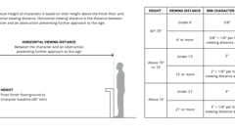Primary

**Sign Character Height: Viewing Dist.**

[**1143A.6 *Raised Characters and Pictorial Symbol Signs***](https://up.codes/viewer/california/ca-building-code-2025/chapter/11A/housing-accessibility#1143A.6)

Diagram

*When raised*[*characters*](https://up.codes/viewer/california/ca-building-code-2025/chapter/2/definitions#characters_)*are required or when pictorial symbols (*[*pictograms*](https://up.codes/viewer/california/ca-building-code-2025/chapter/2/definitions#pictogram_)*) are used on such*[*signs*](https://up.codes/viewer/california/ca-building-code-2025/chapter/2/definitions#sign_hcd_1_ac_dsa_ac_)*, they shall comply with this section. Raised*[*characters*](https://up.codes/viewer/california/ca-building-code-2025/chapter/2/definitions#characters_)*and pictorial symbols shall be duplicated in Braille complying with*[*Section 1143A.7*](https://up.codes/viewer/california/ca-building-code-2025/chapter/11A/housing-accessibility#1143A.7)*.*

1. ***Character type.****Raised*[*characters*](https://up.codes/viewer/california/ca-building-code-2025/chapter/2/definitions#characters_)*on*[*signs*](https://up.codes/viewer/california/ca-building-code-2025/chapter/2/definitions#sign_hcd_1_ac_dsa_ac_)*shall be 1/32inch (0.8 mm) minimum above their background.*[*Characters*](https://up.codes/viewer/california/ca-building-code-2025/chapter/2/definitions#characters_)*shall be sans serif uppercase, and shall not be italic, oblique, script, highly decorative or of other unusual forms.*
2. ***Character height.****Character height measured vertically from the baseline of the character shall be 5/8inch (15.9 mm) minimum and 2 inches (51 mm) maximum based on the height of the uppercase letter "I".*
3. ***Character format.***[*Characters*](https://up.codes/viewer/california/ca-building-code-2025/chapter/2/definitions#characters_)*and Braille shall be in a horizontal format.*
4. ***Proportions.****Raised*[*characters*](https://up.codes/viewer/california/ca-building-code-2025/chapter/2/definitions#characters_)*on*[*signs*](https://up.codes/viewer/california/ca-building-code-2025/chapter/2/definitions#sign_hcd_1_ac_dsa_ac_)*shall be selected from fonts when the width of the uppercase letter "O" is 60 percent minimum and 110 percent maximum of the height of the uppercase letter "I".*
5. ***Stroke thickness.****Stroke thickness of the uppercase letter "I" shall be 15 percent maximum of the height of the character.*
6. ***Character spacing.****Character spacing shall be measured between the two closest points of adjacent raised*[*characters*](https://up.codes/viewer/california/ca-building-code-2025/chapter/2/definitions#characters_)*within a message, excluding word*[*spaces*](https://up.codes/viewer/california/ca-building-code-2025/chapter/2/definitions#space_)*. When*[*characters*](https://up.codes/viewer/california/ca-building-code-2025/chapter/2/definitions#characters_)*have rectangular cross sections, spacing between individual raised*[*characters*](https://up.codes/viewer/california/ca-building-code-2025/chapter/2/definitions#characters_)*shall be 1/8inch (3.2 mm) minimum and 4 times the raised character stroke width maximum. When*[*characters*](https://up.codes/viewer/california/ca-building-code-2025/chapter/2/definitions#characters_)*have other cross sections, spacing between individual raised*[*characters*](https://up.codes/viewer/california/ca-building-code-2025/chapter/2/definitions#characters_)*shall be 1/16inch (1.6 mm) minimum and 4 times the raised character stroke width maximum at the*[*base*](https://up.codes/viewer/california/ca-building-code-2025/chapter/2/definitions#base_dsa_ss_dsa_ss_cc_oshpd_1_1r_2_4_5_)*of the cross sections, and*[*1*](https://up.codes/viewer/california/ca-building-code-2025/chapter/1/administration#1)*/*[*8*](https://up.codes/viewer/california/ca-building-code-2025/chapter/8/interior-finishes#8)*inch (3.2 mm) minimum and 4 times the raised character stroke width maximum at the top of the cross sections.*[*Characters*](https://up.codes/viewer/california/ca-building-code-2025/chapter/2/definitions#characters_)*shall be separated from raised borders and decorative*[*elements*](https://up.codes/viewer/california/ca-building-code-2025/chapter/2/definitions#element_dsa_ac_)*3/8inch (9.5 mm) minimum.*
7. ***Line spacing.****Spacing between the baselines of separate lines of raised*[*characters*](https://up.codes/viewer/california/ca-building-code-2025/chapter/2/definitions#characters_)*within a message shall be 135 percent minimum and 170 percent maximum of the raised character height.*
8. [***Location***](https://up.codes/viewer/california/ca-building-code-2025/chapter/L/earthquake-recording-instrumentation#L101.2)***.****When a*[*tactile sign*](https://up.codes/viewer/california/ca-building-code-2025/chapter/2/definitions#tactile_sign_)*is provided at a door, the*[*sign*](https://up.codes/viewer/california/ca-building-code-2025/chapter/2/definitions#sign_hcd_1_ac_dsa_ac_)*shall be located alongside the door at the latch side. When a*[*tactile sign*](https://up.codes/viewer/california/ca-building-code-2025/chapter/2/definitions#tactile_sign_)*is provided at double doors with one active leaf, the*[*sign*](https://up.codes/viewer/california/ca-building-code-2025/chapter/2/definitions#sign_hcd_1_ac_dsa_ac_)*shall be located on the inactive leaf. When a*[*tactile sign*](https://up.codes/viewer/california/ca-building-code-2025/chapter/2/definitions#tactile_sign_)*is provided at double doors with two active leafs, the*[*sign*](https://up.codes/viewer/california/ca-building-code-2025/chapter/2/definitions#sign_hcd_1_ac_dsa_ac_)*shall be located to the right of the right hand door. When there is no*[*wall*](https://up.codes/viewer/california/ca-building-code-2025/chapter/2/definitions#wall_)[*space*](https://up.codes/viewer/california/ca-building-code-2025/chapter/2/definitions#space_)*at the latch side of a single door or at the right side of double doors,*[*signs*](https://up.codes/viewer/california/ca-building-code-2025/chapter/2/definitions#sign_hcd_1_ac_dsa_ac_)*shall be located on the nearest adjacent*[*wall*](https://up.codes/viewer/california/ca-building-code-2025/chapter/2/definitions#wall_)*.*[*Signs*](https://up.codes/viewer/california/ca-building-code-2025/chapter/2/definitions#sign_hcd_1_ac_dsa_ac_)*containing*[*tactile*](https://up.codes/viewer/california/ca-building-code-2025/chapter/2/definitions#tactile_)[*characters*](https://up.codes/viewer/california/ca-building-code-2025/chapter/2/definitions#characters_)*shall be located so that a*[*clear floor space*](https://up.codes/viewer/california/ca-building-code-2025/chapter/2/definitions#clear_floor_space_dsa_ac_hcd_1_ac_)*of 18 inches (457 mm) minimum by 18 inches (457 mm) minimum, centered on the*[*tactile*](https://up.codes/viewer/california/ca-building-code-2025/chapter/2/definitions#tactile_)[*characters*](https://up.codes/viewer/california/ca-building-code-2025/chapter/2/definitions#characters_)*, is provided beyond the arc of any door swing between the closed position and 45 degree open position. When*[*permanent*](https://up.codes/viewer/california/ca-building-code-2025/chapter/2/definitions#permanent_dsa_ac_)[*identification*](https://up.codes/viewer/california/ca-building-code-2025/chapter/22A/steel#2201A.2)*signage is provided for rooms and*[*spaces*](https://up.codes/viewer/california/ca-building-code-2025/chapter/2/definitions#space_)*they shall be located on the approach side of the door as one enters the room or*[*space*](https://up.codes/viewer/california/ca-building-code-2025/chapter/2/definitions#space_)*.*[*Signs*](https://up.codes/viewer/california/ca-building-code-2025/chapter/2/definitions#sign_hcd_1_ac_dsa_ac_)*that identify*[*exits*](https://up.codes/viewer/california/ca-building-code-2025/chapter/2/definitions#exit_)*shall be located on the approach side of the door as one*[*exits*](https://up.codes/viewer/california/ca-building-code-2025/chapter/2/definitions#exit_)*the room or*[*space*](https://up.codes/viewer/california/ca-building-code-2025/chapter/2/definitions#space_)*.*
9. ***Height.***[*Signs*](https://up.codes/viewer/california/ca-building-code-2025/chapter/2/definitions#sign_hcd_1_ac_dsa_ac_)*with raised*[*characters*](https://up.codes/viewer/california/ca-building-code-2025/chapter/2/definitions#characters_)*shall be located 48 inches (1219 mm) minimum above the finish floor, measured from the baseline of the lowest Braille cells and 60 inches (1524 mm) maximum above the finish floor, measured from the baseline of the highest line of raised*[*characters*](https://up.codes/viewer/california/ca-building-code-2025/chapter/2/definitions#characters_)*.*

***Exception:***[*Tactile*](https://up.codes/viewer/california/ca-building-code-2025/chapter/2/definitions#tactile_)[*characters*](https://up.codes/viewer/california/ca-building-code-2025/chapter/2/definitions#characters_)*for elevator car controls shall not be required to comply with this section.*

1. ***Pictorial symbol***[***signs***](https://up.codes/viewer/california/ca-building-code-2025/chapter/2/definitions#sign_hcd_1_ac_dsa_ac_)***(***[***pictograms***](https://up.codes/viewer/california/ca-building-code-2025/chapter/2/definitions#pictogram_)***).****Pictorial symbol*[*signs*](https://up.codes/viewer/california/ca-building-code-2025/chapter/2/definitions#sign_hcd_1_ac_dsa_ac_)*(*[*pictograms*](https://up.codes/viewer/california/ca-building-code-2025/chapter/2/definitions#pictogram_)*) shall be accompanied by a text description located directly below the*[*pictogram*](https://up.codes/viewer/california/ca-building-code-2025/chapter/2/definitions#pictogram_)*field. The text description shall comply with Sections 1143A.6 and 1143A.7. The outside dimension of the*[*pictogram*](https://up.codes/viewer/california/ca-building-code-2025/chapter/2/definitions#pictogram_)*field shall be a minimum of 6 inches (152 mm) in height.*[*Characters*](https://up.codes/viewer/california/ca-building-code-2025/chapter/2/definitions#characters_)*and Braille shall not be located in the*[*pictogram*](https://up.codes/viewer/california/ca-building-code-2025/chapter/2/definitions#pictogram_)*field.*

**UpCodes Diagram (1)**

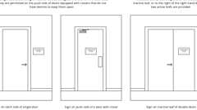

**Sign Locations at Doors**

[**1143A.7 *Braille***](https://up.codes/viewer/california/ca-building-code-2025/chapter/11A/housing-accessibility#1143A.7)

*Contracted*[*Grade*](https://up.codes/viewer/california/ca-building-code-2025/chapter/J/grading#grade_)*2 Braille shall be used wherever Braille is required in other portions of these standards.*

[**1143A.7.1 *Dimensions and Capitalization***](https://up.codes/viewer/california/ca-building-code-2025/chapter/11A/housing-accessibility#1143A.7.1)

*Braille dots shall have a domed or rounded shape and shall comply with*[*Table*](https://up.codes/viewer/california/ca-building-code-2025/chapter/11B/accessibility-to-public-buildings-public-accommodations-commercial-buildings-and#table)*1143A.7.1. The indication of an uppercase letter or letters shall only be used before the first word of sentences, proper nouns and names, individual letters of the alphabet, initials and acronyms.*

[*TABLE*](https://up.codes/viewer/california/ca-building-code-2025/chapter/11B/accessibility-to-public-buildings-public-accommodations-commercial-buildings-and#table)*1143A.7.1— BRAILLE*[*DIMENSIONS*](https://up.codes/viewer/california/ca-building-code-2025/chapter/23/wood#2301.2)

|  |  |
| --- | --- |
| [***MEASUREMENT***](https://up.codes/viewer/california/ca-building-code-2025/chapter/32/encroachments-into-the-public-right-of-way#3201.2)***RANGE*** | ***MINIMUM IN INCHES***  ***MAXIMUM IN INCHES*** |
| *Dot*[*base*](https://up.codes/viewer/california/ca-building-code-2025/chapter/2/definitions#base_dsa_ss_dsa_ss_cc_oshpd_1_1r_2_4_5_)*diameter* | *0.059 (1.5 mm) to 0.063 (1.6 mm)* |
| *Distance between two dots in the same cell1* | *0.100 (2.5 mm)* |
| *Distance between corresponding dots in adjacent cells1* | *0.300 (7.6 mm)* |
| *Dot height* | *0.025 (0.6 mm) to 0.037 (0.9 mm)* |
| *Distance between corresponding dots from one cell directly below1* | *0.395 (10 mm) to 0.400 (10.2 mm)* |

1. *Measured center to center.*

[**1143A.7.2 *Position***](https://up.codes/viewer/california/ca-building-code-2025/chapter/11A/housing-accessibility#1143A.7.2)

*Braille shall be positioned below the corresponding text in a horizontal format, flush left or centered. If text is multilined, braille shall be placed below the entire text. Braille shall be separated 3/8inch (9.5 mm) minimum and 1/2inch (12.7 mm) maximum from any other*[*tactile*](https://up.codes/viewer/california/ca-building-code-2025/chapter/2/definitions#tactile_)[*characters*](https://up.codes/viewer/california/ca-building-code-2025/chapter/2/definitions#characters_)*and 3/8inch (9.5 mm) minimum from raised borders and decorative*[*elements*](https://up.codes/viewer/california/ca-building-code-2025/chapter/2/definitions#element_dsa_ac_)*.*

***Exception:****Braille provided on elevator car controls shall be separated 3/16inch (4.8 mm) minimum and shall be located directly below the corresponding raised*[*characters*](https://up.codes/viewer/california/ca-building-code-2025/chapter/2/definitions#characters_)*or symbols.*

[**1143A.8 *Symbols of Accessibility***](https://up.codes/viewer/california/ca-building-code-2025/chapter/11A/housing-accessibility#1143A.8)

Diagram

*Symbols of*[*accessibility*](https://up.codes/viewer/california/ca-building-code-2025/chapter/30/elevators-and-conveying-systems#3001.4)*and their background shall have a non-glare finish. Symbols of*[*accessibility*](https://up.codes/viewer/california/ca-building-code-2025/chapter/30/elevators-and-conveying-systems#3001.4)*shall contrast with their background with either a light symbol on a dark background or a dark symbol on a light background. Symbols of*[*accessibility*](https://up.codes/viewer/california/ca-building-code-2025/chapter/30/elevators-and-conveying-systems#3001.4)*shall comply with the following:*

1. [***International Symbol of Accessibility***](https://up.codes/viewer/california/ca-building-code-2025/chapter/2/definitions#international_symbol_of_accessibility_)***.****The "*[*International Symbol of Accessibility*](https://up.codes/viewer/california/ca-building-code-2025/chapter/2/definitions#international_symbol_of_accessibility_)*" shall consist of a white*[*figure*](https://up.codes/viewer/california/ca-building-code-2025/chapter/11B/accessibility-to-public-buildings-public-accommodations-commercial-buildings-and#figure)*on a blue background. The color blue shall approximate FS 15090 in Federal Standard 595C. (See*[*Figure*](https://up.codes/viewer/california/ca-building-code-2025/chapter/11B/accessibility-to-public-buildings-public-accommodations-commercial-buildings-and#figure)*11A-1A.)*
2. ***International Symbol of TTY.****(See*[*Figure*](https://up.codes/viewer/california/ca-building-code-2025/chapter/11B/accessibility-to-public-buildings-public-accommodations-commercial-buildings-and#figure)*11A-11C.)*
3. ***Volume Control Telephones.****(See*[*Figure*](https://up.codes/viewer/california/ca-building-code-2025/chapter/11B/accessibility-to-public-buildings-public-accommodations-commercial-buildings-and#figure)*11A-11D.)*
4. [***Assistive Listening Systems***](https://up.codes/viewer/california/ca-building-code-2025/chapter/2/definitions#assistive_listening_system_%28als%29_dsa_ac_)***.****(See*[*Figure*](https://up.codes/viewer/california/ca-building-code-2025/chapter/11B/accessibility-to-public-buildings-public-accommodations-commercial-buildings-and#figure)*11A-11E.)*
5. ***Cleaner Air Symbol.****(See*[*Chapter 11B*](https://up.codes/viewer/california/ca-building-code-2025/chapter/11B/accessibility-to-public-buildings-public-accommodations-commercial-buildings-and#11B)*.)*
6. ***Toilet and Bathing***[***Facilities***](https://up.codes/viewer/california/ca-building-code-2025/chapter/2/definitions#facility_)***Geometric Symbols****. (See*[*Section 1127A.7*](https://up.codes/viewer/california/ca-building-code-2025/chapter/11A/housing-accessibility#1127A.7)*.)*

**UpCodes Diagrams (6)**

Primary

**CA 11A: Figure 11A-11C International TTY Symbol**

Primary

**CA 11A: Figure 11A-11D Volume Control Telephones**

Primary

**CA 11A: Figure 11A-11E International Symbol of Access for Hearing Loss**

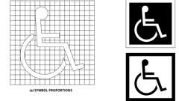Primary

**CA 11A: Figure 11A-1A International Accessibility Symbol**



**Parking Spaces: Van and Single (CA 11A)**



**Parking Signage (11A)**

[**Section 1144A *Reserved***](https://up.codes/viewer/california/ca-building-code-2025/chapter/11A/housing-accessibility#1144A)

[**Section 1145A *Reserved***](https://up.codes/viewer/california/ca-building-code-2025/chapter/11A/housing-accessibility#1145A)

[**Section 1146A *Reserved***](https://up.codes/viewer/california/ca-building-code-2025/chapter/11A/housing-accessibility#1146A)

[**Section 1147A *Reserved***](https://up.codes/viewer/california/ca-building-code-2025/chapter/11A/housing-accessibility#1147A)

[**Section 1148A *Reserved***](https://up.codes/viewer/california/ca-building-code-2025/chapter/11A/housing-accessibility#1148A)

[**Section 1149A *Reserved***](https://up.codes/viewer/california/ca-building-code-2025/chapter/11A/housing-accessibility#1149A)

[**Division VI *Site Impracticality Tests***](https://up.codes/viewer/california/ca-building-code-2025/chapter/11A/housing-accessibility#divider_11A_VI)

[**Section 1150A *Site Impracticality Tests***](https://up.codes/viewer/california/ca-building-code-2025/chapter/11A/housing-accessibility#1150A)

[**1150A.1 *General***](https://up.codes/viewer/california/ca-building-code-2025/chapter/11A/housing-accessibility#1150A.1)

[*Covered multifamily dwellings*](https://up.codes/viewer/california/ca-building-code-2025/chapter/2/definitions#covered_multifamily_dwellings_hcd_1_ac_)*in buildings without an elevator, located on*[*sites*](https://up.codes/viewer/california/ca-building-code-2025/chapter/2/definitions#site_)*with difficult terrain conditions or unusual characteristics, may employ the*[*site*](https://up.codes/viewer/california/ca-building-code-2025/chapter/2/definitions#site_)*impracticality tests in this division for determining the*[*accessibility*](https://up.codes/viewer/california/ca-building-code-2025/chapter/30/elevators-and-conveying-systems#3001.4)*and adaptability provisions required by this chapter.*

*Except as provided for in*[*Section 1102A.3.1*](https://up.codes/viewer/california/ca-building-code-2025/chapter/11A/housing-accessibility#1102A.3.1)*, the provisions of this section do not apply to*[*multistory dwelling units*](https://up.codes/viewer/california/ca-building-code-2025/chapter/2/definitions#multistory_dwelling_unit_hcd_1_ac_)*in nonelevator buildings.*

|  |
| --- |
| ***SINGLE BUILDING WITH ONE COMMON (***[***LOBBY***](https://up.codes/viewer/california/ca-building-code-2025/chapter/2/definitions#lobby_sfm_hcd_1_hcd_2_)***)***[***ENTRANCE***](https://up.codes/viewer/california/ca-building-code-2025/chapter/2/definitions#entrance_hcd_1_hcd_2_hcd_1_ac_and_dsa_ac_) |
| *The following may only be used for determining required access to covered multifamily*[*dwelling units*](https://up.codes/viewer/california/ca-building-code-2025/chapter/2/definitions#dwelling_unit_)*, in a single building with one common (*[*lobby*](https://up.codes/viewer/california/ca-building-code-2025/chapter/2/definitions#lobby_sfm_hcd_1_hcd_2_)*)*[*entrance*](https://up.codes/viewer/california/ca-building-code-2025/chapter/2/definitions#entrance_hcd_1_hcd_2_hcd_1_ac_and_dsa_ac_)*, located on a*[*site*](https://up.codes/viewer/california/ca-building-code-2025/chapter/2/definitions#site_)*with difficult terrain conditions or unusual characteristics:* |
| *All*[*ground floor*](https://up.codes/viewer/california/ca-building-code-2025/chapter/2/definitions#ground_floor_)*units in nonelevator buildings shall be*[*adaptable*](https://up.codes/viewer/california/ca-building-code-2025/chapter/2/definitions#adaptable_dsa_ac_)*and on an*[*accessible route*](https://up.codes/viewer/california/ca-building-code-2025/chapter/2/definitions#accessible_route_dsa_ac_hcd_1_ac_)*unless an*[*accessible route*](https://up.codes/viewer/california/ca-building-code-2025/chapter/2/definitions#accessible_route_dsa_ac_hcd_1_ac_)*to the common (*[*lobby*](https://up.codes/viewer/california/ca-building-code-2025/chapter/2/definitions#lobby_sfm_hcd_1_hcd_2_)*)*[*entrance*](https://up.codes/viewer/california/ca-building-code-2025/chapter/2/definitions#entrance_hcd_1_hcd_2_hcd_1_ac_and_dsa_ac_)*is not required as determined by Test No. 1, Individual Building Test, or Test No. 3, Unusual Characteristics Test, as described in this section.* |
| [*Sites*](https://up.codes/viewer/california/ca-building-code-2025/chapter/2/definitions#site_)*where either Test No. 1 or Test No. 3 is used and it is determined that an*[*accessible route*](https://up.codes/viewer/california/ca-building-code-2025/chapter/2/definitions#accessible_route_dsa_ac_hcd_1_ac_)*to the common (*[*lobby*](https://up.codes/viewer/california/ca-building-code-2025/chapter/2/definitions#lobby_sfm_hcd_1_hcd_2_)*)*[*entrance*](https://up.codes/viewer/california/ca-building-code-2025/chapter/2/definitions#entrance_hcd_1_hcd_2_hcd_1_ac_and_dsa_ac_)*is not required, at least 20 percent of the*[*ground floor*](https://up.codes/viewer/california/ca-building-code-2025/chapter/2/definitions#ground_floor_)[*dwelling units*](https://up.codes/viewer/california/ca-building-code-2025/chapter/2/definitions#dwelling_unit_)*shall comply with Division IV, and all remaining*[*ground floor*](https://up.codes/viewer/california/ca-building-code-2025/chapter/2/definitions#ground_floor_)[*dwelling units*](https://up.codes/viewer/california/ca-building-code-2025/chapter/2/definitions#dwelling_unit_)*shall comply with the features listed in*[*Section 1150A.2*](https://up.codes/viewer/california/ca-building-code-2025/chapter/11A/housing-accessibility#1150A.2)*unless exempted by Test No. 3, Unusual Characteristics Test.* |
| *Test No. 1—Individual Building Test may only be used if the*[*site*](https://up.codes/viewer/california/ca-building-code-2025/chapter/2/definitions#site_)*has terrain over 15 percent*[*slope*](https://up.codes/viewer/california/ca-building-code-2025/chapter/J/grading#slope_)*.* |
| *Test No. 3 —Unusual Characteristics Test may be used if applicable.* |

***Provisions to Test Nos. 1 and 2.****Where a building elevator is provided only as means of creating an*[*accessible route*](https://up.codes/viewer/california/ca-building-code-2025/chapter/2/definitions#accessible_route_dsa_ac_hcd_1_ac_)*to covered multifamily*[*dwelling units*](https://up.codes/viewer/california/ca-building-code-2025/chapter/2/definitions#dwelling_unit_)*on a*[*ground floor*](https://up.codes/viewer/california/ca-building-code-2025/chapter/2/definitions#ground_floor_)*, the building is not considered to be an elevator building for purposes of this code; hence, only the*[*ground floor*](https://up.codes/viewer/california/ca-building-code-2025/chapter/2/definitions#ground_floor_)[*dwelling units*](https://up.codes/viewer/california/ca-building-code-2025/chapter/2/definitions#dwelling_unit_)*would be covered.*

[***Test No. 1—Individual Building Test***](https://up.codes/viewer/california/ca-building-code-2025/chapter/11A/housing-accessibility#test_no_1_)

*It is not required by this code to provide an*[*accessible route*](https://up.codes/viewer/california/ca-building-code-2025/chapter/2/definitions#accessible_route_dsa_ac_hcd_1_ac_)*when the terrain of the*[*site*](https://up.codes/viewer/california/ca-building-code-2025/chapter/2/definitions#site_)*is such that both of the following apply:*

1. *The*[*slopes*](https://up.codes/viewer/california/ca-building-code-2025/chapter/J/grading#slope_)*of the undisturbed*[*site*](https://up.codes/viewer/california/ca-building-code-2025/chapter/2/definitions#site_)*measured between the planned*[*entrance*](https://up.codes/viewer/california/ca-building-code-2025/chapter/2/definitions#entrance_hcd_1_hcd_2_hcd_1_ac_and_dsa_ac_)*and all*[*vehicular or pedestrian arrival points*](https://up.codes/viewer/california/ca-building-code-2025/chapter/2/definitions#vehicular_or_pedestrian_arrival_points_hcd_1_ac_)*within 50 feet (15 240 mm) of the planned*[*entrance*](https://up.codes/viewer/california/ca-building-code-2025/chapter/2/definitions#entrance_hcd_1_hcd_2_hcd_1_ac_and_dsa_ac_)*exceed 15 percent; and*
2. *The*[*slopes*](https://up.codes/viewer/california/ca-building-code-2025/chapter/J/grading#slope_)*of the planned*[*finished grade*](https://up.codes/viewer/california/ca-building-code-2025/chapter/J/grading#grade_finished_)*measured between the*[*entrance*](https://up.codes/viewer/california/ca-building-code-2025/chapter/2/definitions#entrance_hcd_1_hcd_2_hcd_1_ac_and_dsa_ac_)*and all*[*vehicular or pedestrian arrival points*](https://up.codes/viewer/california/ca-building-code-2025/chapter/2/definitions#vehicular_or_pedestrian_arrival_points_hcd_1_ac_)*within 50 feet (15 240 mm) of the planned*[*entrance*](https://up.codes/viewer/california/ca-building-code-2025/chapter/2/definitions#entrance_hcd_1_hcd_2_hcd_1_ac_and_dsa_ac_)*also exceed 15 percent.*

*If there are no*[*vehicular or pedestrian arrival points*](https://up.codes/viewer/california/ca-building-code-2025/chapter/2/definitions#vehicular_or_pedestrian_arrival_points_hcd_1_ac_)*within 50 feet (15 240 mm) of the planned*[*entrance*](https://up.codes/viewer/california/ca-building-code-2025/chapter/2/definitions#entrance_hcd_1_hcd_2_hcd_1_ac_and_dsa_ac_)*, the*[*slope*](https://up.codes/viewer/california/ca-building-code-2025/chapter/J/grading#slope_)*for the purposes of Test No. 1 will be measured to the closest vehicular or*[*pedestrian*](https://up.codes/viewer/california/ca-building-code-2025/chapter/2/definitions#pedestrian_hcd_1_ac_)*arrival point.*

*For purposes of these requirements,*[*vehicular or pedestrian arrival points*](https://up.codes/viewer/california/ca-building-code-2025/chapter/2/definitions#vehicular_or_pedestrian_arrival_points_hcd_1_ac_)*include public or resident parking areas, public transportation stops, passenger loading*[*zones*](https://up.codes/viewer/california/ca-building-code-2025/chapter/2/definitions#zone_)*and public streets or*[*sidewalks*](https://up.codes/viewer/california/ca-building-code-2025/chapter/2/definitions#sidewalk_)*. To determine*[*site*](https://up.codes/viewer/california/ca-building-code-2025/chapter/2/definitions#site_)*impracticality, the*[*slope*](https://up.codes/viewer/california/ca-building-code-2025/chapter/J/grading#slope_)*would be measured at ground level from the point of the planned*[*entrance*](https://up.codes/viewer/california/ca-building-code-2025/chapter/2/definitions#entrance_hcd_1_hcd_2_hcd_1_ac_and_dsa_ac_)*on a straight line to (1) each vehicular or*[*pedestrian*](https://up.codes/viewer/california/ca-building-code-2025/chapter/2/definitions#pedestrian_hcd_1_ac_)*arrival point that is within 50 feet (15 240 mm) of the planned*[*entrance*](https://up.codes/viewer/california/ca-building-code-2025/chapter/2/definitions#entrance_hcd_1_hcd_2_hcd_1_ac_and_dsa_ac_)*, or (2) if there are no*[*vehicular or pedestrian arrival points*](https://up.codes/viewer/california/ca-building-code-2025/chapter/2/definitions#vehicular_or_pedestrian_arrival_points_hcd_1_ac_)*within the specified area, the vehicular or*[*pedestrian*](https://up.codes/viewer/california/ca-building-code-2025/chapter/2/definitions#pedestrian_hcd_1_ac_)*arrival point closest to the planned*[*entrance*](https://up.codes/viewer/california/ca-building-code-2025/chapter/2/definitions#entrance_hcd_1_hcd_2_hcd_1_ac_and_dsa_ac_)*. In the case of*[*sidewalks*](https://up.codes/viewer/california/ca-building-code-2025/chapter/2/definitions#sidewalk_)*, the closest point to the*[*entrance*](https://up.codes/viewer/california/ca-building-code-2025/chapter/2/definitions#entrance_hcd_1_hcd_2_hcd_1_ac_and_dsa_ac_)*will be where a public*[*sidewalk*](https://up.codes/viewer/california/ca-building-code-2025/chapter/2/definitions#sidewalk_)*entering the*[*site*](https://up.codes/viewer/california/ca-building-code-2025/chapter/2/definitions#site_)*intersects with the*[*walk*](https://up.codes/viewer/california/ca-building-code-2025/chapter/2/definitions#walk_dsa_ac_)*to the*[*entrance*](https://up.codes/viewer/california/ca-building-code-2025/chapter/2/definitions#entrance_hcd_1_hcd_2_hcd_1_ac_and_dsa_ac_)*. In the case of resident parking areas, the closest point to the planned*[*entrance*](https://up.codes/viewer/california/ca-building-code-2025/chapter/2/definitions#entrance_hcd_1_hcd_2_hcd_1_ac_and_dsa_ac_)*will be measured from the entry point to the parking area that is located closest to the planned*[*entrance*](https://up.codes/viewer/california/ca-building-code-2025/chapter/2/definitions#entrance_hcd_1_hcd_2_hcd_1_ac_and_dsa_ac_)*.*

[***Test No. 2—Site Analysis Test***](https://up.codes/viewer/california/ca-building-code-2025/chapter/11A/housing-accessibility#test_no_2_)

*For a*[*site*](https://up.codes/viewer/california/ca-building-code-2025/chapter/2/definitions#site_)*having multiple buildings, or a*[*site*](https://up.codes/viewer/california/ca-building-code-2025/chapter/2/definitions#site_)*with a single building with multiple*[*entrances*](https://up.codes/viewer/california/ca-building-code-2025/chapter/2/definitions#entrance_hcd_1_hcd_2_hcd_1_ac_and_dsa_ac_)*, it is not required to provide an*[*accessible route*](https://up.codes/viewer/california/ca-building-code-2025/chapter/2/definitions#accessible_route_dsa_ac_hcd_1_ac_)*to all*[*ground floor*](https://up.codes/viewer/california/ca-building-code-2025/chapter/2/definitions#ground_floor_)*units under the following conditions:*

1. *Calculate the percentage of the total buildable area of the undisturbed*[*site*](https://up.codes/viewer/california/ca-building-code-2025/chapter/2/definitions#site_)*with a natural*[*grade*](https://up.codes/viewer/california/ca-building-code-2025/chapter/J/grading#grade_)*less than 10-percent*[*slope*](https://up.codes/viewer/california/ca-building-code-2025/chapter/J/grading#slope_)*. The analysis of the existing*[*slope*](https://up.codes/viewer/california/ca-building-code-2025/chapter/J/grading#slope_)*(before*[*grading*](https://up.codes/viewer/california/ca-building-code-2025/chapter/J/grading#grading_)*) shall be done on a topographic survey with 2-foot (610 mm) contour intervals with*[*slope*](https://up.codes/viewer/california/ca-building-code-2025/chapter/J/grading#slope_)*determination made between each successive interval. The accuracy of the*[*slope*](https://up.codes/viewer/california/ca-building-code-2025/chapter/J/grading#slope_)*analysis shall be certified by a licensed engineer, landscape architect, architect or surveyor.*
2. *Determine the requirement of providing an*[*accessible route*](https://up.codes/viewer/california/ca-building-code-2025/chapter/2/definitions#accessible_route_dsa_ac_hcd_1_ac_)*to planned multifamily*[*dwellings*](https://up.codes/viewer/california/ca-building-code-2025/chapter/2/definitions#dwelling_)*based on the topography of the existing natural terrain. The minimum percentage of*[*ground floor*](https://up.codes/viewer/california/ca-building-code-2025/chapter/2/definitions#ground_floor_)*units required on an*[*accessible route*](https://up.codes/viewer/california/ca-building-code-2025/chapter/2/definitions#accessible_route_dsa_ac_hcd_1_ac_)*shall equal the percentage of the total buildable area (not restricted-use areas) of the undisturbed*[*site*](https://up.codes/viewer/california/ca-building-code-2025/chapter/2/definitions#site_)*with an existing natural*[*grade*](https://up.codes/viewer/california/ca-building-code-2025/chapter/J/grading#grade_)*of less than 10-percent*[*slope*](https://up.codes/viewer/california/ca-building-code-2025/chapter/J/grading#slope_)*. In no case shall less than 20 percent of the*[*ground floor*](https://up.codes/viewer/california/ca-building-code-2025/chapter/2/definitions#ground_floor_)[*dwelling units*](https://up.codes/viewer/california/ca-building-code-2025/chapter/2/definitions#dwelling_unit_)*be on an*[*accessible route*](https://up.codes/viewer/california/ca-building-code-2025/chapter/2/definitions#accessible_route_dsa_ac_hcd_1_ac_)*and comply with the provisions of Division IV.*
3. *In addition to the percentage established in paragraph (2), all additional*[*ground floor*](https://up.codes/viewer/california/ca-building-code-2025/chapter/2/definitions#ground_floor_)*units in a building or*[*ground floor*](https://up.codes/viewer/california/ca-building-code-2025/chapter/2/definitions#ground_floor_)*units served by a particular*[*entrance*](https://up.codes/viewer/california/ca-building-code-2025/chapter/2/definitions#entrance_hcd_1_hcd_2_hcd_1_ac_and_dsa_ac_)*, that fall within an 8.33-percent*[*slope*](https://up.codes/viewer/california/ca-building-code-2025/chapter/J/grading#slope_)*between their planned*[*entrances*](https://up.codes/viewer/california/ca-building-code-2025/chapter/2/definitions#entrance_hcd_1_hcd_2_hcd_1_ac_and_dsa_ac_)*and an arrival point shall be on an*[*accessible route*](https://up.codes/viewer/california/ca-building-code-2025/chapter/2/definitions#accessible_route_dsa_ac_hcd_1_ac_)*and comply with the provisions of Division IV.*
4. *All additional*[*ground floor*](https://up.codes/viewer/california/ca-building-code-2025/chapter/2/definitions#ground_floor_)*units in a building, or*[*ground floor*](https://up.codes/viewer/california/ca-building-code-2025/chapter/2/definitions#ground_floor_)*units served by a particular*[*entrance*](https://up.codes/viewer/california/ca-building-code-2025/chapter/2/definitions#entrance_hcd_1_hcd_2_hcd_1_ac_and_dsa_ac_)*, not on an*[*accessible route*](https://up.codes/viewer/california/ca-building-code-2025/chapter/2/definitions#accessible_route_dsa_ac_hcd_1_ac_)*shall comply with the features listed in*[*Section 1150A.2*](https://up.codes/viewer/california/ca-building-code-2025/chapter/11A/housing-accessibility#1150A.2)*.*

[***Test No. 3—Unusual Characteristics Test***](https://up.codes/viewer/california/ca-building-code-2025/chapter/11A/housing-accessibility#test_no_3_)

*Unusual characteristics include*[*sites*](https://up.codes/viewer/california/ca-building-code-2025/chapter/2/definitions#site_)*located in a state or federally designated floodplain or*[*coastal high-hazard areas*](https://up.codes/viewer/california/ca-building-code-2025/chapter/2/definitions#coastal_high_hazard_area_)*and*[*sites*](https://up.codes/viewer/california/ca-building-code-2025/chapter/2/definitions#site_)*subject to other similar requirements of law or code that require the*[*lowest floor*](https://up.codes/viewer/california/ca-building-code-2025/chapter/2/definitions#lowest_floor_)*or the lowest structural member of the*[*lowest floor*](https://up.codes/viewer/california/ca-building-code-2025/chapter/2/definitions#lowest_floor_)*to be designed to a specified level at or above the*[*base flood elevation*](https://up.codes/viewer/california/ca-building-code-2025/chapter/2/definitions#base_flood_elevation_)*. An*[*accessible route*](https://up.codes/viewer/california/ca-building-code-2025/chapter/2/definitions#accessible_route_dsa_ac_hcd_1_ac_)*to a building*[*entrance*](https://up.codes/viewer/california/ca-building-code-2025/chapter/2/definitions#entrance_hcd_1_hcd_2_hcd_1_ac_and_dsa_ac_)*is impractical due to unusual characteristics of the*[*site*](https://up.codes/viewer/california/ca-building-code-2025/chapter/2/definitions#site_)*when:*

1. *The original*[*site*](https://up.codes/viewer/california/ca-building-code-2025/chapter/2/definitions#site_)*characteristics result in a difference in*[*finished grade*](https://up.codes/viewer/california/ca-building-code-2025/chapter/J/grading#grade_finished_)*elevation exceeding 30 inches (762 mm) and 10 percent measured between an*[*entrance*](https://up.codes/viewer/california/ca-building-code-2025/chapter/2/definitions#entrance_hcd_1_hcd_2_hcd_1_ac_and_dsa_ac_)*and all*[*vehicular or pedestrian arrival points*](https://up.codes/viewer/california/ca-building-code-2025/chapter/2/definitions#vehicular_or_pedestrian_arrival_points_hcd_1_ac_)*within 50 feet (15 240 mm) of the planned*[*entrance*](https://up.codes/viewer/california/ca-building-code-2025/chapter/2/definitions#entrance_hcd_1_hcd_2_hcd_1_ac_and_dsa_ac_)*; or*
2. *If there are no*[*vehicular or pedestrian arrival points*](https://up.codes/viewer/california/ca-building-code-2025/chapter/2/definitions#vehicular_or_pedestrian_arrival_points_hcd_1_ac_)*within 50 feet (15 240 mm) of the planned*[*entrance*](https://up.codes/viewer/california/ca-building-code-2025/chapter/2/definitions#entrance_hcd_1_hcd_2_hcd_1_ac_and_dsa_ac_)*, the unusual characteristics result in a difference in*[*finished grade*](https://up.codes/viewer/california/ca-building-code-2025/chapter/J/grading#grade_finished_)*elevation exceeding 30 inches (762 mm) and 10 percent measured between an*[*entrance*](https://up.codes/viewer/california/ca-building-code-2025/chapter/2/definitions#entrance_hcd_1_hcd_2_hcd_1_ac_and_dsa_ac_)*and the closest vehicular or*[*pedestrian*](https://up.codes/viewer/california/ca-building-code-2025/chapter/2/definitions#pedestrian_hcd_1_ac_)*arrival point.*

[**1150A.2 *Additional Requirements for Section 1150A***](https://up.codes/viewer/california/ca-building-code-2025/chapter/11A/housing-accessibility#1150A.2)

*All other*[*ground floor*](https://up.codes/viewer/california/ca-building-code-2025/chapter/2/definitions#ground_floor_)[*dwelling units*](https://up.codes/viewer/california/ca-building-code-2025/chapter/2/definitions#dwelling_unit_)*in nonelevator buildings shall be made to comply with the following requirements:*

1. [*Grab bar*](https://up.codes/viewer/california/ca-building-code-2025/chapter/2/definitions#grab_bar_dsa_ac_hcd_1_ac_)[*reinforcement*](https://up.codes/viewer/california/ca-building-code-2025/chapter/19A/concrete#reinforcement)*: see*[*Section 1134A*](https://up.codes/viewer/california/ca-building-code-2025/chapter/11A/housing-accessibility#1134A)*.*
2. *Thirty-two inch (813 mm)*[*clear*](https://up.codes/viewer/california/ca-building-code-2025/chapter/2/definitions#clear_dsa_ac_)*door interior opening width: see*[*Section 1132A.3*](https://up.codes/viewer/california/ca-building-code-2025/chapter/11A/housing-accessibility#1132A.3)*.*
3. *Lever*[*hardware*](https://up.codes/viewer/california/ca-building-code-2025/chapter/2/definitions#hardware_)*: see*[*Section 1132A.8*](https://up.codes/viewer/california/ca-building-code-2025/chapter/11A/housing-accessibility#1132A.8)*.*
4. [*Door signal devices*](https://up.codes/viewer/california/ca-building-code-2025/chapter/11B/accessibility-to-public-buildings-public-accommodations-commercial-buildings-and#11B-809.1.1)*: see*[*Section 1132A.10*](https://up.codes/viewer/california/ca-building-code-2025/chapter/11A/housing-accessibility#1132A.10)*.*
5. [*Clear*](https://up.codes/viewer/california/ca-building-code-2025/chapter/2/definitions#clear_dsa_ac_)[*space*](https://up.codes/viewer/california/ca-building-code-2025/chapter/2/definitions#space_)*by doors: see Chapters*[*10*](https://up.codes/viewer/california/ca-building-code-2025/chapter/10/means-of-egress#10)*and*[*11A*](https://up.codes/viewer/california/ca-building-code-2025/chapter/11A/housing-accessibility#11A)*.*
6. *Minimum 15-inch (381 mm) water closet seat height: see*[*Section 1134A.7*](https://up.codes/viewer/california/ca-building-code-2025/chapter/11A/housing-accessibility#1134A.7)*, Item 3.*
7. *Electrical receptacle outlet height: see*[*Section 1136A*](https://up.codes/viewer/california/ca-building-code-2025/chapter/11A/housing-accessibility#1136A)*.*
8. *Lighting and environmental control height: see*[*Section 1136A*](https://up.codes/viewer/california/ca-building-code-2025/chapter/11A/housing-accessibility#1136A)*.*
9. *Faucet controls: see*[*Section 1134A.8*](https://up.codes/viewer/california/ca-building-code-2025/chapter/11A/housing-accessibility#1134A.8)*, Item 7.*
10. *Water closet, bathtub and*[*lavatory*](https://up.codes/viewer/california/ca-building-code-2025/chapter/2/definitions#lavatory_)*minimum*[*space*](https://up.codes/viewer/california/ca-building-code-2025/chapter/2/definitions#space_)*requirements: see*[*Section 1134A*](https://up.codes/viewer/california/ca-building-code-2025/chapter/11A/housing-accessibility#1134A)*.*
11. *Removable cabinets under the kitchen*[*sink*](https://up.codes/viewer/california/ca-building-code-2025/chapter/2/definitions#sink_)*counter area: see*[*Section 1133A.3*](https://up.codes/viewer/california/ca-building-code-2025/chapter/11A/housing-accessibility#1133A.3)*.*

[**Division VII *Figures***](https://up.codes/viewer/california/ca-building-code-2025/chapter/11A/housing-accessibility#divider_11A_VII)

*Diagrams illustrate the specific requirements of these regulations and are intended only as an aid for building*[*design*](https://up.codes/viewer/california/ca-building-code-2025/chapter/22A/steel#2210A.1.1)*and*[*construction*](https://up.codes/viewer/california/ca-building-code-2025/chapter/4/special-detailed-requirements-based-on-occupancy-and-use#407.1.1)*. Diagrams are not to scale.*

[**Figure 11A-1A International Accessibility Symbol**](https://up.codes/viewer/california/ca-building-code-2025/chapter/11A/housing-accessibility#11A-1A)

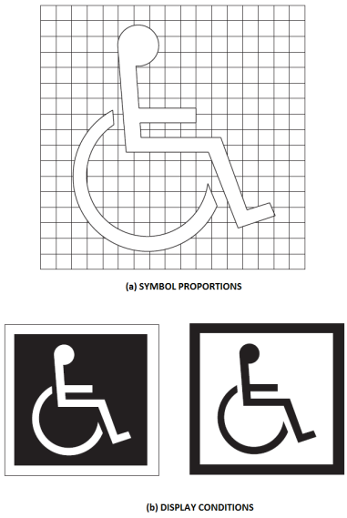

[**Figure 11A-1B Headroom Clearance and Overhanging Obstruction**](https://up.codes/viewer/california/ca-building-code-2025/chapter/11A/housing-accessibility#11A-1B)

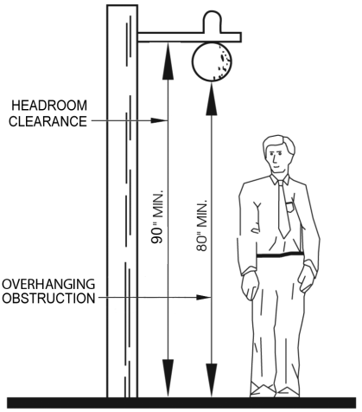

[**Figure 11A-1C Width of Accessible Route at Turns**](https://up.codes/viewer/california/ca-building-code-2025/chapter/11A/housing-accessibility#11A-1C)

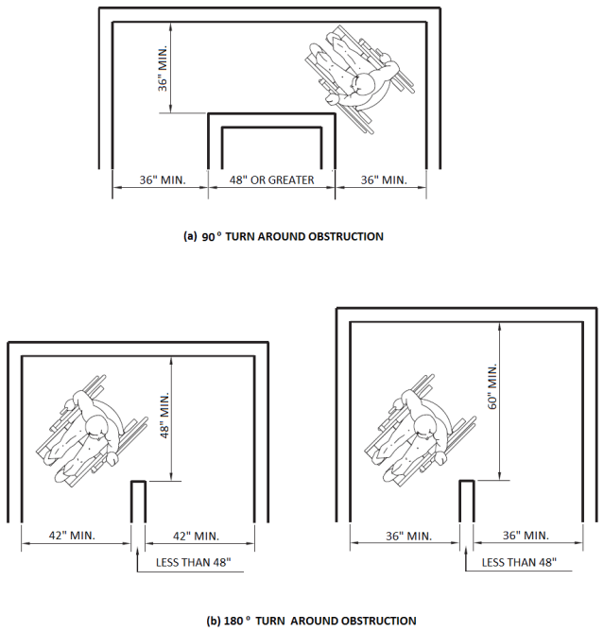

[**Figure 11A-1D Wheelchair Turning Space**](https://up.codes/viewer/california/ca-building-code-2025/chapter/11A/housing-accessibility#11A-1D)

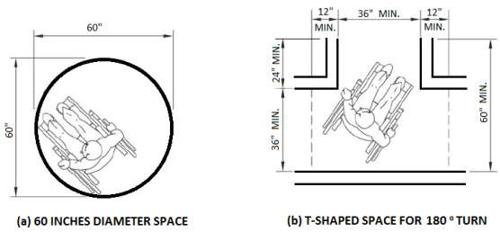

[**Figure 11A-1E Wheelchair Passage Width**](https://up.codes/viewer/california/ca-building-code-2025/chapter/11A/housing-accessibility#11A-1E)

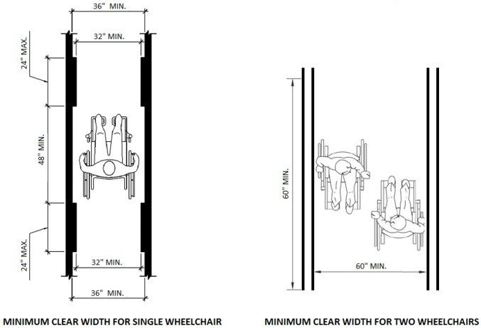

[**Figure 11A-1F Change in Level**](https://up.codes/viewer/california/ca-building-code-2025/chapter/11A/housing-accessibility#11A-1F)

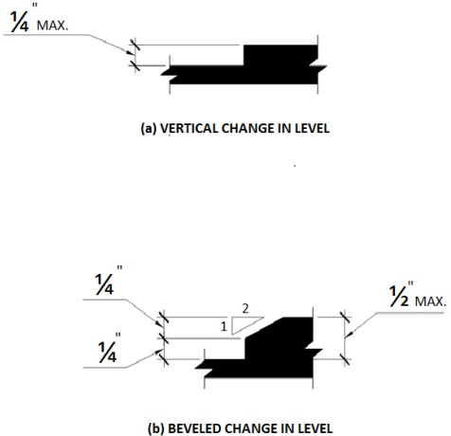

[**Figure 11A-1G Minimum Clear Floor Space for Wheelchairs**](https://up.codes/viewer/california/ca-building-code-2025/chapter/11A/housing-accessibility#11A-1G)

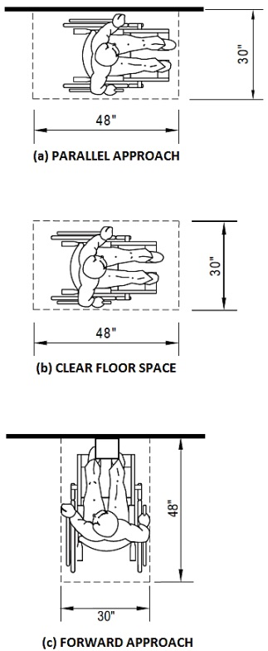

[**Figure 11A-1H Minimum Clear Floor Space in Alcoves**](https://up.codes/viewer/california/ca-building-code-2025/chapter/11A/housing-accessibility#11A-1H)

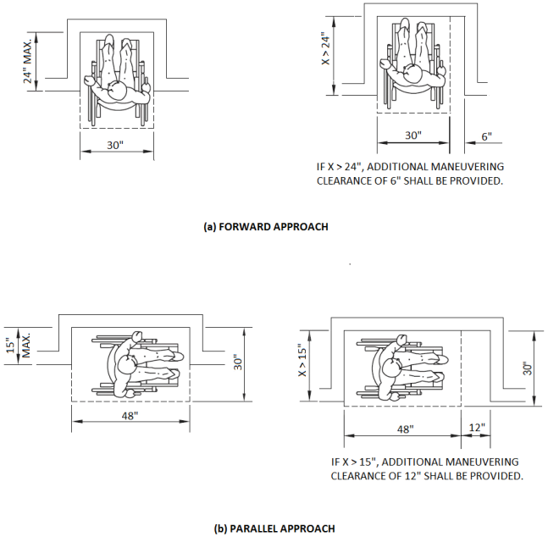

[**Figure 11A-1I Forward Reach**](https://up.codes/viewer/california/ca-building-code-2025/chapter/11A/housing-accessibility#11A-1I)

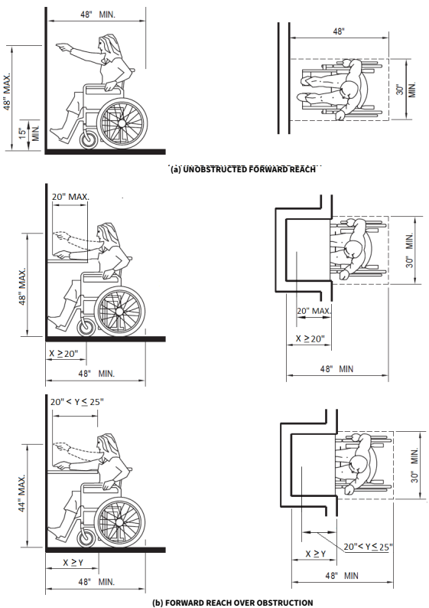

[**Figure 11A-1J Side Reach**](https://up.codes/viewer/california/ca-building-code-2025/chapter/11A/housing-accessibility#11A-1J)

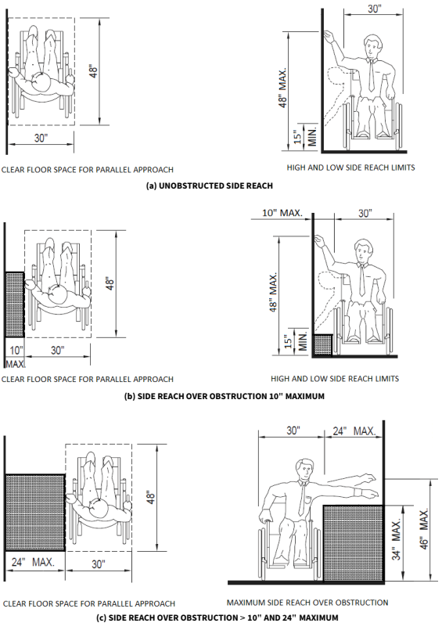

[**Figure 11A-1K Minimum Clearances for Seating and Table**](https://up.codes/viewer/california/ca-building-code-2025/chapter/11A/housing-accessibility#11A-1K)

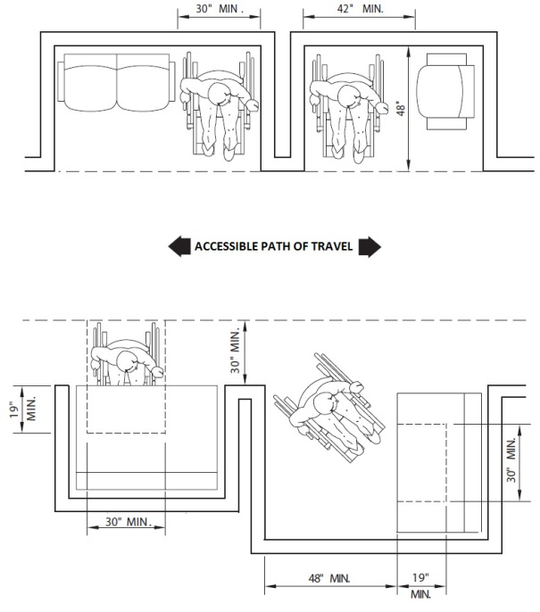

[**Figure 11A-1L Interior Accessible Route (Corridor) Over 200 Feet; Occupant Load 10 or More**](https://up.codes/viewer/california/ca-building-code-2025/chapter/11A/housing-accessibility#11A-1L)

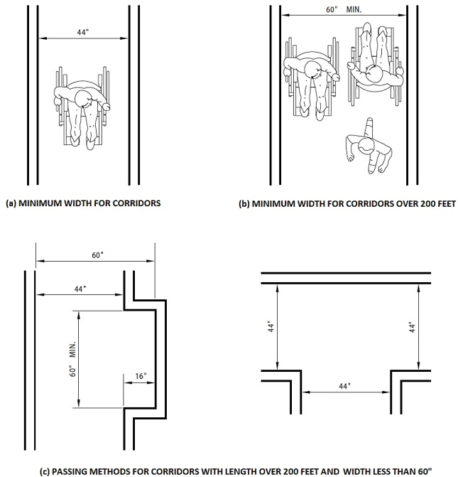

[**Figure 11A-2A Double Parking Stalls**](https://up.codes/viewer/california/ca-building-code-2025/chapter/11A/housing-accessibility#11A-2A)

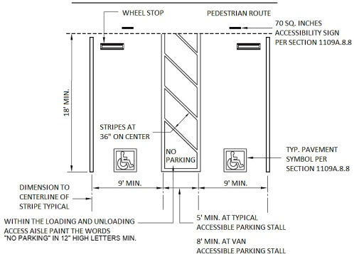

[**Figure 11A-2B Single and Van Accessible Parking Stalls**](https://up.codes/viewer/california/ca-building-code-2025/chapter/11A/housing-accessibility#11A-2B)

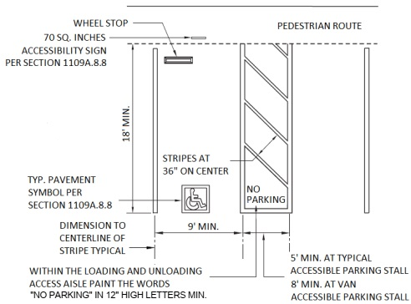

[**Figure 11A-2C Diagonal Parking Stalls**](https://up.codes/viewer/california/ca-building-code-2025/chapter/11A/housing-accessibility#11A-2C)

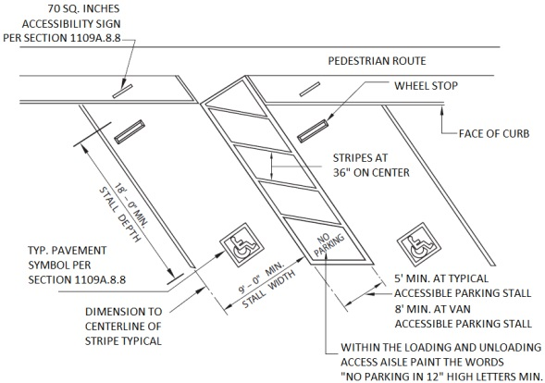

[**Figure 11A-3A Curb Details**](https://up.codes/viewer/california/ca-building-code-2025/chapter/11A/housing-accessibility#11A-3A)

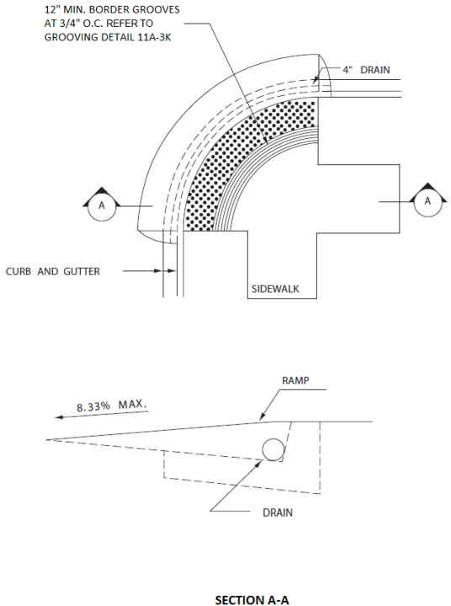

[**Figure 11A-3B Curb Detail**](https://up.codes/viewer/california/ca-building-code-2025/chapter/11A/housing-accessibility#11A-3B)

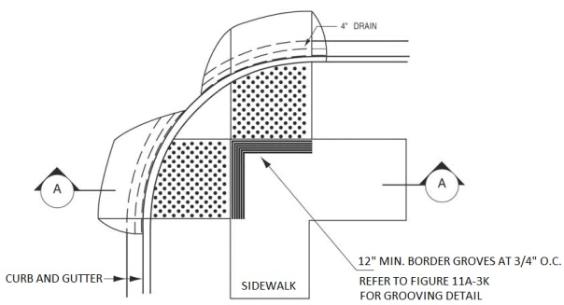

[**Figure 11A-3C Curb Detail**](https://up.codes/viewer/california/ca-building-code-2025/chapter/11A/housing-accessibility#11A-3C)

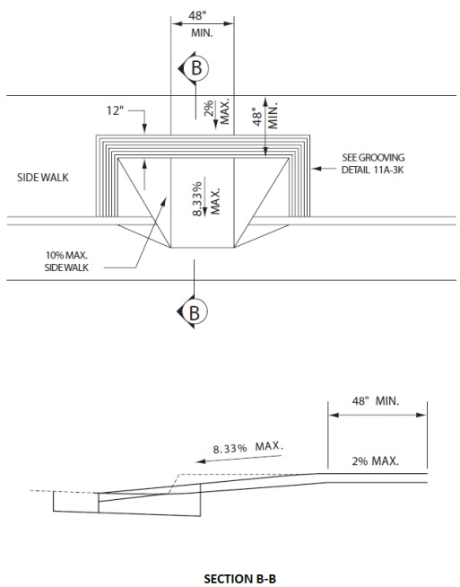

[**Figure 11A-3D Curb Detail**](https://up.codes/viewer/california/ca-building-code-2025/chapter/11A/housing-accessibility#11A-3D)

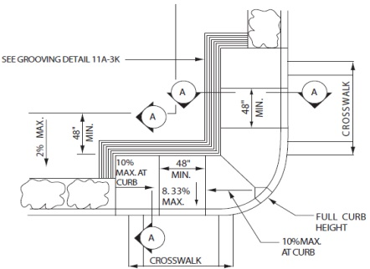

[**Figure 11A-3E Curb Detail**](https://up.codes/viewer/california/ca-building-code-2025/chapter/11A/housing-accessibility#11A-3E)

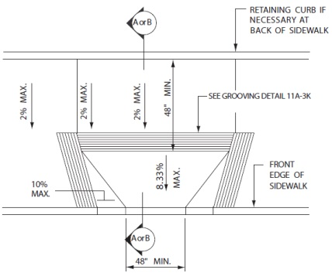

[**Figure 11A-3F Curb Detail - Sidewalk Less Than 60" Wide**](https://up.codes/viewer/california/ca-building-code-2025/chapter/11A/housing-accessibility#11A-3F)

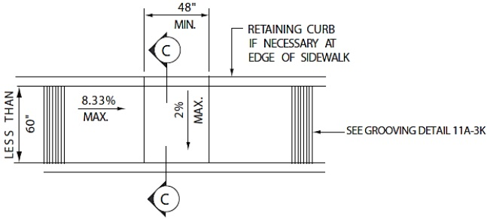

[**Figure 11A-3G Curb Detail**](https://up.codes/viewer/california/ca-building-code-2025/chapter/11A/housing-accessibility#11A-3G)

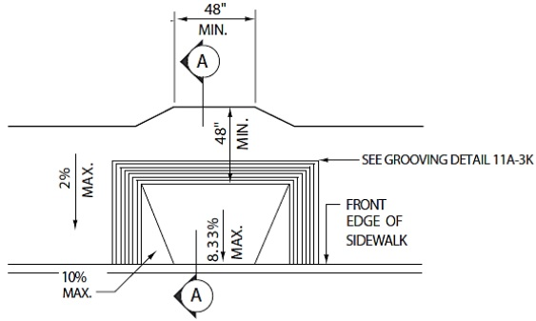

[**Figure 11A-3H Curb Detail**](https://up.codes/viewer/california/ca-building-code-2025/chapter/11A/housing-accessibility#11A-3H)

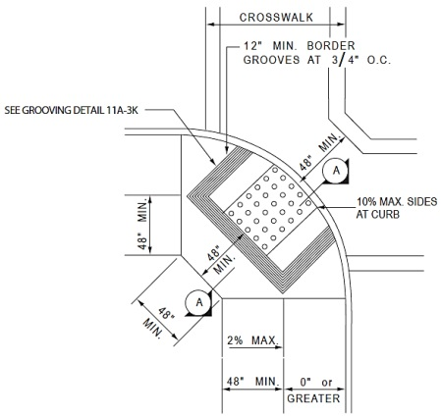

[**Figure 11A-3I Curb Detail**](https://up.codes/viewer/california/ca-building-code-2025/chapter/11A/housing-accessibility#11A-3I)

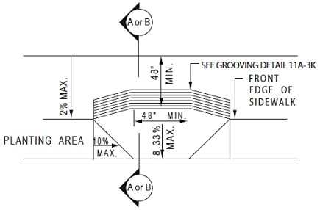

[**Figure 11A-3J Curb Detail**](https://up.codes/viewer/california/ca-building-code-2025/chapter/11A/housing-accessibility#11A-3J)

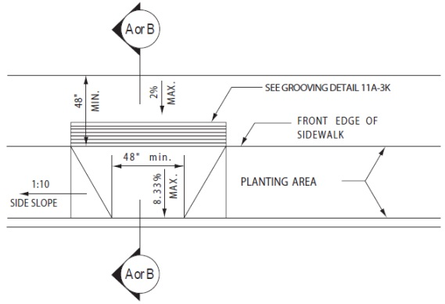

[**Figure 11A-3K Curb Detail**](https://up.codes/viewer/california/ca-building-code-2025/chapter/11A/housing-accessibility#11A-3K)

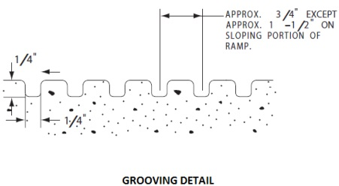

[**Figure 11A-3L Curb Sections**](https://up.codes/viewer/california/ca-building-code-2025/chapter/11A/housing-accessibility#11A-3L)

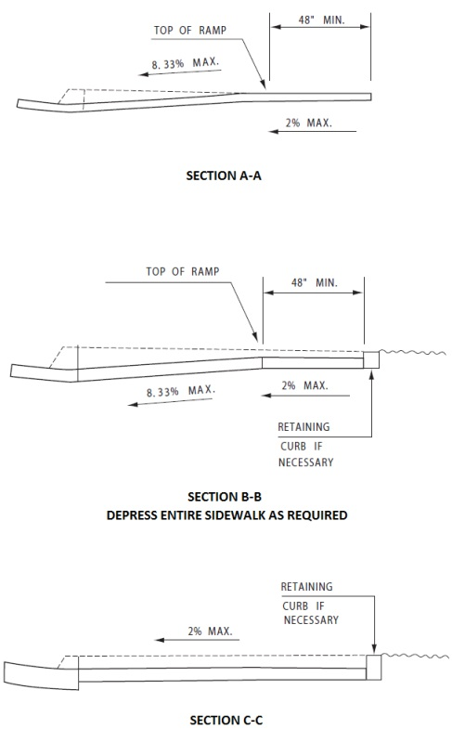

[**Figure 11A-5A Ramps and Sidewalks**](https://up.codes/viewer/california/ca-building-code-2025/chapter/11A/housing-accessibility#11A-5A)

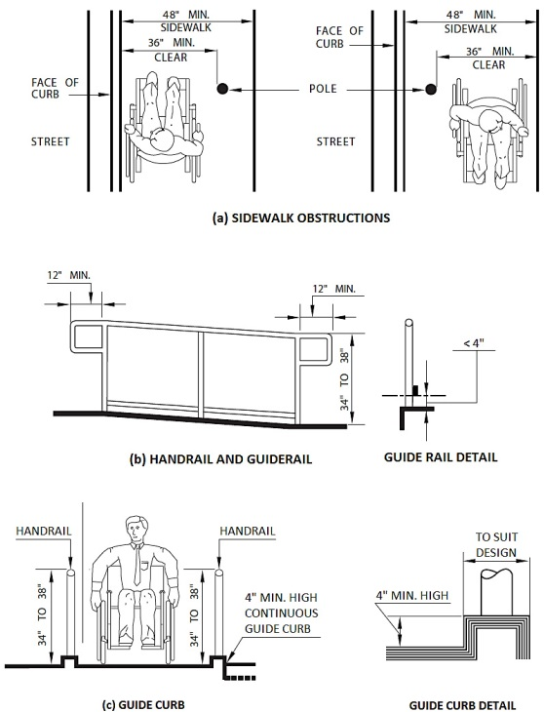

[**Figure 11A-6A Warning Striping and Handrail Extensions**](https://up.codes/viewer/california/ca-building-code-2025/chapter/11A/housing-accessibility#11A-6A)

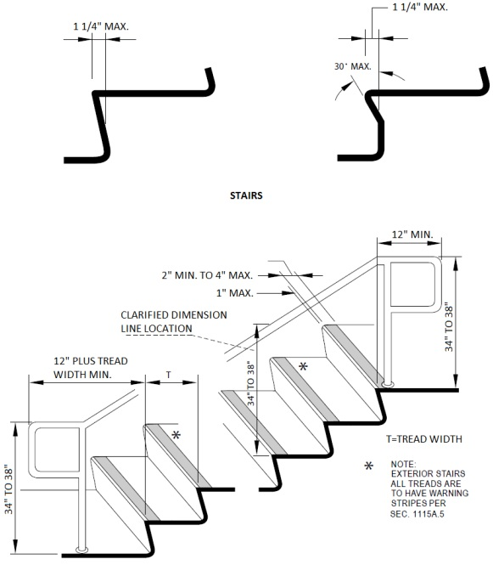

[**Figure 11A-6B Handrails**](https://up.codes/viewer/california/ca-building-code-2025/chapter/11A/housing-accessibility#11A-6B)

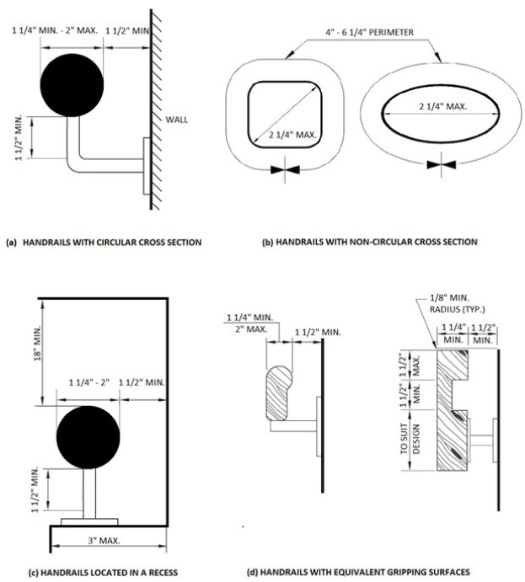

[**Figure 11A-6C Ramp Dimensions**](https://up.codes/viewer/california/ca-building-code-2025/chapter/11A/housing-accessibility#11A-6C)

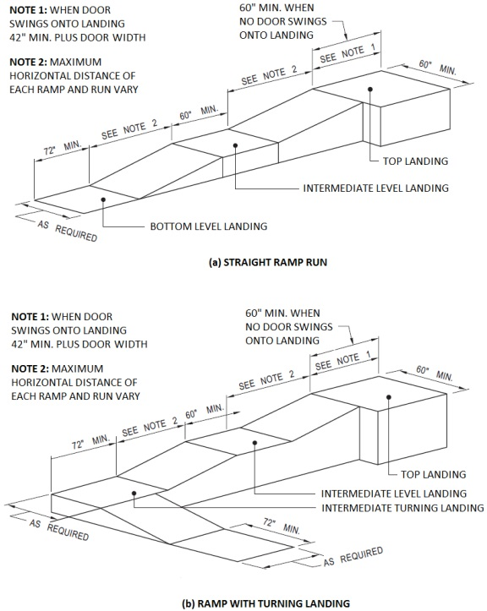

[**Figure 11A-6D Ramp Landing and Doorway**](https://up.codes/viewer/california/ca-building-code-2025/chapter/11A/housing-accessibility#11A-6D)

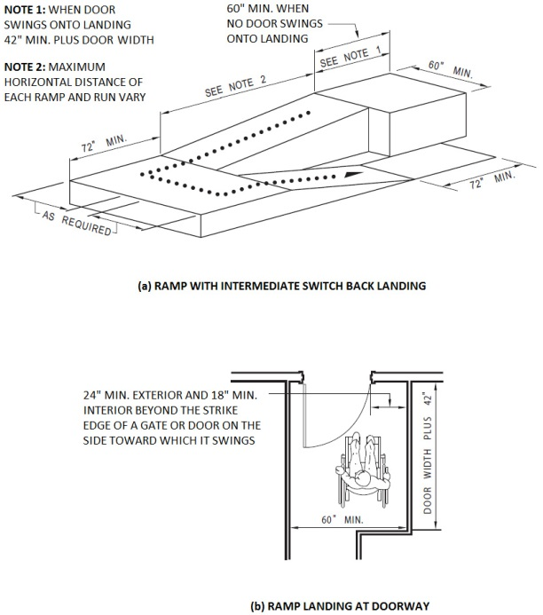

[**Figure 11A-6E Stair Handrails**](https://up.codes/viewer/california/ca-building-code-2025/chapter/11A/housing-accessibility#11A-6E)

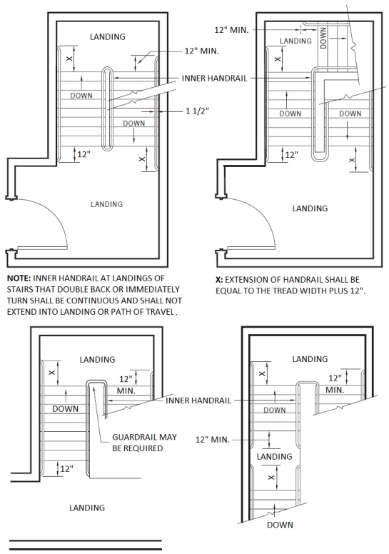

[**Figure 11A-7A Minimum Dimensions of Elevator Cars**](https://up.codes/viewer/california/ca-building-code-2025/chapter/11A/housing-accessibility#11A-7A)

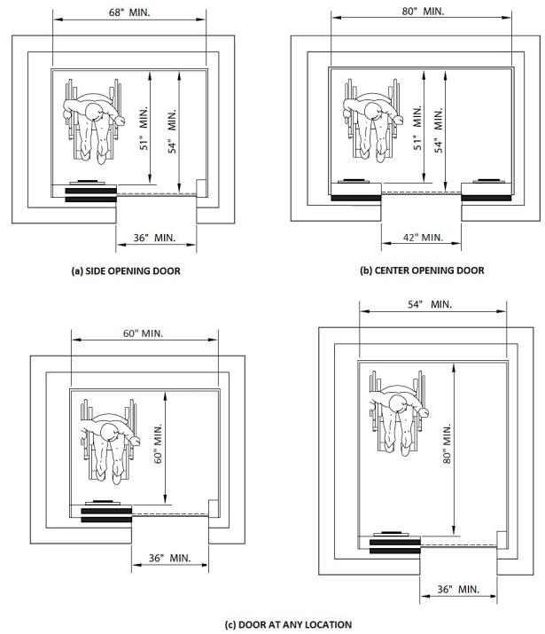

[**Figure 11A-7B Elevator Control Panel**](https://up.codes/viewer/california/ca-building-code-2025/chapter/11A/housing-accessibility#11A-7B)

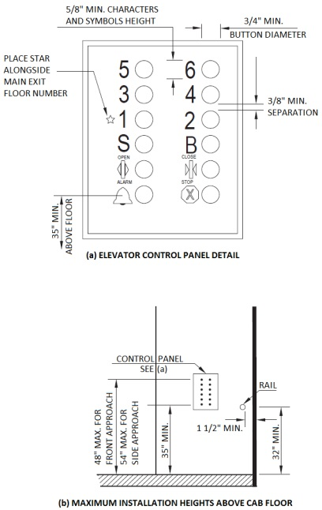

[**Figure 11A-7C Hoistway and Elevator Entrances**](https://up.codes/viewer/california/ca-building-code-2025/chapter/11A/housing-accessibility#11A-7C)

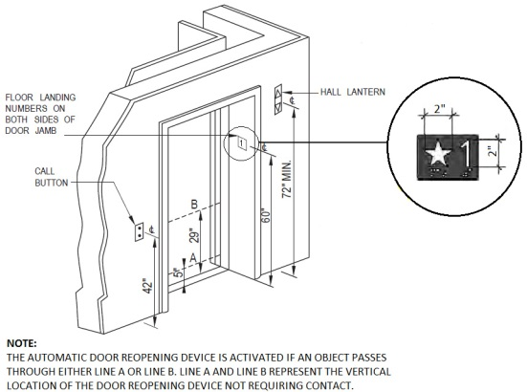

[**Figure 11A-7D Graph of Timing Equation**](https://up.codes/viewer/california/ca-building-code-2025/chapter/11A/housing-accessibility#11A-7D)

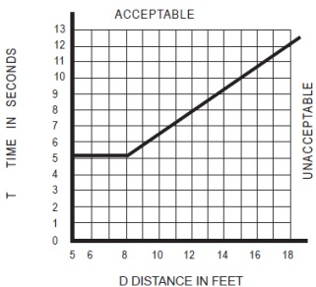

[**Figure 11A-8A Maneuvering Clearance at Swinging Doors**](https://up.codes/viewer/california/ca-building-code-2025/chapter/11A/housing-accessibility#11A-8A)

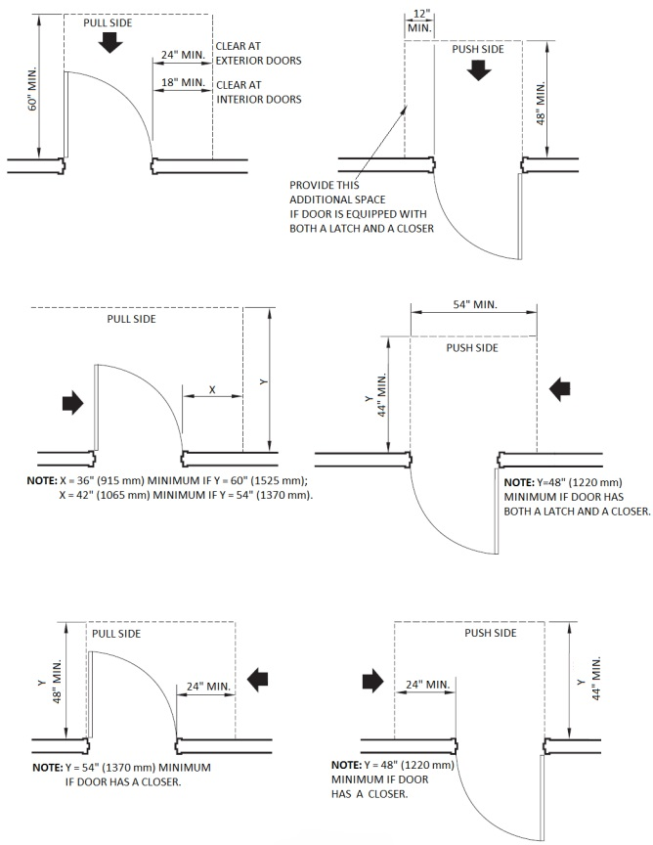

[**Figure 11A-8B Maneuvering Clearance at Doorways, Sliding Doors and Folding Doors**](https://up.codes/viewer/california/ca-building-code-2025/chapter/11A/housing-accessibility#11A-8B)

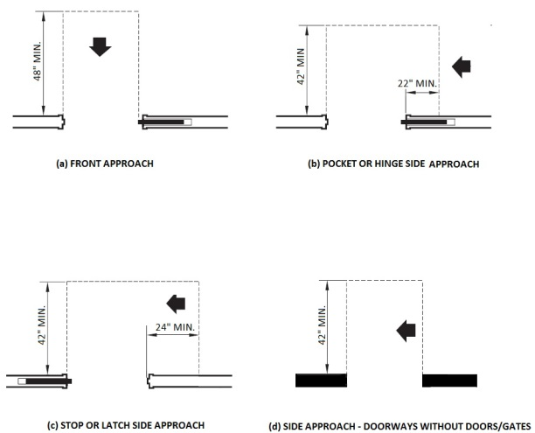

[**Figure 11A-8C Maneuvering Clearances at Recessed Doors**](https://up.codes/viewer/california/ca-building-code-2025/chapter/11A/housing-accessibility#11A-8C)

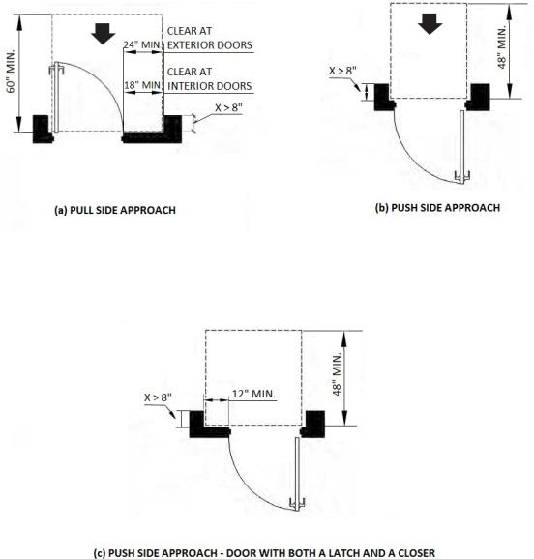

[**Figure 11A-8G Vestibule**](https://up.codes/viewer/california/ca-building-code-2025/chapter/11A/housing-accessibility#11A-8G)

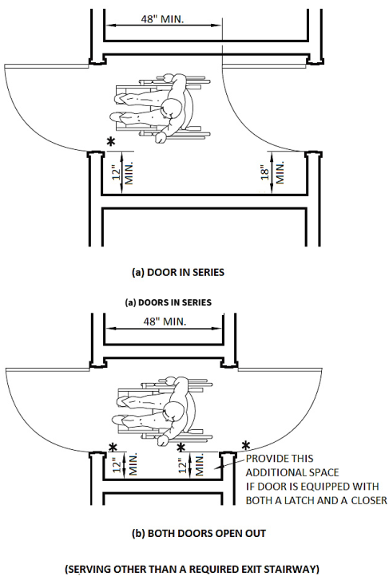

[**Figure 11A-8H Vestibule (Serving Other Than a Required Exit Stairway)**](https://up.codes/viewer/california/ca-building-code-2025/chapter/11A/housing-accessibility#11A-8H)

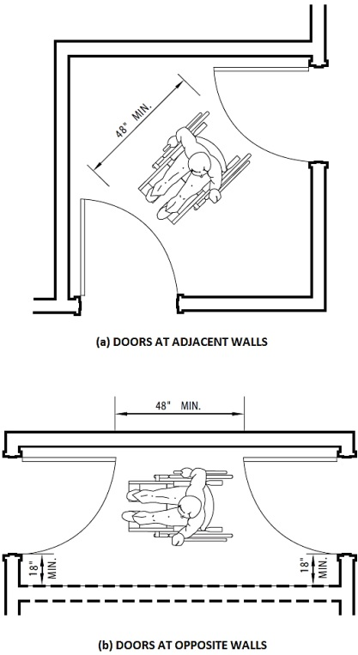

[**Figure 11A-8I Thresholds**](https://up.codes/viewer/california/ca-building-code-2025/chapter/11A/housing-accessibility#11A-8I)

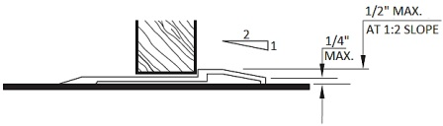

[**Figure 11A-8J Platform at Secondary Exterior Door**](https://up.codes/viewer/california/ca-building-code-2025/chapter/11A/housing-accessibility#11A-8J)

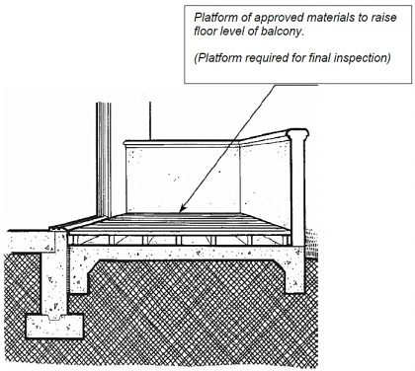

[**Figure 11A-8K Ramp at Secondary Exterior Door**](https://up.codes/viewer/california/ca-building-code-2025/chapter/11A/housing-accessibility#11A-8K)

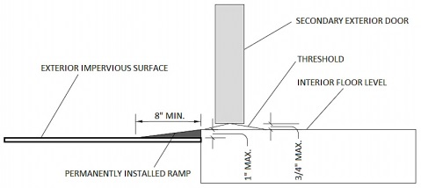

[**Figure 11A-9A Toilet Facilities**](https://up.codes/viewer/california/ca-building-code-2025/chapter/11A/housing-accessibility#11A-9A)

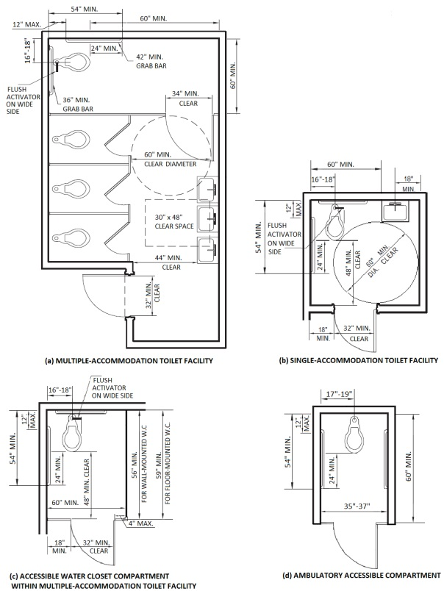

[**Figure 11A-9B Water Closets**](https://up.codes/viewer/california/ca-building-code-2025/chapter/11A/housing-accessibility#11A-9B)

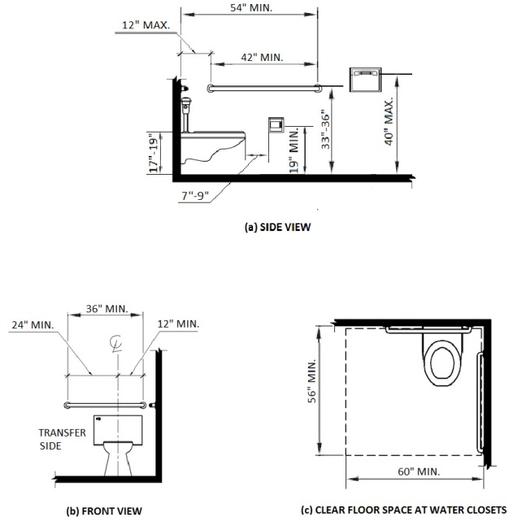

[**Figure 11A-9C Grab Bars**](https://up.codes/viewer/california/ca-building-code-2025/chapter/11A/housing-accessibility#11A-9C)

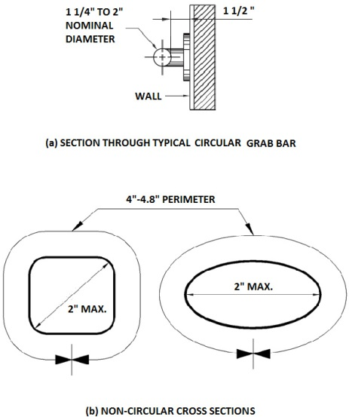

[**Figure 11A-9D Knee and Toe Space**](https://up.codes/viewer/california/ca-building-code-2025/chapter/11A/housing-accessibility#11A-9D)

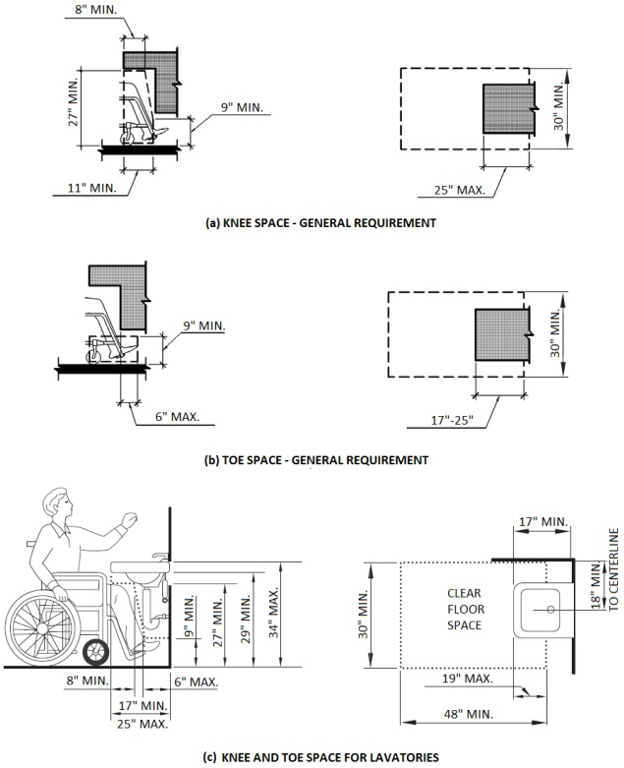

[**Figure 11A-9E Clear Floor Space at Bathtubs**](https://up.codes/viewer/california/ca-building-code-2025/chapter/11A/housing-accessibility#11A-9E)

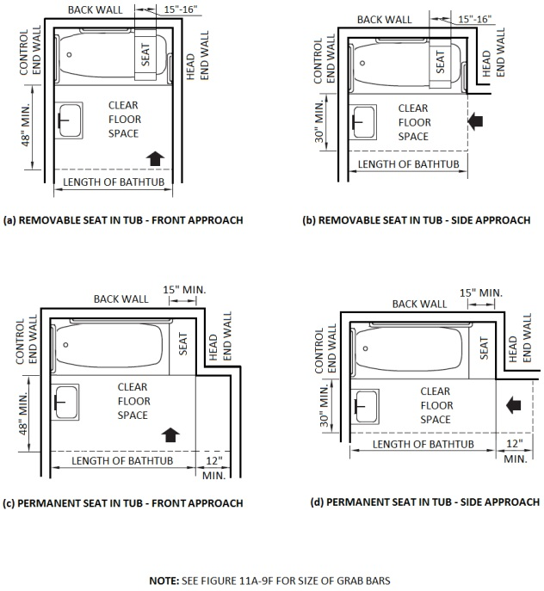

[**Figure 11A-9F Grab Bars at Bathtubs**](https://up.codes/viewer/california/ca-building-code-2025/chapter/11A/housing-accessibility#11A-9F)

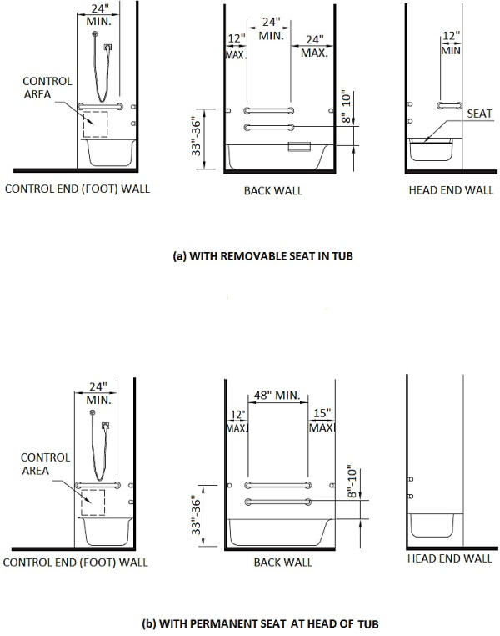

[**Figure 11A-9G Reinforcement for Grab Bars**](https://up.codes/viewer/california/ca-building-code-2025/chapter/11A/housing-accessibility#11A-9G)

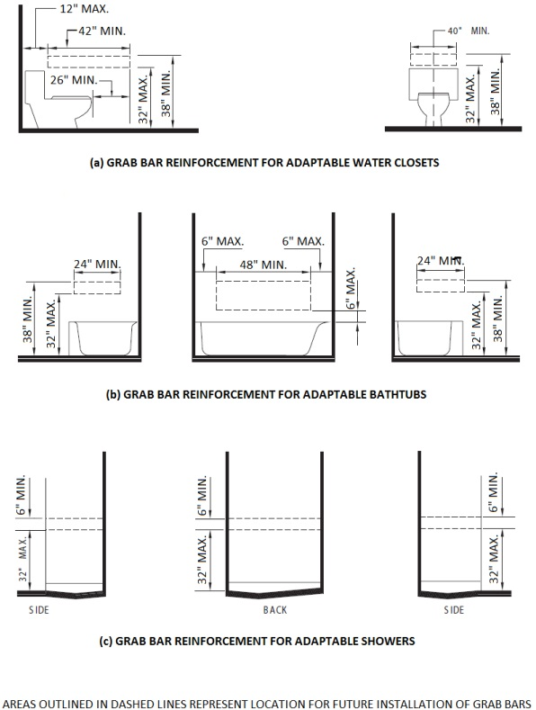

[**Figure 11A-9H Standard Roll-in Shower**](https://up.codes/viewer/california/ca-building-code-2025/chapter/11A/housing-accessibility#11A-9H)

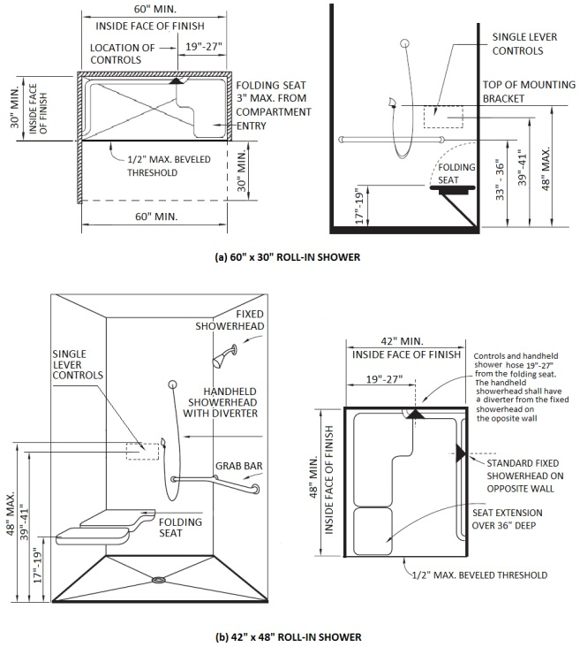

[**Figure 1A-9I Shower Seats and Grab Bars**](https://up.codes/viewer/california/ca-building-code-2025/chapter/11A/housing-accessibility#1A-9I)

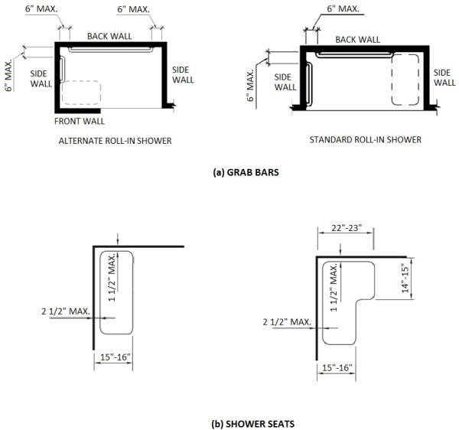

[**Figure 11A-9J Open Shower**](https://up.codes/viewer/california/ca-building-code-2025/chapter/11A/housing-accessibility#11A-9J)

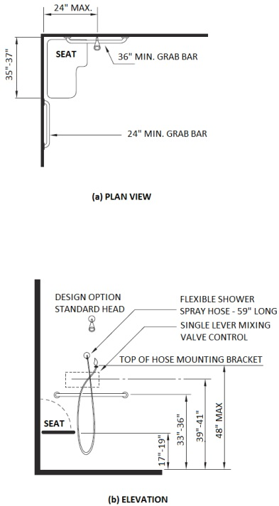

[**Figure 11A-9K Alternate Roll-in Shower**](https://up.codes/viewer/california/ca-building-code-2025/chapter/11A/housing-accessibility#11A-9K)

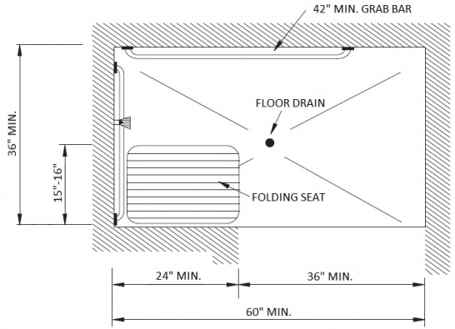

[**Figure 11A-9L Shower With Water Closet**](https://up.codes/viewer/california/ca-building-code-2025/chapter/11A/housing-accessibility#11A-9L)

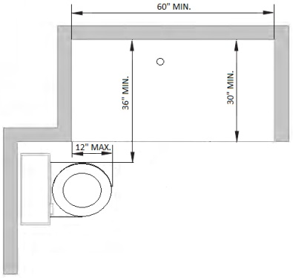

[**Figure 11A-9M Wing Wall or Cabinet at Water Closet**](https://up.codes/viewer/california/ca-building-code-2025/chapter/11A/housing-accessibility#11A-9M)

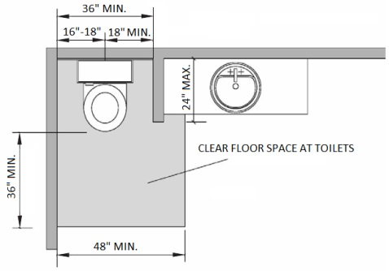

[**Figure 11A-10A Kitchen Specifications**](https://up.codes/viewer/california/ca-building-code-2025/chapter/11A/housing-accessibility#11A-10A)

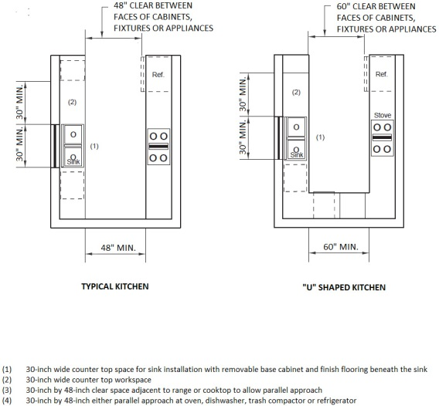

[**Figure 11A-11A Drinking Fountains**](https://up.codes/viewer/california/ca-building-code-2025/chapter/11A/housing-accessibility#11A-11A)

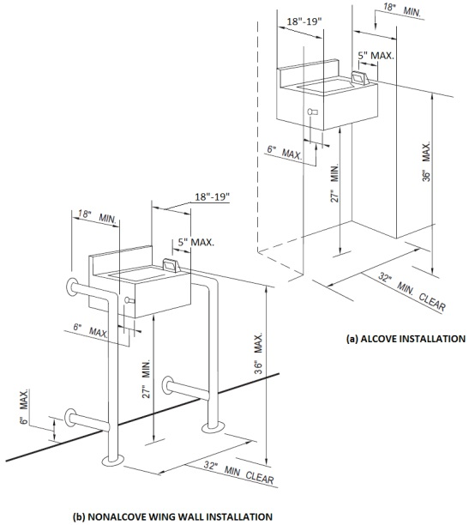

[**Figure 11A-11B Telephones**](https://up.codes/viewer/california/ca-building-code-2025/chapter/11A/housing-accessibility#11A-11B)

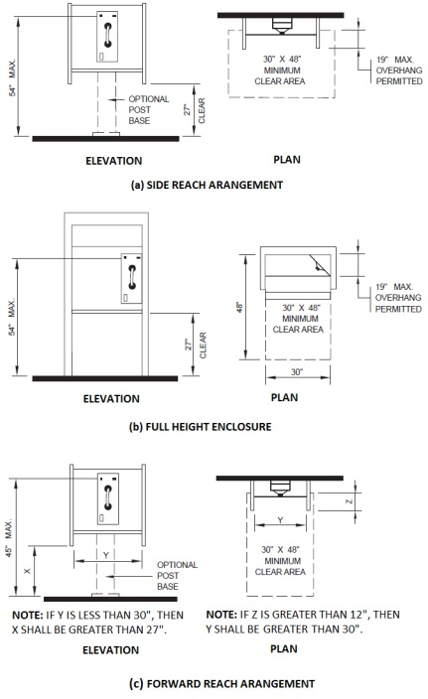

[**Figure 11A-11C International TTY Symbol**](https://up.codes/viewer/california/ca-building-code-2025/chapter/11A/housing-accessibility#11A-11C)



[**Figure 11A-11D Volume Control Telephones**](https://up.codes/viewer/california/ca-building-code-2025/chapter/11A/housing-accessibility#11A-11D)



[**Figure 11A-11E International Symbol of Access for Hearing Loss**](https://up.codes/viewer/california/ca-building-code-2025/chapter/11A/housing-accessibility#11A-11E)

